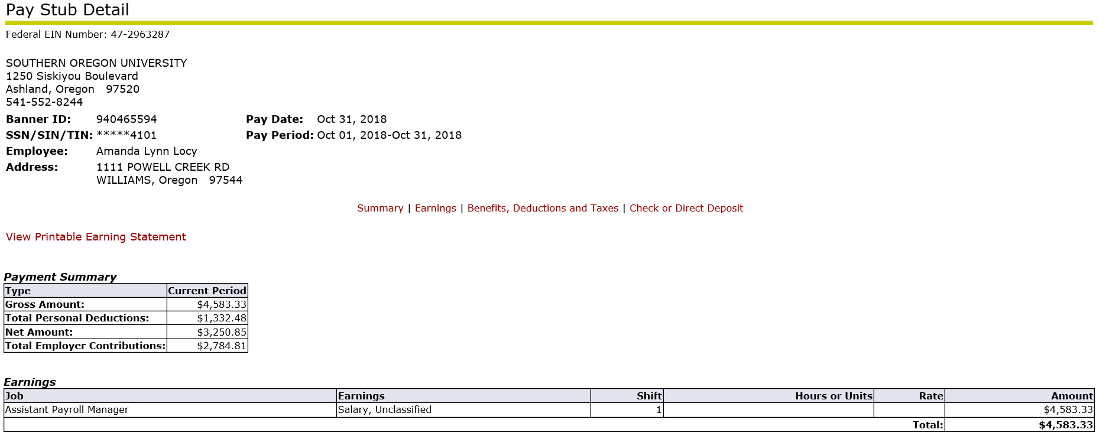
5

4

2

1

3
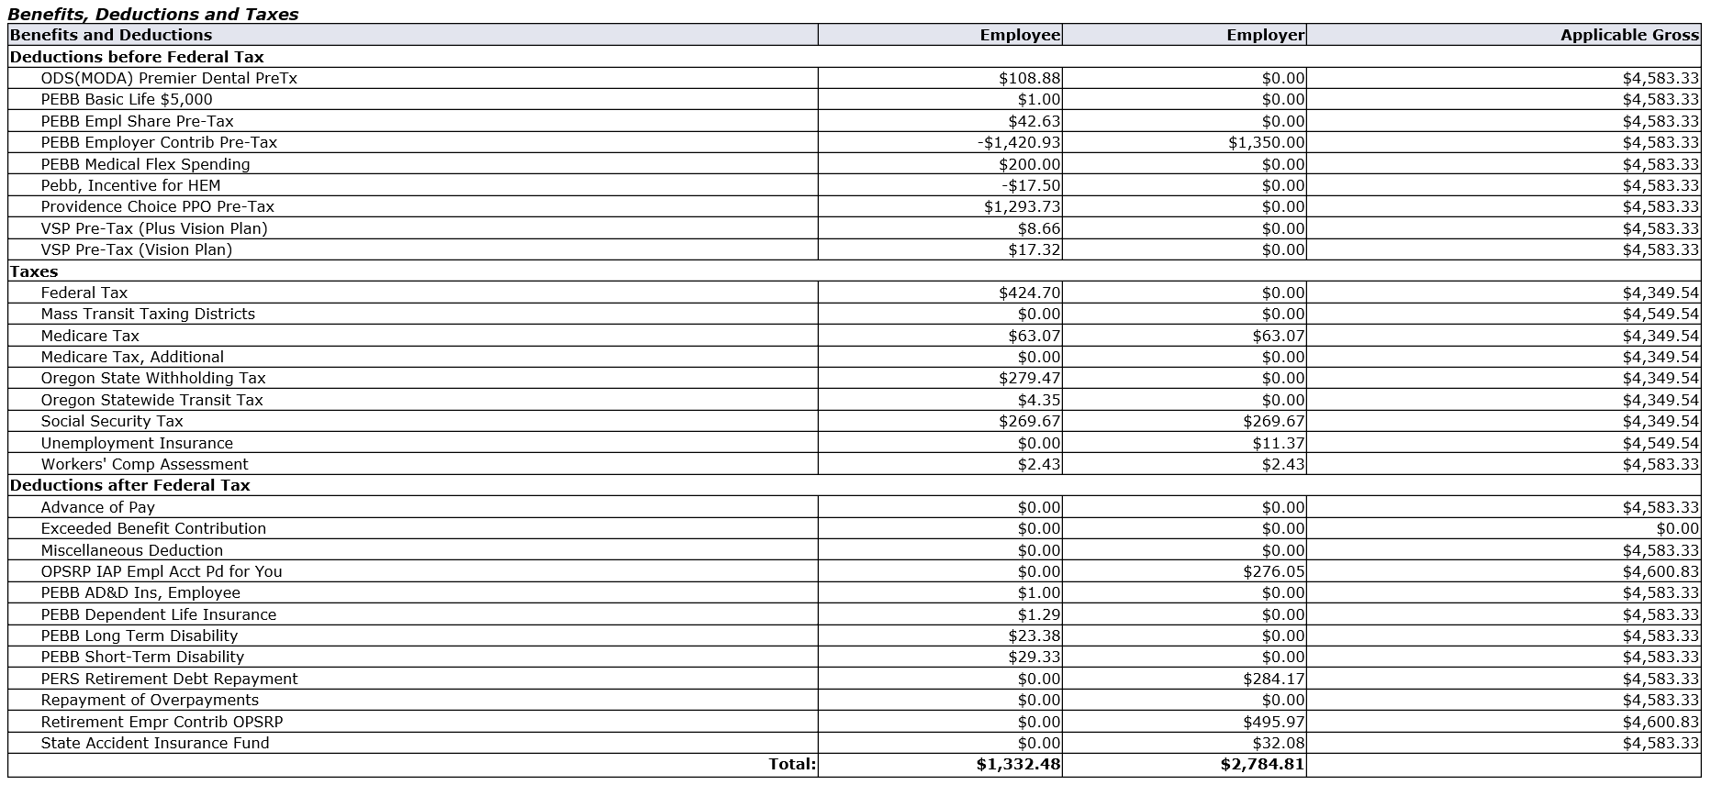
7
6

8

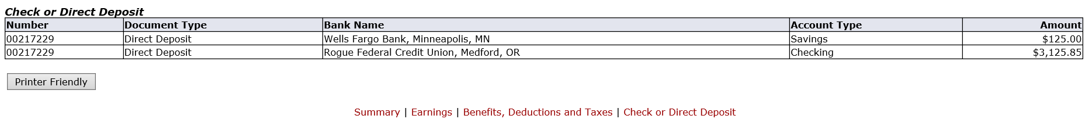
10
9

Pay Stub Section Details
Below are detailed explanations of each numbered section from the sample pay stub above.
Section 1 – Header includes Employee's name, Employee ID and current home address.

Section 2 – Date Header includes begin and end dates for current pay period. The Pay Date is the actual payday.

Section 3 – Payment Summary includes the current pay period total of gross pay, personal deductions, and the resulting net pay. Total employer contributions is what was paid for you. Payment summary information corresponds with your earnings, deductions, and employer paid totals in sections 4, 5, 6, and 7.

Section 4 – Earnings shows your earnings paid, separated by job, for the current pay period. Hours or units paid and/or your pay rate are displayed. Earnings types include, but are not limited to: Regular hours and salary, overtime, overload pay, stipends, SEIU differentials, deferred payout, and cash allowances (cell/internet). The total amount shown is your gross pay.

Section 5 – Deductions before Federal Tax are deductions taken from your earnings before tax is applied to your income. These include your healthcare plan, tax deferred investments and other pre-tax retirement contributions, flexible spending account deductions, pre-tax parking or bus pass costs, and other pre-tax deductions. If you are benefit eligible, this section will include the overall cost of your medical, dental, vision and basic life insurance amounts. The total of those amounts is not what you are paying out of pocket. The PEBB Employer Contribution, pre-tax line is a negative and therefore will result in $0.00. You are only charged the 3% (Providence Choice) or 5% (all other Medical Plan choices) on that total. Below is a breakdown from the pay stub sample above:

PEBB Basic Life Ins $5000.00 | $ 1.00
ODS (MODA) Premier Dental Pre Tax | $ 108.88
Providence Choice PPO Pre Tax | $1,293.73
VSP Pre tax (Plus Vision Plan) | $ 8.66
VSP Pre tax (Vision Plan) | $ 17.32
PEBB Employer Contribution Pre tax | $-1,420.93
Total net effect to you | $ 0.00
PEBB Employee 3% Share of the ($1,420.93) $ 42.63

Section 6 – Taxes include both the tax withholdings from your pay and tax assessments paid by Southern Oregon University on your behalf as an associated cost of employment.

Section 7 – Deductions after Federal Tax are all other deductions taken from your earnings. These include post-tax deductions, Oregon Tech-paid retirement account contributions, PERS employer cost assessments, union dues/fair share, PEBB post-tax life/disability/long term care deductions, charitable donations, and others.

Section 8 – Federally Taxable Benefits - These are non-cash benefits subject to taxation that you’ve received, including but not limited to taxable tuition benefits, domestic partner benefits, and taxable moving expenses.

Section 9 – Check or Direct Deposit - Depending on the method by which you are paid, you will see here either a check number or a transaction number and your bank information.

Section 10 - Printer Friendly Button allows you to print or save your pay stub when you need an official Southern Oregon University pay stub to provide proof of employment and wages received.

