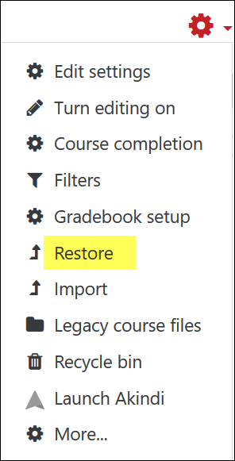
Adding the Student Resource book to your course just takes a few minutes—mostly, you just click on Next a bunch of times!
Here’s how to install the book in your course:
- Save the backup file to your computer.
- In your course, open the course admin gear in the upper right corner, then click on Restore.
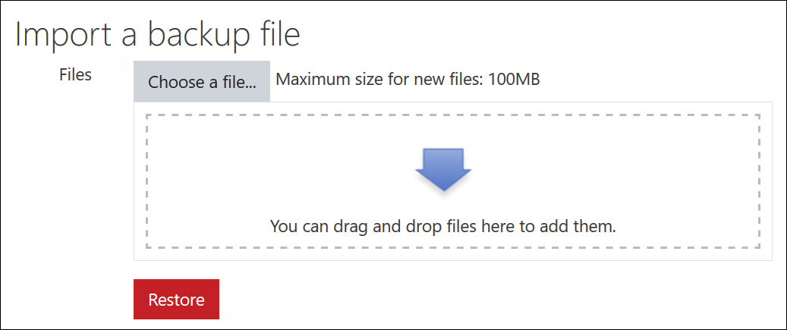
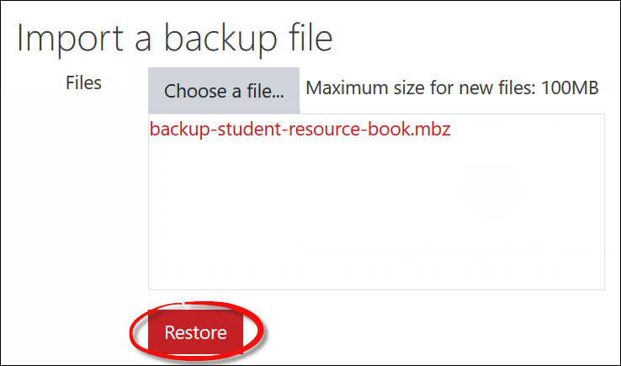
- Drag and drop the backup file in the file picker field:

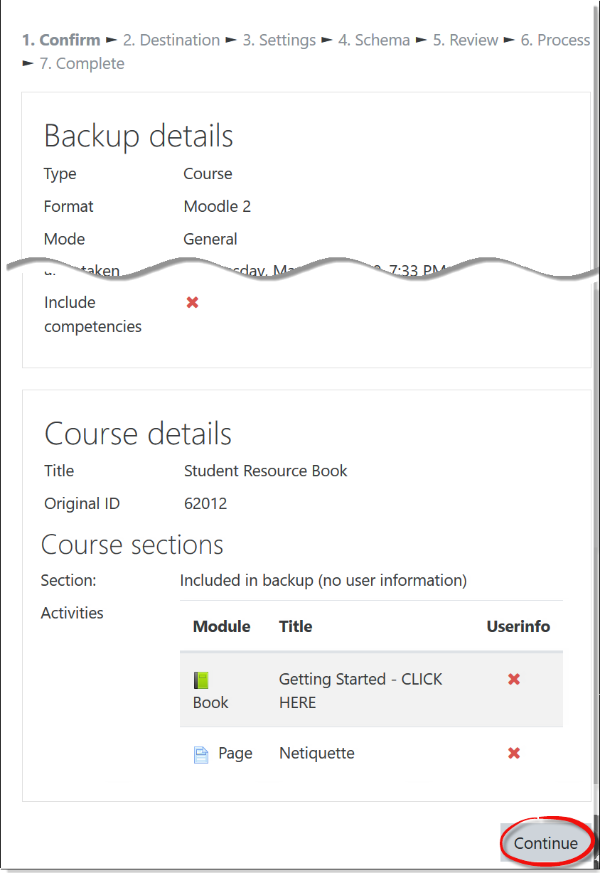
- On the Confirm page, scroll down and click on Continue.
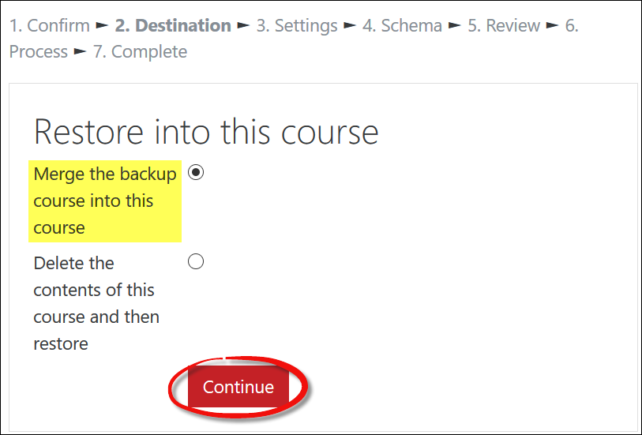
- Merge the backup course (book, in this case) into
your course by clicking on Continue.

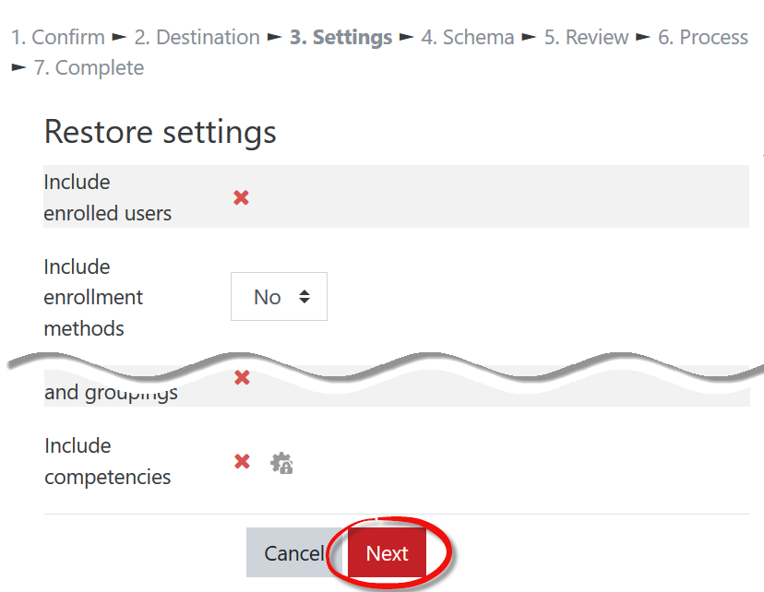
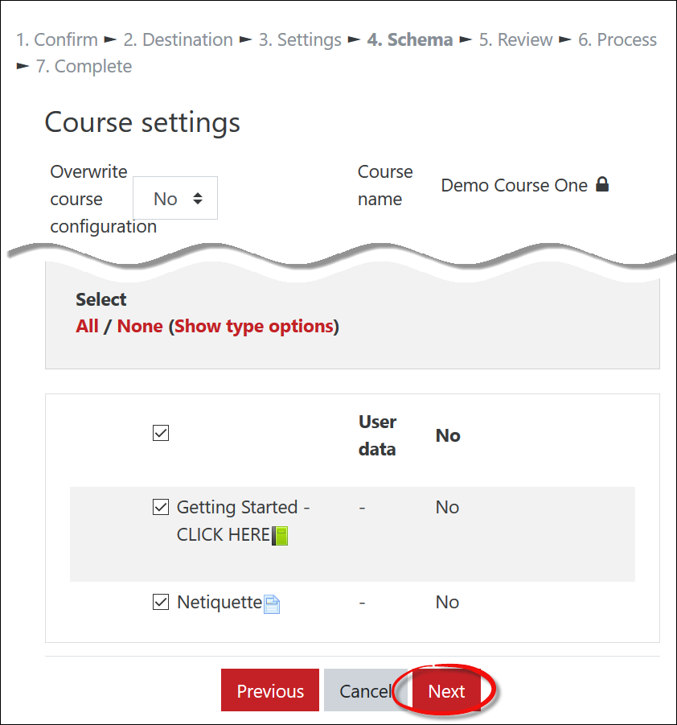
- On the Settings page, leave everything alone and scroll down to click on Next, then do the same thing on the next page (Schema).

- On the review page, scroll down and (finally!) click on Perform restore.
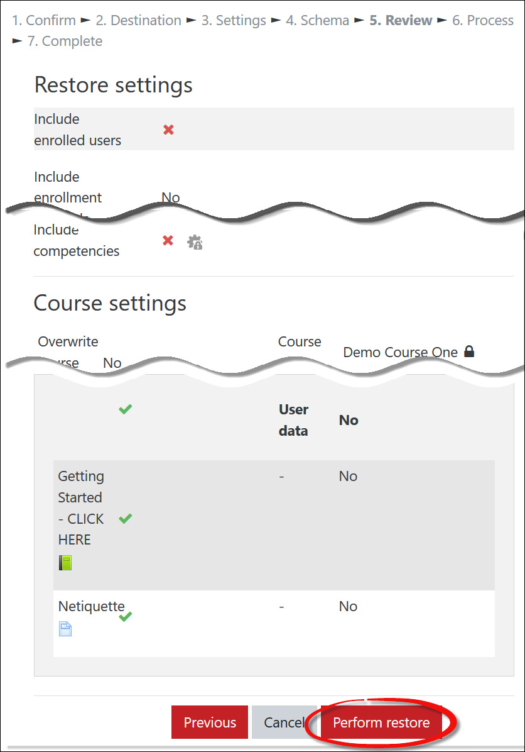
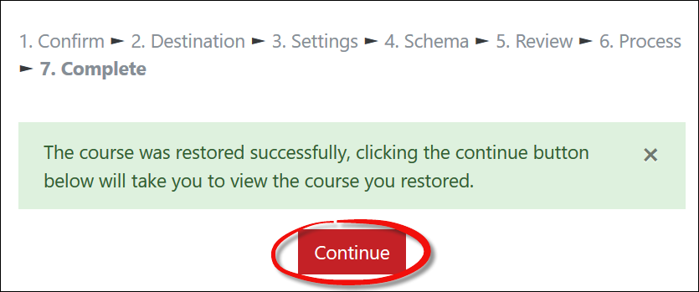
- You'll get this confirmation notice—click on continue to return to your course.

