Tutor Schedule Winter 2018

Language | Name | Days | Times
Spanish | Roberto | Monday & Wednesday | 3:30 - 5:00 pm
Spanish | Gloria | Monday, Tuesday & Thursday | 1:00 - 2:30 pm
French | Wesley | Tuesday & Thursday | 12:00 - 3:00 pm
French | Jeanne | Monday & Wednesday | 2:00 - 5:00 pm
Japanese | Kana | Monday & Wednesday | 3:30 - 5:00 pm
Japanese | Kana | Tuesday | 3:00 - 5:00 pm
Japanese | Ryo | Monday & Wednesday | 12:00 - 1:00 pm
German | Jamie | Tuesday & Thursday | 12:00 - 1:00 pm
German | Nicole | Tuesday & Thursday | 1:30 - 2:30 pm
German | Magdalena | Tuesday | 1:30 - 2:30 pm
German | Magdalena | Thursday | 1:00 - 2:00 pm
ASL | Austin | Tuesday | 1:30 - 3:00 pm
ASL | Austin | Thursday | 12:00 - 3:00 pm

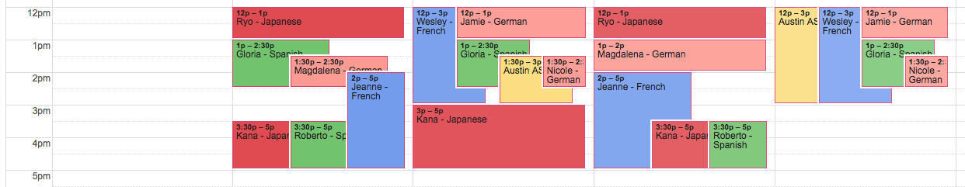
Monday
Tuesday
Wednesday
Thursday

