Summer Language Institute (Guanajuato, Mexico)
Southern Oregon University
Master of Arts in Spanish Language Teaching

SPAN 520:
Cuento corto y cortometrajes de México
Horario de clase: Lunes a viernes, 12-1:50 pm
17 de julio-4 de agosto, 2023
Profesor: | Dr. Enrique Chacón
E-mail: | chaconl@sou.edu

Descripción
Este seminario busca analizar la producción más relevante que se ha realizado en cuanto a cuentos cortos y cortometrajes en México. A través de la discusión, el comentario y la investigación colectiva, se generará conocimiento sobre las técnicas narrativas, sobre las técnicas cinematográficas y sobre la cultura de Latinoamérica.
Este curso está enfocado a problematizar y a profundizar a través del pensamiento crítico, en los aspectos centrales de la cultura de América Latina, por lo que su organización se ha realizado a través de ejes temáticos, como el concepto de la muerte, la frontera, los pueblos originarios y otros. También se incluye un contenido teórico que se encamina a analizar la narrativa y el lenguaje audiovisual.

Objetivo
El objetivo de este seminario es generar conocimiento sobre estos dos géneros artísticos y a la vez, generar conocimiento sobre aspectos importantes de la cultura latinoamericana. Al final del curso cada estudiante tendrá más herramientas para discutir y problematizar la tradición literaria y cinematográfica de América Latina, así como un conocimiento mayor de los aspectos culturales más relevantes de esta región.
Toda la discusión y la escritura será en español. La gramática y el contenido serán calificados de manera detallada.
El profesor se reserva el derecho de hacer modificaciones a los materiales de la clase.

Materiales del curso
Todos los materiales del curso estarán en Moodle. Para la mayoría de las sesiones habrá lecturas que van de las 10 a las 20 páginas, parte de los cortometrajes se verán como tarea y otra parte se verán en clase.

Asistencia y participación
Según los lineamientos de nuestro programa SLI, no se permite ninguna falta durante el curso. Cada ausencia causará penalización con un 10% de la nota final. En caso de una causa razonable para no asistir a una sesión, el estudiante deberá comunicarse con el profesor y la coordinación de nuestro programa.
Puesto que esta clase requiere una preparación para cada clase, cada estudiante debe participar en cada sesión. La participación también tendrá una calificación importante para el curso. La puntualidad en la clase también será calificada, los retardos serán penalizados también.

Presentación
La presentación se hará sobre uno de los temas que se abordan durante el curso. Se sugiere que este tema sea abordado también en el trabajo final para que una investigación impacte dos actividades y esta sea más extensa y profunda.
Dependiendo del número de estudiantes en la clase, la presentación debe tener una duración de entre 10-15 minutos. Quien presente debe ofrecer preguntas para que la clase contribuya a la discusión.

Ensayo final
Se hará un ensayo breve de 6 páginas. El ensayo es un escrito en el que se exploren las técnicas de discusión del curso y los conocimientos generados, para comentar un cuento o cortometraje mexicano. Este ensayo debe contener citas de la teoría que se ha revisado en clase.

Actividades en clase
Durante cada sesión se realizarán actividades en clase que expandirán y profundizarán el conocimiento; en general estas actividades serán en grupo.

Distribución de la calificación

Asistencia y participación 10%
Actividades en clase y pruebas 15%
Presentación 20%
Tarea 20%
Trabajo final 35%

Calificación

A | 94 – 100% | C | 74 – 76%
A– | 90 – 93% | C– | 70 – 73%
B+ | 87 – 89% | D+ | 67 – 69%
B | 84 – 86% | D | 64 – 66%
B– | 80 – 83% | D– | 60 – 63%
C+ | 77 – 79% | F | 0 - 59%

Semana 1
17 de julio | La cultura de los pueblos originarios de México.  Antes de clase:  Cuentos:  “El león, el cacomixtle y la zorra”  “El conejito y la culebra”  “El santamontes colorado”  “El coyotito y el zorrito”  Eagleton, Terry. “What Is Literature?” Literary Theory: An Introduction. 1-14  Durante la clase:  Cortometraje:  Cómo llegó el conejo a la luna. Gabriela Badillo.
18 de  Julio | Las culturas de los pueblos originarios.  Cuentos:  José María Arguedas, “La agonía de Rasu Ñiti”  Vicenta María Sosi, “Esa horrible costumbre de alejarme de ti, la señorita iguana”  Cortometraje:  El origen de la vida en la tierra. COMBO  Danzak, Patricia Yépez.  Piurek, hijos del agua. Colectivo Nido.
19 de julio | Reflexiones sobre la muerte  Antes de clase:  Cuentos:  Juan Rulfo: “Diles que no me maten”  Silvina Ocampo: “Tales eran sus rostros”  Durante la clase:  Presentación 1  Cortometraje:  “La inquilina”. Raúl Pierri
20 de julio | Día de muertos.  Antes de la clase  Cuentos:  Rosa Beltrán. “Optimistas”  Alejandra Bernal. “Altar a solas”  Durante la clase.  Presentación 2  Cortometraje:  Hasta los huesos. René Castillo.  Cortometraje: El Pib. Miguel Ventura Herrera.
21 de julio | La idealización del pasado prehispánico. Conflictos y percepciones.  Antes de clase:  Cuento:  Elena Garro: “La culpa es de los tlaxcaltecas”  Jorge Luis Borges. “La escritura del dios”  Durante la clase:  Presentación 3  Cortometraje: Las Marias. Margarita Sánchez.  El día de las comadres. Wanda López

Semana 2
24 de julio | Varias versiones de la mujer.  Antes de clase:  Cuentos: Elena Poniatowska:  “Querido Diego, te abraza tu querida Quiela”  Samantha Schweblin: “Casas vacías”  Durante la clase:  Presentación 4  Cortometraje:  María Bonita. Amanda de la Rosa  Sol, Julio Vega
25 de julio | Otras versiones femeninas.  Cuento:  Giovanna Rivero. “Nieve”  Guadalupe Nettel, “El matrimonio de los peces rojos”  Presentación 5  Cortometraje:  De Mesmer con amor o té para dos. Alejandro Lubezki  Sin decir nada Diana Montenegro.
26 de julio | Las representaciones de la niñez.  Fernanda Melchor. “Luces en el cielo”  Betina González. “Receta para obtener un niño melancólico”  María Fernanda Ampuero. “Crías”  Presentación 6  Cortometraje:  Era yo. Andrea Casaseca  La ventana abierta, Lucía las Heras  A veces juegan con muñecas, Alexandra López Correa.
27 de julio | Las figuras revolucionarias.  Antes de clase:  Cuentos: Sub Comandante Marcos. “Don durito de la Lacandona”  Julio Cortázar, “Reunión”  Horacio Castellanos Moya. “Perfil de un prófugo”  Durante la clase:  Presentación 7  Cortometraje:  Dios te salve. Cecilia Martínez
28 de julio | El asunto de la inmigración.  Antes de clase:  Roberto Bolaño. “Llamadas telefónicas”  Luis Humberto Crosswhite. “Instrucciones para cruzar la frontera” 13-34.  Durante la clase:  Presentación 8  Cortometraje:  400 maletas. Fernanda Valenzuela  Amanecer. Álvaro Ruiz.

Semana 3
31 de julio | La maternidad: varias percepciones.  Antes de clase:  Cuento:  Eduardo Antonio Parra. “La madre del difunto”  María Cristina Ampuero. “Ali”  Durante la clase:  Presentación 9  Cortometraje:  La madre buena. Sarah Clift  Lagonegro. Lucía Puenzo.
1 de agosto | Paternidad, otras ideas.  Hernán Casciari. “Mi hija quiere que le explique el sistema financiero”  Juan Rulfo, “¿No oyes ladrar los perros?”  Samantha Schweblin. “Un hombre sin suerte”  Presentación 10  Cortometraje:  Un viaje. Gabriela Monroy  Padre. Santiago Grasso
2 de agosto | Cuento  Felisberto Hernández. “El acomodador”  Clarice Lispector. “La mujer más pequeña del mundo”  Cortometraje:  On/Off, Nicolás Villarreal  Loop. Pablo Polledri
3 de agosto | La vida “real”  Silvia Aguilar Zéleny “Señorita ansiedad”  Mario Levrero. “La casa abandonada”  Cortometraje:  Bestia. Hugo Covarrubias.  La casa. Paola Michaels
4 de agosto | Sumario del curso, conclusiones, comentarios finales.

Apéndices. Rúbricas.
Participación en clase y presentación personal.

A | - Las ideas expresadas son claras, bien argumentadas y sustentadas con ejemplos  - Excelente uso del lenguaje  - Los comentarios son relevantes al tema y son un buen aporte a la discusión
B | - Las ideas expresadas no tienen argumento convincentes ni ejemplos que las sustenten  - Buen uso del lenguaje  - Las ideas no son relevantes o importantes para las preguntas o comentarios acerca del tema a discutir
C | - Las ideas expresadas no son sustentadas  - El uso del lenguaje es suficiente  - Los comentarios son inconsistentes, repetitivos o son comentarios irrelevantes
D | - Las ideas expresadas son vagas y no ofrecen evidencias  - El uso del lenguaje es deficiente  - Los comentarios son irrelevantes, inapropiados o sin conexión a la discusión
F | - No expresa ninguna idea; no participa en las discusiones

Rúbrica para escritos y para el trabajo final.
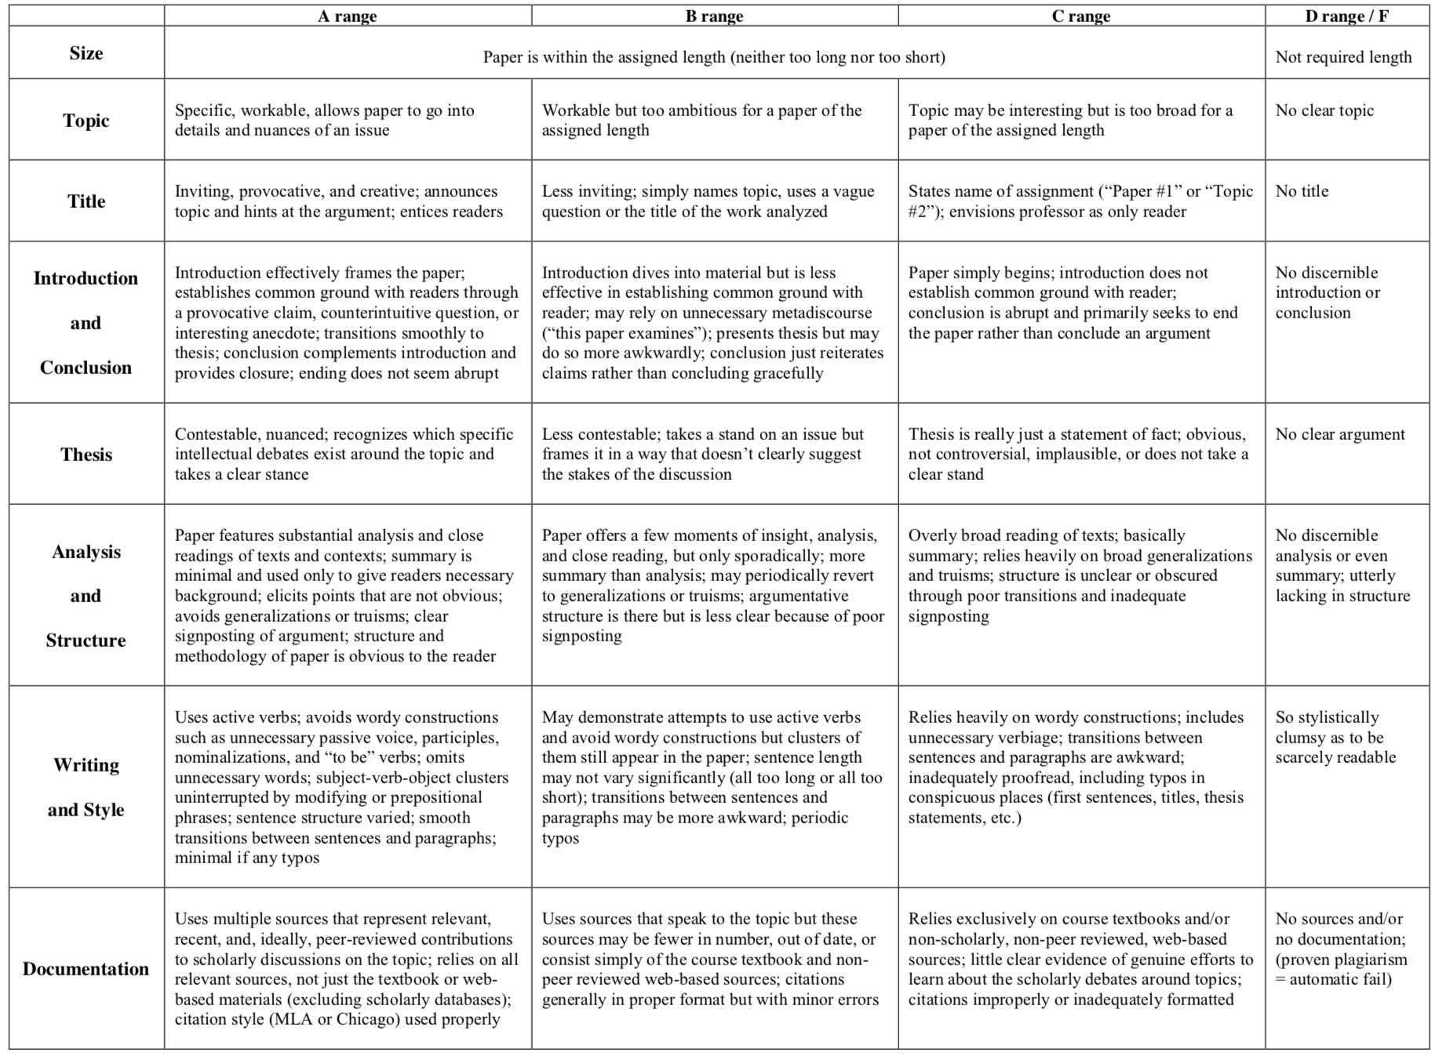

Raider Reminder
All students must abide by the Code of Student Conduct and Equal Opportunity, Harassment, and Sexual Misconduct Policy. Make sure that any contact with others is wanted, that any recording is done with informed consent of any other party, and that it involves no illegal downloads or activity.

In addition, we remain committed to the University's mission and values. We provide a healthy, safe and civil campus; respectful, inclusive, and equitable interactions in all of our learning spaces including physical and virtual classrooms; and no tolerance for racist, sexist, or other forms of hurtful discourse.

COVID-19 Response

We continue to monitor national and regional developments regarding Covid-related guidelines. We also monitor and modify our internal SOU policies and procedures to reflect the changes to Jackson County Public Health, OHA and CDC's guidelines. Please review the revised vaccine policy and protocols.

To reduce risk to the campus community, all staff, faculty, students, and visitors are required to adhere to SOU’s face covering policy.

We will continue our efforts to keep all members of the SOU community safe; those efforts will include attempts to limit contact between individuals and may include restricted access to buildings and other spaces on campus. Please follow all guidelines provided on SOU's COVID-19 pages and adhere to campus building closures and restrictions. Should these guidelines be adjusted, SOU will communicate any adjusted expectations to all students.

SOU Cares and Equity Grievance Reporting
SOU has a wide range of resources to help you succeed. Our faculty, staff, and administration are dedicated to providing you with the best possible support. The SOU Cares System allows us to connect you with staff members who can assist with concerns and connect you to further available resources. This includes concerns regarding finances, food security, health, housing, mental health, wellbeing, legal concerns, family concerns, study skills, time management, etc. You are also welcome to use the SOU Cares System to share concerns about yourself, a friend, or a classmate. Go to www.sou.edu/cares to submit a note of concern.

The Dean of Students’ Office and the Office of Equity Grievance provide recourse for students through the Student Code of Conduct, Equal Opportunity, Harassment and Sexual Misconduct Policy, and other applicable policies, regulations, and laws. SOU’s Equity Grievance Program addresses concerns about sexual harassment, sexual assault, stalking, intimate partner violence, bias and discrimination for students, staff and faculty. Reports related to sexual misconduct, assault, harassment, or bias may be made anonymously or confidentially by completing this form.

Academic Honesty Statement and Code of Student Conduct
Students are expected to maintain academic integrity and honesty in completion of all work for this class. According to SOU’s Student Code of Conduct: “Acts of academic misconduct involve the use or attempted use of any method that enables a student to misrepresent the quality or integrity of his or her academic work and are prohibited.”

Such acts include, but are not limited to: copying from the work of another, and/or allowing another student to copy from one’s own work; unauthorized use of materials during exams; intentional or unintentional failure to acknowledge the ideas or words of another that have been taken from any published or unpublished source; placing one’s name on papers, reports, or other documents that are the work of another individual; submission of work resulting from inappropriate collaboration or assistance; submission of the same paper or project for separate courses without prior authorization by faculty members; and/or knowingly aiding in or inciting the academic dishonesty of another.

Any incident of academic dishonesty will be subject to disciplinary action(s) as outlined in SOU’s Code of Student Conduct. In case of loss, theft, destruction, or dispute over authorship, always retain a copy of any work you produce and submit for grades. Retain all work that has been graded and returned to you.

Turnitin Originality Checker
Per SOU’s Code of Student Conduct, each student’s education is the product of their own intellectual effort and engagement. Breaches of academic integrity compromise the overall quality of scholarship and detract from the value of the SOU degree. In order to provide opportunities for the instructor and students to review their work for originality, instructors may require students to submit all or some of their work to Turnitin. In order to meet this requirement, students must agree to the Turnitin End User License Agreement (EULA). Any work submitted to Turnitin without a EULA in place may not be accepted by the instructor for credit. Any student who does not wish to accept the EULA in a course where Turnitin is required should withdraw from the course. Learn more about Turnitin and review the terms and conditions.

Emergency Notifications
SOU is committed to a safe community. Student, faculty and staff emails are automatically enrolled in SOU Alert, the campus emergency communication system. In the event of emergency, closure, or other significant disruption to campus operations, such as inclement weather, messages are delivered via SOU Alert. To ensure timely notification, students, faculty, staff are strongly encouraged to visit Inside SOU to register their cell phone numbers and/or add family members to the system. Campus Public Safety is available 24 hours/day by dialing 541-552-6911. CPS responds to safety concerns, incidents, and emergencies and can provide safety escorts to on-campus locations. CPS works in collaboration with Ashland Police and Fire.

Statement on Title IX and Mandatory Reporting
Federal law requires that employees of institutions of higher learning (faculty, staff and administrators) report to a Title IX officer any time they become aware that a student is a victim or perpetrator of gender-based bias, sexual harassment, sexual assault, domestic violence, or stalking. Further, Oregon law requires a mandatory report to law enforcement of any physical or emotional abuse of a child or other protected person, including elders and people with disabilities, or when a child or other protected person is perceived to be in danger of physical or emotional abuse. If you are the victim of sexual or physical abuse and wish to make a confidential disclosure please use SOU’s confidential advising or SOU’s Anonymous Harassment, Violence, and Interpersonal Misconduct Reporting Form.

SOU Academic Support/Disability Resources
To support students with disabilities in acquiring accessible books and materials, and in planning their study and time management strategies, SOU requires all professors to include information regarding Academic Support and Disability Resources on course syllabi. It is the policy of Southern Oregon University that no otherwise qualified person shall, solely by reason of disability, be denied access to, participation in, or benefits of any service, program, or activity operated by the University. Qualified persons shall receive reasonable accommodation/ modification needed to ensure equal access to employment, educational opportunities, programs, and activities in the most appropriate, integrated setting, except when such accommodation creates undue hardship on the part of the provider. These policies comply with Section 504 of the Rehabilitation Act of 1974, the Americans with Disabilities Act of 1990, and other applicable federal and state regulations that prohibit discrimination on the basis of disability.

If you are in need of support because of a documented disability (whether it be learning, mobility, psychiatric, health-related, or sensory) you may be eligible for academic or other accommodations through Disability Resources. See the Disability Resources webpage for more information or to schedule an appointment. If you are already working with Disability Resources, make sure to request your accommodations for this course as quickly as possible to ensure that you have the best possible access since these services are not retroactive.

All students may benefit from the ability to convert files posted in Moodle to alternate formats including audio, ebook and Braille. Learn more about file conversion.

Statement on Military and Other Forms of Active Service Duty
Pursuant to Oregon law, any student enrolled at a public university who is a member of the military, state National Guard, or other federal or state service protected by ORS 352.293 who is ordered to active duty for more than 30 consecutive days has the right to request accommodation for such service, subject to the conditions and requirements of applicable Oregon law or regulation. Such accommodations may include, but are not limited to, the right to withdraw from a course without penalty, a grade of Incomplete and option to complete at a later date once service has concluded, and/or the right to credit for any tuition and fees already paid, depending on the student's status.

Any student enrolled at a public university who is a member of the military, state National Guard, or other federal or state service protected by ORS 352.293 who is ordered to active duty for fewer than 30 consecutive days and misses a course session, assignment, examination or other coursework due to serving on active duty or is receiving medical treatment for an injury sustained on active duty has the right to request accommodation for their service or medical treatment, subject to the conditions and requirements of applicable Oregon law or regulation. Such accommodations may include, but are not limited to, the right to submit any missed examination, assignment or other course requirement upon completion of service or treatment; and/or the right to have a course grade assigned without submitting missed assignment or examinations, should the instructor determine that sufficient work has been assessed for the determination of a grade. Any student who expects to be called for active duty should contact instructors as soon as possible to discuss accommodations.

Attendance and Financial Aid
Students who receive federal financial aid are required to attend and participate in all of the courses for which they register, starting with the first week of class. For face-to-face courses, in-person attendance is necessary. The US Department of Education (USDE) describes the following activities as indicators of attendance and active participation (see the formal rules at the USDE website):
● Attending a synchronous class, lecture, recitation, or field or laboratory activity where there is an opportunity for interaction between the instructor and students;
● Submitting an assignment;
● Taking an assessment or an exam;
● Participating in an interactive tutorial or webinar;
● Participating in an assigned study group, group project or an online discussion; or
● Interacting with an instructor about academic matters.
The following activities are not considered by the USDE to be indicators of first-week engagement:
● Living in campus housing or using an institutional meal plan,
● Logging into an online class or tutorial without any further participation, or
● Participating in academic counseling or advising.

Instructors will report students who are absent during the first week of an in-person course or those who do not participate in an online course as described above. Any students who are reported as no-shows will have their financial aid status reviewed and their award may be adjusted as a result.

