Making Documents for the Web Accessible – the quick and dirty version

For links to Microsoft’s guides to making various Office documents accessible (for all platforms), see DR’s webpage at: https://inside.sou.edu/dr/facstaffresources.html

Start with the Accessibility Checker
These instructions assume you have Windows and the most recent version of Word. For other platforms or older versions, please go to the above link.
- Click File > Info.
- Select the Check for Issues button.
TIP: To the right of the Check for Issues button, under the Inspect heading, is a list of any potential issues.
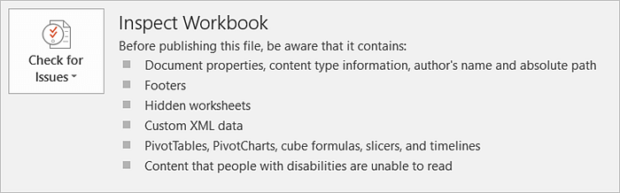
- In the Check for Issues drop-down menu, select Check Accessibility.
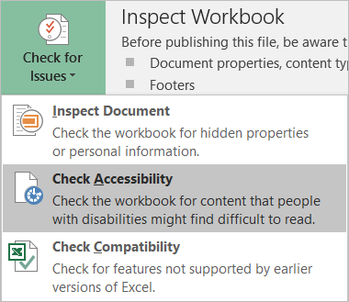
- The Accessibility Checker task pane appears next to your content and shows the inspection results.
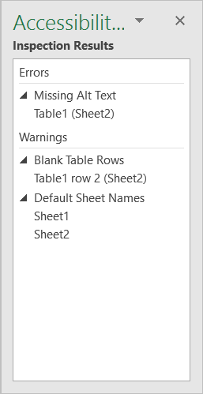
- To see information on why and how to fix an issue, under Inspection Results, select an issue. Results appear under Additional Information, and you’re directed to the inaccessible content in your file.
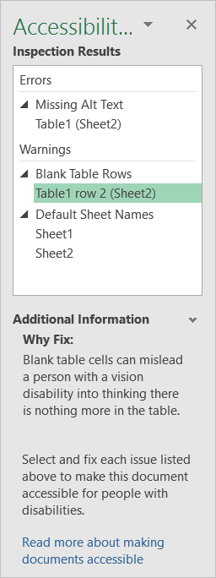

Fixing Common Issues – Alt text
- Right-click an image
- Select Format Picture > Layout & Properties
- Select Alt Text
- Type a description and a title
SmartArt can also have alt text included (see links for directions), though with complex graphics it may be easier (and wiser) to just create a text alternative

Guide to writing good alt text
- Start with the most important information first – think of it like a newspaper headline
- No need to include “image”, “graphic”, etc. in the description
- It’s critical to think of the purpose of the image. Include whatever information a sighted user would be looking to receive from that image.
- If there’s a bunch of data in the image, put a brief summary first, then include the data

Fixing Common Issues – Heading structure
- Rather than using text formatting (bold, changing the size and font, etc.), use the heading styles that Word provides. Don’t like how they look? You can modify them!
- Think of headings like an outline. They provide structure to the document. Use them sequentially (heading 2 comes after heading 1 and so on). Use as few Heading 1s as possible; if you have a heavily layered document, use the Title style to give you more room to create heading structure.

Apply built-in heading styles
- Select the heading text.
- On the Home tab, in the Styles group, select a heading style, for example, Heading 1 or Heading 2.
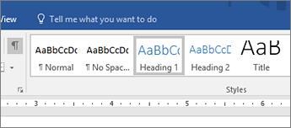

Fixing Common Issues – Table Headings
This is important – only use tables for data, not for layout. Yes, tables make layout easy and it looks pretty. It’s also a disaster for accessibility. If you must create a table for layout purposes, create a separate document that provides that information without a table – in a tabbed list, for example – and post both versions with the list one titled “accessible”.

Applying table headers to data tables
- Position the cursor anywhere in a table.
- On the Table Tools Design tab, in the Table Style Options group, select the Header Row check box.
- Type the column headings.
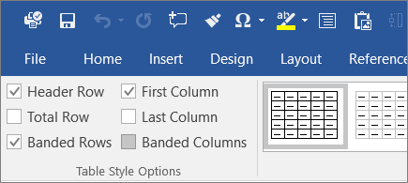

Exporting Your Word Document to PDF to Maximize Accessibility
Do not use Print to PDF. You will lose all the work you just did.
- Click File > Save As and choose where you want the file to be saved.
- In the Save As dialog box, choose PDF in the Save as type list.
- Click Options, make sure the Document structure tags for accessibility check box is selected, and then click OK.

Using the Accessibility Checker in Acrobat
First, you’ll need to turn on the Make Accessible Action.
- Click Tools > Action Wizard
- From the Action List, click Make Accessible
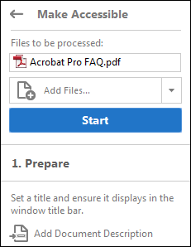
- Click Start
- Follow the prompts.

After a few basic prompts, it will then ask you if you want to run the full Accessibility Checker. You do. You can, however, skip saving the accessibility report.

The report displays one of the following statuses for each rule check:

Passed: The item is accessible.
Skipped By User: Rule was not checked because it wasn't selected in the Accessibility Checker Options dialog box.
Needs Manual Check: The Full Check feature couldn't check the item automatically. Verify the item manually.
Failed: The item didn't pass the accessibility check.
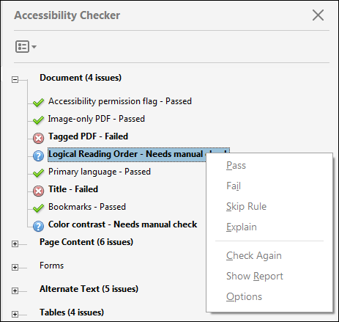
If you created the PDF from Word and used the Make Accessible feature, using the previous directions, it’s likely the only items that will show up are the ones needing a manual check – the Logical Reading Order and Color Contrast.
- If it’s a simple document from Word, Reading Order should be fine and you can just mark that one as Pass.
- If it’s a more complex document or you are working with a PDF you don’t have the Word file for, then check the reading order and fix if necessary.

Checking the Reading Order in Acrobat
Reflow view will show you what the reading order is currently set to be. It’s good for a quick double-check of fairly simple documents.
- View > Zoom > Reflow
- Check your document to make sure it is ordered in a sensible and logical way

Fixing Reading Order in Acrobat
Caution – you cannot use Undo to reverse changes made with this tool. Make a copy FIRST. Save the new version separately.
- Choose View > Page Display > Single Page View. This will prevent unintended changes to pages that are partially visible.
- View > Accessibility > Touch Up Reading Order
Each section of contiguous page content appears as a separate highlighted region and is numbered according to its placement in the reading order. Within each region, text is ordered left to right and top to bottom. (You can change this order in the Touch Up preferences.) If a single highlighted region contains two columns of text or text that won’t flow normally, divide the region into parts that can be reordered. Because highlighted regions are rectangular, they may overlap somewhat, especially if their page content is irregularly shaped. Unless page content overlaps or is contained within two highlighted regions, no reading order problem is indicated. Page content should belong to no more than one highlighted region.

You can change the reading order of the highlighted regions by moving an item in the Order panel or by dragging it on the page in the document pane. By reordering highlighted regions on the page, you can make a figure and caption read at the specific point that they are referenced in the text. By changing the order of a highlighted region, you effectively change the reading order of that item without changing the actual appearance of the PDF.

Changing the reading order in the Order panel
There are several ways to fix reading order, but I find this the least confusing. For more help and information, check out Acrobat’s page on the Touch Up Reading Order tool.
- In the Touch Up Reading Order dialog box, click Show Order Panel.
- In the Order panel, navigate to view a list of highlighted regions that appear in the document pane.
- In the Order panel, drag the tag for a highlighted region to the location you want. As you drag, a line appears to show potential locations. After you drag an item to a new location, the highlighted regions are renumbered to show the new reading order. You can select and move multiple, adjacent regions.
- Make sure to save your changes in a NEW document.

