On August 21, beginning at 10:10 pacific Daylight Time starting in Salem, Oregon a total solar eclipse (when the moon passes between Earth and the sun, blocking our view of the sun) will move across the United States. The event will be visible in all of our region in varying degrees, but all will be able to view a partial eclipse during the day. With safety in mind, NASA and the American Astronomical Society recommendations to keep you, your family, and friends safe by wearing the proper eye protection to view the eclipse.

The last time most Americans experienced a total solar eclipse was 1991. In 2017, an estimated 500 million people will be able to observe the August 21, 2017 total solar eclipse, in partial or total form: 391 million in the U.S.

The celestial event of the eclipse can be a major distraction and can cause accidents and injuries. Remember before you put on your viewing glasses and look up, look around for hazards. During the event stop running power equipment not only you can be distracted by the event but others will be. If you are driving during the event and intend on view it pull over to a safe location. In 2015 according to the NHTSA, over 3,477 people were killed in auto accidents connected to distracted driving. This event has the potential to be a major distraction for drivers. The event also has the potential to increase traffic and delay your travel times.

SAFETY SAFELY VIEW THE ECLIPSE:
Although this event will be spectacular no matter your location in the United States, looking directly at the sun during an eclipse is unsafe and could cause severe damage to your retina. Ultraviolet rays from the sun can give your eye sunburn. The only safe way to protect your eyes during an eclipse is to wear special-purpose solar filters, such as “eclipse glasses” or hand-held solar viewers. Homemade filters, ordinary sunglasses, and dark safety glasses (even very dark ones) are not safe to view the sun during an eclipse and may cause severe eye damage. When preparing to view the eclipse, please consider the following: • Refrain from looking at the un-eclipsed or partially eclipsed sun through an unfiltered camera, telescope, binoculars, or other optical device.

Select one of the NASA or American Astronomical Society recommended brands of solar viewing glasses/filter below:
• American Paper Optics
• Baader Planetarium (AstroSolar Silver/Gold film only)
• Rainbow Symphony

Read and follow any instructions printed on or packaged with the glasses/filter.
If solar glasses/filter are scratched or damaged, discard them.
Ensure the glasses follow the safety standard ISO 12312-2 for proper protection.
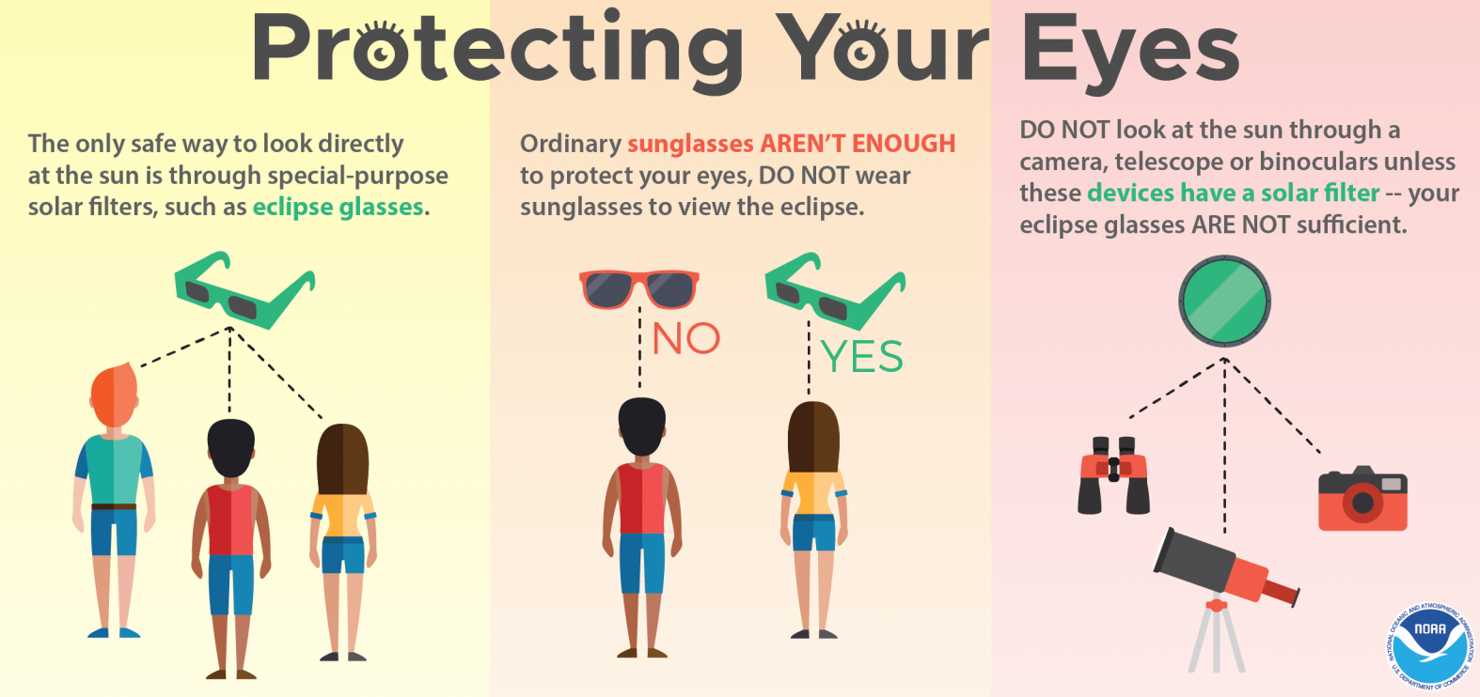
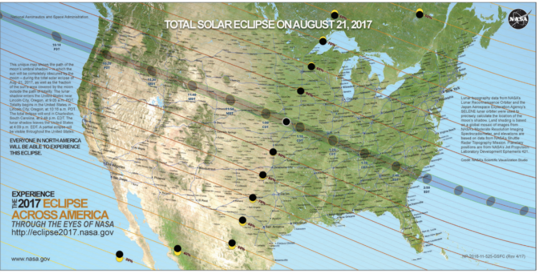
More information can be found at:
https://www.weather.gov/source/crh/eclipse.html
Thank you and stay safe,

