Energy Control Program
(Lockout/Tagout)

Southern Oregon University

Energy Control (Lockout/Tagout) Program
Purpose
This Energy Control (Lockout/Tagout) Program aims to ensure that, before any
employee performs any servicing or maintenance on a machine or piece of
equipment where the unexpected energization or start-up of the machine or
equipment, or the release of stored energy, could occur and cause injury, the
machine or equipment is isolated from the energy source and rendered inoperative.
It is our intent to comply with OSHA requirements.
Administrative Duties
The Manager of Environmental Health & Safety, our company’s Energy Control
(Lockout/Tagout) Program Administrator, is responsible for establishing and
implementing the written program. This person has full authority to make necessary
decisions to ensure the success of this program. The Manager of Environmental
Health & Safety is also qualified by appropriate training and experience that is
commensurate with the complexity of the program to administer or oversee our
program and conduct the required evaluations of program effectiveness. Copies of
the written Energy Control (Lockout/Tagout) Program may be obtained from the
office of Environmental Health & Safety.
If after reading this program, you find that improvements can be made, please
contact The Manager of Environmental Health & Safety. We encourage all
suggestions because we are committed to the success of our written Energy Control
(Lockout/Tagout) Program. We strive for a comprehensive, integrated prevention
system that obtains clear understanding, safe behavior, and involvement in the
program from every level of the company.
Machine/Equipment Hazard Analysis Procedure
Our procedure for analyzing the energy source hazards of a machine or piece of
equipment is listed below. This procedure will be performed by department
Supervisors.
1. We ensure that those who make machine or equipment analysis decisions are
equipped with appropriate information and knowledge about the following
before making any machine or equipment analysis decisions: All aspects of
an Energy Control Program.
2. We assess the following to identify the hazards of each machine or
equipment upon initial installation
at the inception of this program
after any equipment changes
after any injury involving a piece of equipment: sources and locations of
energy.
3. We determine Types of energy
Location of source(s)
Number of sources
Any potential for stored energy
Devices necessary to ensure zero energy.
4. All findings and determinations are documented along with the date and filed
with the Energy Control Program, maintained in the Environmental Health &
Safety office and the Maintenance shop.
5. The findings and determinations are used to create or update all energy
control (lockout/tagout) procedures and perform employee training.
Energy Control (Lockout/Tagout) Procedures
Our energy control (lockout/tagout) procedures meet the OSHA requirements. We
have attached copies of our procedures in the Appendices to this written Energy
Control (Lockout/Tagout) Program. Copies are also available at each piece of
equipment requiring LO/TO procedures, the EHS office and the maintenance
office.
Training
As soon as the first day is scheduled for a new or transfer employee, we make
arrangements with department management and the trainer(s) to schedule
lockout/tagout training session(s) to ensure that employees who need training
receive it prior to using energy control procedures or conducting lockout/tagout
activities.
The Manager of EHS or his/her designee presents general training according to
specifications in the OSHA regulations. The Manager of EHS or his/her designee
presents employees with workplace-specific training in individual energy control
procedures, energy control devices, and lockout/tagout devices, as necessary.
Training will generally be held in the FMP conference room, or other appropriate
location as determined by need
Retraining
We identify the employees who will need lockout/tagout retraining at the following
times:
Annual refresher
New hire
Upon change of job duties
After injury resulting from improper LO/TO
Upon observation of improper LO/TO
After new equipment is installed
We make arrangements with department management and the trainer(s) to schedule
lockout/tagout retraining session(s) to ensure that employees who need retraining
receive it prior to using energy control procedures or conducting further
lockout/tagout activities.
The Manager of EHS or his/her designee presents retraining according to
specifications in the OSHA regulations. Retraining may include, but is not be limited
to, classroom and/or hands on, equipment specific training
Training/Retraining Certification
We certify all lockout/tagout general and specific training and retraining. We use
training sign-in sheets and certificates and file this certification in the EHS office.
Certification documents contain the employee's name, department and date of
training/retraining and name of trainer.
Periodic Inspections
Authorized employees review the energy control procedures with each authorized
employee (and also each affected employee when tagout is used) according to the
following:

Machine Equipment | Authorized Employees who perform the inspection: | Frequency of inspection and how inspection is implemented: | Location of inspection records:
All affected equipment | Supervisor/Mgr. EHS or other properly trained employee | Annual or at time of any change. Implemented by testing machine specific procedure and equipment | EHS office

These inspections provide for a demonstration of the procedures. We determine
whether steps are being used and followed, whether the procedures are adequate
and effective to provide protection, and what changes, if any, are necessary.
The inspections are documented through a certification process that identifies any
deficiencies or changes needed to ensure 100% zero energy. We then file
inspection documentation in the EHS office.
Any necessary changes and corrections of deviations or inadequacies identified
during periodic inspections are made by: the Manager of EHS or his/her designee..
The Manager of EHS or his/her designee retrains all affected, authorized, and other
employees in any procedure changes in accordance with the Retraining subsection
of this program.
Contractors
Our company ensures that we exchange energy control procedures with outside
contractors prior to service or maintenance on our machines and equipment. Before
these contract employees are allowed access to their work areas, the Manager of EHS or his/her designee provides the contract employer with our written Energy
Control (Lockout/Tagout) Program and related procedures. These are provided via
paper copies for specific areas.ds:
We ensure that our contract stipulates that the contractor must provide the
Manager of EHS or his/her designee with the energy control program and
procedures to be used by its employees at our facility. If a contractor fails to
provide the energy control program and procedures, work will be stopped until
proper LO/TO procedures and proof of training is supplied.
The Manager of EHS or his/her designee then reviews any contractor energy
control program and procedures and determines their impacts on our employees
and whether the contractor program and procedures are at least as protective of
our facility employees as the written Energy Control (Lockout/Tagout) Program
and related procedures used by our own facility. If they are not as protective, we
provide our employees with any necessary training and/or protection prior to
contractor lockout/tagout activity.
Also, prior to contractor lockout/tagout activity, the Manager of EHS or his/her
designee trains our employees in the restrictions and prohibitions of the contractor’s
energy control program, as well as the lockout and tagout devices used by
contractors and the means of identifying those devices. We certify all training using
training sign in sheet and file this certification in the EHS office. Certification
documents contain name of trainee, trainer and date.
We encourage the contract employer to review our written Energy Control
(Lockout/Tagout) Program and its procedures and determine their impacts on its
employees and whether our program and procedures are at least as protective of
contractor employees as its own program and procedures. If our program and
procedures are not as protective, then we encourage the contractor to provide their
employees with any necessary training and/or protection prior to contractor
lockout/tagout activity.
We ensure that the contract employer signs a provision in the contract
acknowledging that it has received our written Energy Control (Lockout/Tagout)
Program and its procedures, understands them, and agrees to comply with
restrictions and prohibitions of our program, procedures, and any other agreements.
If the contractor fails to meet our restrictions, prohibitions, and agreements, work
will be stopped until proper training has been accomplished.
Recordkeeping
The Manager of EHS is responsible for maintaining the following records and
documentation:
Record/Document | Details: | Location: | Duration Kept:
Proof of Training | Date, Time | EHS Office | 3 years
Energy Control Program (LO/TO) | Original document with review dates | EHS Office | No Limit
Copies of specific procedures | All types of energy, sources and location of each source | EHS Office | Until replaced by update

Appendices Our company has attached the following appendices to this written program: Copies of all relevant procedures

Appendix A

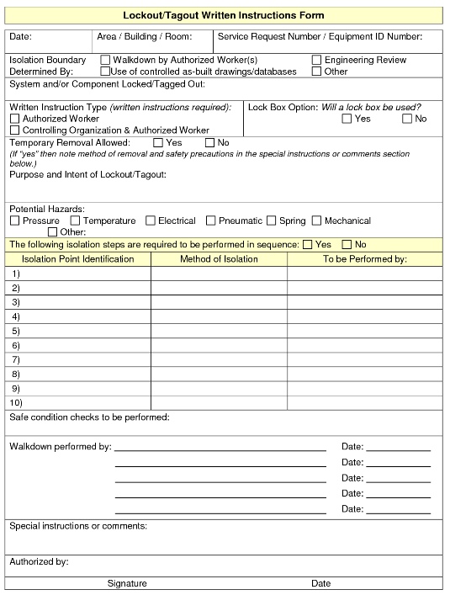

Appendix B
ABANDONED LOCKOUT REMOVAL LOG
EQUIPMENT | AUTHORIZED EMPLOYEE | DATE/TIME OF CALL | RESULT OF CALL | DATE/TIME OF LOCK REMOVAL | REMOVED BY

Appendix C
