
Family Housing Fire Emergency Guide
This guide has been prepared to let you know of the fire safety features of your building.
In the event of a fire emergency inside,
- Leave your apartment immediately
- Call 9-1-1
- Once outside, go to the designated meeting place
- Do not return to the building until the fire department has said it is safe to re-enter.
Your apartment building is equipped with fire safety equipment and tools which will help to protect you.
Smoke Alarms
Each apartment is equipped with a smoke alarms. The smoke alarms are powered either by electricity with battery backup or non-electric with a 10 year battery as the sole power.
In order to make sure the smoke alarm works when it is needed, please do the following:
- Test the smoke alarm monthly
- Change the smoke alarm battery annually (unless equipped with 10 year battery)
- Never remove or disable the smoke alarm
Portable Fire Extinguishers
Each apartment building has been equipped with a fire extinguisher. These extinguishers can be used by residents to put out a small fire if safe to do so. Please familiarize yourself with the location of fire extinguishers in the event you need to use one. Do not jeopardize your safety or the safety of others by attempting to put out a fire that is more than one fire extinguisher can extinguish. A trash can or stove top fire may be within the scope of one fire extinguisher.
If a skillet or pan catches fire, the quickest way to extinguish is putting a lid on it if safe to do so.
Some apartments are equipped with sprinkler systems. These are designed to give residents time to escape.

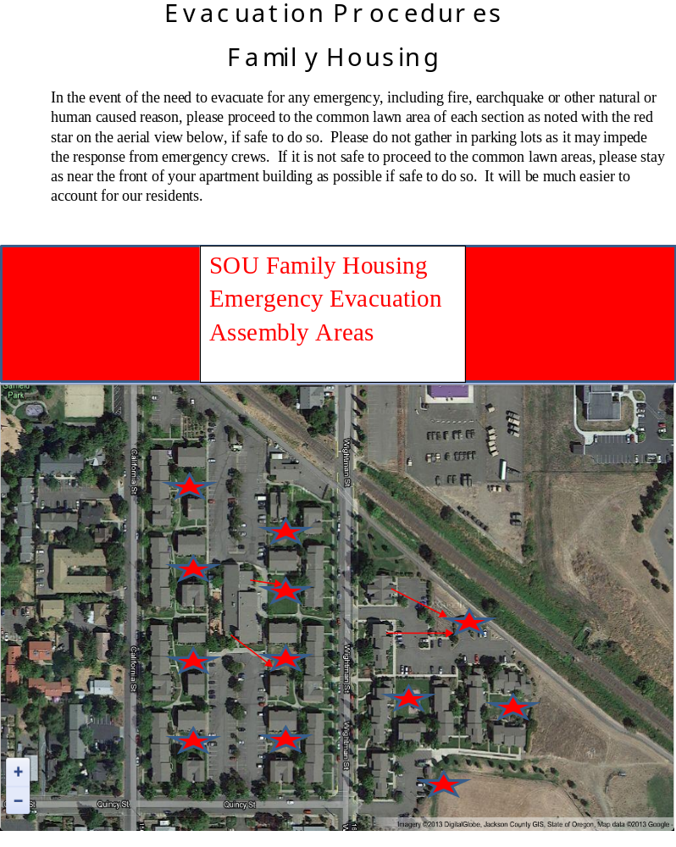Revision 1
Date: 03/03/2015

