

|  |
| --- |
| Fire Protection Impairment Procedure |

**Office: Environmental Health, Safety, and Risk**

**Procedure Contact: Russell Deen**

**Related Policy or Policies: Environmental Health and Safety Policy**

**Revision History**

|  |  |  |
| --- | --- | --- |
| **Revision Number:** | **Change:** | **Date:** |
| Initial |  | 11/12/2024 |
|  |  |  |

1. **Purpose**

|  |
| --- |
| Southern Oregon University is dedicated to the safety of personnel, whether faculty, staff, students, or non-University personnel. This procedure is designed to establish procedures to be followed when a fire protection system is taken out of service due to construction, alteration, power outage, repair or an emergency condition. These procedures include measures taken during the impairment to ensure that increased risks are minimized and the duration of the impairment is limited.  The probability of a fire or explosion causing major damage is increased whenever a fire  protection system is impaired. The longer the fire protection system is impaired, the greater  the probability becomes. Therefore, it is necessary to minimize the duration and scope of any  impairment or provide for an alternate protection system. The Fire Protection Impairment Program is an effective management program used to:   * Supervise the safe shutdown of fire protection systems. * Control potential fire hazards during the impairments. * Restore the fire protection system to service as soon as possible. |

**B. Definitions**

|  |
| --- |
| * Firewatch: A person or persons designated to physically patrol the area where the   fire protection system is impaired.   * Fire Protection Systems: Sprinkler systems, standpipe systems, underground fire   service mains, fire pumps, water storage tanks, water spray fixed systems, foam-water  systems, special extinguishing systems, fire service control valves, fire alarms systems, and  emergency lights.   * Impairment: a shutdown, in whole or part, of a fire protection system. * 1. Emergency impairment: when a fire protection system is out of service due to an   unexpected occurrence, such as a ruptured pipe or an unexpected power outage.   * 2. Planned impairment: when a fire protection system is out of service due to work   that has been planned in advance, such as revisions to the water supply or sprinkler piping  system.   * 3. Level 2 impairment: when a limited number of components of a fire protection   system are found defective or removed from service. A Level 2 impairment represents a  minimal impact to the overall life safety of building occupants.   * 4. Level 1 impairment: a shutdown of an entire fire protection system, or major   portion, significantly affecting occupant life safety.   * Impairment Coordinator (IC): The person who manages the impairment while system   work is being performed and has overall responsibility for proper implementation of the   * Fire Protection Impairment Program. The EHS Manager or   designee will be designated as the Impairment Coordinator. |

**C. Procedures**

|  |
| --- |
| * Any employee who impairs a fire protection system, in whole or part, must first notify   the Impairment Coordinator. If an impairment permit is required, the employee will  attach the Fire & Life Safety System Permit/Impairment Tag (Appendix A)  to the fire department connection for sprinkler system impairments or to the fire  alarm annunciator/control panel for fire alarm systems.   * Any Contractor/contractor’s representative or outside worker who impairs a fire   protection system, in whole or part, must first notify the Impairment Coordinator. If  an impairment permit is required, the contractor, contractor’s representative, or  outside worker will attach the Fire & Life Safety System Permit/Impairment Tag (Appendix A) to the fire department connection for sprinkler system impairments or to the fire alarm annunciator/control panel for fire alarm systems.   * The IC will determine the level of impairment due to a shutdown, in whole or part, of a   fire protection system.   * The IC will be responsible for completion of the Impairment Worksheet (Appendix B)   when authorizing Level 1 impairments.   * The IC will be responsible for issuing and verifying removal of fire & life safety system   permit/impairment tags when authorizing Level 1 impairments.   * The IC will be responsible for coordination of the firewatch, if it has been determined   that a firewatch is necessary. The IC will document firewatch activities on Appendix C,  the Firewatch Log Sheet.   * The IC will be responsible for making training available to SOU employees who will be   utilized as firewatch personnel.  **IMPAIRMENT COORDINATION PROCEDURES – LEVEL 2**  Preplanned Impairments   * All level 2 impairments, both preplanned and emergency, must be reported to   the impairment coordinator.   * EHS and CPS will be notified of a preplanned impairment of a fire alarm system. * The fire alarm monitoring company, if utilized to monitor that particular fire   alarm system, will be notified of a preplanned impairment of a fire alarm  system.   * The impairment coordinator will ensure that level 2 impairments are   satisfactorily remediated.  **IMPAIRMENT COORDINATION PROCEDURES – LEVEL 1**   * EHS and CPS will be notified of a preplanned impairment of a   fire alarm system.   * The fire alarm monitoring company, if utilized to monitor that particular fire alarm   system, will be notified of a preplanned impairment of a fire alarm system.   * The Local Office Manager for the affected building will be notified of the preplanned   impairment.   * The impairment coordinator will complete the Impairment Worksheet (Appendix B). * The impairment coordinator will complete the fire & life safety system   permit/impairment tag (Appendix A). The IC will authorize the preplanned  impairment and verify that the following procedures have been implemented:  1. The extent and expected duration of the impairment have been determined.  2. The areas or buildings involved have been considered and the increased risks  determined.  3. When a required automatic sprinkler system is out of service for an extended  duration, the impairment coordinator will arrange for one of the following:  a) Evacuation of the building or portion of the building affected by the  system out of service, or  b) A fire watch for all portions of the building left unprotected by the  shutdown until the fire alarm or sprinkler system has been returned to  service. A fire watch utilized for a fire alarm or automatic sprinkler  system shutdown will be composed of individuals beyond normal  staffing, assigned to walk the areas affected. The number of fire watch  personnel utilized will be determined by the impairment coordinator.  Firewatch personnel used for fire alarm shutdowns must be specially  trained in fire prevention and in occupant and fire department  notification techniques. Fire watch personnel used for automatic  sprinkler system shutdowns must be specially trained in fire prevention  and in the use of fire extinguishers, and in occupant and fire department  notification techniques.  4. When a required fire alarm system is out of service for an extended duration,  the impairment coordinator will arrange for one of the following:  a) Evacuation of the building or portion of the building affected by  the system out of service, or  b) Implementation of mitigating measures for the period that the  system is impaired. This considers the building occupancy type,  nature and duration of impairment, building occupancy level  during the impairment period, active work being conducted on the  fire alarm system during the impairment, condition of other fire  protection systems and features, and hazards and assets at risk.  Appropriate mitigating measures range from simple occupant  notification to full-time fire watch.  5. Sprinkler systems: the impairment coordinator will complete or authorize a  Fire & Life Safety System Permit/Impairment Tag (Appendix A), making sure it  is located at the fire department connection, indicating which system, or part  thereof, has been removed from service.  6. Fire alarm systems: the impairment coordinator will complete or authorize a  Fire & Life Safety System Permit/Impairment Tag (Appendix A), making sure it  is located at the fire alarm annunciator or fire alarm control panel.  **Emergency Impairment Procedures**   * When an emergency impairment occurs, emergency action will be taken to minimize   potential injury and damage.   * The impairment coordinator will implement items 1 through 6 of section Preplanned   Impairments with the following exception:   * Any damage to fire protection systems caused by the contractor will be repaired   by a licensed fire protection company at the contractor’s expense. Any required  firewatch activities due to damage of the fire protection equipment will be  supplied by the contractor. Contractor must supply their own firewatch  activities to ensure compliance with this procedure and other SOU policies and procedures, i.e. Hot  Work Permit.  **Restoring Systems to Service**   * When all impaired equipment is restored to normal working order, the impairment   coordinator will verify that the following procedures have been implemented:   * Any necessary inspections and tests have been conducted to verify that affected   systems are operational.   * Local Office Managers for the affected buildings have been advised that protection is   restored.   * If a fire alarm system is involved, EHS and CPS along with the monitoring   company have been advised that protection is restored.   * The Fire & Life Safety System Permit/Impairment Tag has been removed. |
| This procedure may be revised at any time without notice. All revisions supersede prior procedures and are effective immediately upon approval. |

**D. Appendix**

**Appendix A:**

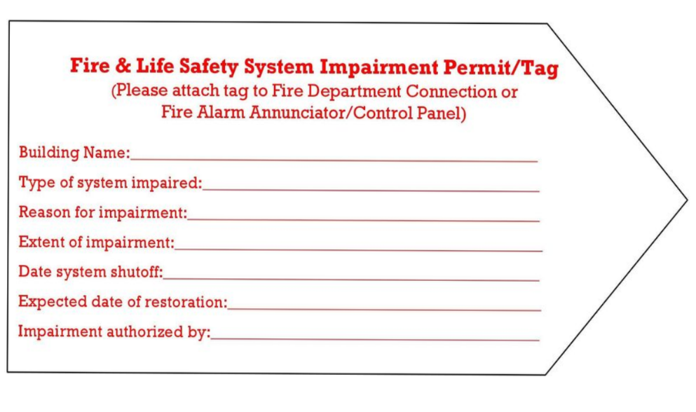

|  |
| --- |
|  |

Appendix B:

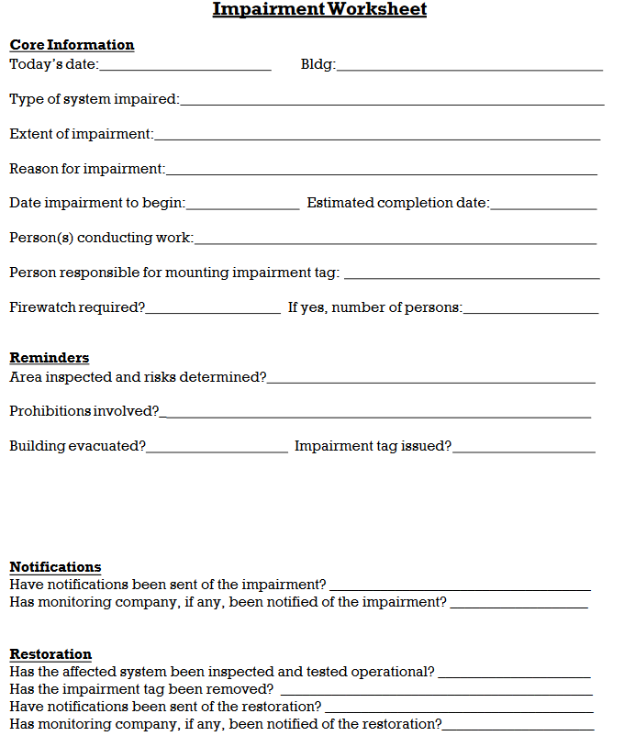

Appendix C:

