Insect Infestation

Office: EHS
Procedure Contact: Russell Deen
Related Policy or Policies: Environmental Health and Safety FAD.085

Revision History
Revision Number: | Change: | Date:
 | Initial version | January 2020

A. Purpose
In the event of insects found in buildings such as lice, fleas or other insect pests.

B. Definitions
Lice (louse),

C. Procedures
1. Students with insect bites or reaction should be sent to Health Center or medical provider.
2. Employees with insect bites or reaction should be sent to medical provider.
3. Limit access to area (Use “Caution” tape to block area off, or close door to space).
4. Submit work request to FMP.
5. Fill out safety form: https://southernoregonuniversity.formstack.com/forms/safety_concern
6. If students, employees or public ask for details about the blocked area. Inform them that the secured area is for authorized personnel and is being treated to address the situation.
7. The area will remain limited access for a minimum of 5 days after cleaning depending on the insect.
8. Further question can be referred to email: ehs@sou.edu or phone: 541-552-8624.

This procedure may be revised at any time without notice. All revisions supersede prior procedures and are effective immediately upon approval.

D. Appendix
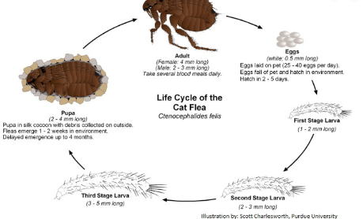
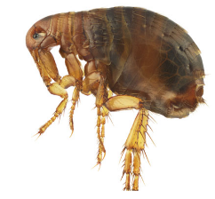
Fleas:
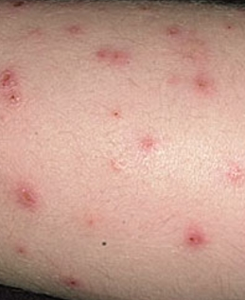
Undisturbed and without a blood meal, a flea can live more than 100 days. On average, they live two to three months. Female fleas cannot lay eggs until after their first blood meal and begin to lay eggs within 36-48 hours after that meal.
Controlling Fleas; Prevent, reduce or eliminate flea infestations:
- Vacuum every day to remove eggs, larvae and adults; this is the best method for initial control of a flea infestation.
- Be sure to vacuum the following areas: carpets, cushioned furniture, cracks and crevices on floors, along baseboards and the basement.
- Steam clean carpets: the hot steam and soap can kill fleas in all stages of the life cycle.
- Pay particular attention to areas where pets sleep.
- Wash all pet bedding and family bedding on which pets lie in hot, soapy water every two to three weeks.
- If an infestation is severe, discard old pet bedding and replace it with fresh, clean material.
- Use a flea comb to suppress adult fleas. Hair can pass through the comb's teeth, but not the fleas, removing fleas as well as flea feces and dried blood.
- Especially comb the neck and tail areas, which is where the most fleas congregate.
- Deposit fleas in hot soapy water to kill them.
- Consider allowing your pets to stay indoors as much as possible, which reduces their chance of being bitten by tick and fleas.

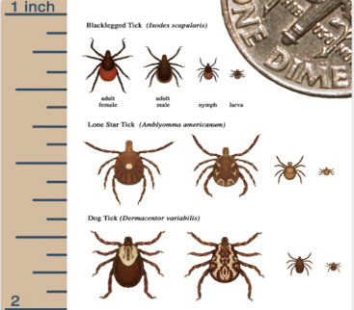
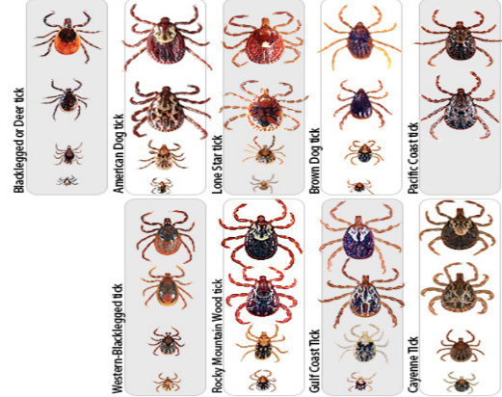
Ticks:
Ticks go through four life stages: Egg; six-legged larva; eight-legged nymph; and adult. After hatching from the eggs, ticks must eat blood at each stage in order to move on to the next one. It can take up to 3 years to complete a full lifecycle, and most will die because they can't find a host for their next feeding
- Check your clothing for ticks. Ticks may attach to clothing. Remove any ticks and wash clothes or put them in dryer if damp. Tumble dry clothes in a dryer on high heat for 10 minutes to kill ticks on dry clothing after you come indoors. If the clothes are damp, you may need to dry them longer. When washing clothes first, use hot water. Cold and medium temperature water will not kill ticks effectively.
- Check your body for ticks after being outdoors. Conduct a full body check when coming from potentially tick-infested areas, even your back yard. Use a hand-held or full-length mirror to view all parts of your body. Check you and your children for ticks after coming indoors.
- Shower soon after being outdoors. Showering within two hours of coming indoors has been shown to reduce your risk of getting Lyme disease and may be effective in reducing the risk of other tickborne diseases. Showering may help wash off unattached ticks and it is a good opportunity to do a tick check.

What to Do if You Find an Attached Tick
- Remove the attached tick as soon as you notice it. Grasp the tick with tweezers, as close to the skin as possible, and pull it straight out. For more information about removing ticks, see the tick removal page.
- Watch for signs of sickness such as rash or fever in the days and weeks following the bite. Your risk of getting a tickborne disease depends on many factors, including where you live, the type of tick that bit you, and how long the tick was attached. Be sure to see a health care provider if you become sick after a tick bite, have a rash or a fever.

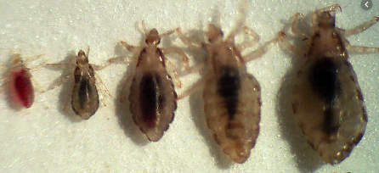
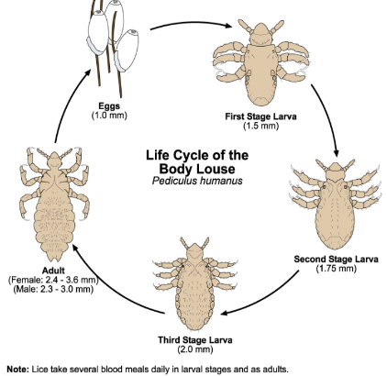
Body Lice:
An infestation by body lice is typically diagnosed by looking at the skin and clothing and observing eggs and crawling lice. The insects are about the size of a sesame seed. They are big enough to see with the naked eye, but a magnifying lens can be used to help find them. The eggs (called nits) are usually found in the seams of clothing.
Recognizing the signs of body lice infestation
Common symptoms of a body lice infestation include:
- intense itching (pruritus)
- rash caused by an allergic reaction to body lice bites
- red bumps on the skin
- thickened or darkened skin, usually near the waist or groin, if the lice have been there for a long time

What is body lice infestation?
An infestation of body lice occurs when a certain type of lice invade the body and clothing. Lice are parasitic insects that feed on human blood and can infest the head, body, and pubic area.
There are three types of lice that infest humans:
- body louse (Pediculus humanus corporis)
- head louse (Pediculus humanus capitis)
- pubic louse (Pthirus pubis)
Lice that are found on the body are different from lice found on the head or on the pubic area. Body lice are only found on humans on the body. Infestations are generally spread by close contact with other people and are typically found in areas of poor hygiene and crowding. Other animals or pets, like dogs and cats, don’t play a role in spreading human lice. Humans are the body louse’s only host and lice will die within five to seven days if they fall off of a person. Good hygiene and regularly washing clothing and bed linens are generally enough to treat and prevent infestations of body lice.
Head Lice:
The head louse, or Pediculus humanus capitis, is a parasitic insect that can be found on the head, eyebrows, and eyelashes of people. Head lice feed on human blodd several times a day and live close to the human scalp. Head lice are not known to spread disease.
Adult head lice are roughly 2–3 mm long. Head lice infest the head and neck and attach their eggs to the base of the hair shaft. Lice move by crawling; they cannot hop or fly.
Head lice infestation, or pediculosis, is spread most commonly by close person-to-person contact. Dogs, cats, and other pets do not play a role in the transmission of human lice.
Head lice move by crawling; they cannot hop or fly. Head lice are spread by direct contact with the hair of an infested person. Anyone who comes in head-to-head contact with someone who already has head lice is at greatest risk. Spread by contact with clothing (such as hats, scarves, coats) or other personal items (such as combs, brushes, or towels) used by an infested person is uncommon. Personal hygiene or cleanliness in the home or school has nothing to do with getting head lice.
Both over-the-counter and prescription medications are available for treatment of head lice infestations.
• Tickling feeling of something moving in the hair.
• Itching, caused by an allergic reaction to the bites of the head louse.
• Irritability and difficulty sleeping; head lice are most active in the dark.
• Sores on the head caused by scratching. These sores can sometimes become infected with bacteria found on the person’s skin.
Head lice should not be considered as a medical or public health hazard. Head lice are not known to spread disease. Head lice can be an annoyance because their presence may cause itching and loss of sleep. Sometimes the itching can lead to excessive scratching that can sometimes increase the chance of a secondary skin infection.
Bed Bugs:
Bed bugs (Cimex lectularius) are small, flat, parasitic insects that feed solely on the blood of people and animals while they sleep. Bed bugs are reddish-brown in color, wingless, range from 1mm to 7mm (roughly the size of Lincoln’s head on a penny), and can live several months without a blood meal.

Bed bug infestations usually occur around or near the areas where people sleep. These areas include apartments, shelters, rooming houses, hotels, cruise ships, buses, trains, and dorm rooms. They hide during the day in places such as seams of mattresses, box springs, bed frames, headboards, dresser tables, inside cracks or crevices, behind wallpaper, or any other clutter or objects around a bed. Bed bugs have been shown to be able to travel over 100 feet in a night but tend to live within 8 feet of where people sleep.

A bed bug bite affects each person differently. Bite responses can range from an absence of any physical signs of the bite, to a small bite mark, to a serious allergic reaction. Bed bugs are not considered to be dangerous; however, an allergic reaction to several bites may need medical attention.
One of the easiest ways to identify a bed bug infestation is by the tell-tale bite marks on the face, neck, arms, hands, or any other body parts while sleeping. However, these bite marks may take as long as 14 days to develop in some people so it is important to look for other clues when determining if bed bugs have infested an area. These signs include:
- the bed bugs’ exoskeletons after molting,
- bed bugs in the fold of mattresses and sheets,
- rusty–colored blood spots due to their blood-filled fecal material that they excrete on the mattress or nearby furniture, and
- a sweet musty odor.
Bed bug bites usually do not pose a serious medical threat. The best way to treat a bite is to avoid scratching the area and apply antiseptic creams or lotions and take an antihistamine. Bed bug infestations are commonly treated by insecticide spraying. If you suspect that you have an infestation, contact your landlord or professional pest control company that is experienced with treating bed bugs. The best way to prevent bed bugs is regular inspection for the signs of an infestation.

