Mold

Office: EHS
Procedure Contact: Russell Deen
Related Policy or Policies: Environmental Health and Safety FAD.085

Revision History
Revision Number: | Change: | Date:
 | Initial version | January 2020

A. Purpose
In the event of mold found in dishwasher, walls or other areas.

B. Definitions
Mildew is a form of fungus. It is distinguished from its closely related counterpart, mold. Mold appears as a thin, superficial growth consisting of minute hyphae (fungal filaments) produced especially on living plants or organic matter such as wood, paper or leather. Both mold and mildew produce distinct offensive odors, and both have been identified as the cause of certain human ailments. Mold can cause many health effects. For some people, mold can cause a stuffy nose, sore throat, coughing or wheezing, burning eyes, or skin rash. People with asthma or who are allergic to mold may have severe reactions. Immune-compromised people and people with chronic lung disease may get infections in their lungs from mold.

C. Procedures
There is always some mold around. Mold can get in your home through open doors, windows, vents, and heating and air conditioning systems. Mold in the air outside can be brought indoors on clothing, shoes, bags, and even pets.
Mold will grow where there is moisture, such as around leaks in roofs, windows, or pipes, or where there has been a flood. Mold grows on paper, cardboard, ceiling tiles, and wood. Mold can also grow in dust, paints, wallpaper, insulation, drywall, carpet, fabric, and upholstery.
- Assess the extent and identify if mildew or mold.
- Submit a work request if needed to identify or cleaning assistance is needed.
- Remove source of moisture if possible.
- Dry area.
- Utilize Concrobium Moldcontrol (https://www.amazon.com/Siamons-International-025-326-Concrobium/dp/B000UVGHQK/ref=sr_1_4?crid=2LMGE3ESJPDRH&keywords=concrobium+mold+control&qid=1579739348&sprefix=concrobium+mold%2Caps%2C204&sr=8-4) or equivalent.
- To clean a moldy dishwasher, start by putting 1 cup of vinegar into a small bowl and placing it in the top rack of an empty dishwasher. Then, run a hot water cycle so the vinegar can work to remove the grime and mold during the wash.
- To remove mold stains utilize mold stain remover products.
- Further question can be referred to email: ehs@sou.edu or phone: 541-552-8624.

This procedure may be revised at any time without notice. All revisions supersede prior procedures and are effective immediately upon approval.

D. Appendix

Mildew
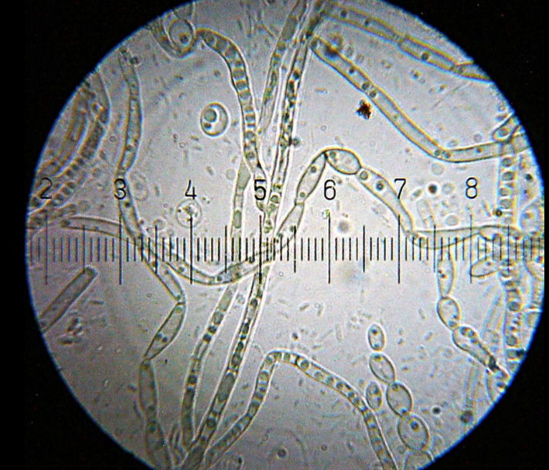

Mold

Chobani Mold
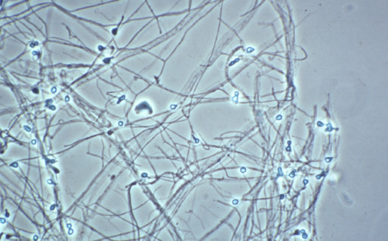
Filamentous fungus found in soil, plants, decaying fruits and vegetables. May cause infections in man, frogs, amphibians, cattle, and swine.

Stachybotrys chartarum
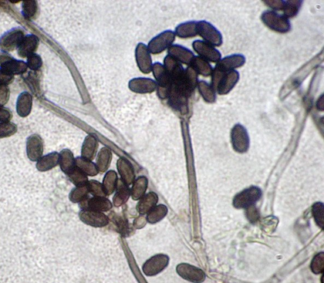
Toxic black mold or black mold can grow in houses and is extremely dangerous to humans.
The general types of symptoms caused by toxic black mold include:
- Respiratory problems
- Skin inflammation
- Hemorrhage
- Irritation of the mucous membranes
- Damage to internal organs
- Mental impairment
- Tiredness
- Nausea
- Immune system suppression

