SUN SAFETY
- Ensure you have potable water. Start drinking water before you start working.
- If you take medications for a health condition, check with your health-care provider to make sure that you are able to work in higher temperatures.
- Take rest breaks in the shade for at least 5 minutes when you work in the heat. Prolonged work makes it harder to concentrate on what you are doing, which can increase the risk of an accident.
- UV exposure
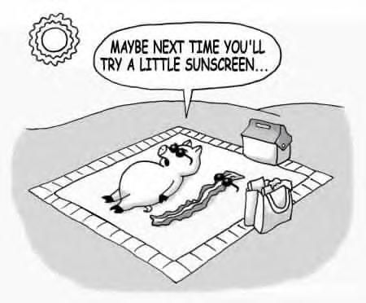
- Wear sunglasses that have 99 percent to 100 percent UV protection and UVB protection.
- Use a full spectrum (UVA and UVB protection) sunscreen. If you are fair-skinned, use sunscreen with a sun protection factor (SPF) of at least 20.
- Cover up. The best protection is a wide-brimmed hat and loose-fitting, lightweight clothing that you cannot see through.
Mosquito Bites
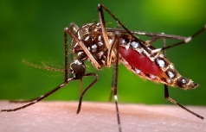

Mosquito bites can be more than just annoying and itchy. Wearing insect repellent is the best way to prevent diseases spread by mosquitoes.
- When used as directed, insect repellent is the BEST way to protect yourself from mosquito bites. Higher percentages of active ingredient provide longer lasting protection.
  - DEET: Products containing DEET include Cutter, OFF!, Skintastic.
  - Picaridin (also known as KBR 3023, Bayrepel, and icaridin): Products containing picaridin include Cutter Advanced, Skin So Soft Bug Guard Plus, and Autan outside the United States).
  - Oil of lemon eucalyptus (OLE) or PMD: Repel contains OLE.
  - IR3535: Products containing IR3535 include Skin So Soft Bug Guard Plus Expedition and SkinSmart.

Preventing Ticks

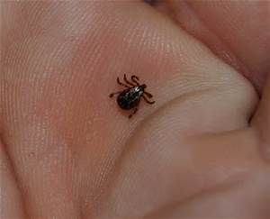
No vaccine is available in the United States to prevent diseases spread by ticks; however, you can take steps to reduce your risk of getting a tick bite:
- Dress appropriately: wear light-colored clothing, wear long pants and sleeves, tuck in shirts, tuck pants into socks, and wear closed-toe shoes.
- Use insect repellents on the skin that contain ≥20% DEET. (“Natural” products, such as citronella, are not effective.)
- Use permethrin-treated clothing and gear, or treat your gear and clothing with permethrin before departure.
- Stay out of tall grass, brush, or heavily wooded areas; walk in the center of hiking trails.
It can take several hours for a tick to attach and begin transmitting the disease, so the sooner the tick can be found and removed, the better. Checking for ticks frequently increases the likelihood of finding a tick before it can transmit the bacteria. Bathe or shower as soon as possible after coming indoors. Then do a full-body tick check with a handheld or full-length mirror. Parents should check their children for ticks under the arms, in and around the ears, inside the belly button, behind the knees, between the legs, around the waist, and especially in their hair. Examine gear and pets; ticks can ride into the home on clothing and pets, and then attach to a person later. Last, tumble clothes in a dryer on high heat for an hour to kill remaining ticks.
- Removing Ticks
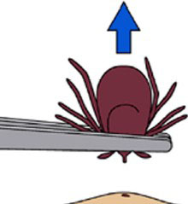
If you find a tick, use tweezers to grasp it as close to the skin as possible. Pull upward with steady, even pressure. Don’t twist or jerk the tick; this can cause the mouth-parts to break off and remain in the skin. If this happens, remove the mouth-parts with tweezers. If you are unable to remove the mouth-parts easily with clean tweezers, leave it alone and let the skin heal. After removing the tick, thoroughly clean the bite area and your hands with rubbing alcohol, an iodine scrub, or soap and water.

