Occupational Safety Advisory Committee

Office: Environmental Health, Safety, and Risk
Procedure Contact: Russell Deen
Related Policy or Policies: Environmental Health and Safety Policy

Revision History
Revision Number: | Change: | Date:
Initial |  | 04/24/2017

A. Purpose
The Occupational and Safety Advisory Committee is appointed by the Vice President for Finance and Administration to promote safety and health on campus in compliance with Oregon Administrative Rule 437-001-0765. OSAC is responsible for providing advice and submitting recommendations related to safety and health issues and concerns to the Envrionmental Health, Safety and Risk Manager (EHS). The EHS Manager is responsible for keeping the Vice President of Administration and Finance informed and assisting and guiding OSAC in carrying out its duties and responsibilities.

B. Definitions
- OSAC is composed of an equal number of SOU management and staff representatives, who shall be voting members. Members should be representative of major work areas on campus.
- Committee members serve at least one year and are appointed to staggering terms to ensure continuity on the committee as membership rotates.
- Staff representatives are asked to volunteer for the program.
- The OSAC Chair is elected by the membership.
- The Vice President for Finance & Administration appoints the administrative liaison for Administration and Finance.
- The Vice President for Finance and Administration may appoint ex-officio members to serve as subject-matter experts and resources.

C. Procedures
The committee will hold meetings at least quarterly in accordance with Oregon OSHA recommendation and OAR 437-001-0765 due to SOU summer schedule and faculty 9 month contracts. Meetings will:
- Have a majority agree on a chairperson.
- Be compensated at their regular rate of pay.
- Have training in the principles of accident and incident investigations for use in evaluating those events.
- Have training in hazard identification.
- Be provided with meeting minutes.
- Represent major activities of your business.
- Safety and health issues
- Accident investigations, causes, and the suggested corrective measures.

Written records for each meeting will be kept for three years and include the following:
- Names of attendees.
- Meeting date.
- All safety and health issues discussed, including tools, equipment, work environment, and work practice hazards.
- Recommendations for corrective action and a reasonable date by which management agrees to respond.
- Person responsible for follow up on any recommended corrective actions.
- All reports, evaluations, and recommendations made by the committee.
- Use form in Appendix A for documentation of meeting minutes.
The committee will inspect administrative buildings at least quarterly with an employer and employee representative using the form in Appendix B.
- Work with management to establish, amend or adopt accident investigation procedures that will identify and correct hazards.
- Have a system that allows employees an opportunity to report hazards and safety and health related suggestions.
- Establish procedures for reviewing inspection reports and for making recommendations to management.
- Evaluate all accident and incident investigations and make recommendations for ways to prevent similar events from occurring.
- Make safety committee meeting minutes available for all employees to review. Minutes will be posted on SOU website.
- Evaluate management’s accountability system for safety and health, and recommend improvements.

This procedure may be revised at any time without notice. All revisions supersede prior procedures and are effective immediately upon approval.

D. Appendix

Appendix A:
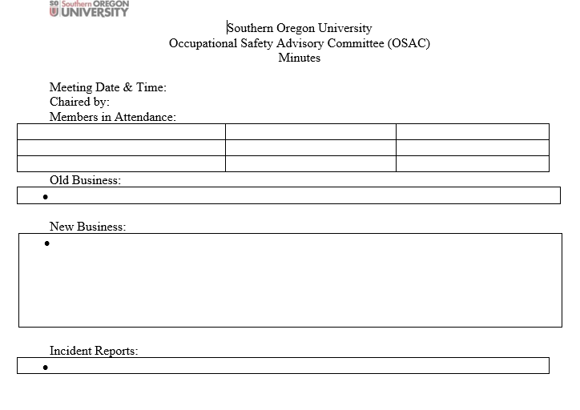

Appendix B
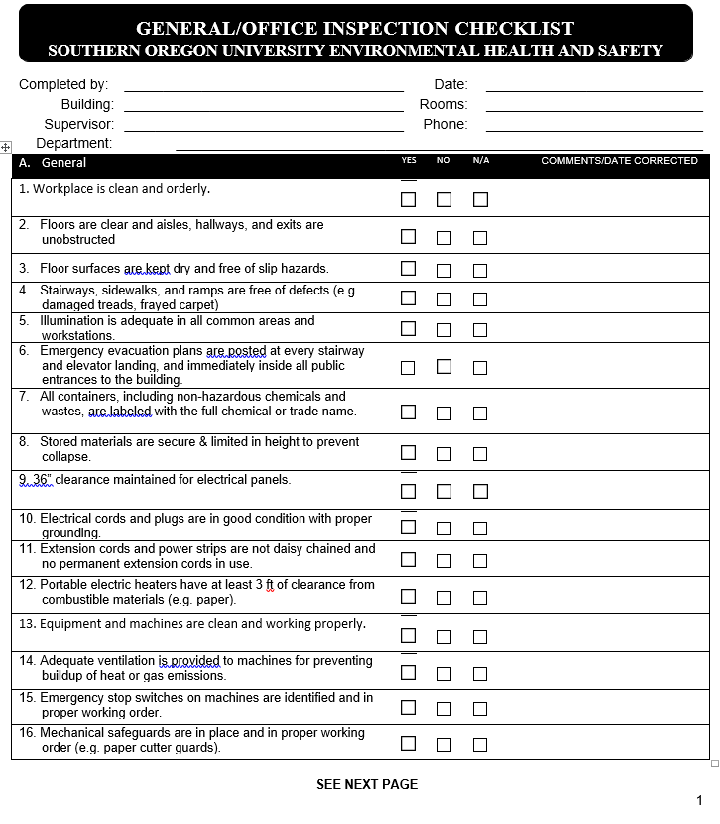

Appendix B (cont.)
