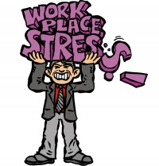You have five minutes to print a report and go upstairs to your meeting. You hit print and run to the copy machine. The error light is blinking. A co-worker is printing 50 copies of her PowerPoint presentation, and, halfway through that job, the machine ran out of toner. You don't know where the toner is stored and, even if you did, you don't know how to open the machine.
The American Institute of Stress reports that stress-related illnesses, such as depression and heart disease, can cost businesses an estimated $200 to $300 billion a year in lost productivity.
According to statistics from the American Psychological Association (APA), two-thirds of Americans claim that work is their main source of stress. Approximately 30 percent of workers surveyed by the APA reported "extreme" stress levels.
Individual strategies for stress reduction
Take a deep breath
Feeling a stressful moment? A few deep abdominal breaths can help calm you.
Eliminate interruptions
Constant interruptions can slow productivity and create tension. Make a plan for dealing with incoming emails and phone calls.
Put on the "breaks"
Take time for a walk or to stretch at your desk. Mini-breaks help you ease stress and refocus. Exercise helps your body metabolize stress hormones, sweeping them out of your system.
Stay healthy
Eat healthy foods, exercise, and get enough sleep. When you are healthy, you can recover more quickly from stress.
Prioritize and plan
You will get more work done in less time if you stay organized. 