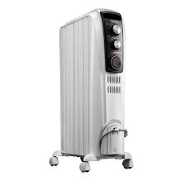
Portable space heaters are used for supplementary heating of spaces. Space heaters that are recommended are the oil filled radiator style space heaters. This is due to safety reasons in that they do not get as hot as other styles of heaters and are more energy efficient.
Space heaters are required to be plugged directly into outlets. Space heaters cannot be plugged into extension cords or power strips. Space heaters cannot be covered by fabric or other flammable material. Damaged units will need to be removed and replaced as required. If unit is causing excessive power drain on building they will need to be replaced.

Portable electric heaters are high-wattage appliances that have the potential to ignite nearby combustible materials like curtains, beds, sofas, paper, clothing, and flammable liquids. If ignition results from a heater left on and unattended, a major fire could result.

Safety is a top consideration when using space heaters. The U.S. Consumer Product Safety Commission estimates that more than 25,000 residential fires every year are associated with the use of space heaters, resulting in more than 300 deaths. In addition, an estimated 6,000 people receive hospital emergency room care for burn injuries associated with contacting the hot surfaces of room heaters, mostly in non-fire situations.

