Workplace Safety and the Flu
Pandemic flu remains a concern for employers and workers. A pandemic can occur at any time and can be mild, moderate, or severe. Although the pandemic H1N1 flu in 2009 was considered by CDC to be mild, it created significant challenges for employers and workers and showed that many workplaces were not prepared.
The best way to reduce your risk of exposure to the flu virus in your workplace is to use the basic hygiene precautions listed below and to avoid close contact with ill people. 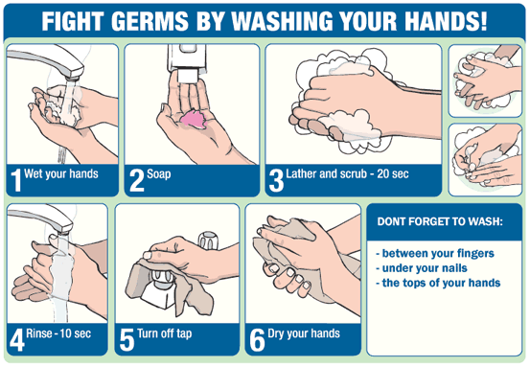

Protect Yourself During Flu Season

- Get vaccinated! Vaccination is the most important way to prevent the spread of the flu. For additional information about seasonal flu vaccine priorities, see Key Facts About Seasonal Flu Vaccine.
- Stay at home if you are sick. The CDC recommends that workers who have a fever and respiratory symptoms stay at home until 24 hours after their fever ends (100 degrees Fahrenheit [37.8 degrees Celsius] or lower), without the use of medication. Not everyone who has the flu will have a fever. Other symptoms could include a runny nose, body aches, headache, tiredness, diarrhea, or vomiting
- Wash your hands frequently with soap and water for 20 seconds; use an alcohol-based hand rub if soap and water are not available.
- Avoid touching your nose, mouth, and eyes.
- Cover your coughs and sneezes with a tissue, or cough and sneeze into your upper sleeve(s). Throw tissues into a "no-touch" wastebasket.
- Clean your hands after coughing, sneezing, or blowing your nose.
  - When using soap and water, rub soapy hands together for at least 20 seconds, rinse hands with water, and dry completely.
  - If soap and water are not available, use of an alcohol-based hand rub is a helpful interim measure until hand washing is possible. When using an alcohol-based hand rub, apply liquid to palm of hand, cover all surfaces of the hands with the liquid, and rub hands together until dry.
- Keep frequently touched common surfaces (e.g., telephones, computer equipment, etc.) clean.
- Try not to use a coworker's phone, desk, office, computer, or other work tools and equipment. If you must use a coworker’s equipment, consider cleaning it first with a disinfectant.
- Avoid shaking hands or coming in close contact with coworkers and others who may be ill.
- Stay in shape. Eat a healthy diet. Get plenty of rest, exercise, and relaxation.
- Speak with your doctor and find out if you are in a high risk category for seasonal flu (e.g., elderly, pregnant women, small children, persons with asthma, etc.).

