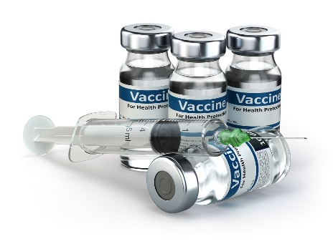
You start to see the signs in August and September – “Flu Shots Here”. They are at every pharmacy and medical facility, and your employer may even host a flu shot clinic at work. Some people are on board right away; others have a bevy of excuses why they won’t get a flu shot. “I got a shot last year and got sick from it the next day.” Or “I never get a flu shot and I never get sick.” Or “I’m allergic to eggs so I can’t get the shot.”
Let’s address each of these statements individually because it is important for as many people as possible to become vaccinated:
Can you get the flu from a flu shot?
The short answer is no. First, it takes two weeks for the flu virus to incubate and cause symptoms. If you have the flu shortly after you get a shot, you most likely contracted it somewhere else within the past two weeks and you were going to get sick anyway. Second, flu vaccines are made one of two ways:
Using an “inactivated” viruses which make it non-infectious
Using absolutely no flu viruses at all
Both of these methods result in a vaccine which cannot cause the flu.
If you get the flu more than two weeks after the shot, you most likely contracted a strain of the virus not covered by the shot you received. The CDC formulates the vaccine based on the most likely strains to hit the US in any given year. It is an educated guess, but sometimes another strain finds its way into the US.
If I have never had the flu before, why would I need a flu shot now?
Just because you have never had the flu (or think you have never had the flu), it is possible this year could be the year. Strains of the flu virus are mutating continually and what has not made you sick in the past, may make you sick now. Additionally, you move through the world and interact with other human beings who may not be as resistant to viruses as you think you are. When you contract the flu, you are contagious from around one day before you have symptoms until five to seven days after. Any hard surfaces you get your germs on during this time can remain contagious for up to 48 hours. To be blunt, even when you don’t feel sick, you may be sick and can make others around you sick.
Can I get a flu shot if I am allergic to eggs?
One of the standard questions on the wellness sheet most places have you sign before the shot asks if you are allergic to eggs. The reason is they are covering themselves because most flu vaccines are produced using an egg-based manufacturing process and contain a small amount of egg protein called ovalbumin; however, unless you have severe allergic reactions to eggs (other than simple hives) like respiratory or other reactions requiring medical intervention, you can receive any flu vaccine. Even if you have had a severe reaction to eggs you can still get a flu vaccine, but it is recommended you receive the vaccine in a medical facility equipped to handle a severe allergic reaction and be sure to notify the person administering the vaccine of your allergy. The only people who should not receive a flu vaccine are those who have had a severe reaction to flu vaccines in the past.
OK, maybe I didn’t get the flu from the flu shot, but I still don’t want to get one. Why should I?
As mentioned earlier, we all interact with one another and the number of people we “touch” is exponential. Door knobs, counters, office furniture, grocery carts, and other public shared surfaces, in addition to person-to-person contact, can spread the flu virus. Have you ever been on an airplane with someone who is coughing, sneezing, etc and inwardly groaned because you just knew whatever they had was making its way around the enclosed cabin?
When you get a flu shot, you are not just protecting yourself, you are helping protect everyone around you. Some people are legitimately not able to get the flu shot due to a compromised immune system or advanced age. The very young (babies under 6 months of age are not old enough for the vaccine and are extremely at risk) and the very old are of particular concern.
People who are cardiac compromised run a larger risk of suffering a cardiac event as the result of contracting the flu and should always get a flu shot. In fact, incidences of cardiac visits to hospitals increase during the peak of flu outbreaks.
If a family member contracted Guillain-Barre Syndrome after a flu shot, should I not get one?
Guillain-Barre syndrome (GBS) is exceptionally rare and occurs in only 1 or 2 people per million vaccinated. In fact, a person prone to getting GBS is more at risk for getting it after having the flu than after receiving the vaccine. There is no evidence to suggest it is hereditary (which is why it is called a “syndrome” and not a “disease”). GBS is a very serious condition and can have a long recovery time. It is understandable someone who has watched a loved one go through all the stages of GBS, many of which are quite painful, would want to avoid enduring the same circumstances. If a family member has had GBS and you are concerned about getting a flu shot, it is recommended you speak with your doctor about it and decide with them what the best course of action is for you.
I’m still not convinced, what can I do to avoid getting the flu besides a shot?
If you still decide not to receive a flu shot, please take precautions during flu season. Eat healthily and stay hydrated, wash your hands often (especially when you are out in public, and definitely before eating or touching your mouth or nose), disinfect surfaces often in your home and office. If you start feeling ill, minimize your contact with others. If you can stay home from work, you should stay home from work – your co-workers will thank you. Staying home and resting is your best bet for a quick recovery anyway.

Stay healthy!

