DRIVER CLEARANCE
Who needs to be driver cleared?
Students, staff, faculty, and volunteers driving for official university business, whether through a rental or personal vehicle, must be cleared to drive prior to the trip.
How do I get driver cleared?
Go to the Service Center website, click on Support Services from the menu and select the driver’s clearance tab. Scroll down to the bottom of the page and select “Form.” Complete and submit the driver clearance form regardless of whether your records are in-state or out-of-state.
Please Note: The driver clearance form will not work unless you are logged into your SOU Gmail account at the same time.
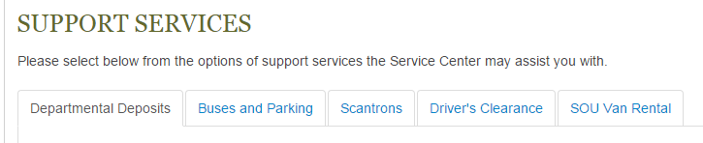
Driver Clearance Requirements
Index code is required, as there is a $5 fee charged to the department to obtain the Oregon DMV records. It is also required that you have had your driver’s license for at least three years. The driver record is reviewed for major traffic violations within the last three years.
Out of State Driving Records
The driver will be responsible for obtaining a court certified driving record from the out-of-state DMV showing the last three preceding years. The record may be sent directly to the Service Center or brought over once obtained.
What happens next?
Allow 5-7 business days to be cleared for Oregon records. For out-of-state records, allow for 1-2 business days after the records have been received by the Service Center.
Driver’s clearance is valid for as long as the driver’s record remains clear for the following time periods:
Students – 2 years
Staff & Faculty – 5 years
Temporary Staff & Volunteers – 1 year
You will receive notice 30-days prior to your driver clearance expiration date allowing you time to renew your driver clearance, if needed.
Van Rentals
SOU Motor Pool has five 11-passenger vans and one 7-passenger van available for rental for university related travel. All drivers must be driver cleared and van certified prior to travel. Van rates and policies may be found on the Service Center website’s Van Rental page.
How do I get van certified?
Before you may drive university vans, you need to be both driver cleared and van certified. Once driver clearance is completed, you will receive a link to the van training presentation and online van test. Once the online van test is completed, you will receive contact information to schedule a driving test with Motor Pool.
Contact Information
For any questions about driver clearance or to check on driver clearance status, please contact either your Support Specialist or Carolyn Trip at 541-552-7097.

