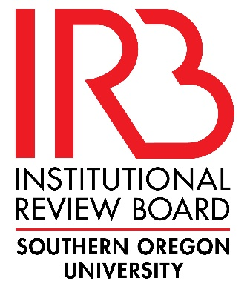 | INSTITUTIONAL REVIEW BOARD (IRB)  REVIEW REQUEST  FOR PROJECTS USING HUMAN SUBJECTS

Investigators are responsible for ensuring that the rights and welfare of human subjects participating in research activities are protected, and that methods used and information provided to gain subject consent are appropriate to the research.

All research activities involving the use of human beings as research subjects (participants) must be reviewed and approved by the Southern Oregon University Institutional Review Board (IRB), unless the IRB determines that the research falls into one or more of the categories of exemption established by federal regulation. Please note that only the IRB may make the determination if the research qualifies for exemption under Title 45 CFR 46.101.

Investigators may not solicit subject participation or begin data collection until they have received approval or written concurrence that research has been determined to be exempt from the Institutional Review Board.

Application forms are available on SOU’s IRB webpage. The form must be downloaded and filled out completely. Once completed, one signed hard copy must be submitted to the IRB Administrator along with any other materials relevant to the proposal (scripts, consent forms, interview questions, surveys, etc.), either via campus mail or directly to the Office of the IRB, and another electronic copy of all materials needs to be submitted via email. If you have questions about the IRB application form or about the review process, contact:

Institutional Review Board
Grants Administration
Computing Services East # 236
541-552-8662
E-mail: trammellj@sou.edu

INSTITUTIONAL REVIEW BOARD (IRB)

The Institutional Review Board generally meets on an ad hoc basis as proposals are submitted for review. Applicants must allow a minimum of 2 weeks for the review of Exempt research activities, and a minimum of 4 weeks for the review of Non-Exempt research activities. A notice of the IRB’s action will be sent to the researcher upon completion of review.

INSTRUCTIONS:

Your responses to the questions in the application are basic to the Institutional Review Board’s determination about the protection of the rights and welfare of human subjects in your research. Your responses should be clear, complete, and concise. Applications that are not clear and/or that have excessive spelling and grammar issues will be returned without review.

All answers to the questions on the IRB Application should be typed out after the appropriate questions on the form in the spaces provided. If you believe that a question does not apply to your research, enter a response such as “N/A” or “does not apply.” If an application is returned with unanswered questions, it will be returned without review.

Your application must include:
- The Investigator and Study Information Sheet
- Completed IRB Review Request Application with signatures from all investigators
- Exempt Category Worksheet(s) (for Exempt research activities)
- Study Plan Narrative (for non-Exempt research activities)
- All relevant materials pertaining to your research design including but not limited to:
  - Survey Instruments
  - Interview/Focus Group Questions
  - Materials provided to participants
- All correspondence used to recruit and inform subjects including but not limited to:
  - Verbal, written, and/or email recruiting scripts
  - Informed consent, assent, and/or permission forms you have designed for your research that the subject(s) will sign (the template provides the basic framework and needs to be customized to your research).

Submit one complete signed hard copy and one digital copy via e-mail to:

Institutional Review Board
Grants Administration
Computing Services East # 236
Attn: Marie Trammell
541-552-8662
trammellj@sou.edu

