How to Certify Position Description in PeopleAdmin
Employee Instructions
Please note: The Position Certification process should be completed for all new employees, when an existing employee changes positions or after there is a major or minor update to an employee’s position description. This process replaces signatures on the paper copy of the position description. If, when verifying the PD, you feel something is incorrect you can contact the person who initiates actions in PeopleAdmin for your Department and they can take the necessary action to update the position or you can contact Human Resources at 541-552-8553.
Step 1 – Login to PeopleAdmin
There are two options
- Login to InsideSOU
- Go to the Online ServicesTab
- Click or Recruiting (PeopleAdmin)
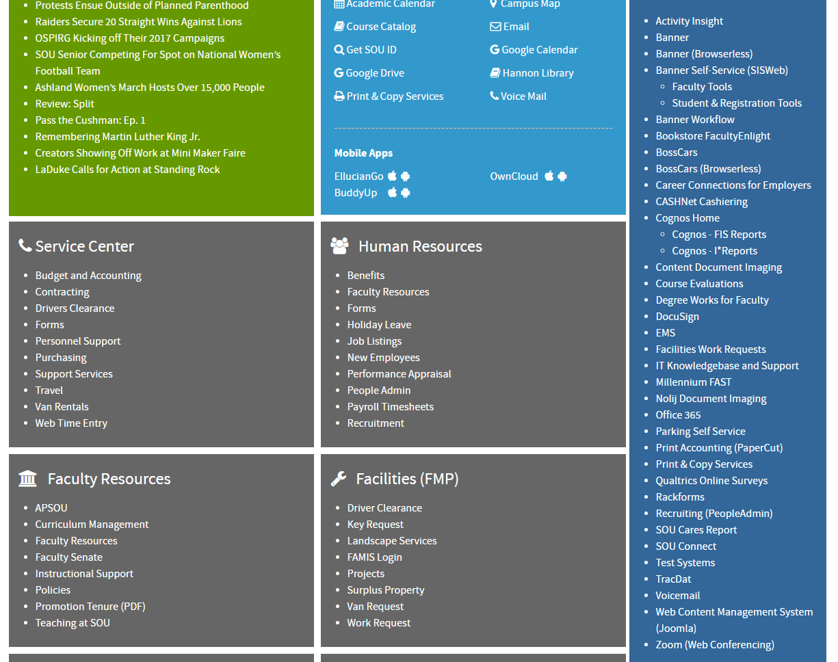

Or

- Go the the URL jobs.sou.edu/hr
- Click on the Click HERE to log in with SOU Credentials (Do not try to login on this page).
- Login with your usual SOU credentials. 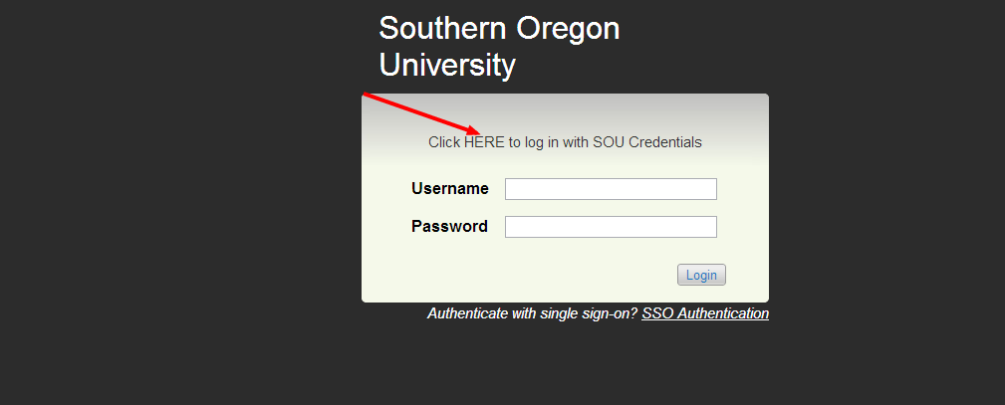
Step 2- Login using your network user name and password 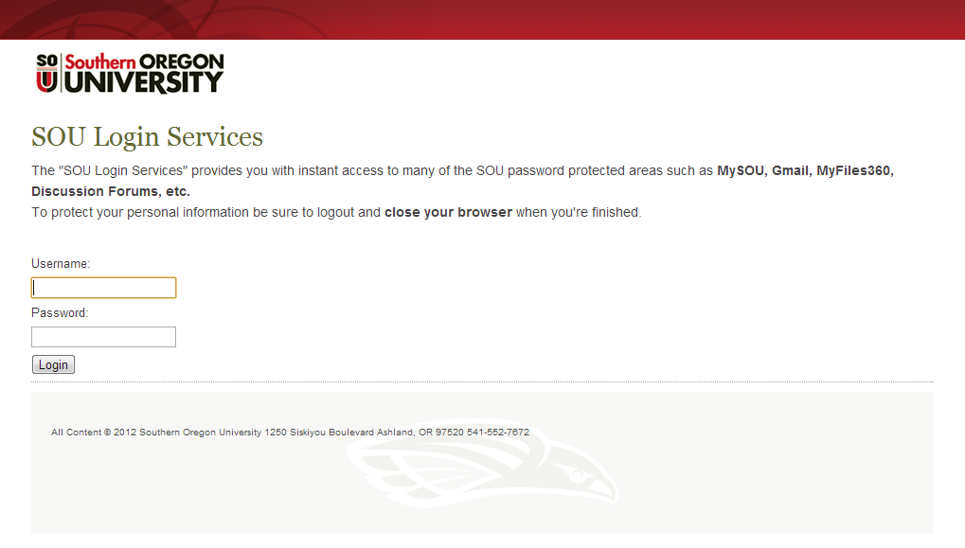
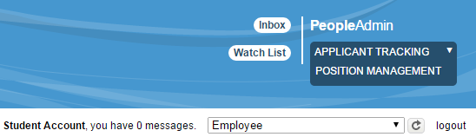
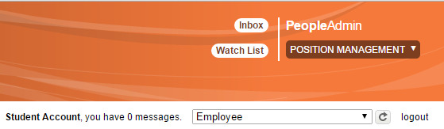
Step 3- When you log in you will see the Applicant Tracking home screen, in blue. You will need to be in the Position Management Screen which will have orange header. If you are not in the position management, hover over the drop down menu to the right of the Watch List tab. And select POSITION MANAGEMENT.

Step 4-Once in the position management screen you will need to select the employee view (1). You will do this in the drop down menu directly under where you selected the position management screen in the white border under the header. You must click the refresh button and look for a green bar to come up across the top of the screen to confirm the view change (2).
Step 3
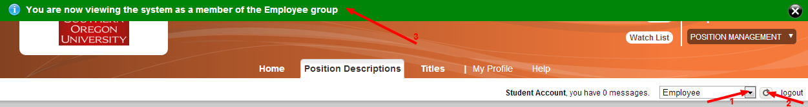
Step 4
Step 5- Select the tab Position Description and then select your position type.
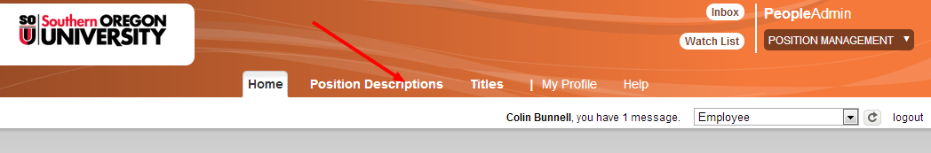
- For this example we will use Administrative
Step 6- Type in your name into the search box. You can use first, last or both. (Note that employees are entered with their legal names) and then click the search button.

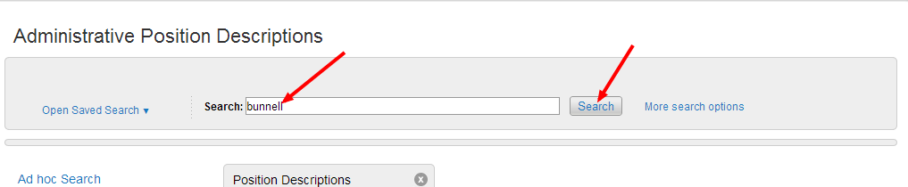

Step 7- Click on the blue job title area (Do not click on the box) and this will direct you to the Position Description summary
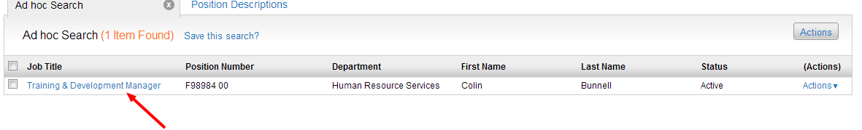
Step 8- You will need to select View Outstanding Actions. Then select Start.

Step 9- Select Edit
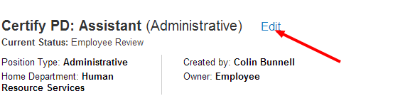
Step 10- Verify the Position Details of your position and hit next when you have verified. Then verify the Duties of your position, once finished verifying duties click next. If when verifying the PD you your duties need to be update or if there is incorrect information you will need to contact your Supervisor and your supervisor will coordinate with Human Resources. If the information is not updated please hold off on certifying your PD until it can be reviewed.

Step 11 – Once you have verified your Position Details and your Duties, enter your initials and click next.
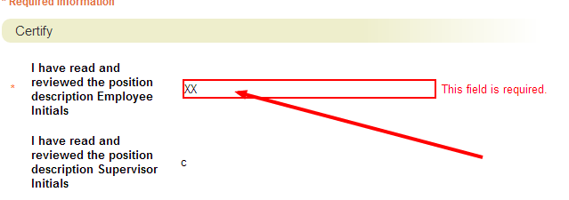
Step 12- Now you are in the summary, next click on take action drop down menu and select Send to HR Review (move to HR Review) tab. A window will pop up and click on Submit
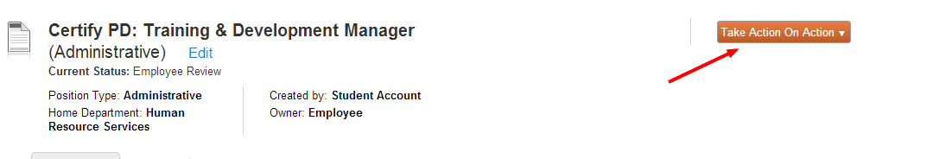

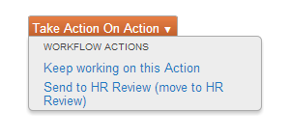
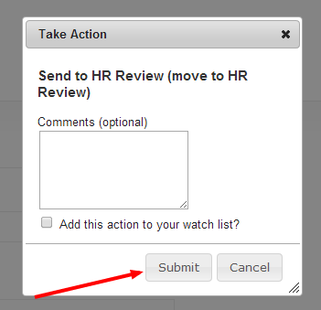
Once you have completed these steps the PeopleAdmin system will send an automated email to the HR Department notifing them the process was completed.

