CLASSIFIED NON-EXEMPT, CLASSIFIED EXEMPT, UNCLASSIFIED NON-EXEMPT TIMESHEETS COMPLETION FOR FURLOUGHS
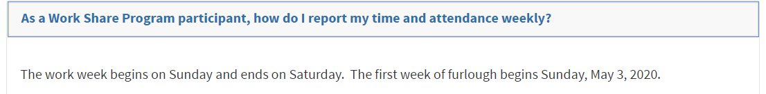
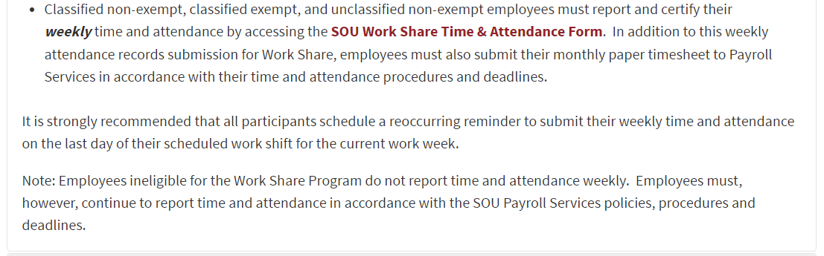
Go to InsideSOU and go to Payroll Services Website to access link for paper timesheet
https://inside.sou.edu/bus-serv/payroll/index.html
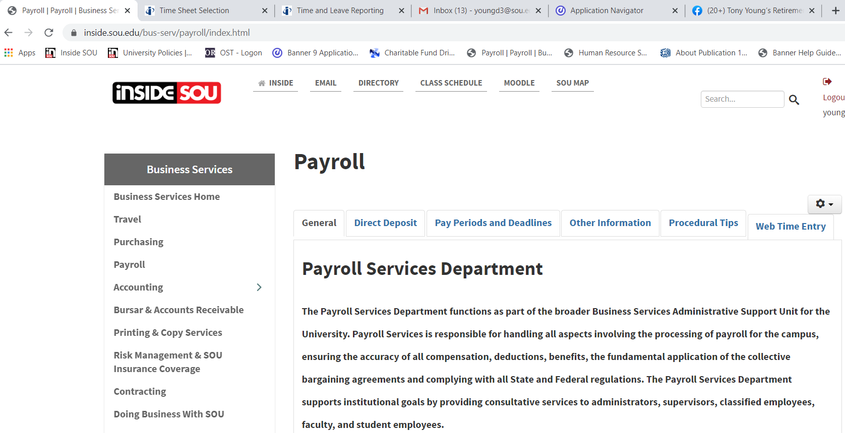

Under Form & Instructions – click on link for paper timesheets
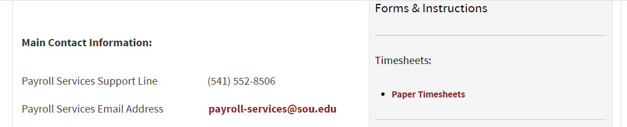

Select correct timesheet for your employment classification
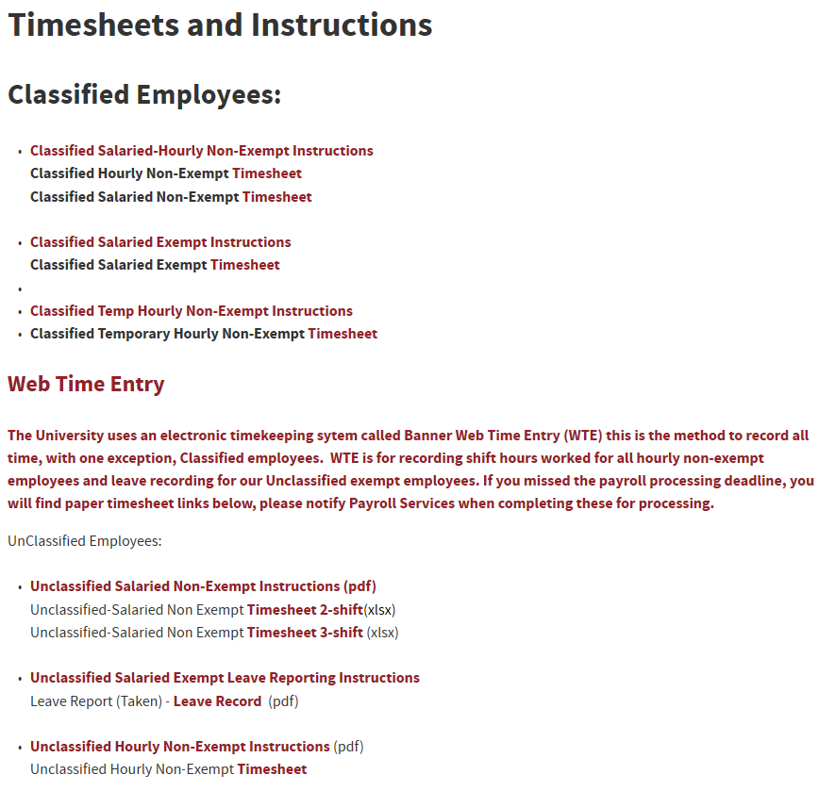
The following timesheet example shows an 8 hours furlough reduction per week:

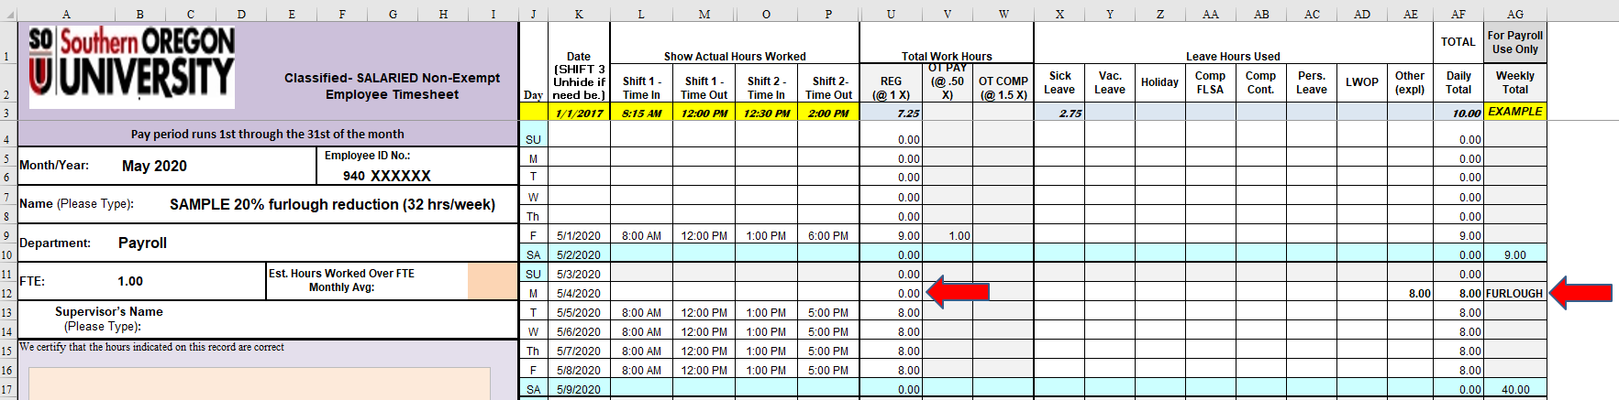

The following timesheet example shows an 8 hours furlough reduction per week with holiday:

