How to Make Major Position Updates in PeopleAdmin
Supervisor Instructions
Please note: The major position update process will allow you to make major changes to the employee’s PD. Please do not change an employee’s Salary, FTE or Title without first consulting with HR and getting the necessary approvals.

Step 1 – Login to PeopleAdmin
There are two ways to log in:
- Login to InsideSOU
- Click on one of the PeopleAdmin links
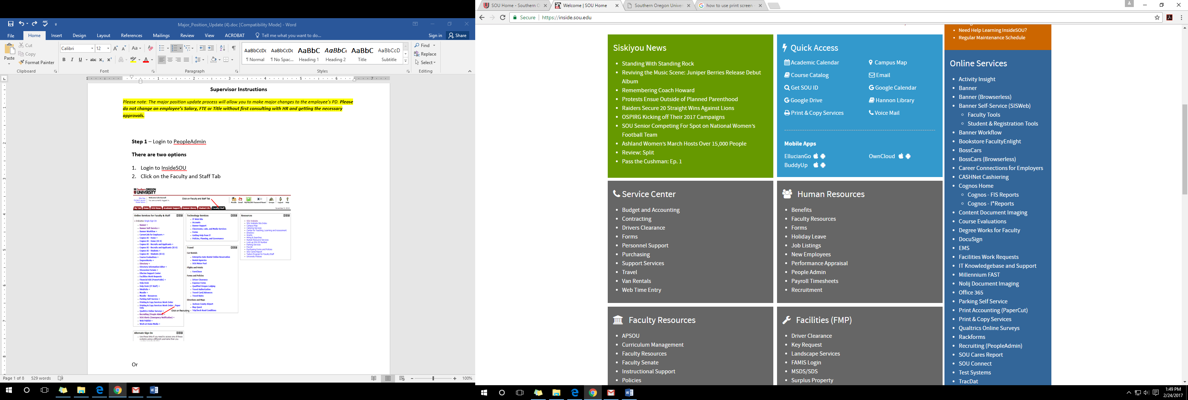

Or

1. Go to the URL jobs.sou.edu/hr
2. Click on the Click HERE to log in with SOU Credentials (Do not try to login on this page).
3. Click on the SSO Authentication Link

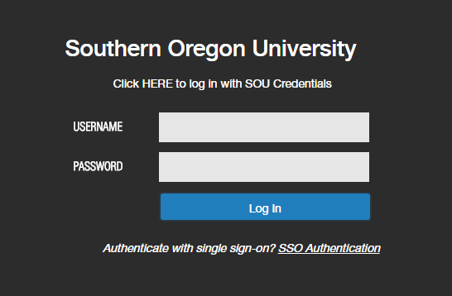
Step 2- Once logged in, you will need to be in the Position Management Screen, which will have the orange header. If you are not in the position management, hover over the drop down menu to the right of the Watch List tab and select POSITION MANAGEMENT.
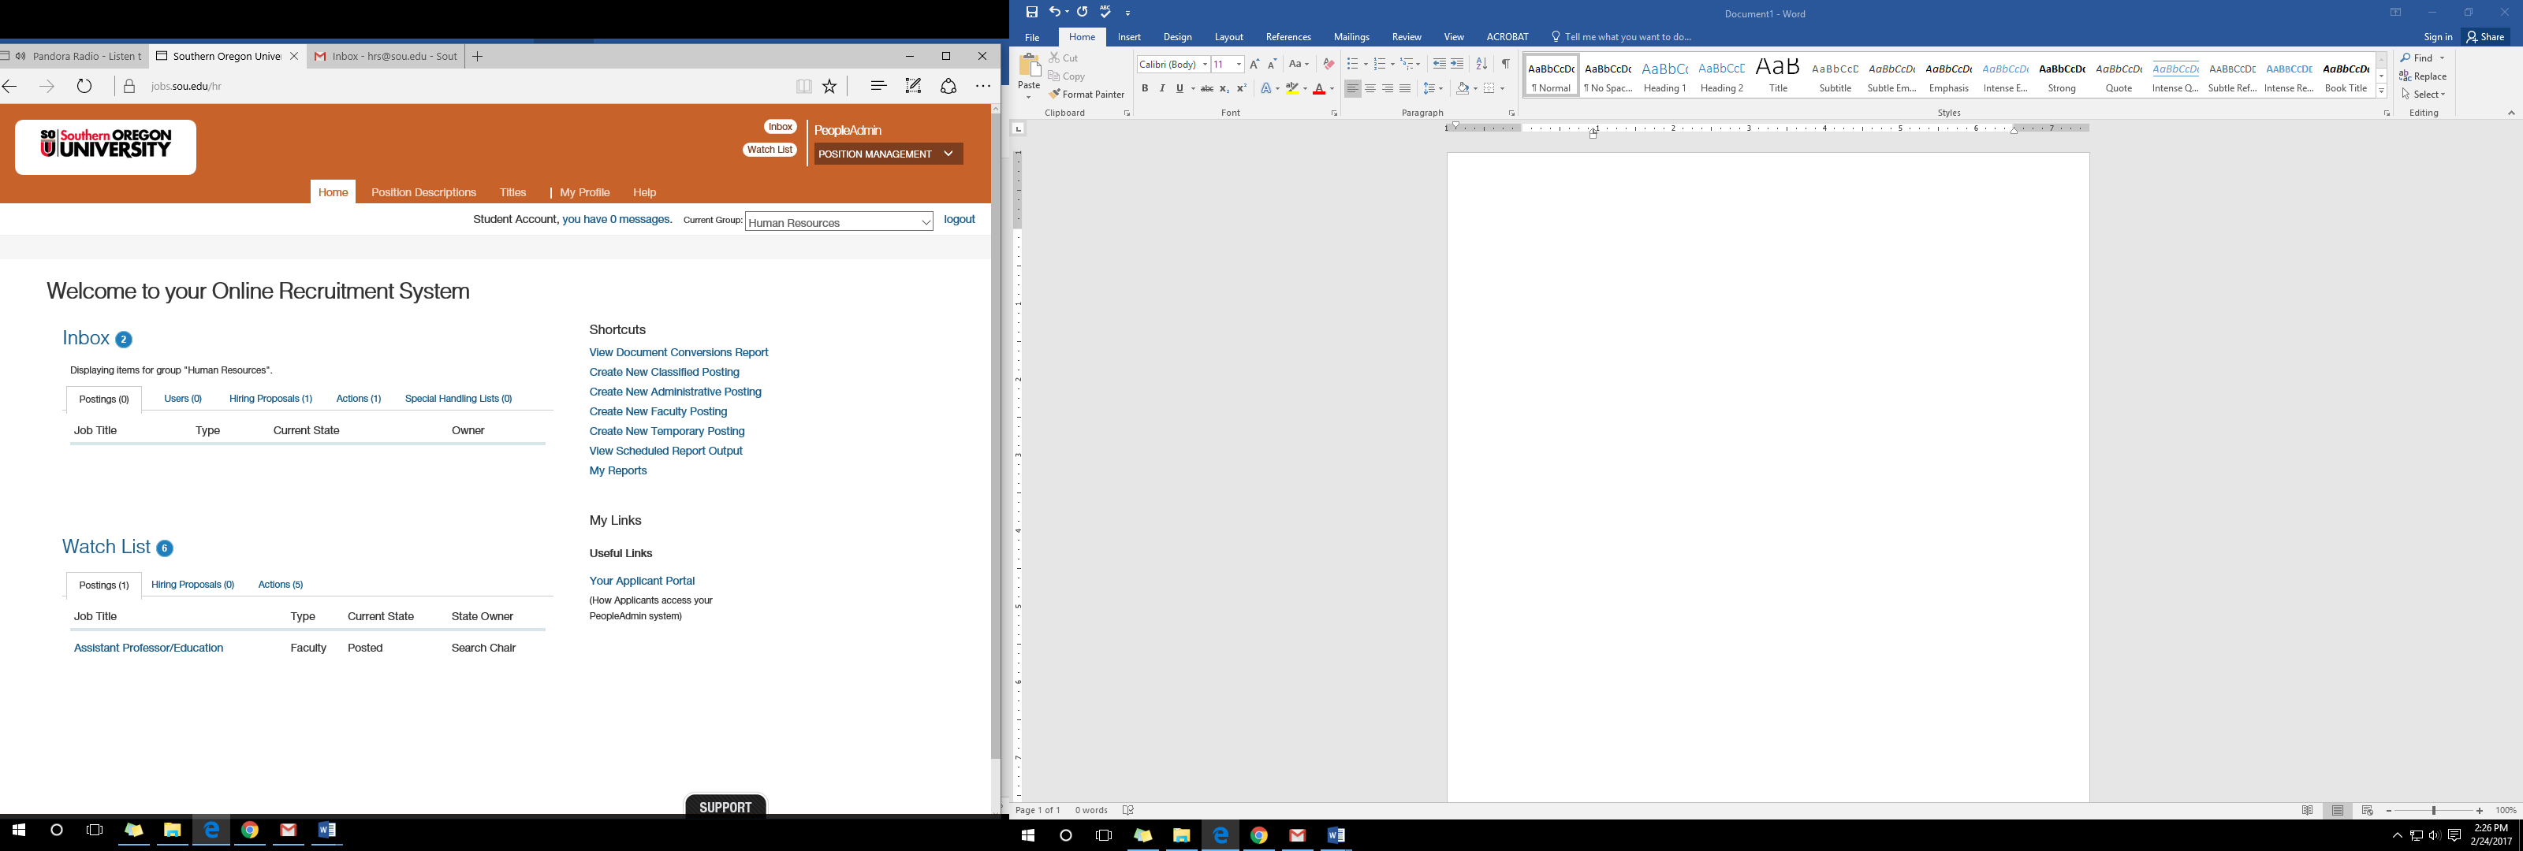

Step 3- Once in the position management screen you will need to select the Initiator View if you are the initiator or Department Authority View if you are the department authority. You will do this in the drop down menu directly under where you selected the position management screen.

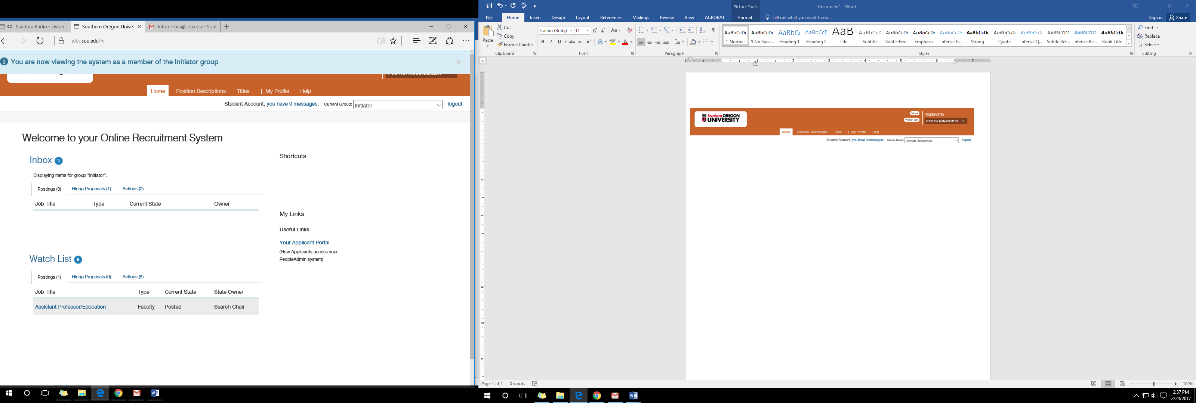
Or
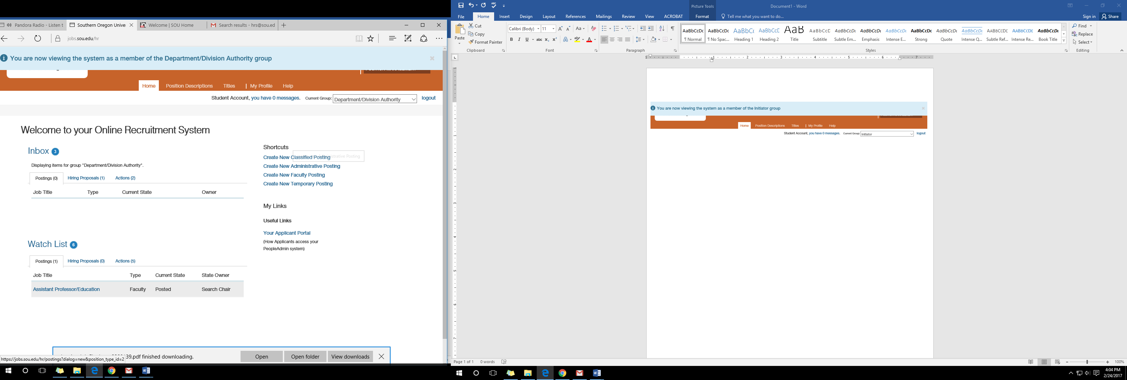

Step 4- Select the tab Position Description and then select the position of the employee you are making changes to
- for this example we will use Classified
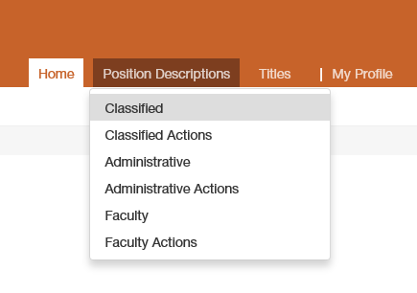
Step 5- Click on More search options
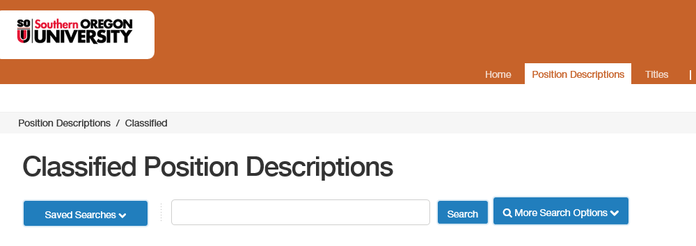
Type in the employee name. You can use first, last or both. (Note that employees are entered with their legal names)
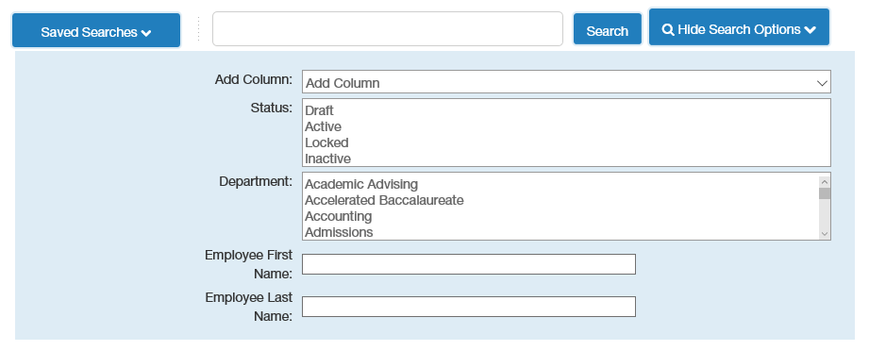

Step 6 Click on the blue job title (Do not click on the box) and this will direct you to the Position Description summary
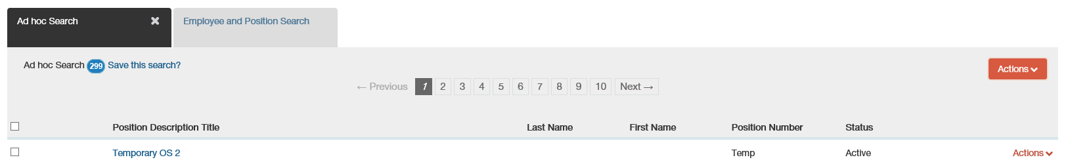
Step 7 Click on Major Position Update Existing Employee.
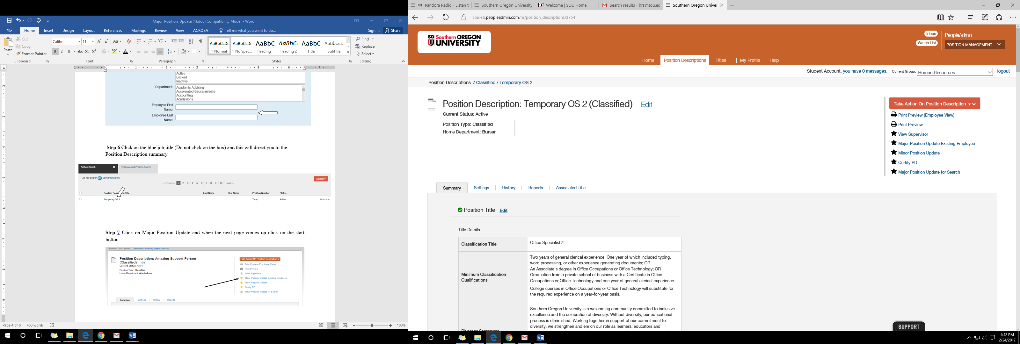

-Start Action
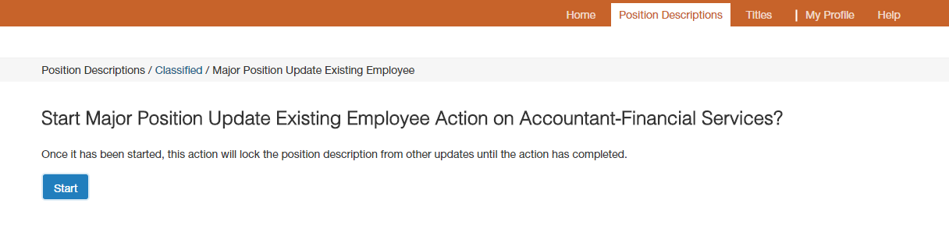
Step 8- You will be able to make major changes to the employee’s PD. Do not make changes to the employee’s salary, FTE or Title unless you have spoken to HR and have gotten the necessary approvals. (If the employee’s position is classified you will not be able to change the Minimum Classification Qualifications, as they are automatically populated from the Class Specs). Click next to save once changes have been made.

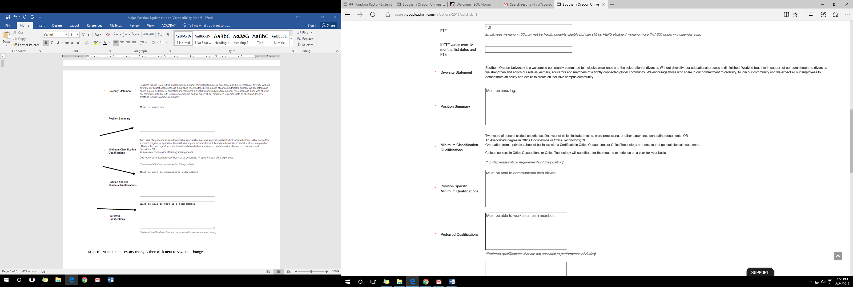

Step 9- You will be able to make changes to the employee’s duties. If you wish to add a new duty click on the Add Job Duties Entry at the bottom, then click save or next to save the changes.
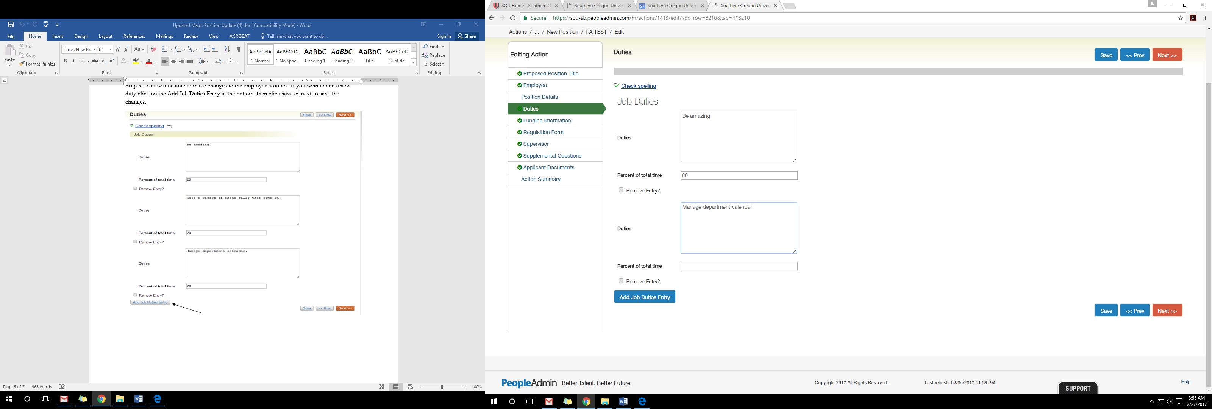
Step 10- Now you are in the summary, click on the Take Action on Action drop down menu and select Department/Division Authority if you are the Initiator or Vice President/President Authority if you are the Department/Division Authority. 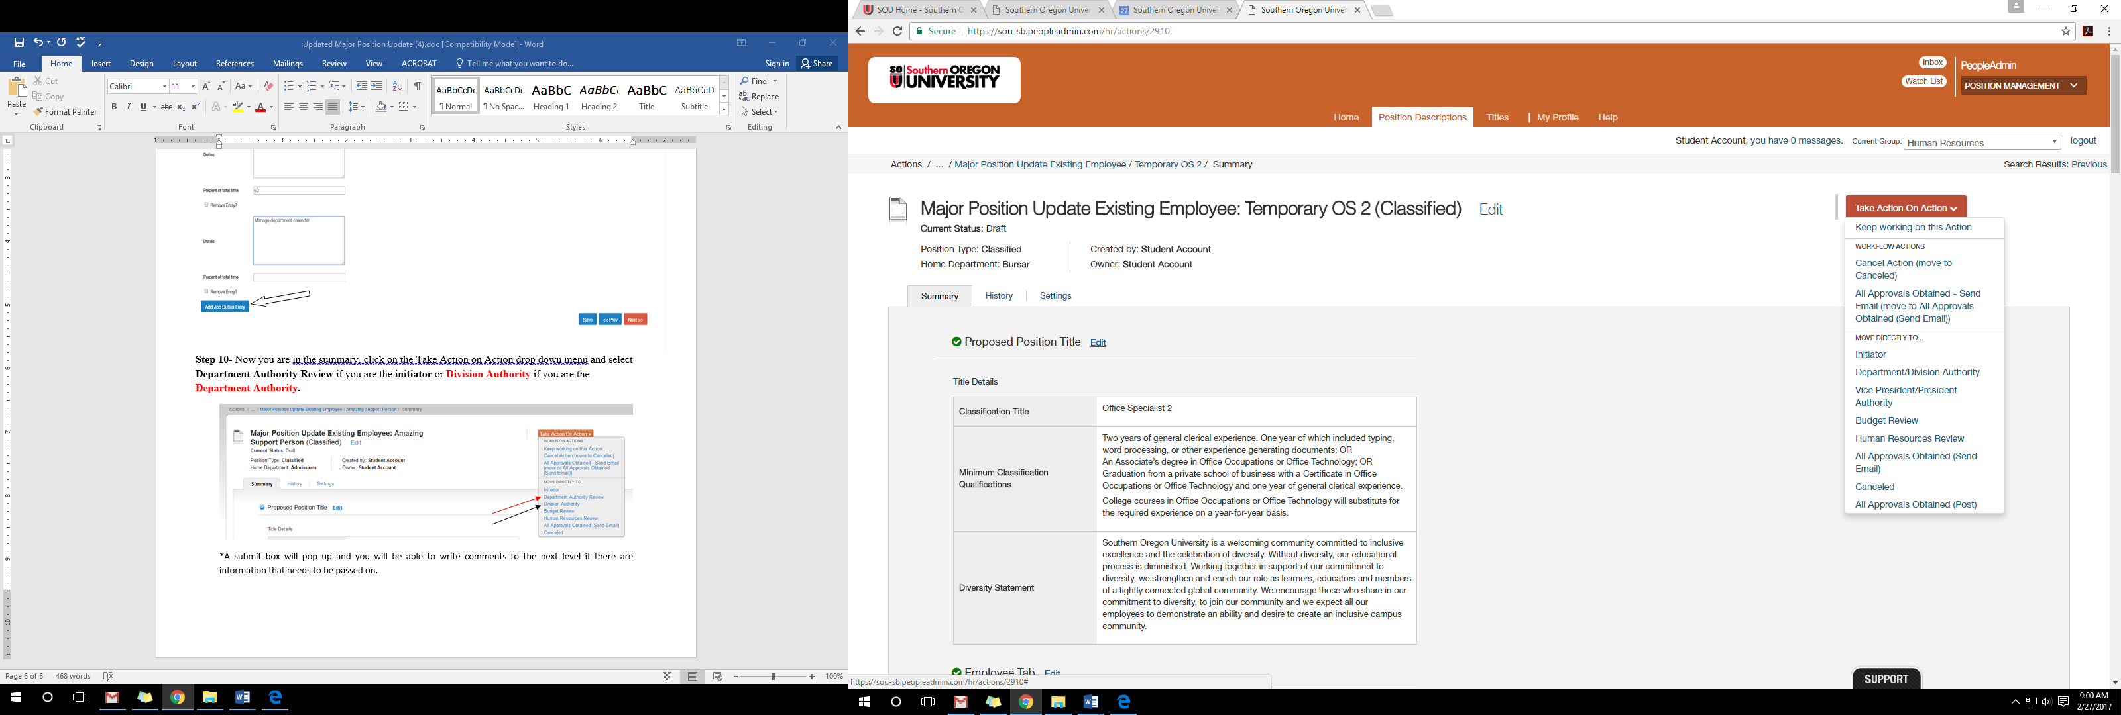*A submit box will pop up and you will be able to write comments to the next level if there are information that needs to be passed on.

