How to Renew a Position in PeopleAdmin
Instructions
Please note: The Renew Position process should be used to update an employee’s start and end date, and salary. Talk to Human Resources BEFORE making changes to an employee’s salary. If you’re making more significant changes, please contact HR.

Step 1 – Login to PeopleAdmin
There are two ways to log in:
- Login to InsideSOU
- Click on one of the PeopleAdmin Links
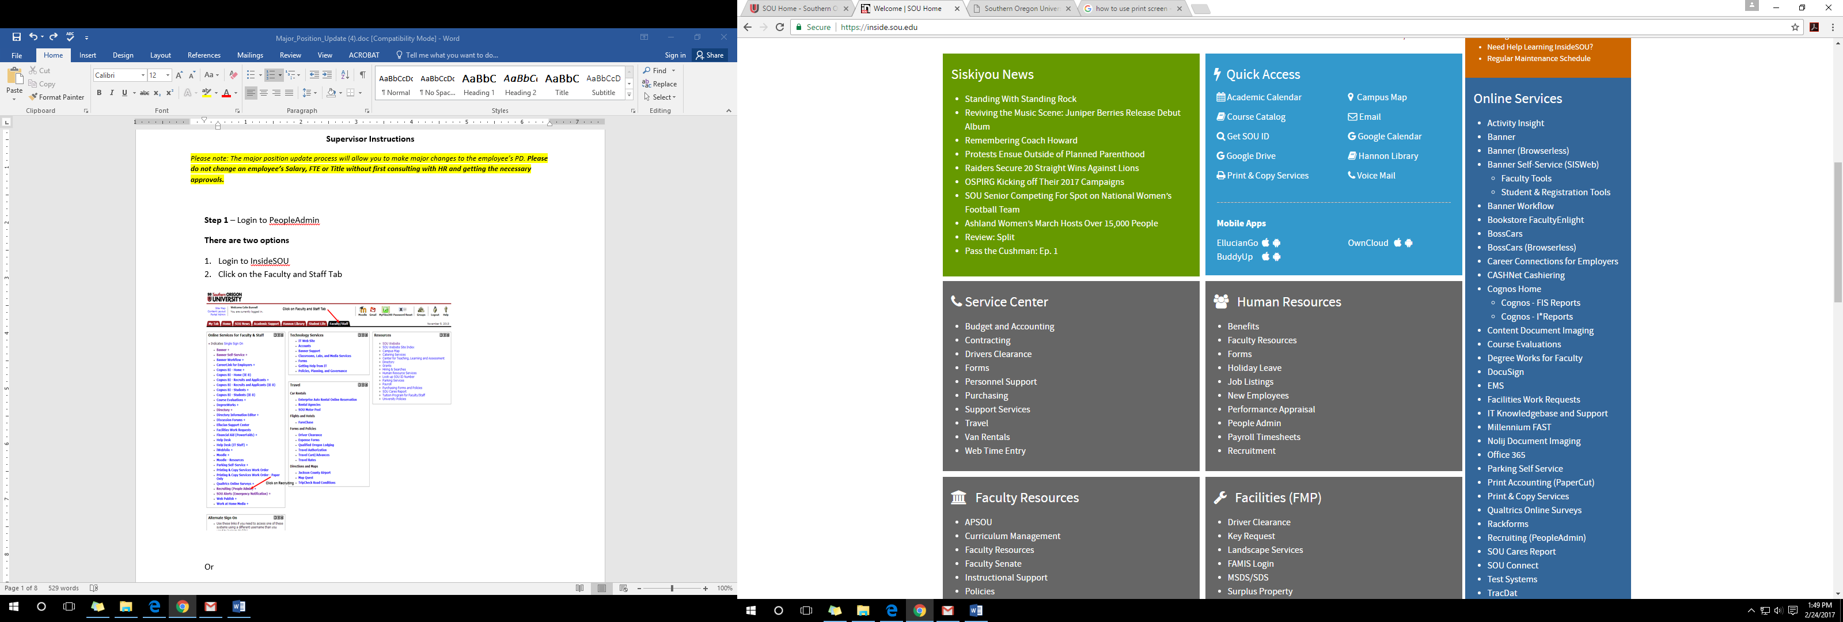

Or

- Go to the URL jobs.sou.edu/hr
- Click on the Click HERE to log in with SOU Credentials (Do not try to login on this page).
- Click on the SSO Authentication Link
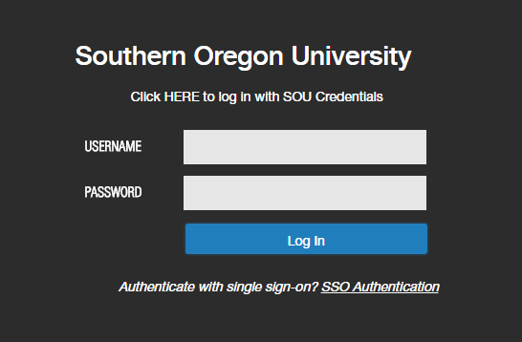
Step 2- Once logged in, you will need to be in the Position Management Screen, which will have the orange header. If you are not in the position management, hover over the drop down menu to the right of the Watch List tab and select POSITION MANAGEMENT.
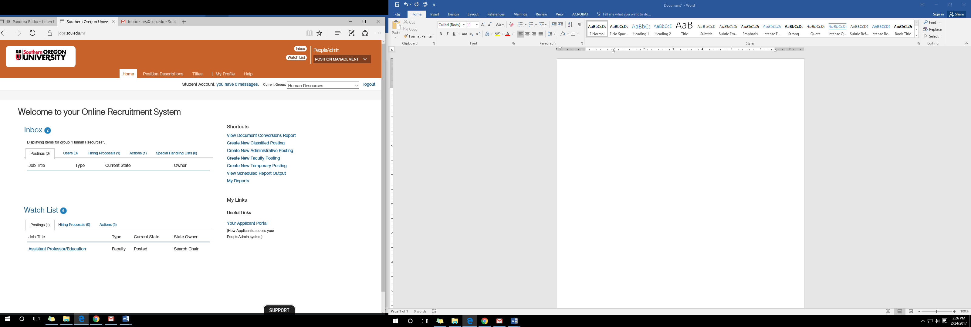

Step 3- Once in the position management screen you will need to select the Initiator View. You will do this in the drop down menu directly under where you selected the position management screen.
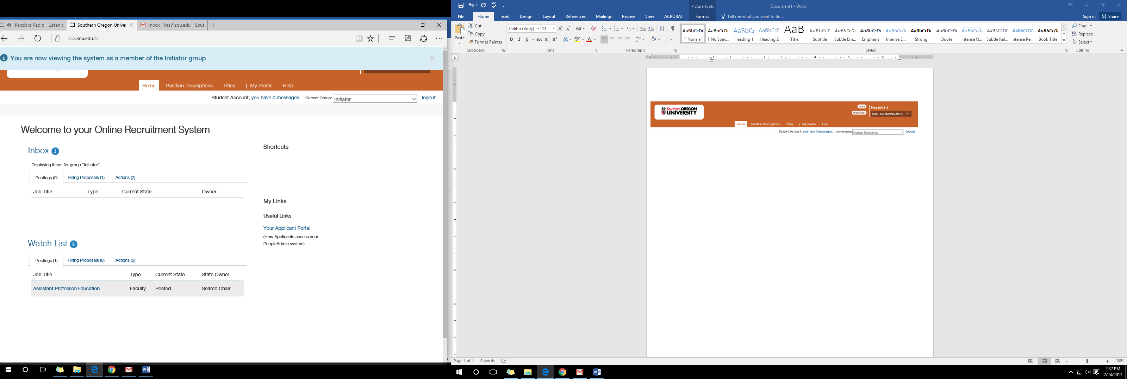

Step 4- Select the tab Position Description and then select the position of the employee you are making changes to (Renew function is only for Administrative and Faculty positions)
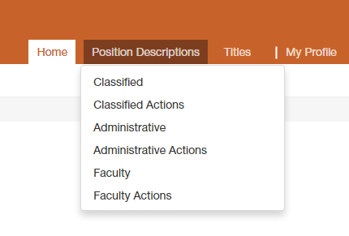

Step 5- Click on More search options
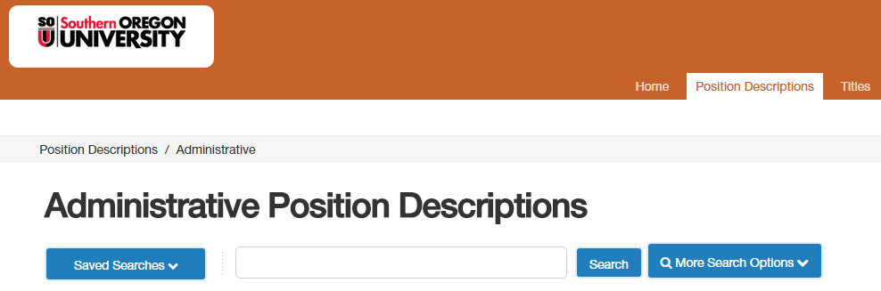

Type in the employee name. You can use first, last or both. (Note that employees are entered with their legal names)
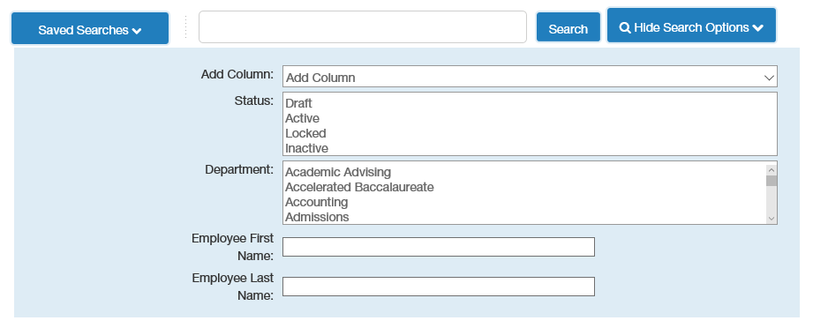
Step 6- Click on the blue job title area (Do not click on the box) and this will direct you to the Position Description summary
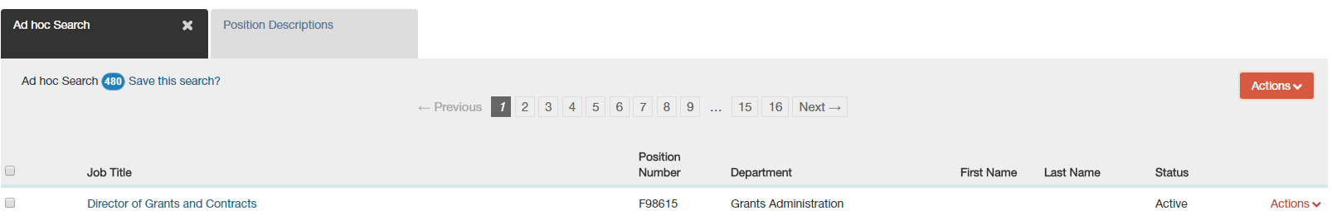

Step 7- Click on Renew Position
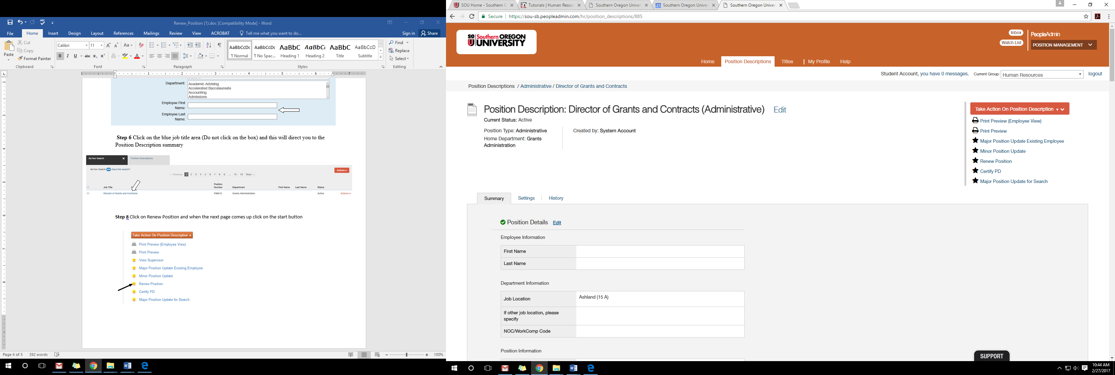

-Start Action
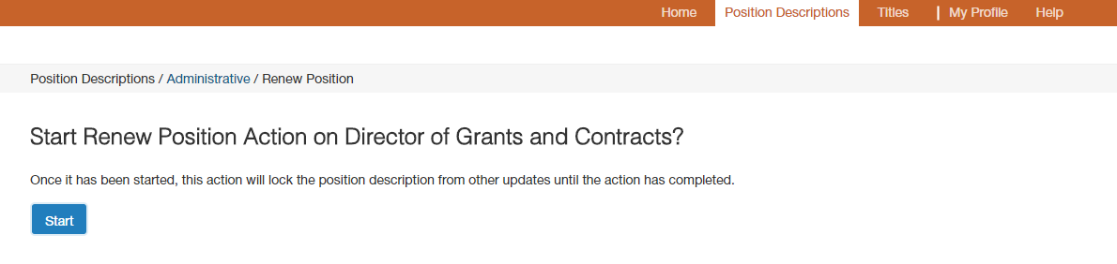

Step 8- You will be able to change the employee’s start and end date. Do not make changes to the employee’s salary unless you have spoken to HR first. (Typically, Administrative appointments run through the fiscal year which is from 7/1- 6/30 and Faculty appointments run through the academic year which is from 9/16- 6/15)

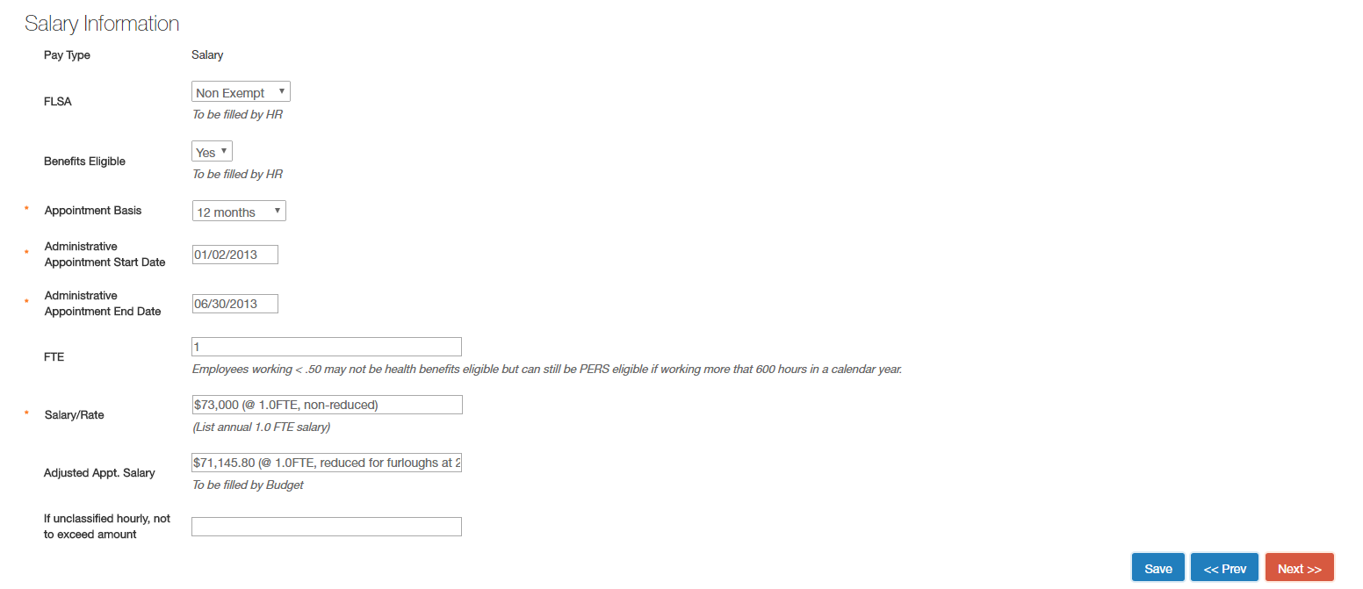
Step 9- Change the employee’s start and end date then click next to save the changes. (If you are making more significant changes, contact HR)

Step 10- Now you are in the summary, click on the Take Action on Action drop down menu and select Department/Division Authority (move to Department/Division Authority)


