How to submit a NEW position for search

Step 1 - Login to PeopleAdmin
There are two ways to log in:
- Login to InsideSOU
- Click on one of the PeopleAdmin links
Or

- Go to the URL jobs.sou.edu/hr
- Click on the Click HERE to log in with SOU Credentials ( DO not try to login on this page)
- Click on the SSO Authentication Link

Step 2- When you log in you will see the home screen. You will need to be in the Position Management Screen which will have orange header. If you are not in the position management, hover over the drop down menu to the right of the Watch List tab. And select POSITION MANAGEMENT.

Step 3- Make sure that you are logged in as Initiator. Select Initiator from the drop down menu, and then click the button to the right of the drop down menu.

Step 4- To submit a NEW position for search we must first create the Position Description. Go to Position Descriptions and select the type of position (Classified, Administrative, or Faculty) you want to create.
Step 5 – Once you have selected the type of position description you want to create, click on create New Position Description. Then click on New Position.
Step 6- You now have two choices, Clone an existing position description, or create a brand new one. Either way you will have the ability to edit. In this case we are going to create a brand new one.
Enter the Job Title, Division, Department/College/School, and Home Department and then click on Start Action.
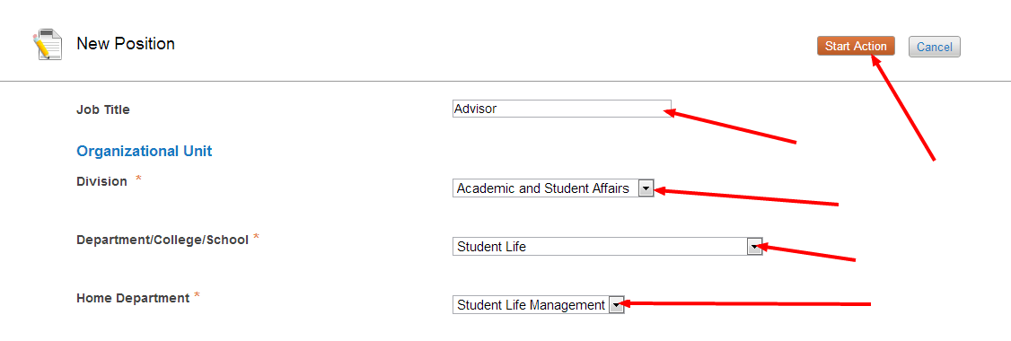

Step 7- Select a job title. You can click on Filter these Results, and search for a job title. Once you have found the correct job title, select it and then click on next. If the Job title that you want to use cannot be found, click next and at the end supply the job title you would like to use in the comments section. HR will then add this on your behalf.
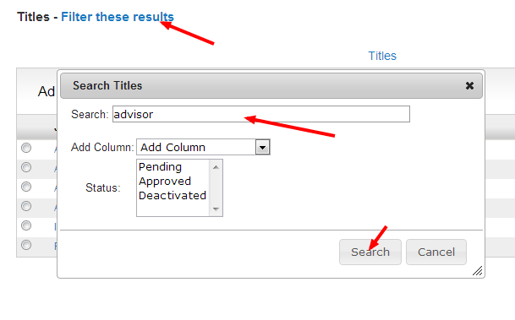
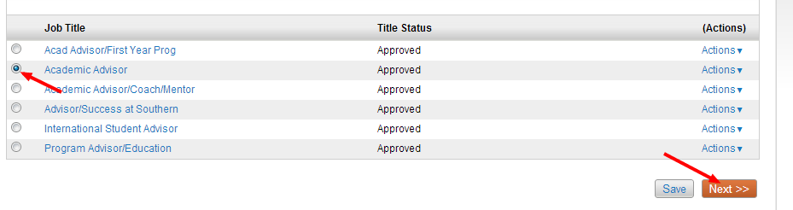
Step 8- Fill in the Position Details, and then click next
Step 9- Click on add Job Duties Entry, add duties and the percent of total time spent on each duty. To add more duties click on Add Job Duties Entry again, and repeat until all job duties have been added, then click next.
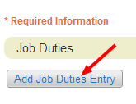
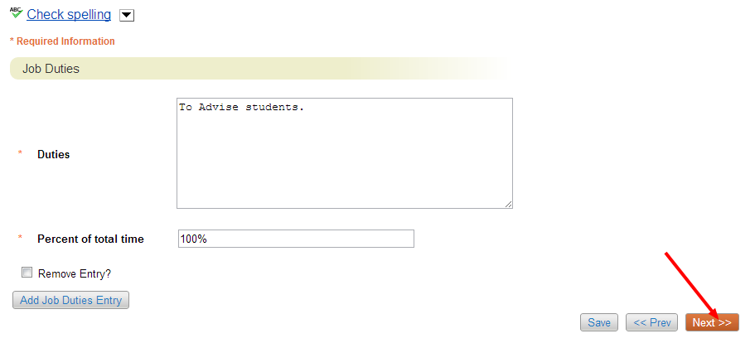
Step 10- add pay index code entry and fill in information and click on next
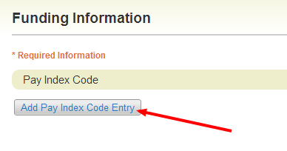
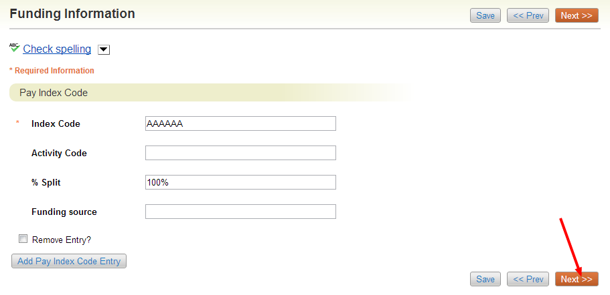
Step 11- The Requisition Form is where you will supply all of the information required to submit the position for search. Keep in mind that before the position is actually posted it will have to go through the approval process which can take a couple days. Once all the information has been filled in Click next.
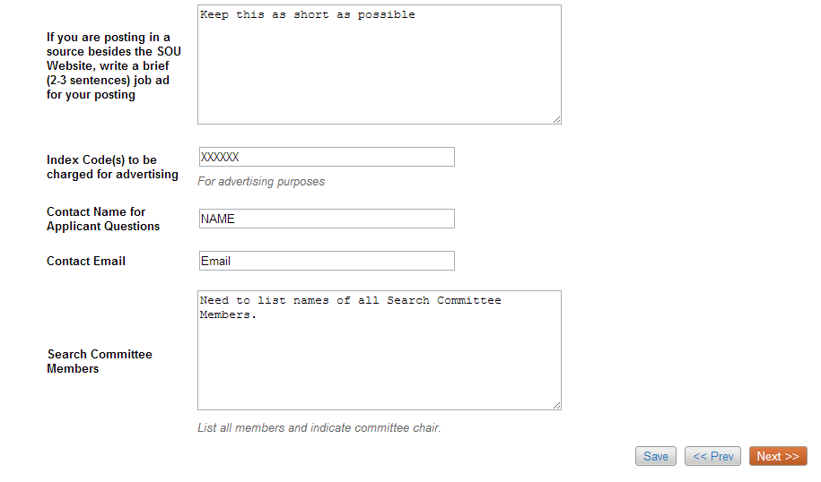
Step 12- Select a supervisor. Click on Filter these results to search for a supervisor, and select the supervisor and click next.
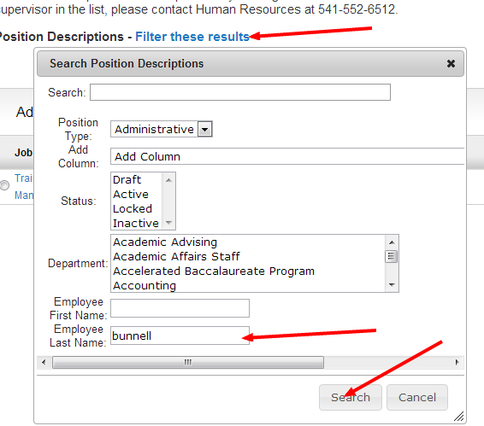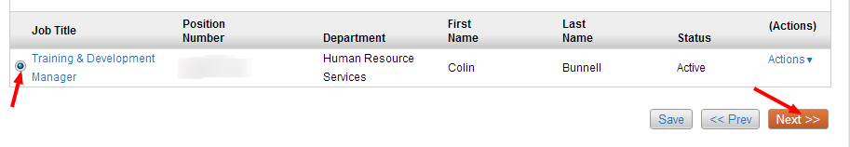
Step 13- If you would like to add Supplemental Questions to the application that candidates will apply to, click on add a question and select the questions you would like to add. This step can also be done by the search committee chair later in the process.
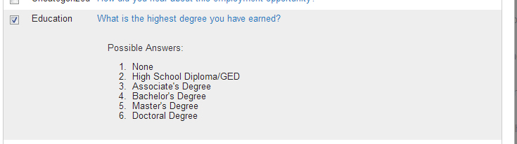
Once you have added the questions you want, or decided to wait and have the search committee chair complete this part, click next.
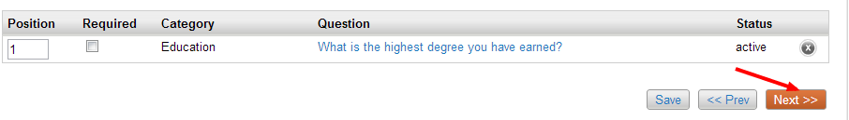
Step 14 – Applicant Documents is where you will select the documents that you either want to be required or optional. This is also something that can be completed later on by the search committee. When you have completed this page or decided to allow the search committee to complete this part, click next and you will be taken to the action summary. In the action summary you will have the opportunity to review the position description before moving forward.
Step 15- Send to department authority review. The action will then be taken through the approval process and go from department authority to division authority and then to budget and then to Human Resources. When the action reaches Human Resources and is approved, it will then be posted.
