How to submit an Existing Position for Search

Step 1 - Login to PeopleAdmin
There are two ways to log in:
- Login to InsideSOU
- Click on one of the PeopleAdmin Links

Or

- Go to the URL jobs.sou.edu/hr
- Click on the Click HERE to log in with SOU Credentials (Do not try to log in on this page)
- Click on the SSO Authentication Link

Step 2- When you log in you will see the home screen. You will need to be in the Position Management Screen which will have orange header. If you are not in the position management, hover over the drop down menu to the right of the Watch List tab. And select POSITION MANAGEMENT.

Step 3- Make sure that you are logged in as Initiator. Select Initiator from the drop down menu, and then click the button to the right of the drop down menu.

Step 4- To submit an existing position for search we must first select the Position Description. Go to Position Descriptions and select the type of position (Classified, Administrative, or Faculty) you want to create.

Step 5- Select the existing Position description that you want to submit for search. Click on the Blue position title.

Step 6- click on Major Position Update for Search
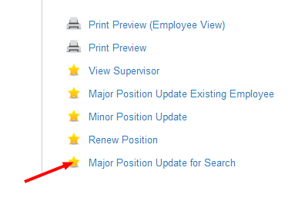
Then click on Start
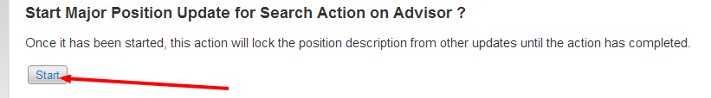
Step 7 – click on the Edit button next to position details and fill in/make necessary changes to the information. Then click Next.

Step 8-In the employee tab the past employee will show up, do not worry about this, the employee name will be updated as soon as a new person is hired into the position. Click next
Step 9– Funding information will also likely stay the same. Change if necessary and click next.

Step 10 – Update duties if necessary and then click next
To add more duties click on Add Job Duties Entry again, and repeat until all job duties have been added, then click next.
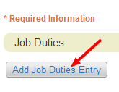
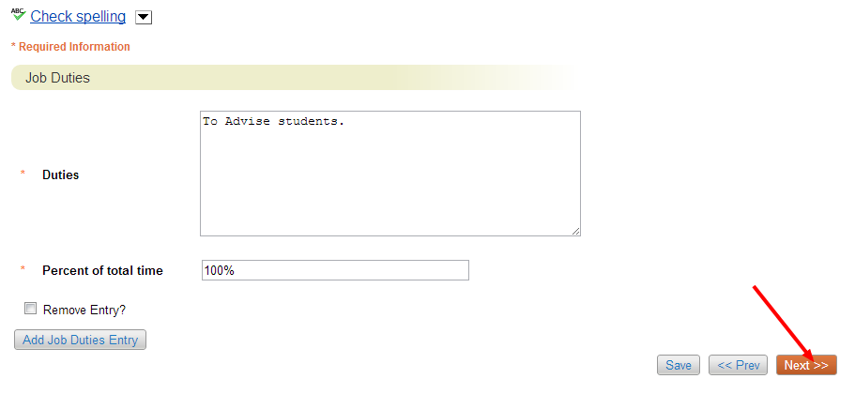
Step 11- The Requisition Form is where you will supply all of the information required to submit the position for search. Keep in mind that before the position is actually posted it will have to go through the approval process which can take a couple days. Once all the information has been filled in Click next.
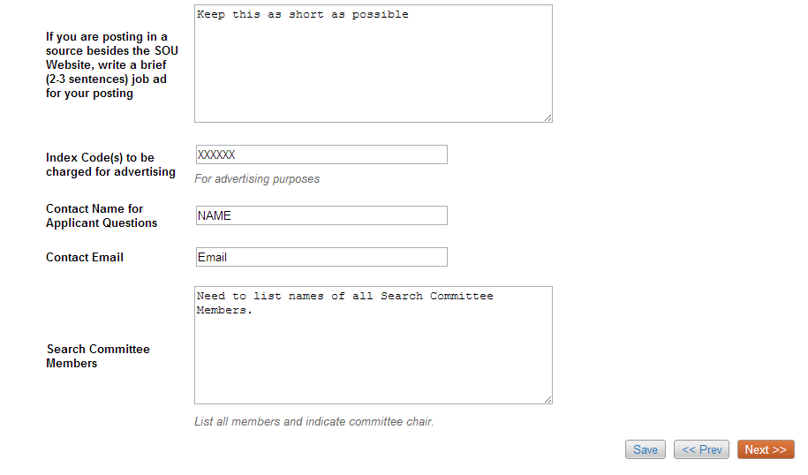
Step 12- Select a supervisor. Click on Filter these results to search for a supervisor, and select the supervisor and click next.
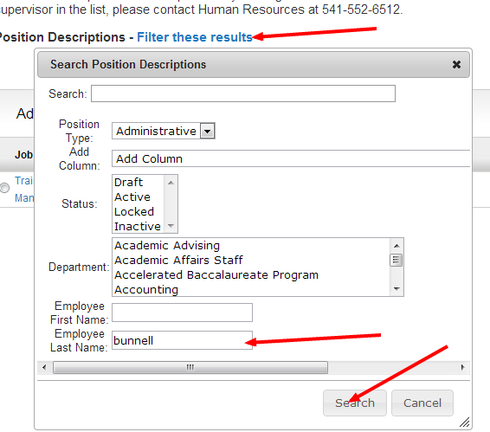
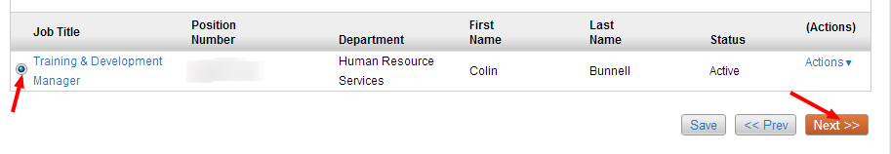
Step 13- If you would like to add Supplemental Questions to the application that candidates will apply to, click on add a question and select the questions you would like to add. This step can also be done by the search committee chair later in the process.
Once you have added the questions you want, or decided to wait and have the search committee chair complete this part, click next.
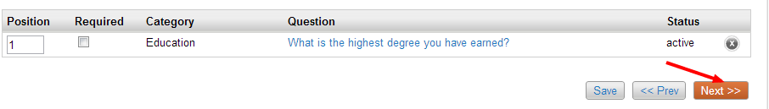
Step 14 – Applicant Documents is where you will select the documents that you either want to be required or optional. This is also something that can be completed later on by the search committee. When you have completed this page or decided to allow the search committee to complete this part, click next and you will be taken to the action summary. In the action summary you will have the opportunity to review the position description before moving forward.
Step 15- Send to department authority review. The action will then be taken through the approval process and go from department authority to division authority and then to budget and then to Human Resources. When the action reaches Human Resources and is approved, it will then be posted.
