How To Start a Hiring Proposal

Logging In
Step 1 - Login to jobs.sou.edu/hr and click on the “Click HERE to log in with SOU Credentials” (Do not try to login on this page). If you are already logged into my SOU and click on the link it will take you directly into the site and you can skip Steps 1 and 2)
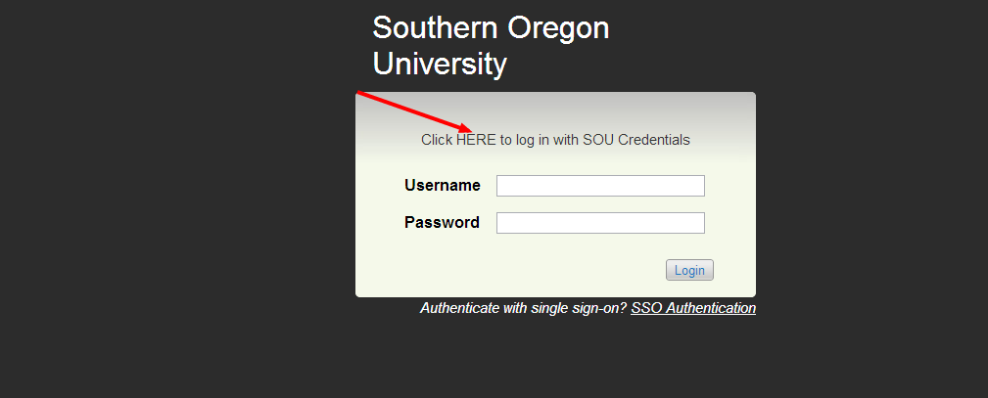
Step 2- Login using your network user name and password
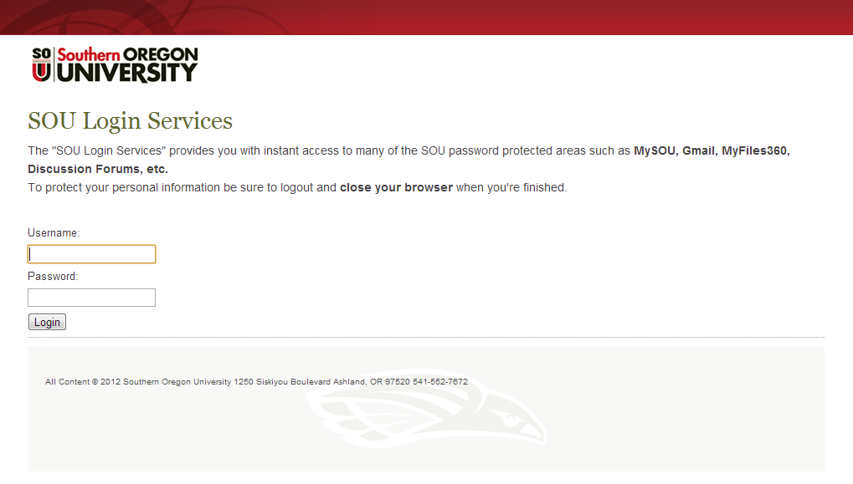
OR
Step 1 - Login to MYSOU
Step 2 - Click on the Faculty and Staff tab
Step 3 - Click on Recruiting
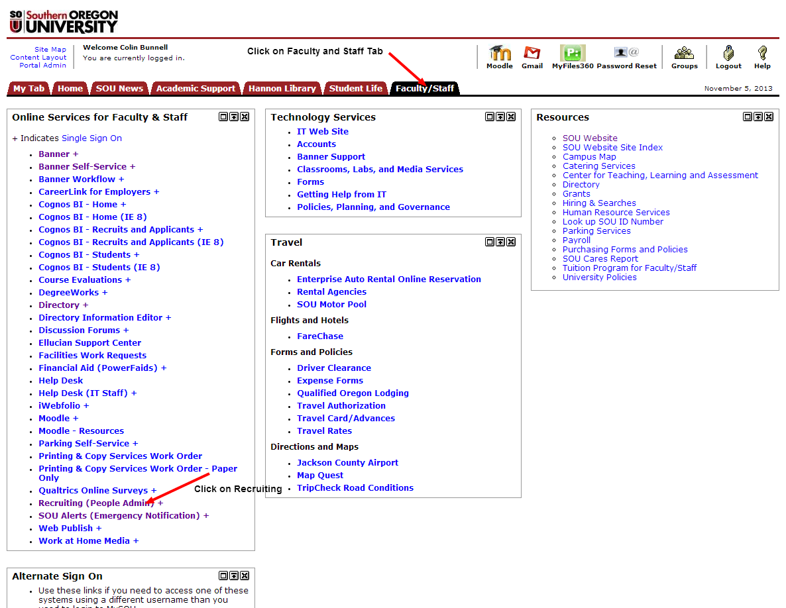
Once you have logged in Follow the Steps Below
Step 1:
Once you are logged into your account on PeopleAdmin you need to log in as Initiator. In order to do this you need to click on the drop down menu and select “Initiator” then click the refresh button.
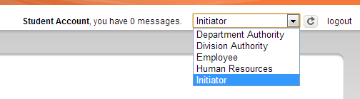
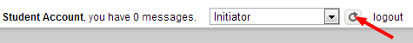

Step 2 - Once you have logged in as Initiator you can now go to the posting that you want to start a hiring proposal on. Hover over Postings and then click on Classified, Administrative, Faculty, or temporary depending on the type of posting you are starting a hiring proposal on.
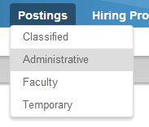
Step 3 - Your next step is to select the posting. Click on the blue lettered working title of the posting you want to start a hiring proposal on. 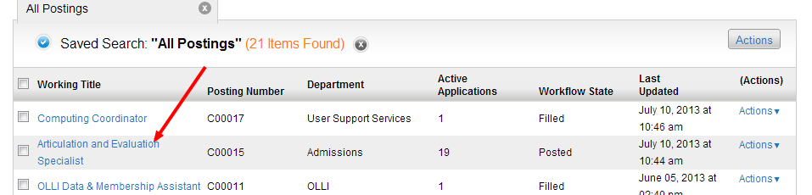

Step 4 – Select the Applicants tab.

Step 5 – In order to start a hiring proposal on an applicant, the applicant must have a workflow state of “On Campus Interview” To change the workflow state of an applicant you need to contact the search chair, and have them do this if “On Campus Interview” has not been selected yet.
If you are hiring more than one applicant from the same posting, contact Human Resources for assistance.
If there are other applicants listed, other than the one selected for hire, you will need to change their workflow status state. Prior to changing the status of an applicant, check with the search chair to determine if the applicants have been contacted and select the appropriate work flow state. You can do this by clicking on name of the applicant in the Legal Last Name column.
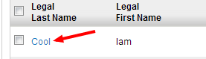
Step 6 – Click on “Take Action On Job Application”, then click on the appropriate state under either “Work Flow Actions” if you want to move them without notification (see example below) or “Move Directly To” if you want an email sent or the applicant was a late apply.

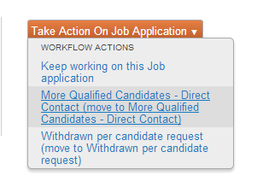
Step 7 – If the applicant you want to start the hiring proposal on has a status of “On Campus Interview”click on the name of the applicant in the Legal Last Name column, and the option to Start Hiring Proposal will appear. Click on Start Hiring Proposal.
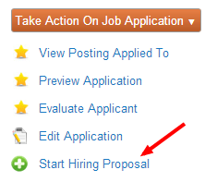

Step 8 –At the top of the screen you will see that the Position Description associated with the posting is already selected. As long as this is the correct position description, scroll to the bottom of the screen and click on Select Position Description.
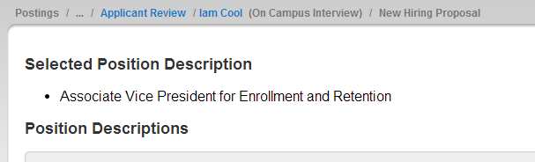
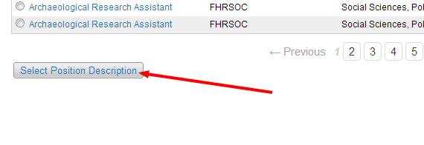
Step 9 – You will then need to fill in the Hiring Proposal Information. Including Pay Type, Salary, Dates and any other necessary information. Once you have completed filling in this information, click next.
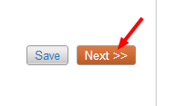
Step 10 – You are now viewing the Hiring Proposal summary. If everything looks good click on “Take Action On Hiring Proposal” and then click on “Send to Department Authority Review” (move to Department Authority Review)
