How to Bulk Move Applicants

Click on the Posting you are the Chair for and Select the ‘Applicants’ Tab. This allows you to see all the applicants, and their status in the interview process.
The Bulk “Move in Workflow” action is helpful to adjust the status of applications before campus interviews.

- Click on the box next to the names of the all the applicants you want to move into the same workflow state. (For example all applicants you are selecting for More Qualified applicants-Direct Contact)
- From the Actions pull down menu select Move in Workflow
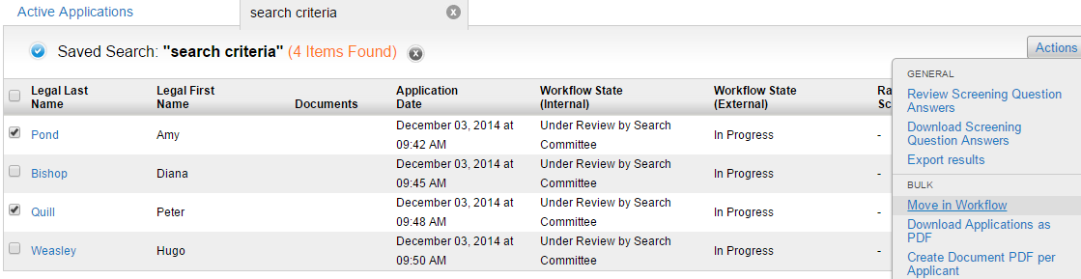

1

2

When the next page appears select the work flow state you want to move the applicants to. Then click on the orange Save Changes tab.
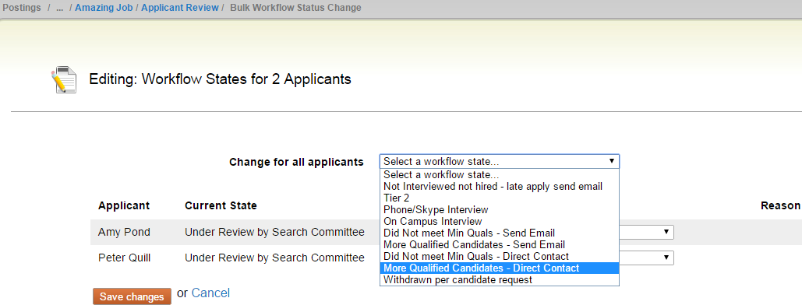

Save your changes, and return to the applicant screen. It may take a few minutes for your updates to show. You can also re-fresh your screen and the changes will show. Next select another group of applicants to move in workflow. For example all applicants you want to move to Skype/Phone Interview

Remember, once one applicant state has been changed to “On Campus Interview,” this option disappears for all applicants. To make things easier for yourself, move all applicants who won’t be campus interviewed first.

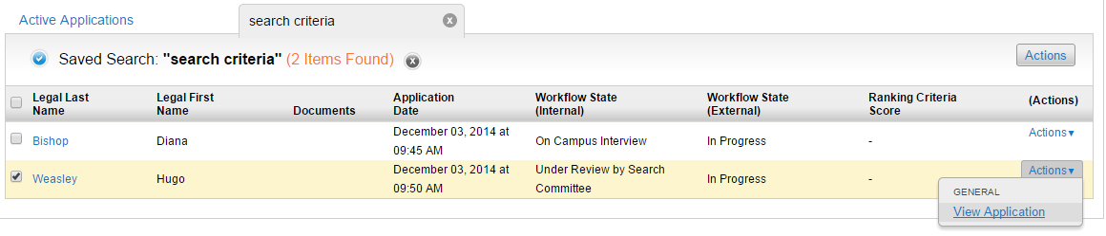
If you have moved applicants to a status of On Campus Interview and still need to change the status of other applicants you can do so by click on the application of the applicant you want to change. See example below:

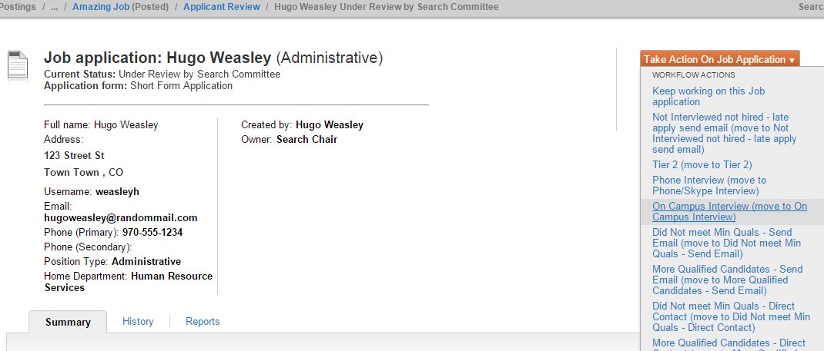
Go into his application, and Click “Take Action on Job Application,” then choose the appropriate option.

Once you have move an applicant to a status of On Campus Interview you will not be able to change that applicant’s workflow status again. Once a final decision has been made by the hiring authority and the verbal offer has been accepted, Human Resources will change the status on the remaining applicants that are at a status of On Campus Interview. Prior to changing their status, Human Resources will confirm with you that applicants not selected have been contacted.

