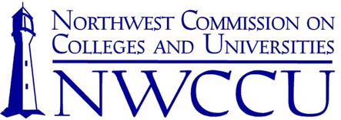

January 29, 2018

Dr. Linda Schott
President
Southern Oregon University
1250 Siskiyou Blvd.
Ashland, OR 97520

Dear President Schott:

This letter serves as formal notification and official record of action taken concerning the Fall 2017 Year One Evaluation and the Fall 2017 Ad Hoc Report of Southern Oregon University by the Northwest Commission on Colleges and Universities (NWCCU) at its meeting on January 10-12, 2018. This action was taken after consideration of the Institutional Report.

Based on these materials and deliberations, the Commissioners took the following actions.

Action
- Accept the Fall 2017 Year One Mission and Core Themes Report
- Accept the Fall 2017 Ad Hoc Report

Status of Previous Recommendations Addressed in These Evaluations
- Recommendations 1 and 2 of the Fall 2016 Year Seven Peer Evaluation Report are fulfilled

Future Evaluations
- Mid-Cycle Evaluation with an Addendum to address Recommendations 3, 4, and 5 of the Fall 2016 Year Seven Peer Evaluation Report in Fall 2019
- Year Seven Evaluation in Fall 2023

If you have any questions, please do not hesitate to contact NWCCU.

Sincerely,

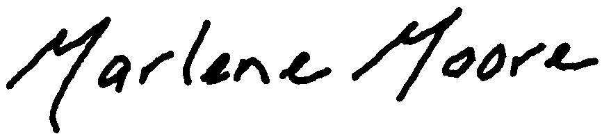
Marlene Moore
President

MM:rb

cc: Dr. Jody Waters, Associate Provost and Director of Graduate Studies

