Cognos Upgrade Information

Version 11.1.7 to 11.2.3

SOU is migrating from Cognos 11.1.7 to 11.2.3 to stay current for ODS. This document is intended to provide you with the information you need as SOU upgrades.
The two versions work very much the same but the presentation and organization of some functionality has changed. The impact of the changes varies depending on your Cognos access and changes you may have previously made to your personal settings such as starting page, number of rows displayed, and portal page display.
For all:
- The login to Cognos has not changed. Within InsideSOU, click the link and enter your SOU credentials when prompted.

- After logging in, depending on your configuration, you may be presented with the option to view the new features for 11.2.3. If you are, it will look like this. You can view the features if you wish, then dismiss the dialog by clicking The Dismiss button as indicated by the arrows:

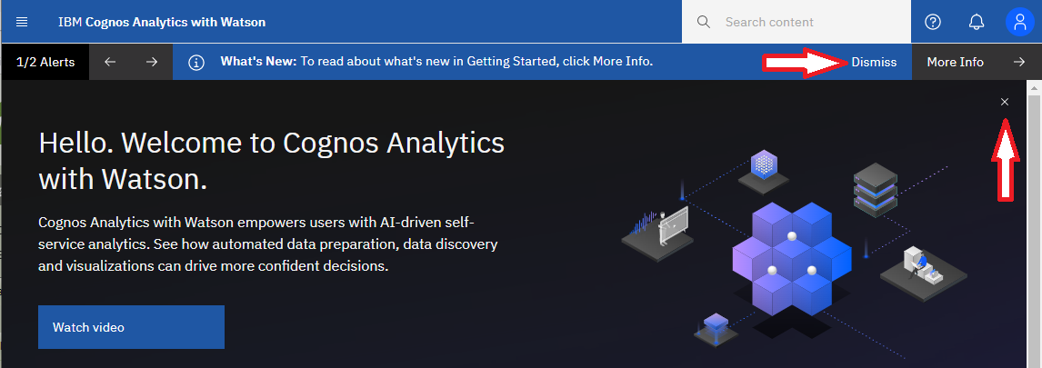
For simplicity of presentation of screen shots, comparisons, etc., the rest of this document will assume you have closed and dismissed.
- There are no changes when running reports, except for the following:

  - If your report produces PDF output, the format will change to a two column presentation with vertical list of page thumbnails on the left and the current full page on the right

  - If your report produces XML output, that output will be directed to a download page instead of being presented in the browser
There are 3 links on InsideSOU for logging into Cognos (production):
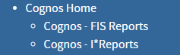
If you always log in via the Cognos – FIS or Cognos I*Reports links and do not navigate to the file/folder structure, there are no further changes affecting you.
If you access content via the file/folder structure, you will encounter additional changes. Examples:
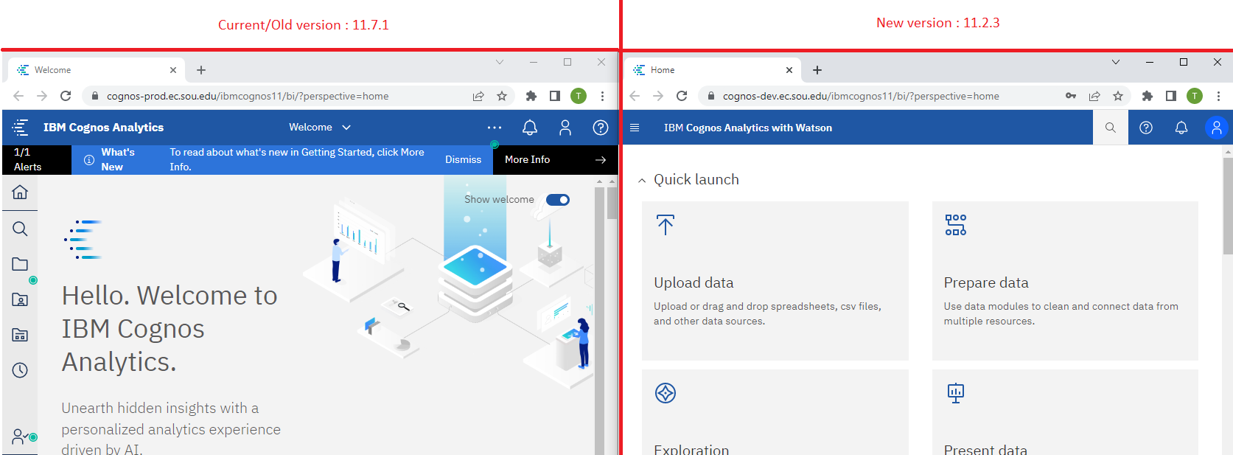
- The left icons are now hidden by default. Click on the menu icon in the top left corner of the screen to display the items.

11.1.7 – wide browser | 11.1.7 – narrow browser | 11.2.3
(note: icons with labels) | (note: icons only, no labels) | Icons are hidden by default.  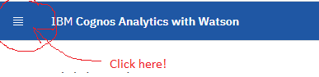
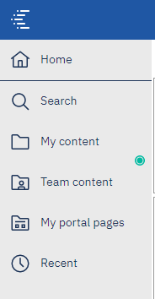 | 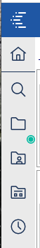 | 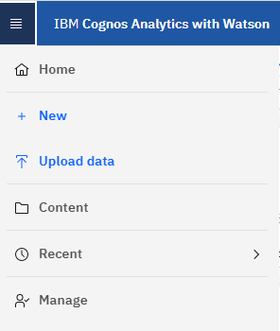

- The content accessed by the icons is rearranged. Comparing 11.1.7 (left) to 11.2.3 (right), some of the icons are relocated and/or merged in the new version. Below is a mapping from the old locations to the new locations.

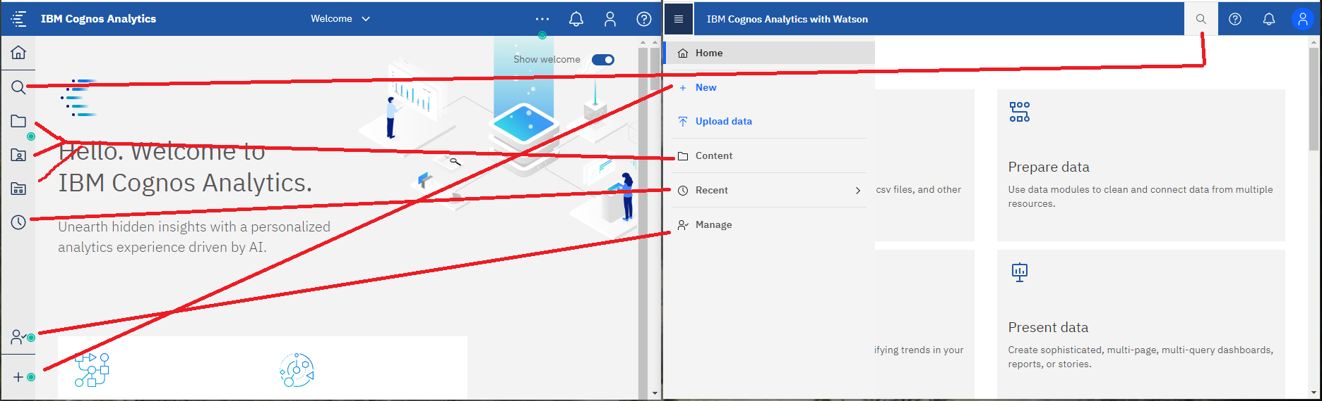

Search has moved from the left icon list to the top toolbar.
The 3 separate icons for My Content, Team Content, and My Portal Pages in 11.1.7 are represented by a single icon Content in 11.2.3. If you click the Content icon it opens the Content folder where My Content, Team Content, and My Portal Pages appear as tabs. Click on the tab to access content under it.
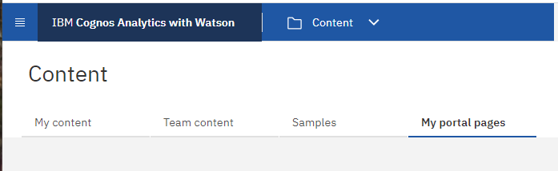

Instead of a folder/list structure like 11.1.7, folders and folder content are shown in a grid format in 11.2.3, however, clicking on the grid item acts the same as clicking on a folder/list item. The action menu which appears as a horizontal ellipsis (…) in 11.1.7 appears as a vertical ellipsis (stack of 3 dots) in 11.2.3 when you move your cursor into the boxes that display below each content tab.

Developer Changes / Differences

The changes to the development environment are more extensive but it is still familiar. It is the same information presented / grouped slightly differently. Icons have changed, however, as before, hovering over any icon will cause its label / function to appear.
- To create a new report, instead of clicking New (+), then choosing report, you must click Home from the menu, then New, then Report.

In version 11.1.7 | 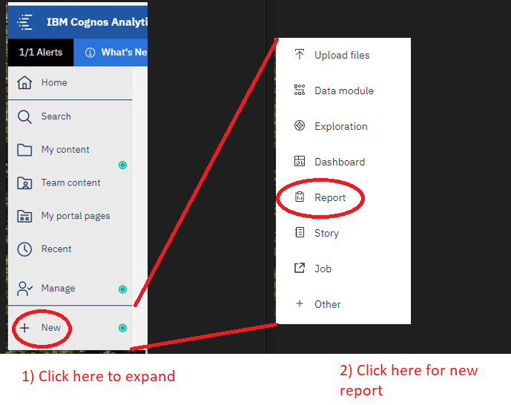
In version 11.2.3 | 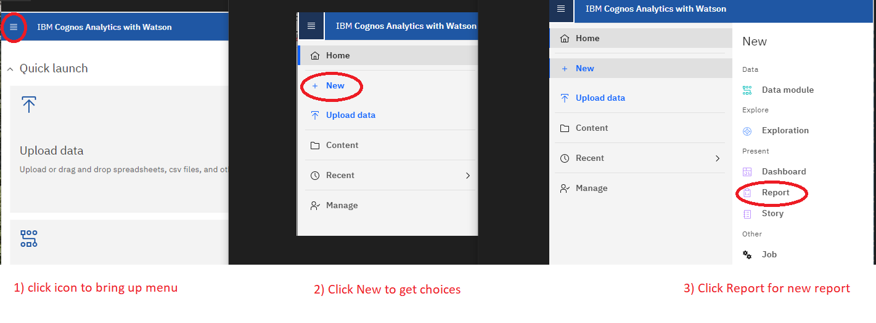

- The page heading is slightly different. The Ok / Cancel buttons at the bottom right are now Cancel / Create buttons in the top right.
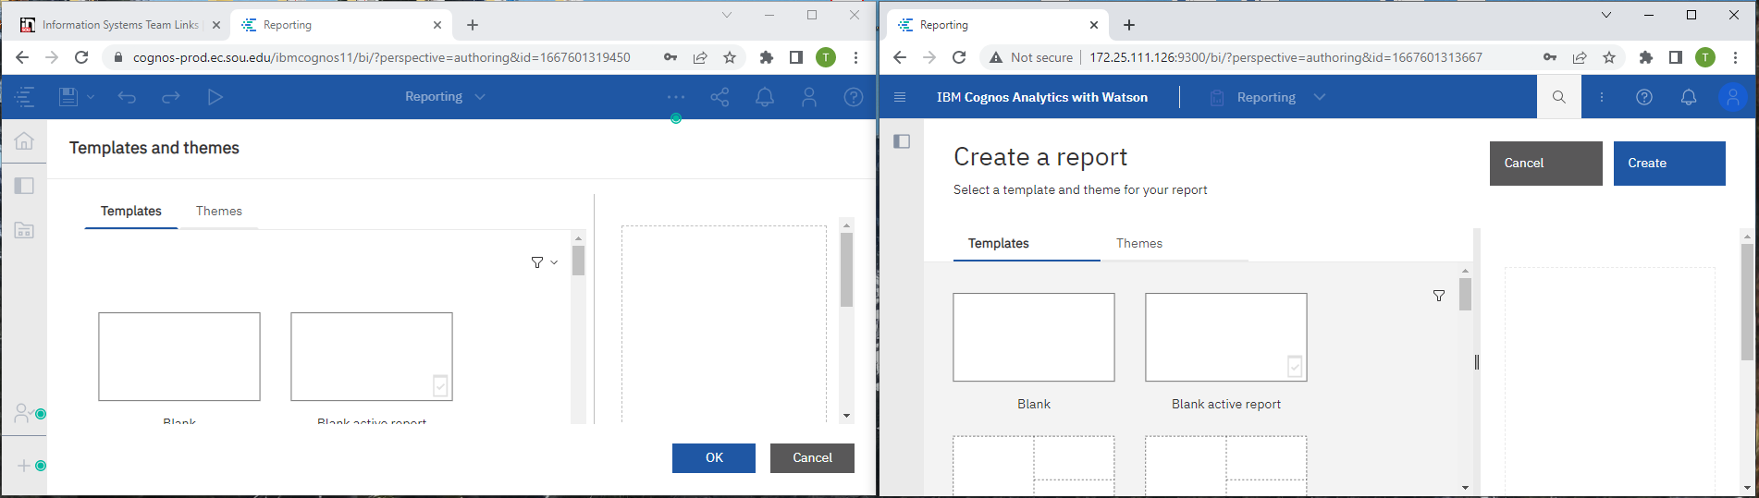
- When selecting a source, Team Content and My Content move from left vertical tabs to “overhead” tabs. The Open and Cancel buttons are now bigger and in a different order.

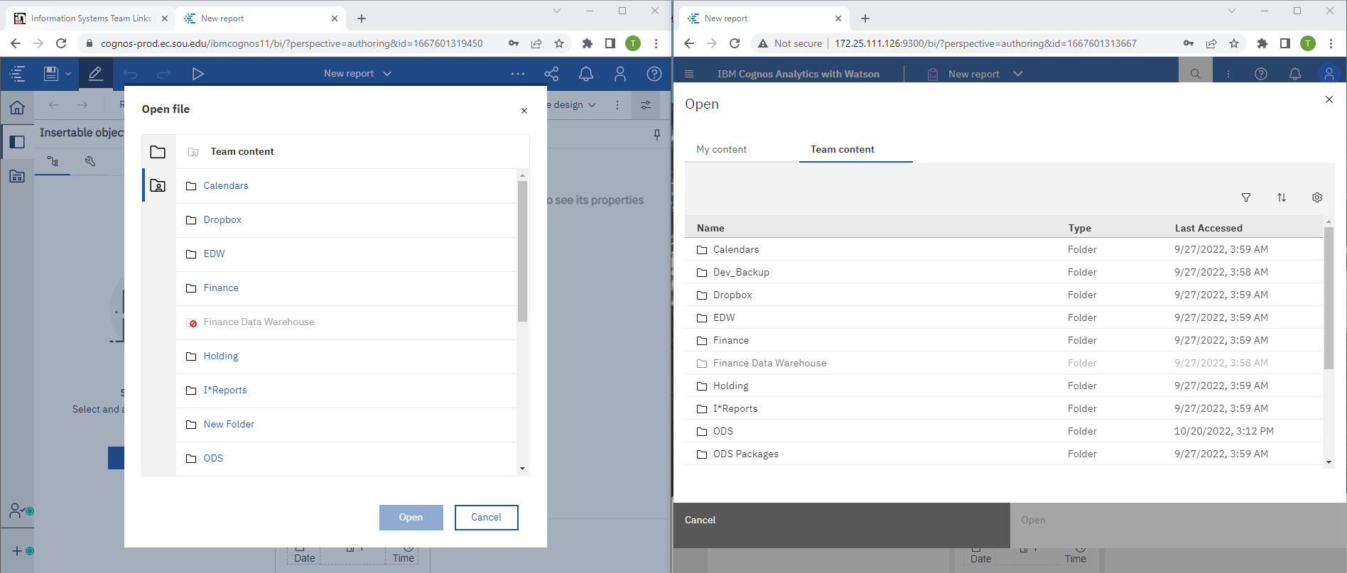

- The icons change slightly when adding things to a report page.

The same functions exist. The icons are recognizeable but some are relocated. For example, the filter and group/ungroup icons are in a different location. As always, you can hover over an icon to see what it does. One consistent change is that the three dots of an ellipsis go from being in a horizontal row to a vertical column representing “more”.

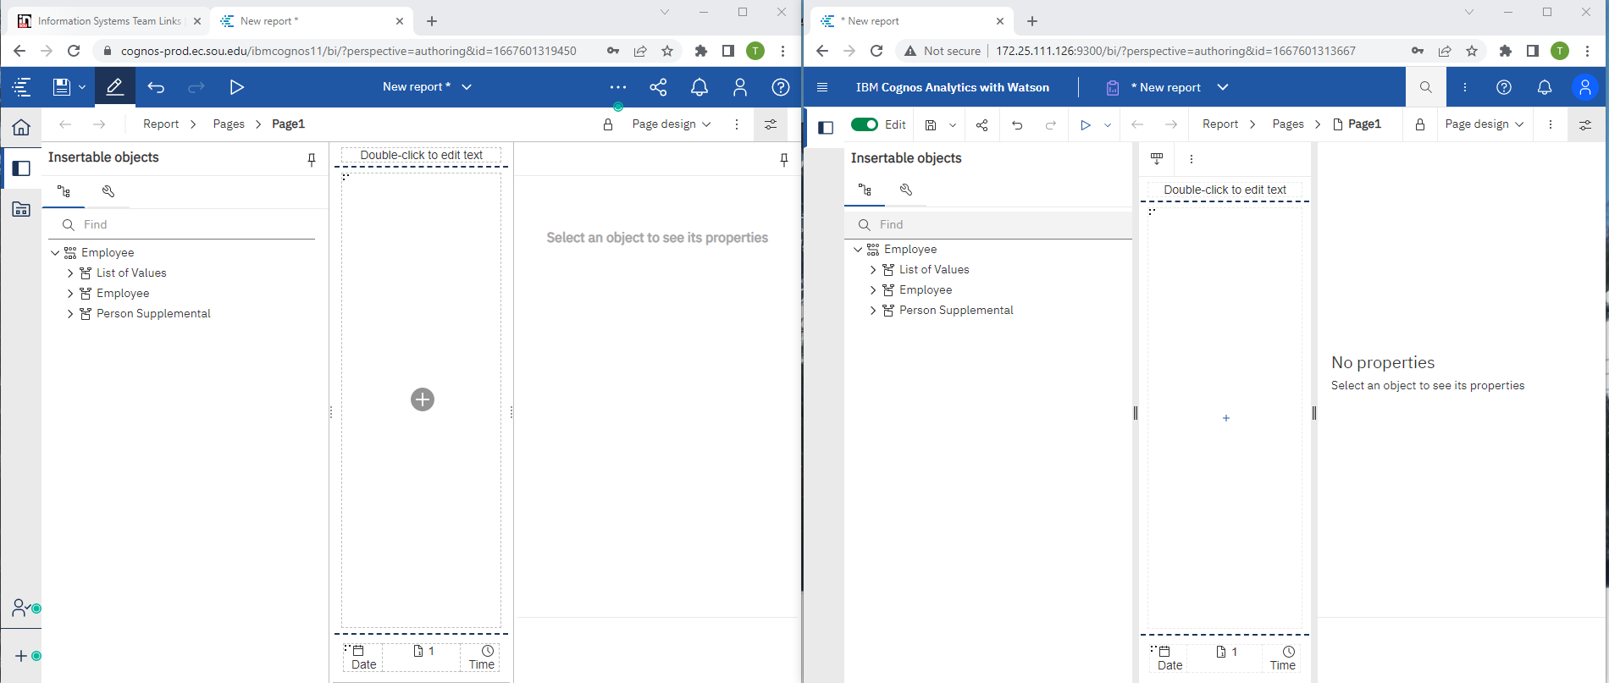

- The view of items under Sources is identical. Icons representing types of data, etc. do not change.

- The default view of insertable items (toolbox) changes from a list to icons: click the “4 box square” to get a list of selections in 11.2.3.

- When creating a report, in 11.2.3 you should click the “+” and choose the type of container for your report – list, chart, etc. 11.1.7 creates a list object for you by default. 11.2.3 often “generates a recommendation”, which amounts to guessing the sort of object you want which may be a visualization (example: pie chart) or crosstab instead of a list. If that happens, you can click Undo, then click the “+” and choose the report type before adding data fields to it.

- We recommend maximizing the width of the report on your screen. In 11.2.3, the “more” button where the selections like “Build Prompt Page” can be difficult to find if the window is narrow. You can also click on the Show Properties button to minimize the Properties section on the right to find the “more” button.

