Faculty Senate Minutes
Monday, March 7, 2022
4:30-5:30 pm
Senators Present: Melissa Anderson, Jackie Apodaca, Edwin Battistella, Amy Belcastro, Jeremy Carlton, Anne Connor, Brian Fedorek, Andrew Gay, Kristin Hocevar, Rachel Jochem, Jesse Longhurst, Christopher Lucas, Merrilyne Lundahl, Matthew Moreali, Anna Oliveri, Jessica Piekielek, Mark Siders, Ellen Siem, Michael Stanfill, Chad Thatcher, Lisa Wileman, Kemble Yates
Senators Absent: Michael Parker (OCA) and Michael Parker (STEM)
Guests: Lee Ayers, Rick Bailey, Sherry Ettlich, Dustin Walcher, Susan Walsh, Ashley King, Mark Axel Tveskov, SOU ROTC, Donna Lane, Holly Gabriel, Nigel Waterton, Daniel DeNeui, Keeley Reiners, John Kinard

Meeting called to order at 4:02 pm

- 4:00 pm Approval of minutes from 2/21/2022
[00:01:28 of recording]

- Motion to Approve Minutes (Mark Siders) → Seconded (Brian Fedorek): Approved
- 14 yes: Edwin Battistella, Amy Belcastro, Anne Connor, Brian Fedorek, Andrew Gay, Christopher Lucas, Merrilyne Lundahl, Matthew Moreali, Anna Oliveri, Jesse Longhurst, Mark Siders, Ellen Siem, Chad Thatcher, Lisa Wileman
- 3 abstain: Kristin Hocevar, Jessica Piekielek, Michael Stanfill
- 4 Arrived after the vote: Jackie Apodaca, Jeremy Carlton, Rachel Jochem, Kemble Yates

- 4:05 pm President’s Report – President Bailey
[00:02:54 of recording]

- COVID Recommendation Committee and Cabinet have decided that the mask mandate ends March 19th. Masks are still welcome after March 19th, but not required. Science into it; science out of it.
- This transition will include removing the mask mandate, no longer requiring proof of vaccinations for interactions with the public, shortening the isolation period from 10 to 5 days.
- He wants the language to say masks are welcome instead of masks are no longer required. In his March video he wants to address the policy of having a mask handy for people that might be uncomfortable.
- Mark Siders Question: Did we survey the students? No, we didn't, but ASSOU did one. Brian and Mellissa were on the committee and do not remember anything presented about the students perspective. It all got rushed and meetings got condolences because the governor moved up the State deadline date.
- Ellen Siem Comment: It's nice to mention that some people might want a mask in a small space like an office.
- Ed Battistella Comment: Some students are uncomfortable about sitting in a room with unmasked students, maybe dropping out for a few terms because of this….
- Anne Connor Question: What if a faculty member has underlying health issues? Work with chairs and directors to get an accommodation through HR.
- Melissa Anderson: Why aren’t we requiring the public to show proof of vaccines anymore but still keeping such a high standard on ourselves and students? Outward facing vs inward facing parts of campus are affected by slightly different policies, we have more control over the inward facing and the state has more control over the outward facing. There will be one policy for all public facing SOU parts of campus and there will need to be scientific evidence to have variable policies. The one place that the state policy does have an exception is the student health and wellness center. Otherwise for consistency the public buildings are all being treated the same.
- Jesse Longhurst Question: What is the trigger to activate campus restrictions? That would be the State and Jackson County Health reactivating requirements (They have orange yellow and green levels) due to case numbers.

- 4:10 pm Provost’s Report – Provost Walsh
[00:22:05 of recording]

- There are two conversations occurring and an email with more details about the plans will be coming out shortly.
- Revising our current academic structure
- The Central Hall remodel

- 4:15 pm Advisory Council Report – Chair-elect Brian Fedorek
[00:24:52 of recording]

- General Education (talked about it for ¾ of the AC meeting): See #8 Below
- The constitution committee is still considering the feedback from the senate about changing the guidelines around colleague evaluations and program personal committees.
- Academic structure changes that were mentioned in the Provost’s report. Humanities and Culture is dissolving and this affects seats on the faculty senate. See #9 Below

- 4:20 pm ASSOU report – Keeley Reiners
[00:26:37 of recording]
[00:33:55 of recording]

- Melissa first presented an overview and then Keeley arrived late and we revisited
- Working on SMART goals to hold each other accountable and make progress in ASSOU.
- They have a walk around campus with CPS at night scheduled during the first week of next term to identify dark areas and improve the lighting. Students are uncomfortable with the dark parts of campus at night. The only reason they are waiting until next term to do this is that SOU is going to replace all of the burnt out lights before the walk so they can focus on where to add more lights. This will make the walk most effective.
  - Students have also commented on the higher ED campus in medford, so maybe this conversations can be about both locations.
  - Dr. Bailey is planning to meet with the Ashland city councilor about this as well to address city lighting around campus.
  - Behind the science building has had cars broken into so that could be an area of focus as well.
- Working on elections for next year.

- 4:25 pm IFS Update – Jesse Longhurst
[00:28:12 of recording]

- ISS met on the 25th via Zoom, continuing with Zoom for this academic year. Their plan is to return to F2F meetings next year.
- Recommendation reports indicate that there is very little agreement among the appointment process of board members at different institutions. This should be clear and uniform. Should there be more faculty members on university boards, instead of just one from each institution.
- Recommendation reports want more communication between Boards and HECC. They believe the boards need training on what work they are doing.
- Oregon has a shockingly high percentage of the costs of college education borne by the students, compared to state funding. This is in comparison to other states like California and Washington. Our State needs to do a better job of supporting Higher Ed students.
- Pell grants will be available to prisoners again. Internet Access is being improved at some of our state prisons, hopefully universities will get back into working to educate the incarcerated.
- Faculty health care, bill that requires access to healthcare for part time faculty.
- About 90 courses are being used to start the common numbering plan.

- 4:30 E/I Grades – Dan DeNeui
[00:38:05 of recording]

- Contact Kristin Duncan, Director of Financial Aid with questions.
- Change at the Federal Level in financial aid policy.
- If students reviece too many I or E grades in a semester they can lose financial aid, their academic audit will not be satisfactory
- Short Solution: don’t assign an I or an E if the student never has a chance of getting better than a D. If the grade is going to be an F no matter what, just assign an F.
- There is a contract that is being developed that you can use with students that are going to get and I or E. This makes sure the student knows what they are getting themselves into. Students are encouraged to contact the office of Financial Aid in the contract because they really need to reach out to them. This is not something faculty can help them with.
- Questions: Where is this information going to come from? How will the information be disseminated? Financial aid or student affairs could write something up to give to the faculty. They don’t want us to be the spokespeople of financial aid. They will also provide the information to the students. It would be nice to have a common syllabus statement.

- 4:35 pm Gen Ed Course Approval Process Update – Andrew Gay
[00:47:31 of recording]

- Final Core Capacity Model has been summarized in a new infographic:
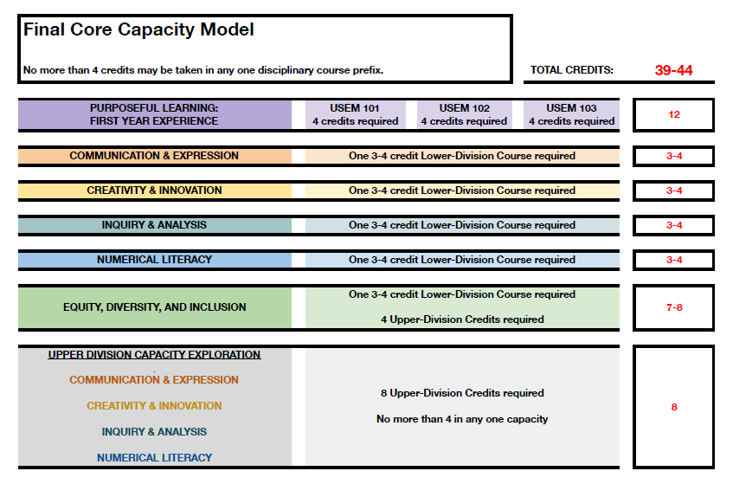

- The next step is to determine how do we transition from reviewing ~100 courses at once, to a standard process of approval through a “University Studies” like entity.
- Mentors will approve courses for 2 or 3 years based on the evaluative gen. ed. score sheet. If you get enough “exemplaries” when evaluated then you get the 3 year over the 2 year. If you meet the criteria but just get “clear” then you will get the 2 year approval.
- Deadline for material is April 1 (this has since changed to April 4)

- 4:45 pm Senate Makeup for AY 2022-2023 – Melissa Anderson
[00:55:42 of recording]

- We cannot resolve this issue today, but we need to start discussing it and getting it on people's radar.
- Current Senate makeup is dependent on divisions, 3 senators from each division, except library and UGS which gets 1 because they are small, then 4 at large senators.
- Does no humanities and culture division make those 3 seats go away? Do we reallocate the seats? Are we the house or the senate?
- We, the Senate, can change the bylaws to be whatever works for us, the faculty, best.

- 4:55 pm Elections Update
[01:04:47 of recording]

- Biology chair election occurring in Winter Term
- Most chair elections will be next term
- FPC election for DEHL
- Sabbatical replacement for STEM
- Holding off till next term on Senator elections until we finish the conversation from #9

- 5:00 Closed Session (Faculty Only)

