SOU Assessment Committee Report
The Quantitative Literacy Survey
2014-2015
Assessment Committee Members
2014-15: Jim Hatton, Kristin Nagy Catz, Craig Stillwell, Lee Ayers, Jamie Vener, Dorothy Ormes, Hart Wilson, Jody Waters, Vicki Suter, Dale Vidmar, Rene Ordonez, Erin Wilder, Peg Sjogren, Tiki Boudreau, John Taylor, Jeff Gayton
Summary
In winter term 2015 the SOU Faculty Senate Assessment Committee developed and disseminated a quantitative literacy survey which was sent out to all programs. By the date of this report, May 8, 2015, sixteen programs had responded. There was major consensus that all SOU graduates should be able to use decimals, percentages and proportions, demonstrate facility with a calculator, create a graph, use a data table, read, use, and critique a graph, apply basic logic concepts, and estimate and round off numbers. Over eighty percent said that graduates should be able to use a spreadsheet. For the most part programs thought that their majors had higher skills that what they wanted in a typical graduate. Over fifty percent of programs felt competent to teach all but formulas, geometry and nonlinear functions and over fifty percent do teach nearly all the quantitative literacy skills listed in the survey. Most of the programs require their majors to have taken Math 243 - Elementary Statistics. Some programs stated that their graduates would be more employable with better quantitative literacy skills. Programs had thoughtful comments about various aspects of quantitative literacy and the SOU curriculum.

Next Steps
- The Assessment Committee should investigate the extent of QL thinking that student already do when looking at the senior writing samples.
- The Assessment Committee should facilitate a session on good QL practice in creating graphs and doing calculations as part of one of its workshops.
- The Assessment Committee should facilitate a conversation about the place of QL in the curriculum.
- The Assessment Committee should develop a QL rubric.
Background

SOU has a college-wide QL learning outcome – Strand D. It states:

Strand D: Quantitative Reasoning

Effectively formulate and use mathematical models and procedures to address abstract and applied problems.

Recognize and express relationships using quantitative symbols.
Proficiencies: Students will be able to

Translate real world phenomena into algebraic expressions that correctly reflect quantitative relationships among variables.

Know the four forms of quantitative symbols

given numbers

unknown constants

parameters (unknown numbers fixed by an applied context)

variables (unknown numbers that vary within an applied context) and use them appropriately.

Apply fundamental mathematical models to a variety of academic contexts.

Interpret, evaluate, and manipulate quantitative representations appropriately.
Proficiencies: Students will be able to

Know the important features of various quantitative models (algebraic, graphical, numeric, tables, charts, verbal).

Use various quantitative models to analyze phenomena.

Choose critically among quantitative models to efficiently discover relevant conclusions.

Communicate quantitative concepts and relationships in plain language.
Proficiencies: Students will be able to

Reason inductively in a quantitative context by imagining, testing, and communicating general relationships from patterns.

Reason deductively in a quantitative context by identifying mathematical premises, inferred conclusions, and errors in reasoning.

Translate and communicate quantitative results into real world contexts.
The Assessment Committee has begun to assess the writing, critical thinking, and information literacy foundational learning outcomes for graduating seniors through its senior writing evaluation process and it reviews programs’ own assessments of their majors but has not to this point addressed the QL strand. The QL survey is a first step in this direction. The hope is that the survey will start a process of discussions about QL skills campus-wide.
Process
During the fall and early winter terms the committee developed a questionnaire and implemented it as a qualtrics survey. This survey form can be found at the end of this report. In the end sixteen programs responded. They were the Honors College,
School of Business, Communication, Mathematics, HPE, OAL, Chemistry, Philosophy, Music, Library and Information Science, Anthropology, Environmental Studies, Gender, Sexuality, and Women's Studies, Physics, English, and Sociology. The information was summarized and graphed and then reviewed by the committee.

Results
Programs think that SOU graduates should have many QL skills and expect that their majors will have more skills than the typical graduate. This can be seen generally in the following graphs which are purposely small to facilitate an overall comparison.
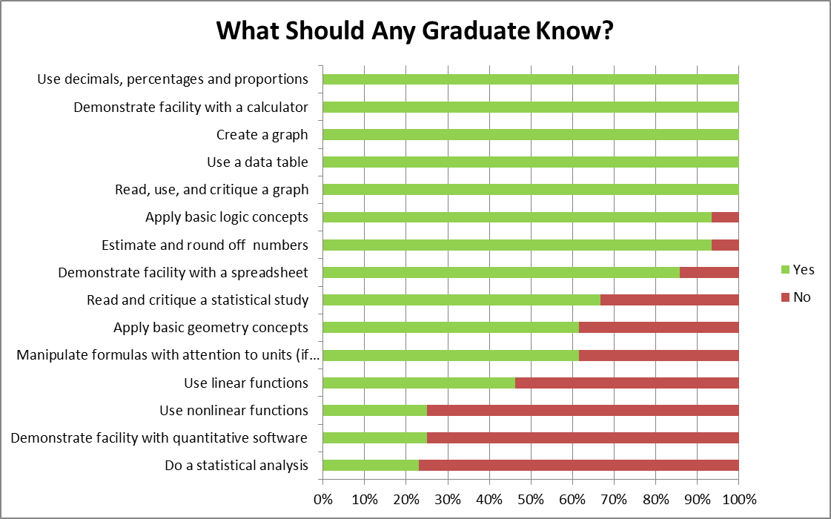 | 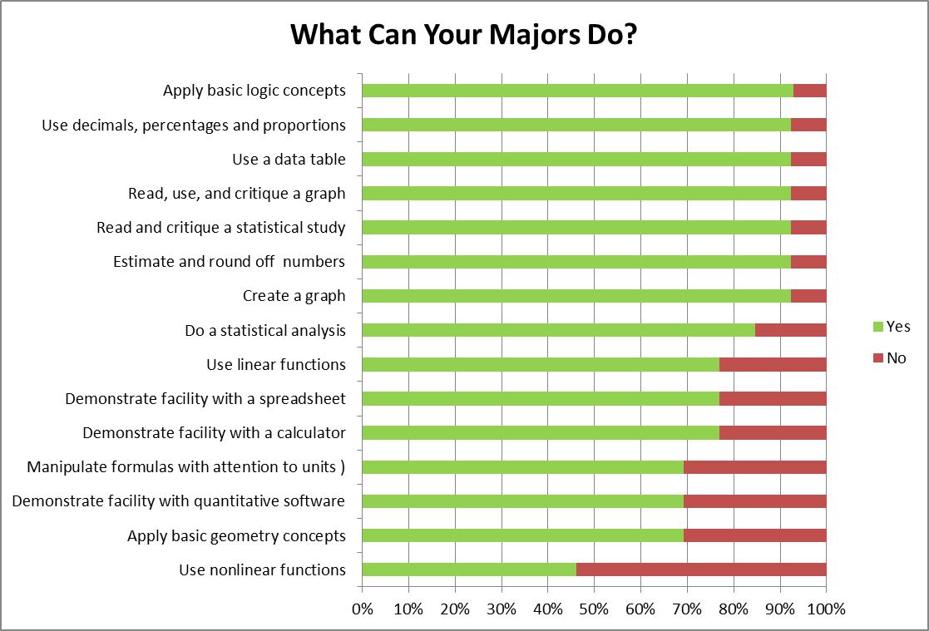

Programs think that they can teach many QL skills but not assess as many skills. This can be seen generally in the following graphs which are purposely small to facilitate an overall comparison. This illogical outcome may be because one or two programs interpreted the question differently from the other programs.
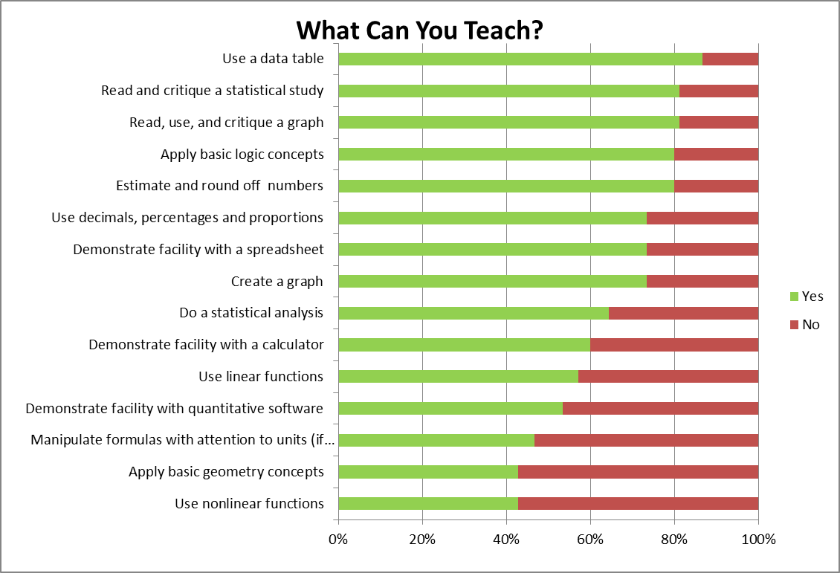 | 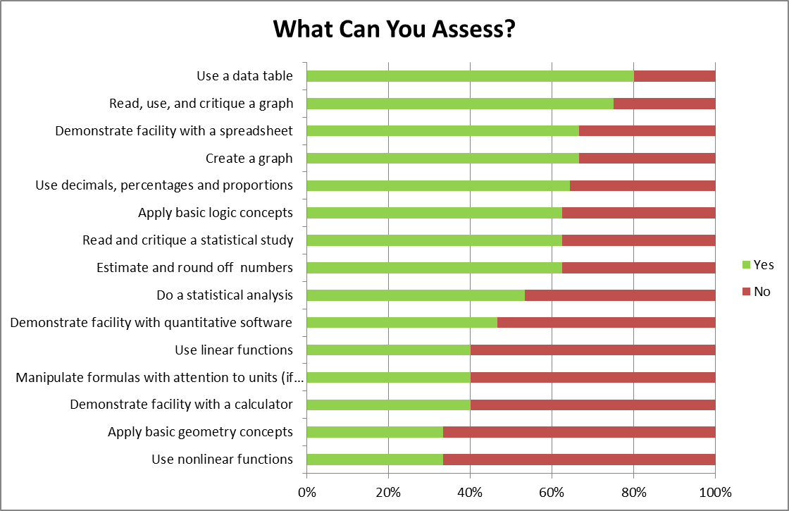

These graphs indicate QL skills that had nearly 100% support: Use Decimals, Percentages and Proportions, Use a Data Table, Read, Use and Critique a Graph, Use a Calculator, Create a Graph, Estimate and Round Off Numbers, and Apply Basic Logic Concepts.
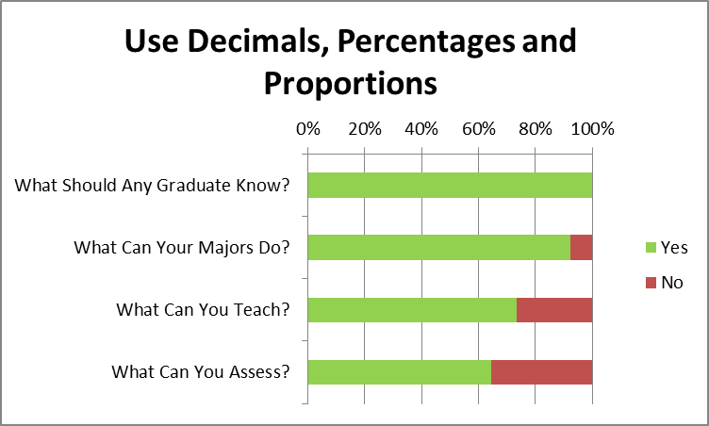 | 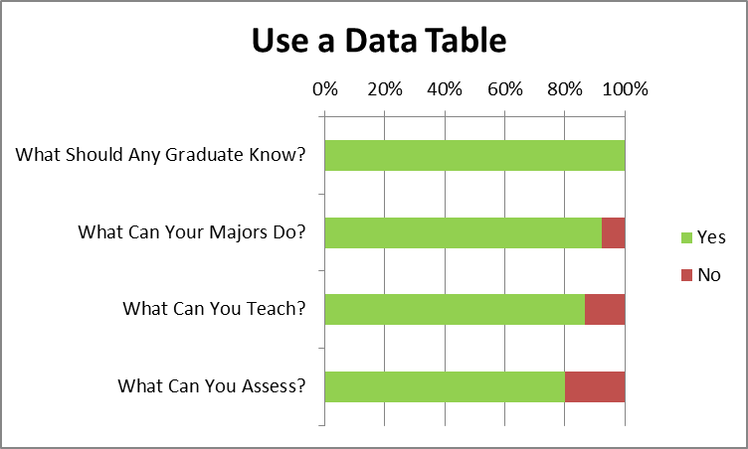
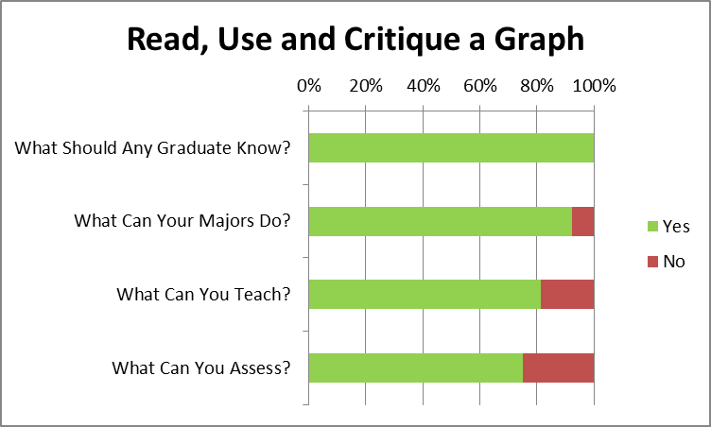 | 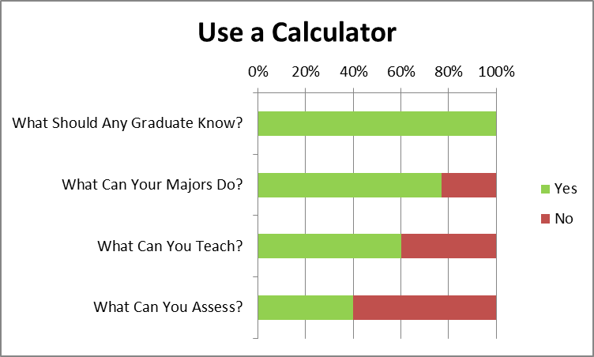
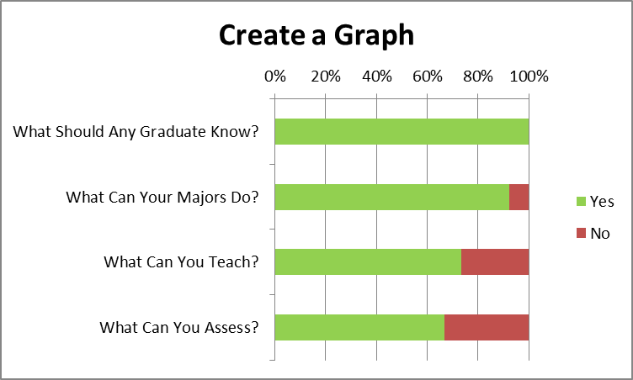 | 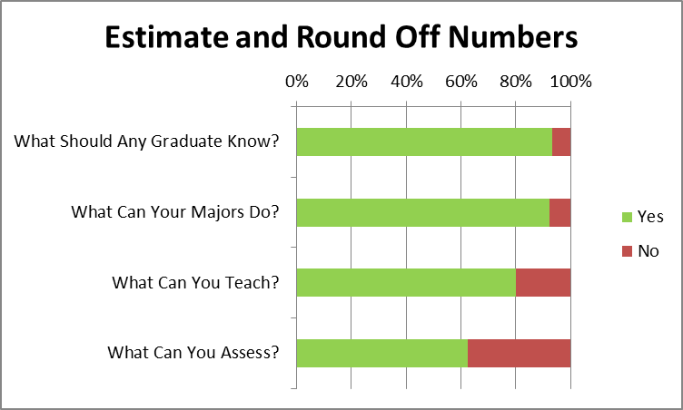
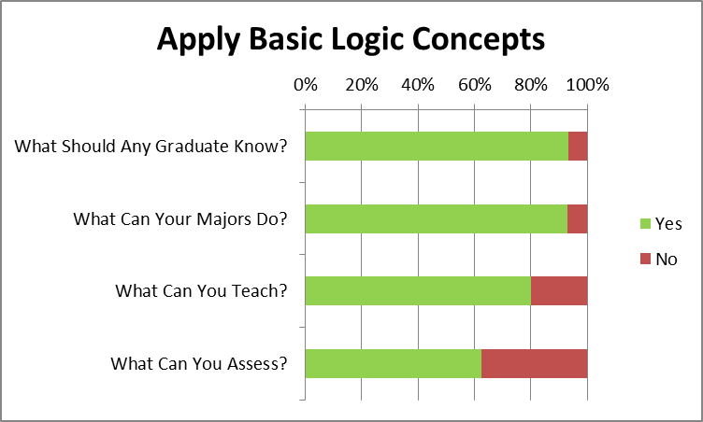

The graphs indicate QL skills that had over 60% support: Use a Spreadsheet, Read and Critique a Statistical Study, Manipulate Formulas with Units, and Apply Basic Geometry Concepts.
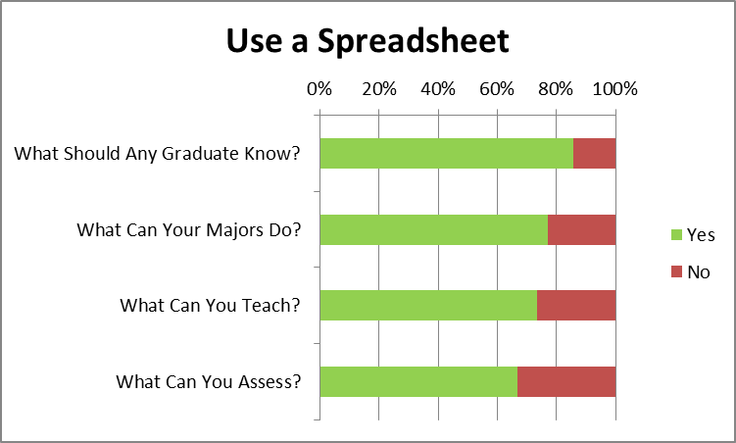 | 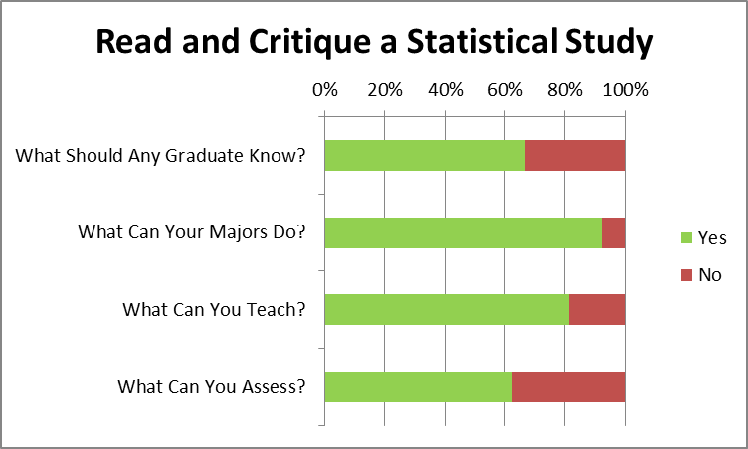
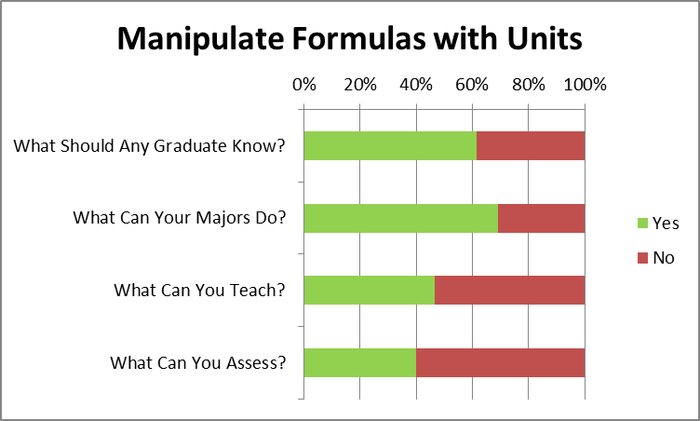 | 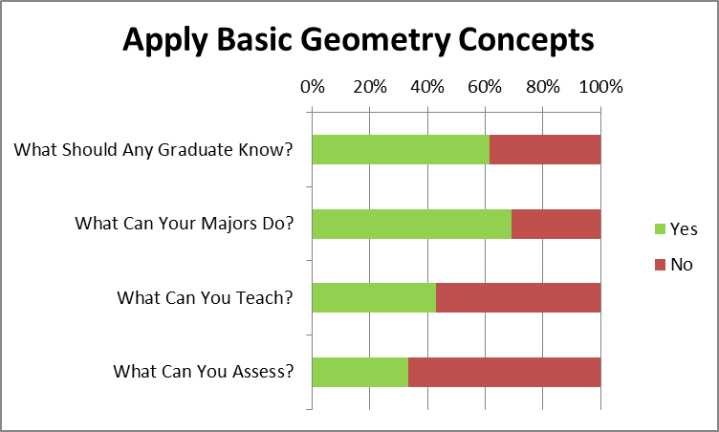

These graphs indicate skills that had less than 50% support for all graduates: Use Linear Functions, Use Nonlinear Functions, Use Quantitative Software, and Do a Statistical Study.
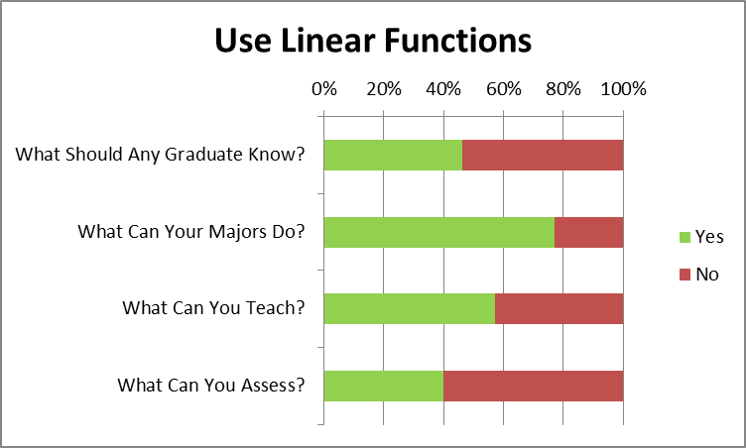 | 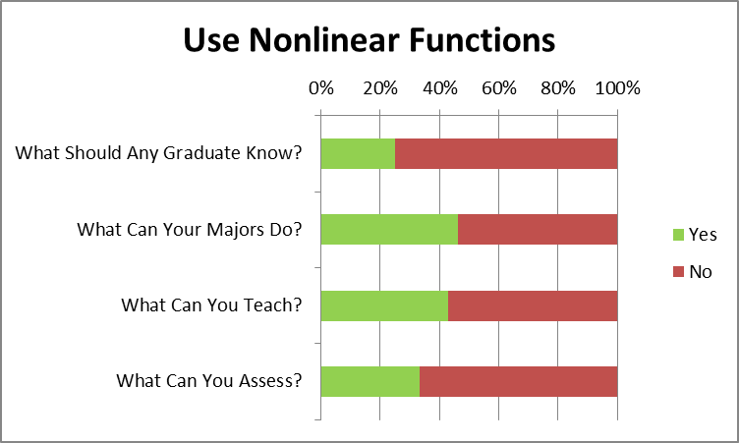
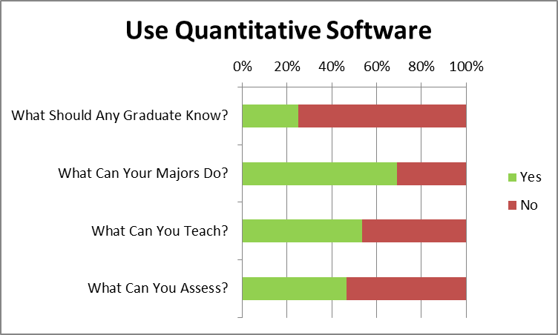 | 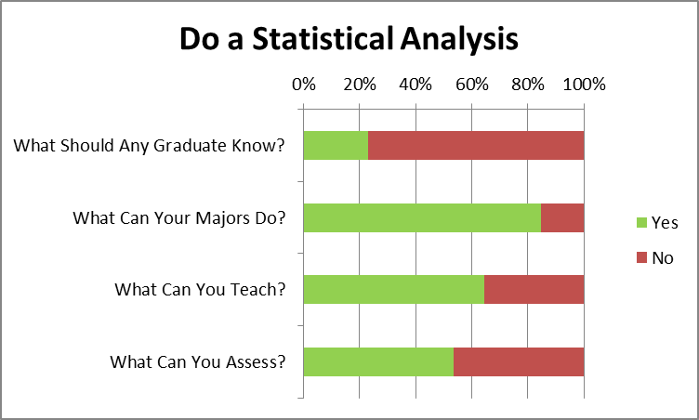

Many QL skills are taught and assessed in many ways as can be seen in the following two graphs.
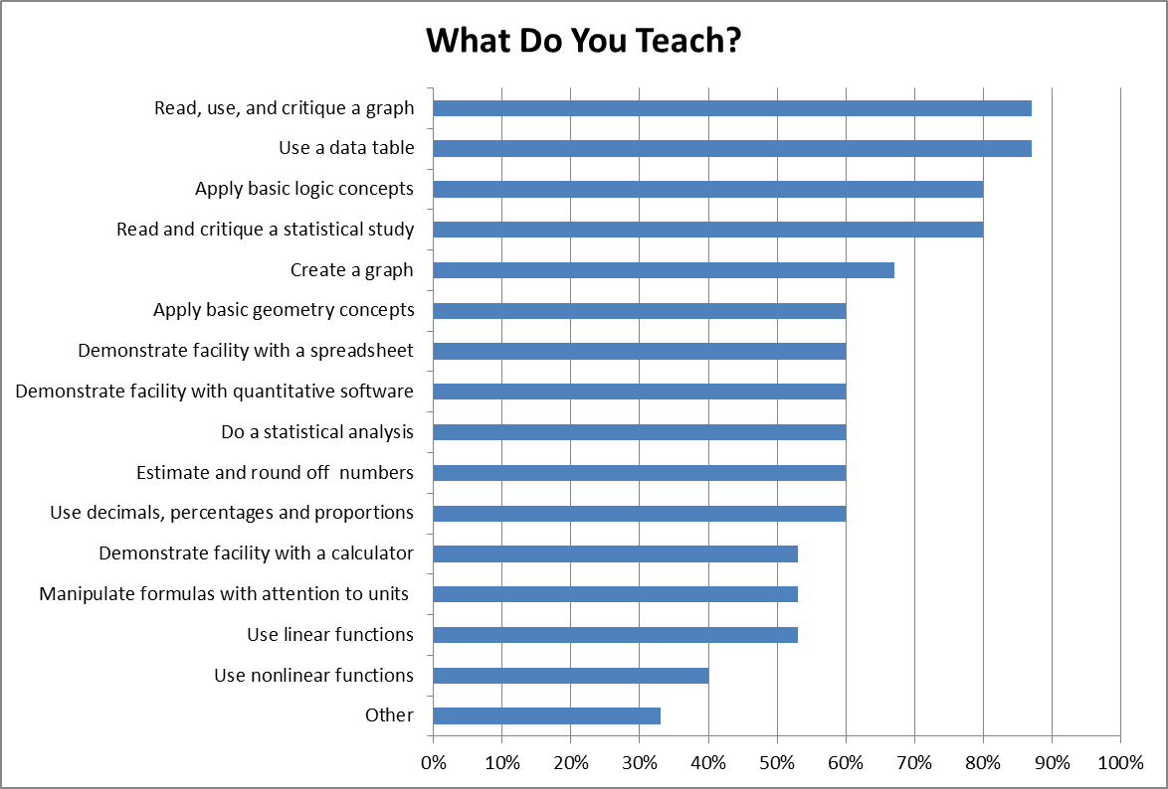
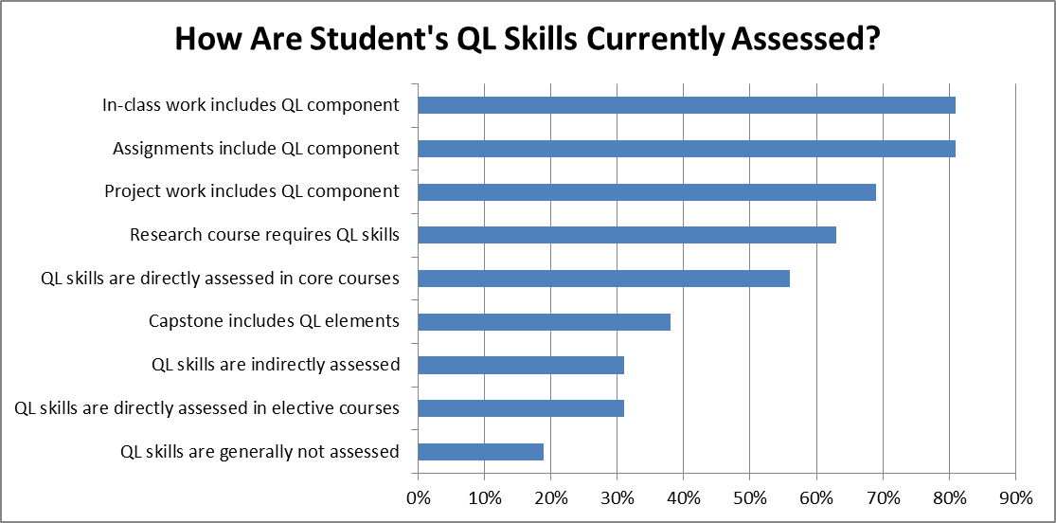

Math 243 – Elementary Statistics was the common prerequisite. Specialized majors require Math 111 and Math 112 the precalculus sequence or Math 211, 212, and 213, the elementary math education sequence.

Here are selected comments. It is clear that the survey prompted some programs to have vigorous and productive discussions.

- Some of the quantitative literacy skills we said we teach are not taught in *all* our courses in the major, and some are only at the most basic level.
- Quantitative literacy and computer coding concepts should not be conflated. Sometimes the University Studies requirements do conflate the two. We feel our students need both.
- Our students need more literacy in collecting and organizing data (identifying data sets, knowing how to collect data, formatting the data to optimize useability, exploring methods as epistemology). These are not math skills, they are data analysis skills.
- The above statement led to a repeating conversation that it would be great if our major were to have a qualitative methods course. We talked about proposing such a course in the 16-17 catalog, but have concerns about staffing it since it would have to be required.
- A quantitative literacy course should be required in the first year like the USem writing and speaking course. Then all faculty could presume that their students had such skills and teach the QL parts of their classes at a higher level.
- Success in Math 243 in the first year of college correlates with increased probability of graduating.
- Also we feel that there is a lingering resentment toward mathematics among some on campus.
- Math courses are a fundamental component of the chemistry curriculum, and we felt that assessment should remain with the mathematics department, as opposed to being spread out among the STEM disciplines.
- I would like to see an open and frank discussion about QL on campus and the administration's thoughts not only on how our campus handles QL assessment but also on how to expand opportunities for greater QL exposure campus-wide.
- Perhaps a broader view of how QL may be imparted. Include elements in a course logic where QL is introduced at a level many non-math majors have access to QL.
- An unrelated comment is that financial literacy should be addressed in some way as part of quantitative literacy.
- Under a proposed plan to merge Sociology and Anthropology into a single degree program, all SOAN students will be required to complete SOC 327: Quantitative Data Analysis (which has a prerequisite of MTH 243 or EC 232). Thus we expect our majors with interests in anthropology will graduate with stronger quantitative literacy skills.
- Our students need more of what they are getting, and they, like all SOU students, need more exposure to data visualization techniques, exercises and software. Like Arthur Benjamin says, statistics, not calculus, should be the pinnacle of math general education. And in the case of our program, like most social and natural science programs, the goal should be using fairly simple methods to explore patterns in data, display those patterns effectively, and to bring those results to bear on empirical research questions in the field.

Interpreting the Results
Programs have agreement on many QL literacy skills that all graduates need. Many programs teach and assess some QL skills. Some programs are thoughtfully considering adding or enhance QL outcomes for their majors. Many programs feel competent to teach and assess QL skills. Some programs would like to see QL discussed at a college-wide level.

Interpreting the Results with a Grain of Salt
Here is a list of the committee’s equivocations.
- The programs are not a random sample of all of the programs at SOU. If the opinions of the non-responders were to be gathered, different skills might be emphasized and more disagreements could be uncovered.
- The survey questions did not have a close correspondence with SOU’s stated QL goals which aspire to a higher level.

Text of the Survey
This survey is the University Assessment Committee’s first attempt at discovering the Quantitative Literacy needs and capabilities of campus programs. As with all surveys there may be unasked questions you wanted to answer or answer choices that we did not list. Please take the opportunity to comment if your program perceives any gaps or omissions. Thank you for providing this important feedback.
Please let us know who is completing this survey:
Your Program's Name
Your Name
Your Email Address
Consider each of the following quantitative literacy skills and indicate your program's views on these questions:
  - Is this a skill that graduates in your program/major should have as they leave SOU?
  - Is this a skill that any graduates from a liberal arts university should have?
  - Is this a skill that your program feels competent to teach?
  - Is this a skill that your program feels competent to assess?
 | Your Majors |  | Any Graduate |  | Can Teach |  | Can Assess
 | Yes | No | Yes | No | Yes | No | Yes | No
Read, use, and critique a graph
Use a data table
Create a graph
Demonstrate facility with a calculator
Demonstrate facility with a spreadsheet
Demonstrate facility with quantitative software
Manipulate formulas with attention to units (if appropriate)
Estimate and round off numbers
Read and critique a statistical study
Do a statistical analysis
Use decimals, percentages and proportions
Use linear functions
Use nonlinear functions
Apply basic geometry concepts
Apply basic logic concepts
If your program teaches quantitative literacy skills, which of these skills does it teach? (Check all that apply.)
Read, use, and critique a graph | Read and critique a statistical study
Use a data table | Do a statistical analysis
Create a graph | Use decimals, percentages and proportions
Demonstrate facility with a calculator | Use linear functions
Demonstrate facility with a spreadsheet | Use nonlinear functions
Demonstrate facility with quantitative software | Apply basic geometry concepts
Manipulate formulas with attention to units (if appropriate) | Apply basic logic concepts
Estimate and round off numbers | Other
Which of the following tools are students in your program expected to use? Which tools should all SOU students be proficient in using?
 | Your Program |  |  | All Students
 | Skilled | Novice | Don't Need | Skilled | Novice | Don't Need
Calculator
Spreadsheet/Excel
MatLab
SPSS
Other
How does your program currently assess the quantitative literacy (QL) skills of your students? (Check all that apply.)
In-class work includes QL component | QL skills are directly assessed in core courses
Assignments include QL component | QL skills are directly assessed in elective courses
Project work includes QL component | QL skills are indirectly assessed
Research course requires QL skills | QL skills are generally not assessed
Capstone includes QL elements
For each of the following skills, indicate the skill level of most students in your program:
 | Can Do | Cannot Do | Don't Know
Calculate a rounded percentage | Calculate a rounded percentage | Interpret a graph | Create a graph
Interpret a graph | Calculate a rounded percentage | Interpret a graph | Create a graph
Create a graph | Calculate a rounded percentage | Interpret a graph | Create a graph
Understand a statistical study | Calculate a rounded percentage | Interpret a graph | Create a graph
If your program has established prerequisite quantitative literacy skills, please describe them:
If graduates of your program could advance in their field if they had greater proficiency in quantitative literacy, what kinds of opportunities would that create for them and/or for your program?
What didn't we ask or what more would you like to tell us? Please feel free to share any additional thoughts about quantitative literacy at SOU.
Thank you for your contribution to our understanding of quantitative literacy at SOU!
Be sure to print your responses to save as an artifact of assessment activity.
Survey Powered By Qualtrics

Pasted from <https://sou.us.qualtrics.com/jfe/previewForm/SV_5iktGJuh57dIYkJ>

