**Assessment Committee Members**

2013-14: Jim Hatton, Kristin Nagy Catz, Craig Stillwell, Lee Ayers, Dorothy Ormes, Hart Wilson, Laura Young, Dale Vidmar, Rene Ordonez, Mark Krause, Erin Wilder, Susan Walsh, Jamie Vener, Peg Sjogren

2014-15: Jim Hatton, Kristin Nagy Catz, Craig Stillwell, Lee Ayers, Jamie Vener, Dorothy Ormes, Hart Wilson, Jody Waters, Vicki Suter, Dale Vidmar, Rene Ordonez, Erin Wilder, Peg Sjogren, Tiki Boudreau, John Taylor, Jeff Gayton

**Summary**

The SOU Faculty Senate Assessment Committee evaluated 34 senior writing papers randomly selected from 457 submissions gathered from nearly every academic program over the summer of 2014. The papers were evaluated using the Senior Writing Evaluation Rubric developed as a result of last year's Capstone Assessment Pilot Project. The rubric uses a four-point scale on which a rating of four is considered Exemplary, while a rating of three indicates Accomplished. The kinds of papers submitted varied greatly, resulting in lower scores for some elements that were not required in all papers. Thus, scores between two and three are not necessarily low.

Papers were reviewed blind, although each paper was identified by major program to enable a representative random sampling. Each paper was identified by student ID number to allow for a deeper analysis of demographic factors, including transfer status. Comparison with the assessment of freshman writing (the Final University Seminar Essay [FUSE]), showed marginal improvement from first-year writing to senior writing. The scores of students who started at SOU vs. transfer students were nearly identical.

The evaluation revealed a wide disparity in quality and completeness. General weaknesses observed included an inability to sustain a central focus, unclear intentions, and a lack of critical thinking. A separate evaluation of information literacy proficiency conducted by Library faculty revealed inconsistent citations, incomplete and substandard quality of sources, and a lack of range in the sources cited.

**Recommendations**

***For Programs***

1. Study the results of this report and seek alignment of written proficiency expectations for graduating seniors with the standards articulated in the evaluation rubric.
2. Review how writing skills are developed throughout the program's curriculum.
3. Gain a deeper understanding of student writing proficiency by conducting an internal evaluation of the program's 2013-14 senior writing submissions using the Assessment Committee model. Help and guidance are available from the Assessment Committee on request.
4. Request assistance and guidance from the Assessment Committee; use any and all resources available.
5. Consider using the evaluation rubric in senior writing courses, or other learning tool, as a self-assessment.
6. Directly address the areas of weakness identified by this review:
   1. Work with students to clearly articulate the context and purpose of their papers.
   2. Help students with their tendency to digress.
   3. Focus on critical thinking.
   4. Work more closely with Library faculty to improve scores on information literacy.

***For the University and the Assessment Committee***

1. Repeat the process next year with full participation of all programs, and more precise specifications about the senior writing samples desired.
2. Consider collecting exemplary papers and developing materials to support student development in writing.
3. Ask the Library faculty to evaluate a sampling of FUSE papers for information literacy and compare the results with the senior writing results.
4. Identify an assessment method for students writing in a foreign language.
5. Design and implement professional development initiatives for faculty focused on writing throughout the curriculum.

**Background**

### SOU has had a senior writing requirement since before 1990. The current catalog states:

### Writing and Research Component

Demonstrate writing and research skills within the academic field of study chosen as a major. This upper division requirement is in addition to the University Studies writing requirement. It is met through coursework in the major that is designed to encourage the use of professional literature.

Students who have achieved the writing and research goals will be able to:

1. systematically identify, locate, and select information and professional literature in both print and electronic formats within the knowledge base of the specific discipline;
2. critically evaluate such materials;
3. use the materials in a way that demonstrates understanding and synthesis of the subject matter; and
4. develop cohesive research papers that use data and professional literature as evidence to support an argument or thesis following the style and conventions within the discipline of the major.

For five years prior to 2013-14, SOU administered the Collegiate Learning Assessment (CLA) which compared our students’ writing and critical thinking to those of other schools. While the results were valuable, administering the test and recruiting enough participants was extremely challenging. Because the test was not tied to actual coursework, it was also difficult to gauge the extent to which students took it seriously. As a result, in the spring of 2013, the Assessment Committee proposed and successfully implemented a pilot program to evaluate student writing skills, by examining senior writing samples. This evaluation had the advantage of using embedded artifacts, that is assignments, typically capstone papers, that were intended to be graded and were required for graduation.

**Process**

The Assessment Committee solicited senior writing samples from all programs; specifically, asking for one paper from each of the program's graduating seniors. All programs except Computer Science submitted at least one paper. In total, the Committee received 457 papers, representing just over half of the 816 bachelor's degrees awarded in 2014. Student names were removed from all of the submissions and, SOU’s Institutional Research Board approved the process. An evaluation rubric developed from AAC&U standards, first used in the pilot program in (year?) was refined for use in 2014.

Sample Size Determination

Using a stratified sampling method as described by Schaeffer et al (1990), Assessment Committee Chair Jim Hatton and committee member Rene Ordonez determined the sample size from each stratum. See Appendix B for the details of the process.

Stratified sampling method was used for the following reasons:

1. It produces a smaller margin of error (*B*) than would be produced by a simple random sampling.
2. It has a lower cost (time) per observation in the survey.
3. It allows for estimating the population means for each stratum, e.g. for estimating averages for each department or program, though for most programs the number of evaluated papers is too small to draw meaningful conclusions.

A total of 36 capstones were selected and randomly chosen from the program strata. The committee determined that a sample size in the thirties was logistically feasible and, in the end, 34 papers were assessed. Two papers were unsuitable for evaluation: one was in a foreign language and the other was the product of group work. In order to ensure fair representation of capstones from each program, this sample size (36) was apportioned to each of the strata (programs) proportionate to the total number of submissions contained in each stratum.

Norming and Evaluation of Sample Papers

Prior to evaluating and rating the selected papers, Director of University Assessment Kristin Nagy Catz chose three papers of varying quality for evaluation by all committee members to calibrate the rubric and norm the evaluation process. Once the rubric (see Appendix A) was calibrated and the process normed, seven teams (two committee members in each team) evaluated and rated five papers each. Each evaluation team followed these steps:

1. Each member independently read, evaluated, and rated the papers assigned to the team using the Writing Evaluation Rubric.
2. The team members met, compared, and discussed their ratings on the assigned papers.
3. Where there were differences in their ratings, the members negotiated an agreement on a single rating.
4. Each team entered its ratings for each paper in a Qualtrics survey to facilitate data collection and analysis.

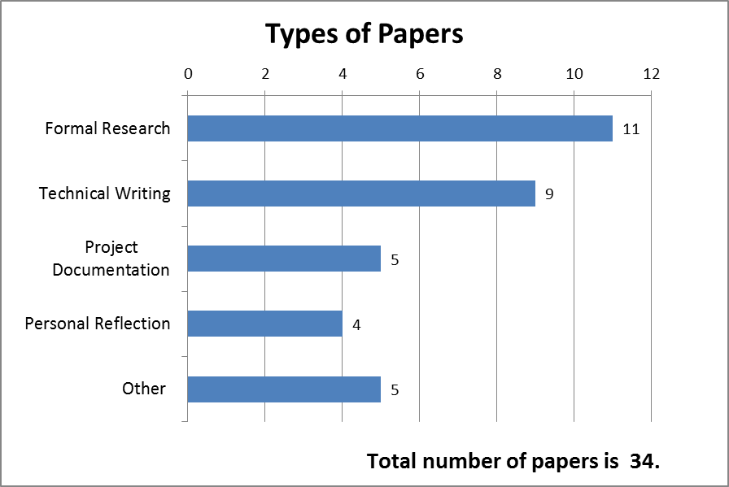While the UAC teams were evaluating writing and critical thinking proficiencies, the Library faculty focused on information literacy. They began by assessing ten samples of senior writing using a norming process described by Peggy Maki (2010)[1] to establish inter-rater reliability. Then four staff members evaluated all 34 writing samples.

Description of the Sample

The UAC evaluated 34 writing samples. The committee classified the samples as shown at right.

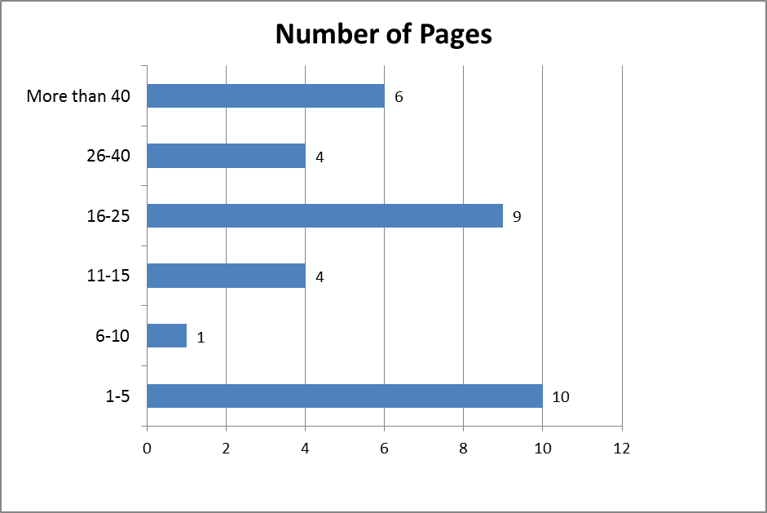Nearly half of the papers were 15 pages or less in length as shown here at right.

The evaluation teams classified 18 of the 34 papers as needing further revision.

**Results of the Evaluation**

The results are presented as a series of graphs with comments if warranted. While the rubric represents a four-point scale, it's important to keep in mind that a rating of four is considered Exemplary, while a rating of three indicates Accomplished. Also, the kinds of papers submitted varied greatly, resulting in lower scores for some elements that were not required in all papers. Thus, scores between two and three are not necessarily low.



In terms of content development and organization, the scores reflect a large percentage of “developing” writers.



Beginning and developing writers make up 35% of the papers scored on effectiveness of expression (fluency, word choice, etc.).



Thirty percent of the students were less than “Accomplished” in the mechanics of writing.



When evaluated on critical thinking skills, 65% showed the ability to maintain a central focus.



More than half of the students had difficulty providing evidence to support their central theme.



Half of the students had difficulty drawing valid inferences and/or drawing a clear conclusion. This category had the lowest mean score.

The charts below offer a comparison among the writing and critical thinking standards.



Scores for the critical thinking categories of providing evidence and drawing inferences are more widely distributed than other dimensions.

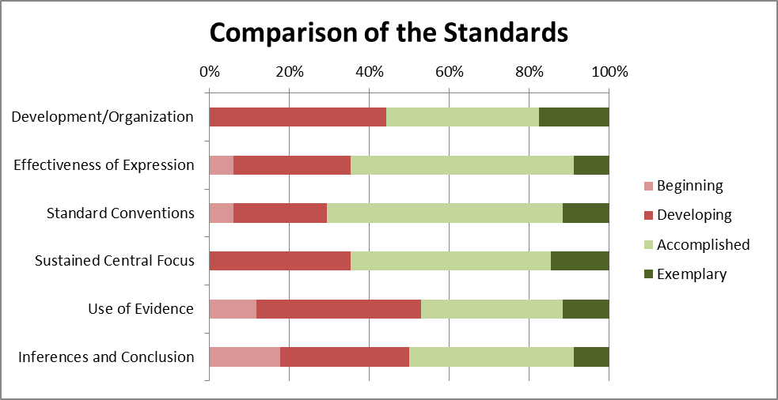This horizontal bar chart offers another way of comparing scores. In the chart below, the more green on a bar, the higher the level of student achievement. The lighter green represents "Accomplished" proficiency.

This graph shows that a substantial proportion of the seniors are somewhat deficient (at the "Beginning" or "Developing" level) in writing and critical thinking. They are particularly deficient in "Use of Evidence" and "Inferences and Conclusions."

Seniors vs. Freshmen

The chart below compares senior writing scores to FUSE evaluation results.

More seniors were “Exemplary” in their ability to organize ideas.



Senior writing for effectiveness of expression varied more widely than FUSE writing, but more seniors are in the two higher categories.



When evaluated for standard English conventions, senior writing displays greater disparity.



Senior writers have somewhat better scores in maintaining a central focus.



The uniformity of FUSE requirements may result in less variability in this category.



Analyzing the ability to draw valid inferences resulted in more variability in senior writing.

In sum, there is more variability in measured achievement in the senior writing samples compared to the FUSE scores. This may not be surprising since University Seminar instructors have identical learning outcomes for their classes and work together to define their measurement. The work submitted by seniors varied greatly in terms of research requirements and type of writing.

Transfer Students vs. Non-Transfers

Recognizing that the samples are small, there seems to be little difference in writing proficiency between transfer students and students who started at SOU in their freshman year. Transfer student results may have a little more variability. The graphs below are illustrative.













**Information Literacy Results**

These charts represent the results of the assessment conducted by Library faculty.



“Necessity to Cite” has a fairly flat distribution.



More than 50% of the students were inconsistent in their citations.



A majority of the students used timely sources.



Two-thirds of the students used sources relevant to their thesis.



Source quality had a flat distribution.



Only 40% of writers integrated an acceptable range of sources.

This graph allows comparison of the Information Literacy standards.

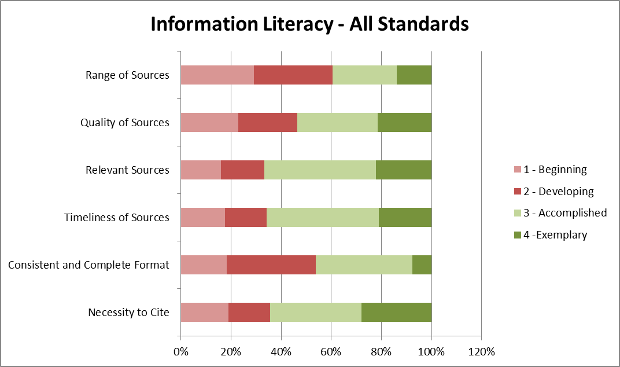

The large percentage of students in the beginning and developing categories for range of sources may be the result of the variety of different types of papers submitted to the committee. The writing samples ranged from academic research papers to reflective essays, with many more sources required for the former. Over 30% of student papers in all categories were rated in the beginning or developing range.

**Interpreting the Results**

The information generated by this evaluation can be considered baseline data, the first measurement in a time series of succeeding studies. This baseline suggests that large percentages of SOU senior writers are less than accomplished in several categories. Improving this situation should be a goal of the University.

Given the small size of the sample, it may not be possible to distinguish an impact from starting at SOU in the first year of college. A comparison of senior writing with FUSE samples reveals no significant rise in proficiency. While writing skills are emphasized in University Seminar classes, it is possible that these skills atrophy from first year to senior year due to lack of focus on writing in later terms.

There are many other ways to have organized the results of the study that might have yielded more insight. As questions come up, the data captured through this analysis can easily be reanalyzed. In addition, we now have a repository of 457 papers which can be used to answer other research questions.

**Interpreting the Results with a Grain of Salt**

The committee recognizes that flaws in this first formal iteration of the Senior Writing study make it hard to come to definitive conclusions. Here is a list of the committee’s equivocations.

1. Small programs are overrepresented in the sample. Since small programs can give their individual majors more attention, this may have resulted in overly high averages in the rubric categories.
2. Not all possible writing samples were submitted. The number of 2014 graduates was 816. The number of submissions was 457. It is possible that the non-submitted samples would have been of lower quality. Without these lower scores, the results in this sample may have been skewed upwards.
3. The degree of polish of the writings can have many causes. The students could have been required by their program to revise and edit their papers multiple times. The program's capstone process could include multiple revisions under the guidance of a faculty member. The students could have had “outside” help, using the writing lab or having access to a good editor. In other words, it is unclear how much the degree of polish is directly due to the individual student’s abilities.
4. The committee explicitly decided not to check for the possibility of plagiarism which might account for some degree of polish. With a repository of 457 papers, questions of plagiarism could be pursued easily by submitting a random sample to Turnitin.com.
5. The submitted papers may not have been the best senior writing samples available from a given program. Programs may not have obtained and stored electronic copies of their students’ work. This may have resulted in skewing the results downward.
6. The FUSE papers were scored by two people during the summer and might have systematic differences with the senior writing results.
7. The expectations of the senior writing evaluators were probably higher than those of the FUSE evaluators since the writers were graduating seniors.
8. Expectations of the seniors’ professors may not have been consistent with the writing and critical thinking expectations that the rubric presumed.
9. The rubric was generated for use by a committee representing various disciplines and with a specific focus on assessment. While the committee urges the use of a rubric as a tool for evaluating writing, it does not prescribe or mandate the use of this particular rubric.

The recommendations from the beginning are repeated here.

***For Programs***

1. Study the results of this report and align written proficiency expectations for their graduating seniors with the standards articulated in the evaluation rubric.
2. Review how writing skills are developed throughout the program's curriculum.
3. Gain a deeper understanding of student writing proficiency by conducting an internal evaluation of the program's 2013-14 senior writing submissions using the Assessment Committee model. Help and guidance are available from the Assessment Committee on request.
4. Consider using the evaluation rubric in senior writing courses as a self-assessment or other learning tool.
5. Directly address the areas of weakness identified by this review:
   1. Work with students to clearly articulate the context and purpose of their papers.
   2. Help students with their tendency to digress.
   3. Focus on critical thinking.
   4. Work more closely with Library faculty to improve scores on information literacy.

***For the University and the Assessment Committee***

1. Repeat the process next year with more complete participation and more precise specifications about the senior writing samples desired.
2. Consider collecting exemplary papers and developing materials to support student development in writing.
3. Ask the Library faculty to evaluate a sampling of FUSE papers for information literacy and compare the results with the senior writing results.
4. Identify an assessment method for students writing in a foreign language.
5. Design and implement professional development initiatives for faculty focused on writing throughout the curriculum.

**Improving the Process**

The Assessment Committee will be repeating the Senior Writing Assessment process next year. It will be asking for more promptness in program submissions. It will also be more careful in expressing the specifications for submissions, asking for complete, finished, polished written examples of seniors’ critical thinking. The committee is considering using outside evaluators.

**Appendix A**

**Senior Writing Evaluation Rubric**

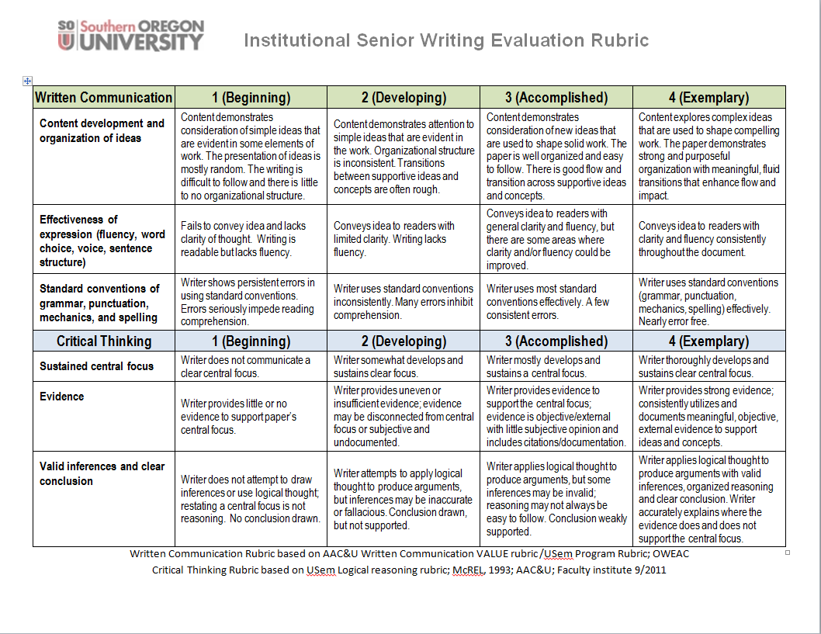

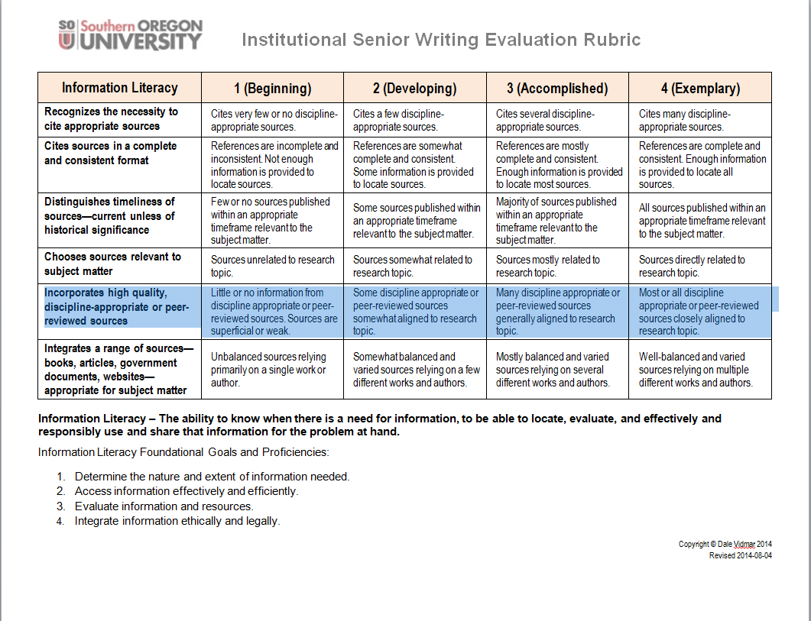

**Appendix B**

**Sample Size Computation**

We used the stratified random sampling in determining the sample size for the study. We defined the strata as the various departments or programs.

The rationale for the stratification of the population was to:

1. Produce a smaller margin of error (*B*) than would be by a simple random sampling,
2. Lower cost (to time) per observation in the survey, and
3. Allow for estimating the population means for each stratum, e.g. for estimating averages for each department or program.

The formula used for computing the sample size for estimating the population mean (µ) is:

$$n=\frac{\sum_{i=1}^{L}{N_{i}^{2}σ_{i}^{2}/w_{i}^{}}}{N_{}^{2}D+\sum_{i=1}^{L}{N_{i}^{}σ_{i}^{2}}}$$

Where:

$w_{i}^{}$ is the fraction of observations allocated to stratum i,

$σ_{i}^{2}$ is the population variance for stratum *i*, Since the actual standard deviation of each stratum, $σ_{i}$ is unknown, it was estimated as: (H-L)/6, or (4-1)/6 = 0.50

*D*, is computed as:

$$D=\frac{B^{2}}{4}$$

*B* is the margin of error for estimating the population mean (µ)

The computation of the samples from each of the strata is detailed in the table below.

Source: Elementary Survey Sampling, 4th Edition, Scheaffer, Mendenhall, Ott (page105)

**Appendix C**

**Sample Distribution**

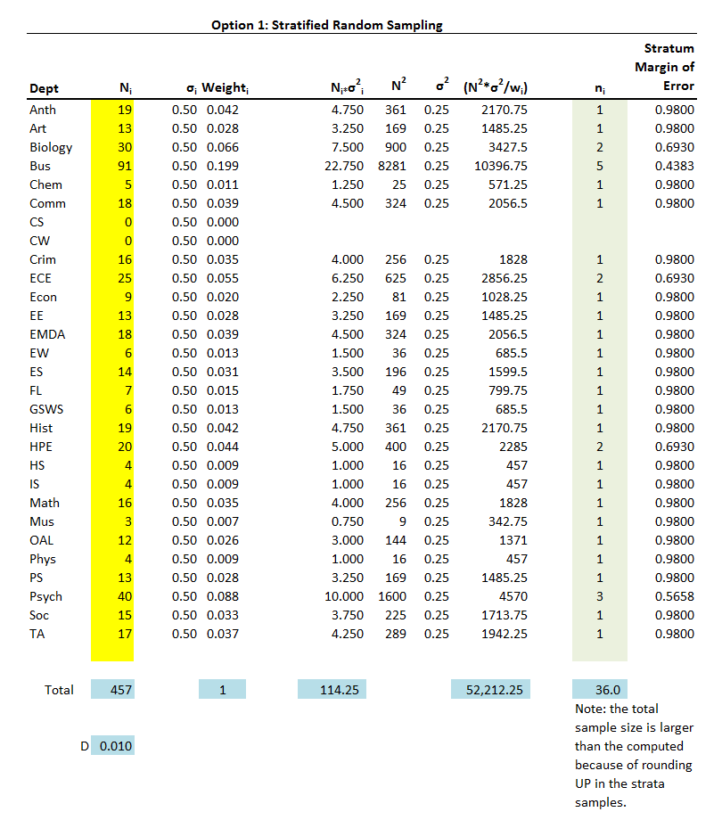

1. Maki, Peggy L. *Assessing for learning: Building a sustainable commitment across the institution* (2nd Edition). Sterling, VA, USA: Stylus Publishing, 2010. Retrieved from <http://www.ebrary.com>.