BYLAWS
of the
CONSTITUTION OF SOUTHERN OREGON UNIVERSITY FACULTY

1.000

Section 1. Faculty Governance
1.100

Guidelines for University Committees with Faculty Representation
1.110

Scope

University Committees are committees that draw their membership from more than one campus department (or unit).
1.120

Organization

University Committees are organized under two major oversight boards: the Faculty Senate and the University Planning Board. Both oversight boards make recommendations directly to the President.
1.130

Composition and Tenure
1.131

Committee Members’ Tenure

Unless otherwise specified, standing committee appointments shall be for a period of three years. Approximately one-third of each committee will be selected each year and ad hoc committee appointments shall be for the duration of the committee’s work.
1.132

Ex Officio Membership

The University President may serve as an ex officio member of all committees and councils; other ex officio members are specifically designated, normally by office or position in the University.
1.133

Other Consultants

Committees and councils may select non-voting consultants as considered necessary for the performance of their assigned functions.
1.140

Naming Conventions

University Committees shall be identified as Committees, Councils, Boards, Task Forces, or Work Groups according to the following conventions:
1.141

Standing Committees

- Committees
- Charged with overseeing and completing specific tasks

- Relatively small in size (often 6-12 members)

- Make recommendations to administrator(s), Faculty Senate, University Planning Board, or other designated committee(s)

- Councils

- Charged with a significant advisory function in addition to overseeing and completing specific tasks

- Larger membership to represent a cross-section of perspectives (often 15-20 members)

- Make recommendations to a program director, administrator, or board

- Boards

- Charged with a significant governance function that includes review of policy and/or budget

- Large membership that is highly representative to facilitate awareness and interaction with all impacted areas across campus

- Decisions are still subject to Presidential approval and carry significant weight in campus governance
1.142

Ad Hoc Committees

- Work Groups

- Convened to complete a particular task with a specific completion date, often within a month or a quarter

- Have a clear outcome or report that signifies termination of the task and dissolution of the committee

- Task Forces

- Convened to complete specific tasks within a limited timeframe, normally under one year

- Have a clear outcome or report that signifies termination of the tasks and dissolution of the committee
1.150

Establishment of a Standing or Ad Hoc University Committee
1.151

Committee Approval

Because the demands University committees place on faculty and staff time, their establishment must be approved by one of the following individuals or boards: University President, Vice President, Dean, Faculty Senate, or University Planning Board.
1.152

Committee Guidance

Upon establishment, a committee should be given a clear description, including charge, appropriate representative membership, reporting structure, and, if ad hoc, a timeline for the committee’s work. Furthermore, the initial individual members should be elected or appointed, as appropriate to that committee’s function.
1.160

Quorum, Voting Rights, and Membership
1.161

Quorum

Fifty percent (50%) of the voting members.
1.162

Student Members

Unless specifically prohibited, student members are encouraged to serve on University Committees, but they may not exceed 20% of the voting members of the committee. Student members have full voting rights, but they may not chair a committee. Unless otherwise specified, ASSOU appoints student members to University committees.
1.163

Ex Officio Members

Ex officio members are non-voting members and, as such, may not be included in determining a committee quorum nor serve as chair, with one exception – program staff may chair their program’s advisory council.
1.170

Meetings, Minutes, and Recommendations
1.171

Standing committees are expected to be actively working or meeting at least quarterly.
1.172

It shall be the responsibility of the chair to schedule meetings and prepare the agenda.
1.173

Each committee shall submit minutes of all meetings to the appropriate reporting body.
1.174

Unless otherwise specified, all recommendations for changes in policy must be submitted to the University President for approval before taking effect.
1.200

Faculty Senate
1.210

Composition
1.211
- Members of the general faculty (as defined in the Faculty Constitution, Article 2) shall be elected to serve on the Faculty Senate as follows:

- Each department (as defined in Section 4.110) shall elect one senator. All members of the general faculty who are certified by the Provost as members of that department (see Section 4.312(b)) are eligible to serve.

- The remaining senators (minimum of four) shall be elected at-large from the general faculty.

- See the Faculty Constitution, Article 5 for further restrictions on the composition of the Faculty Senate.

1.212
- Senate terms begin and end at the last Faculty Senate of the academic year.
1.213
- Proxy votes are not allowed for senators not in attendance at the meeting. Proxy votes are allowed if a senator must leave a meeting that exceeds the expected ending time, after informing the secretary of the fact that he/she has left a proxy with another senator. The expected ending time for senate meetings has been set for 5:30 PM.
1.214
- Should a senator be scheduled absent from senate meetings for one full academic term, the Faculty Senate Chair shall direct the Elections Committee to conduct a special election in a manner consistent with these Bylaws to replace that senator for the period of time during which he/she shall be absent. At the end of the scheduled absence, the originally elected senator shall resume his/her duties with the Faculty Senate.
1.215
- A vacancy on the Senate of more than one academic term will be filled by special election. The Faculty Senate Chair is responsible for directing the Elections Committee to conduct that interim election in a manner consistent with these Bylaws.
1.220

Elections
1.221
- Elections shall be conducted each year by the Senate Elections Committee in a manner that demonstrates fairness, is consistent with Section 1.211, and ensures the seating of all newly elected senators by the last senate meeting of the academic year.
1.222
- Each year, prior to the last senate meeting of the fall term, the Senate Elections Committee shall submit an election plan and timeline to the Senate Chair for approval. The plan must satisfy the following requirements:

  - Eligibility
The Elections Committee shall obtain from the Provost a list of the members of the general faculty with their department(s) and/or administrative affiliations.

  - Department Elections

The Committee shall:

- Provide a list of eligible faculty members to each department with seats open for election and direct the department to conduct the election.

- Allow at least ten (10) University days for departments to conduct elections.

- Remind departments that they must elect a senate representative, following their department’s established procedures and report the name of their elected representative to the Elections Committee.

- Warn departments that if they fail to elect a representative, they ipso facto forfeit representation on the Faculty Senate for the upcoming year.

  - At-Large Elections

The Committee shall:

- Conduct at-large elections following the department election deadline.

- Provide the faculty with a list of eligible persons and solicit nominations. There shall be up to two calls for nominations, seeking to identify a number of candidates equal to twice the number of vacancies. Only nominees who consent in writing can be placed on a ballot. Those nominees who are named the greatest number of times will be placed on the ballot. All persons tied for the final position will be declared nominees.

- Allow at least five (5) University days for each round of nominations, for nominees to accept or reject the nomination in writing, and before the conclusion of the elections.
1.230

Recall of a Senate Member

If absenteeism or other factors appear to render a senator ineffectual, a recall vote may be requested by a) one-third of the electorate for a department senator; b) twenty percent (20%) of the general faculty for a senator-at-large; or c) two-thirds of the Faculty Senate. The Elections Committee will supervise a vote on the appropriate electorate by secret ballot. A two-thirds vote of the electorate is necessary for recall of the senator.
1.300

Committees that Report to the Faculty Senate
1.310

Subcommittees of the Faculty Senate
1.311
- Advisory Committee

- Charge

- The Advisory Council shall work in close cooperation with the University President in the implementation of policies and shall be responsible for establishment and coordination of duties of the other senate committees. The Advisory Council shall also review and make recommendations concerning the general allocations of institutional funds. On matters the University President deems too urgent to permit time for a meeting, the Advisory Council may act for the Faculty Senate. All such actions are subject to review by the Senate.

- Membership

The Advisory Council consists of the senate chair, vice chair, secretary, immediate past chair, three (3) additional senators (all of whom are elected by and from the newly seated Senate at is first meeting in June of each year), the President, and the Provost.

- Meetings

The Advisory Council meets on the second and last Mondays of the month during the academic year (in the week preceding the regularly scheduled Senate meeting).
1.312
- Committee on Committees

- Charge

The Committee on Committees shall assign items of business to the appropriate committee or council and shall be responsible for the composition and performance of all faculty standing and ad hoc committees, except for the Faculty Personnel Committee. The committee will ascertain faculty member preferences and abilities for committee assignments and will ensure equitable distribution of assignments among the college, schools and departments, where appropriate and possible. Committee appointments for the following academic year shall be reported to the Faculty Senate for approval by the last senate meeting of spring term.

- Membership

The Committee on Committees consists of three (3) senators (all of whom are elected by and from the newly seated Senate at is first meeting in June of each year).
1.313
- Constitution Committee

- Charge

The Constitution Committee shall consider items related to the interpretation and revision of the Faculty Constitution and the Bylaws and make recommendations on these matters to the Faculty Senate.

- Membership

The Constitution Committee consists of three (3) senators (all of whom are elected by and from the newly seated Senate at is first meeting in June of each year).
1.314
- Elections Committee

- Charge

The Elections Committee will hold elections of department chairs, members of the Faculty Personnel Committee, and faculty senators and all votes of the general faculty. The committee will also certify the faculty nominations for the University Planning Board.

The committee shall approve all lists of eligible faculty for positions, certify election results, and make the results public at the next Faculty Senate meeting. The Elections Coordinator and the Senate Webmaster will maintain a record of department chairs, Faculty Senate and Faculty Personnel Committee membership, election date and terms. Each year, prior to the last Senate meeting of the fall term, the Senate Elections Committee shall submit a comprehensive election plan and timeline to the Faculty Senate Chair for approval. This plan must be consistent with the Bylaws governing elections of department chairs, members of the Faculty Personnel Committee, Faculty Senators and all votes of the general faculty.

- Membership

The Elections Committee consists three (3) senators (all of whom are elected by and from the newly seated Senate at its first meeting in June of each year). One member shall be designated the elections coordinator and shall conduct all elections and certify that all nominations submitted for Senate confirmation were selected in accord with these bylaws.
1.315
- Hearing Panel and Committees

- Charge

A hearing committee shall hear the grievance of a faculty member as provided in section 6.100 and challenges to disciplinary actions or procedures as provided in section 6.200 of these bylaws.

- Membership

The panel consists of ten (10) senators (all of whom are elected by and from the newly seated Senate at is first meeting in June of each year); from this panel, the Senate shall name five to serve as the hearing committee for each appeal. The faculty member and the administration are each allowed one peremptory challenge; the Senate will then replace a committee member so challenged from the panel. The committee shall be constituted promptly with the Faculty Senate Chair designating a convener. The hearing committee shall elect a chair from among its members. The committee shall complete the hearing and its report within 30 days of its constitution, if possible.
1.320

General Faculty Committees

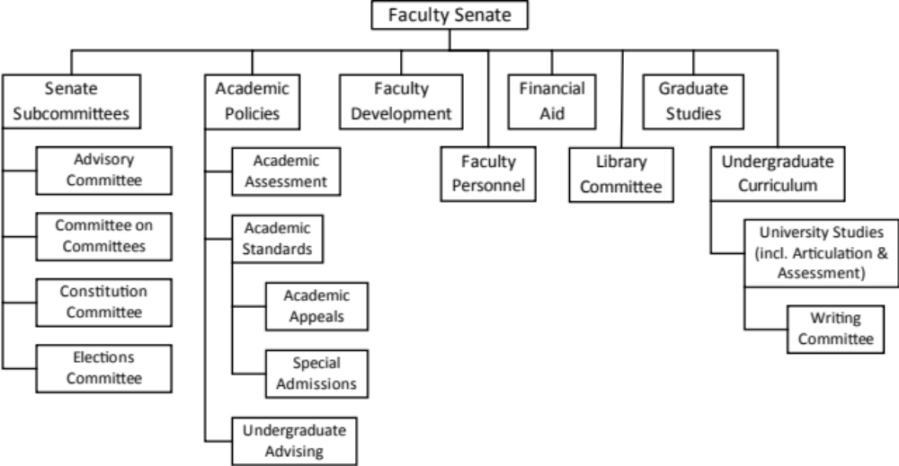
1.321
- Academic Policies Committee

- Charge

The Academic Policies Committee shall recommend policies regarding admission, transfer, general academic regulations and graduation.

Specifically, the Committee will:
- Review academic policies, including those maintained in the Catalog, and make recommendations to the Faculty Senate regarding changes or additions.
- Review recommendations from its subcommittees (Academic Assessment, Academic Standards, Community-based Learning, e-Learning, and Undergraduate Advising) that may impact existing academic policies.
- Receive recommendations from departments or administrative units regarding clarifying or exploring policy needs.
- Be a resource to departments and units across campus needing clarification to effectively implement academic policies.

- Membership

The Faculty Senate appoints six faculty members to this committee. The Student Senate may appoint a student member. In addition, the chairs of Academic Assessment, Academic Standards, Community-based Learning, Distance Education and Undergraduate Advising Committees (or their designees) may be appointed to this committee to provide better coordination among all these areas.

- Ex Officio Membership and Administrative Contact

The Registrar, Associate Provost, Associate Director of Academic Advising, and Dean of Graduate Studies serve ex officio. The Associate Provost is the administrative contact.

- Reporting, Meetings and Workload

The Academic Policies Committee makes recommendations to the Faculty Senate and reports on actions taken as directed by the Senate. The Committee meets every other week (sometimes weekly). The workload is consistent throughout the academic year.
1.322
- Academic Assessment Committee

  - Charge

The Academic Assessment Committee will oversee the institution, maintenance and development of student learning outcomes for the curriculum at Southern Oregon University.

Specifically, the Committee will:
- Review and recommend university-wide assessment tools.
- Advise and assist academic programs in developing and monitoring student learning.
- Collaborate with the University Studies Committee on university-wide assessment of University Studies goal strands and proficiencies.
- Collaborate with the Accreditation Steering Committee to report on accreditation standards that include academic assessment.
- Report information on university-wide assessments to the Institutional Assessment and Accreditation Committee.
- Report and make policy recommendations to the Faculty Senate through the Academic Policies Committee.

  - Membership

The Academic Assessment committee will be composed of seven faculty members from the following subdivisions:

- Three faculty from departments in the College of Arts and Sciences, one from each of the following disciplinary groupings:
  - Fine and Performing Arts and Humanities Disciplines: Art and Art History; Performing Arts (Music and Theater Arts); Communication; and Language, Literature, and Philosophy
  - Computational, Mathematical, and Natural Sciences: Biology; Chemistry, Physics, Materials & Engineering; Computer Science; Environmental Studies; and Mathematics
  - Social Sciences: Criminology & Criminal Justice; Health, Physical Education & Leadership; History & Political Science; Psychology; and Social Sciences, Policy & Culture (Economics, Sociology, Anthropology, Geography, International Studies, Native American Studies, Gender, Sexuality & Women’s Studies)
- One faculty member from University Seminar
- One faculty member from the School of Business
- One faculty member from the School of Education
- One faculty member from the Library

  - Ex Officio Membership and administrative Contact

The Associate Provost, the Director of Institutional Research, the Director of the Center for Teaching and Learning, the Director of University Studies, the Director of Academic Assessment, and one student. The Associate Provost is the administrative contact for this committee.

  - Reporting, Meetings, and Workload

The Academic Assessment Committee makes recommendations to the Academic Policies Committee and the Institutional Assessment and Accreditation Committee. The Committee meets every other week. The workload is consistent throughout the academic year.
1.323
- Academic Standards Committee

- Charge

The Academic Standards Committee shall advise on policies pertaining to student academic performance including warning, probation, suspension, and readmission and shall act on student petitions regarding these matters and grade grievances.

Specifically, the Committee will:
- Appoint Academic Appeals Committees (normally consisting of three to five Academic Standards Committee members) to hear academic appeals and grade grievances.
- Reviews and recommends changes in policies related to students’ academic progress, including criteria for good standing, warning, probation, and suspension, to Faculty Senate through the Academic Policies Committee.
- Oversees the appointment of and criteria employed by the Special Admissions Committee.
- Review recommendations by the Special Admissions Committee for potential impact on policy and practice, forwarding recommendations when appropriate.

- Membership

The Faculty Senate appoints twelve faculty members to this committee. The Student Senate may appoint up to two student members. Student members should be in good standing, never been suspended and not been on academic warning or probation within twelve months of appointment.

- Ex Officio Membership and Administrative Contact

Registrar and Associate Provost serve ex officio. The Associate Provost is the administrative contact.

- Reporting, Meetings and Workload

The Academic Standards Committee makes recommendations to the Academic Policies Committee. The Committee meets frequently at the beginning and end of each term to hear petitions, then as needed during the academic year. The workload is heaviest just after the petition deadline each term.
1.324
- Faculty Development Committee

- Charge

The Faculty Development Committee shall advise on matters related to faculty development.

Specifically, the Committee will:
- Study and recommend means to evaluate and improve the instructional program and general scholarship of the faculty.
- Promote research activities.
- Establish criteria and review faculty applications for faculty development monies.
- Recommend disbursement of faculty development monies such as Carpenter grants, instructional development funds, and research funds.
- Support and advise the Center for Teaching and Learning.

- Membership

The Faculty Senate appoints six faculty members. The Student Senate may appoint a student member.

- Ex Officio Membership and Administrative Contact

The Director of the Center for Teaching and Learning and Associate Provost serve ex officio. The Associate Provost is the administrative contact.

- Reporting, Meetings and Workload

The Faculty Development Committee makes recommendations to the Faculty Senate and reports on actions taken as directed by the Senate. The Committee meets frequently following key deadlines. The workload fluctuates throughout the academic year with those deadlines.
1.325
- Faculty Personnel Committee

- Charge

The Faculty Personnel Committee shall advise on matters related to faculty appointments, including sabbaticals, promotions, and tenure.

Specifically, the Committee will:
- Review applications for promotion, tenure, and sabbatical leaves, making recommendations to the Provost regarding approval or denial.
- Review and make recommendations to Faculty Senate regarding departmental promotion and tenure expectations documents.
- Study matters of balance, standards, and equity as related to faculty personnel matters.
- Participate in the evaluation of the President, vice presidents, and deans as provided for in 2.100, 2.200, and 3.400 of these bylaws.

- Membership

The Faculty Personnel Committee shall consist of six faculty members of Southern Oregon University elected from the following subdivisions:

- Three faculty from departments in the College of Arts and Sciences, one from each of the following disciplinary groupings:
  - Fine and Performing Arts and Humanities Disciplines: Art and Art History; Performing Arts (Music and Theater Arts); Communication, Language, Literature, and Philosophy; and University Seminar
  - Computational, Mathematical, and Natural Sciences: Biology; Chemistry, Physics, Materials & Engineering; Computer Science; Environmental Studies; and Mathematics
  - Social Sciences: Criminology & Criminal Justice; Health, Physical Education & Leadership; History & Political Science; Psychology; and Social Sciences, Policy & Culture (Economics, Sociology, Anthropology, Geography, International Studies, Native American Studies, Gender, Sexuality & Women’s Studies)
- One faculty member from the School of Business
- One faculty member from the School of Education
- One faculty member from the Library

(2) Membership on this committee shall be restricted to faculty with:
- At least four years-in-rank as a Senior Instructor 1 or 2, Associate Professor, or Professor,
- Indefinite tenure or a three-year extendable appointment, and
- At least five years of service at Southern Oregon University.

Furthermore, department chairs, deans, vice presidents, members of the Faculty Senate, and members of school personnel shall not be eligible to serve on this committee during their term of service.

(3) The Elections Committee’s shall submit an election plan and timetable to the Senate Chair for approval no later than the first Senate meeting winter term. That plan must satisfy the following requirements:
(a) Nominations. The committee shall provide the faculty with a list of eligible persons for each vacancy and solicit nominations. There shall be up to two calls for nominations, seeking to identify a number of candidates equal to twice the number of vacancies. Only nominees who consent in writing can be placed on a ballot. Those nominees who are named the greatest number of times will be placed on the ballot. All persons tied for the final position will be declared nominees.
(b) Allow at least five (5) university days for each round of nominations, for nominees to accept or reject nomination in writing, and before elections are concluded.
(c) Complete the election process during winter term.

- Ex Officio Membership and Administrative Contact

The Provost serves ex officio and is the administrative contact.

- Reporting, Meetings and Workload

The Faculty Personnel Committee makes recommendations to the Faculty Senate and reports on actions taken as directed by the Senate. The Committee meets frequently following key deadlines (primarily sabbaticals, promotion and tenure, and departmental expectations). The workload fluctuates throughout the academic year with those deadlines.
1.326
- Financial Aid Committee

- Charge

The Financial Aid Committee shall advise on matters related to scholarships, grants-in-aid, and other types of student awards and honors.

Specifically, the Committee will:
- Appoint Financial Aid Appeals Committees (normally consisting of three Financial Aid Committee members) to hear appeals.
- Review applications and award Institutional Scholarships.

- Membership

The Faculty Senate appoints twelve faculty members to this committee. The Student Senate may appoint up to two student members. Student members who also receive financial aid must be making good progress toward graduation.

- Ex Officio Membership and Administrative Contact

The Director of Financial Aid serves ex officio and is the administrative contact.

- Reporting, Meetings and Workload

The Financial Aid Committee makes recommendations to the Faculty Senate and reports on actions taken as directed by the Senate. The Committee meets frequently during the first week of each term to hear petitions, then as needed during the academic term. The workload is heaviest during the first week of each term and in the spring when scholarship applications are reviewed.
1.327
- Graduate Studies Committee

- Charge

The Graduate Studies Committee shall advise on matters related to graduate curriculum and programs.

Specifically, the Committee will:
- Review and recommend changes in criteria for membership in the graduate faculty.
- Review recommendations from departments for changes to the composition of the graduate faculty (additions and deletions).
- Study existing graduate curricula and consider all changes in graduate curricula including degrees offered, degree requirements, and specific courses.
- Review and recommend to Faculty Senate new graduate courses and programs for approval.
- Recommend policy changes or additions needed to support graduate study at Southern Oregon University.
- Approve or deny proposed modifications to existing graduate courses and programs. Approved modifications should be reported to Faculty Senate, but do not require further approval.
- Work cooperatively with the Undergraduate Curriculum Committee on the approval of 400/500 courses.
- Solicit and review applications for Oregon Lottery Scholarships for Graduate Studies, and determine awardees.

- Membership

The Faculty Senate appoints six faculty members. The Student Senate may appoint a student member. Coordinators of graduate degree programs are encouraged, but not required, to serve on this committee.

- Ex Officio Membership and Administrative Contact

Associate Provost and Dean of Graduate Studies serve ex officio. The Dean of Graduate Studies is the administrative contact.

- Reporting, Meetings and Workload

The Graduate Studies Committee makes recommendations to the Faculty Senate and reports on actions taken as directed by the Senate. The Committee meets every other week. The workload is consistent throughout the academic year.
1.328
- Library Committee

- Charge

The Library Committee shall advise on matters related to the library operation and materials.

Specifically, the Committee will:
- Review and propose policies and practices regarding library operation and materials.
- Act as a liaison between the library and departments across campus.

- Membership

The Faculty Senate appoints six faculty members to this committee. The Student Senate may appoint a student member.

- Ex Officio Membership and Administrative Contact

The Dean of the Library serves ex officio and is the administrative contact.

- Reporting, Meetings and Workload

The Library Committee makes recommendations to the Faculty Senate and reports on actions taken as directed by the Senate. The Committee meets quarterly. The workload is consistent throughout the academic year.
1.329
- Undergraduate Advising Committee

- Charge

The Undergraduate Advising Committee shall advise on matters related to the academic advising of undergraduates.

Specifically, the Committee will:
- Review and recommend modifications to policies and practices for effective academic advising of undergraduate students.
- Support and advise the group of professional advisors in Academic Support Programs and the Higher Education Center.
- Provide leadership in undergraduate academic advising initiatives.
- Review and make recommendations for infrastructure changes to better facilitate undergraduate academic advising.

- Membership

The Faculty Senate appoints six faculty members to this committee. The Student Senate may appoint up to one student member.

- Ex Officio Membership and Administrative Contact

The Associate Director of Academic Advising and the Associate Provost serve ex officio. The Associate Provost is the administrative contact.

- Reporting, Meetings and Workload

The Undergraduate Advising Committee makes recommendations to the Academic Policies Committee. The Committee meets once or twice a week. The workload is consistent throughout the academic year.
1.32(10)
- Undergraduate Curriculum Committee

- Charge

The Undergraduate Curriculum Committee shall advise on matters related to undergraduate curriculum.

Specifically, the Committee will:
- Study existing undergraduate curricula and consider all changes in undergraduate curricula including degrees offered, degree requirements, and specific courses.
- Recommend policy changes or additions needed to support undergraduate study at Southern Oregon University.
- Review and recommend to Faculty Senate new undergraduate courses and programs for approval.
- Approve or deny proposed modifications to existing undergraduate courses and programs. Approved modifications should be reported to Faculty Senate, but do not require further approval.
- Work cooperatively with the Graduate Studies Committee on the approval of 400/500 courses.
- Review Recommendations from the University Studies Committee that impact the general education curriculum.

- Membership

The Faculty Senate appoints six faculty members. The Student Senate may appoint a student member. In addition, the chair of the University Studies Committee (or designee) may be appointed to this committee to provide better coordination between these areas.

- Ex Officio Membership and Administrative Contact

The Registrar and Associate Provost for Curriculum serve ex officio. The Associate Provost is the administrative contact.

- Reporting, Meetings and Workload

The Undergraduate Curriculum makes recommendations to the Faculty Senate and reports on actions taken as directed by the Senate. The Committee meets every other week. The workload is consistent throughout the academic year.
1.32(11)
- University Studies Committee

- Charge

The University Studies Committee shall oversee the institution, maintenance, and development of the University Studies (general education) curriculum.

Specifically, the Committee will:
- Review and recommend modifications, as needed, to the general education program, including the associated goals and proficiencies.
- Develop and maintain criteria for courses meeting specific goals.
- Review and recommend new courses to Faculty Senate through the Undergraduate Curriculum Committee that will meet University Studies criteria.
- Develop and maintain a systematic process for reviewing existing courses that are approved for University Studies at least once every five years to assure they continue to meet current criteria.
- Recommend policy changes or additions needed to support general education at Southern Oregon University.
- Assist faculty or staff responsible for evaluating transfer courses.
- Work with the Institutional Assessment Committee regarding the effectiveness of the general education component of Southern Oregon University’s undergraduate degrees.

- Membership

The University Studies Committee will be composed of seven faculty members from the following subdivisions:

- Three faculty from departments in the College of Arts and Sciences, one from each of the following disciplinary groupings:
  - Fine and Performing Arts and Humanities Disciplines: Art and Art History; Performing Arts (Music and Theater Arts); Communication; and Language, Literature, and Philosophy
  - Computational, Mathematical, and Natural Sciences: Biology; Chemistry, Physics, Materials & Engineering; Computer Science; Environmental Studies; and Mathematics
  - Social Sciences: Criminology & Criminal Justice; Health, Physical Education & Leadership; History & Political Science; Psychology; and Social Sciences, Policy & Culture (Economics, Sociology, Anthropology, Geography, International Studies, Native American Studies, Gender, Sexuality & Women’s Studies)
- One faculty member from University Seminar
- One faculty member from the School of Business
- One faculty member from the School of Education
- One faculty member from the Library

- Ex Officio Membership and Administrative Contact

The Associate Provost; Director of University Studies, Chair of the Academic Assessment Committee (or designee), and one professional advisor from Academic Support Programs serve ex officio. The Associate Provost is the administrative contact for this committee.

- Reporting, Meetings and Workload

The University Studies Committee makes recommendations to the Undergraduate Curriculum Committee. The Committee meets every other week. The workload is consistent throughout the academic year.

1.400

University Planning Board
1.410

Charge

The University Planning Board shall create effective collaboration between University planning and resource allocations, providing transparency to strategic planning and budgeting.

Specifically, the Board will:
- Monitor progress on strategic planning goals and objectives.
- Recommend strategic investments and allocation of resources for programmatic, physical, and technology needs.
- Recommend priorities for capital construction and deferred maintenance.
1.420

Membership

The University Planning Board consists of one faculty member from each School and the Library; three faculty members from the College of Arts and Sciences; one member of APSOU; two members of SEIU; the Dean of Students or Executive Director of Student Life; one graduate student; one undergraduate student; and the chairs of the Enrollment Council, the Budget Committee, Institutional Assessment, Facilities Planning and Utilization, and Student Success.

The chair of the University Planning Board is elected from its membership.
1.430

Ex Officio Membership and Administrative Contact

The Vice President for Business and Finance, the Vice President for Student Affairs, the Provost, and the Faculty Senate Chair (or designee) serve ex officio. The Provost also serves as the administrative contact person for the Board.
1.440

Meetings and Reporting

The University Planning Board meets at least once each month and reports to the Executive Cabinet.
1.500

Committees that Report to the University Planning Board

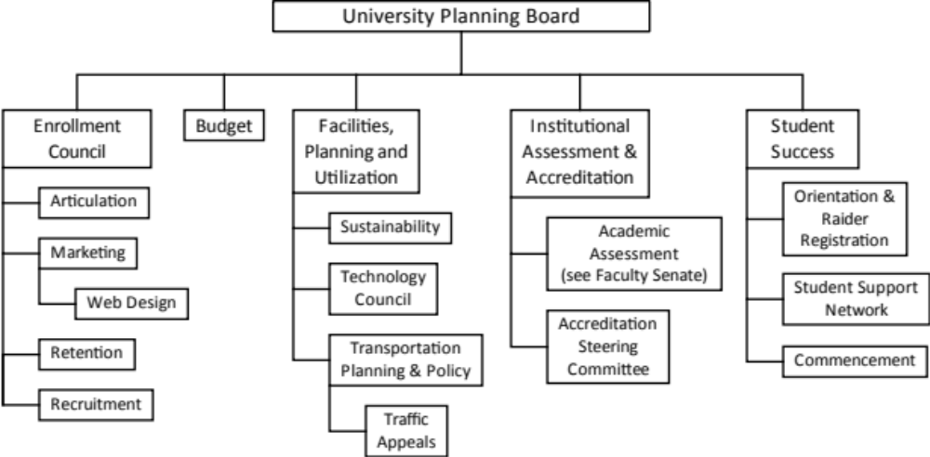
1.510

Committees Reporting to the University Planning Board
1.511
- Enrollment Council

- Charge

- The Enrollment Council shall create an optimal integrated approach for enrollment planning and assessment.

- Specifically, the Council will:

- Review and analyze enrollment related trends
- Formulate policies and strategies for enrollment
- Integrate various functions, programs, and operations
- Link marketing and enrollment strategies
- Coordinate retention efforts and assess for effectiveness

- Membership

The membership of the Enrollment Council consists of Assistant Vice President for Enrollment, Dean of the School of Business, Dean and Associate Dean of the College of Arts and Sciences, Director of Admissions, Director of Interactive Marketing and Media Relations, Budget Director, Director of Office of Institutional Research, Director of Educational Outreach and Engagement Programs, and Director of Distance Education. The Assistant Vice President for Enrollment serves as chair.

- Ex Officio Membership and Administrative Contact

The Provost and Vice President for Student Affairs serve ex officio. The Provost also serves as the administrative contact.

- Reporting, Meetings and Workload

The Enrollment Council makes recommendations to the University Planning Board and reports on actions taken as directed by that Board. The Council meets at least every other week, sometimes weekly. The workload is fairly consistent throughout the year.
1.512
- Budget Committee

- Charge

- The Budget Committee shall review information that has budgetary impact, monitor budget development, and recommend priorities for funding to the Executive Cabinet.

- Specifically, the Committee will:

- Develop assumptions on enrollment and revenue to aid in budget development.
- Hold annual hearings for each University department throughout winter and spring terms.

- Membership

The membership of the Budget Committee consists of the Provost, Vice President for Finance and Administration, Vice President for Student Affairs, one School or College Dean, one Academic Department Chair, one faculty member appointed by the Faculty Senate, one faculty member appointed by the President, two unclassified administrators, two classified staff members, one graduate student, and one undergraduate student appointed by ASSOU. The Provost serves as chair.

- Ex Officio Membership and Administrative Contact

The Budget Director serves ex officio. Executive Assistant to the Vice President for Finance and Administration serves as the administrative contact.

- Reporting, Meetings and Workload

The Budget Committee makes recommendations to the University Planning Board and reports on actions taken as directed by that Board. The Committee meets monthly, more frequently when budget hearings are held (winter and spring terms). The workload is heavier in the winter and spring.
1.513
- Facilities, Planning, and Utilization Committee

- Charge

The Facilities, Planning, and Utilization Committee shall review and recommend resource distribution for space, technology, sustainability, transportation, and other issues related to physical and infrastructure needs.

Specifically, the Committee will:
- Recommend distribution of space for departments and individuals.
- Recommend strategic investments in technology, sustainability, and the physical plant.
- Recommend priorities in capital construction and deferred maintenance.

- Membership

The membership of the Facilities, Planning, and Utilization Committee consists of the Chair of the Technology Council, Chair of the Sustainability Council, Chair of the Transportation Planning and Policy Committee, one faculty member from each School and College, one member of APSOU, one member of SEIU, and one student (either undergraduate or graduate). The chair shall be elected from the membership.

- Ex Officio Membership and Administrative Contact

The Director of Facilities, Director of Campus Public Safety, and the Associate Vice President for Facilities and Planning serve ex officio. The Vice President for Finance and Administration serves as the administrative contact.

- Reporting, Meetings and Workload

The Facilities, Planning, and Utilization Committee makes recommendations to the University Planning Board and reports on actions taken as directed by that Board. The Committee meets monthly. The workload is consistent throughout the year.
1.514
- Institutional Assessment and Accreditation Committee

- Charge

The Institutional Assessment and Accreditation Committee shall coordinate and facilitate institutional assessment.

Specifically, the Committee will:
- Maintain a schedule for program reviews
- Evaluate Program Reviews and recommend actions to the University Planning Board.
- Review recommendations of the Academic Assessment Committee and recommend actions to the University Planning Board.
- Review recommendations of the Accreditation Steering Committee and recommend actions to the University Planning Board.

- Membership

The membership of the Institutional Assessment and Accreditation Committee consists of the Chair of the Accreditation Steering Committee, the Chair of the Academic Assessment Committee, the Chair of the University Studies Committee, one faculty member from each School and College, one member of APSOU, one member of SEIU, and one student (either undergraduate or graduate). The chair shall be elected from the membership.

- Ex Officio Membership and Administrative Contact

The Associate Provost, Director of Academic Assessment, Director of University Studies, and Director of Institutional Research serve ex officio. The Provost is the administrative contact.

- Reporting, Meetings and Workload

The Institutional Assessment and Accreditation Committee makes recommendations to the University Planning Board and reports on actions taken as directed by that Board. The Committee meets once or twice each month during the academic year. The workload is consistent throughout the year.
1.515
- Student Success Committee

- Charge

The Student Success Committee shall coordinate activities related to welcoming, orientation, and retention of students.

Specifically, the Committee will:
- Coordinate retention efforts across all divisions and academic departments (instructional units).
- Review and recommend investments in infrastructure and technology to support retention efforts.
- Serve as an advisory committee to the Learning Commons.
- Review and advise actions taken for Orientation, Welcoming, and Commencement.

- Membership

The membership of the Student Success Committee consists of the Chair of the Orientation and Registration Committee, Chair of the Commencement Committee, The Chair of the Student Support Network, one faculty member from each School and College, one member of APSOU, one member of SEIU, and one student (either undergraduate or graduate). The chair shall be elected from the membership.

- Ex Officio Membership and Administrative Contact

The Associate Vice President for Enrollment or Registrar, the Dean of Students or Executive Director of Residential and Student Life, and the Director of the Learning Commons serve ex officio. The Vice President for Student Affairs is the administrative contact.

- Reporting, Meetings and Workload

The Student Success Committee makes recommendations to the University Planning Board and reports on actions taken as directed by that Board. The Committee meets once or twice each month during the academic year. The workload is consistent throughout the year.
1.600

Other Select Committees

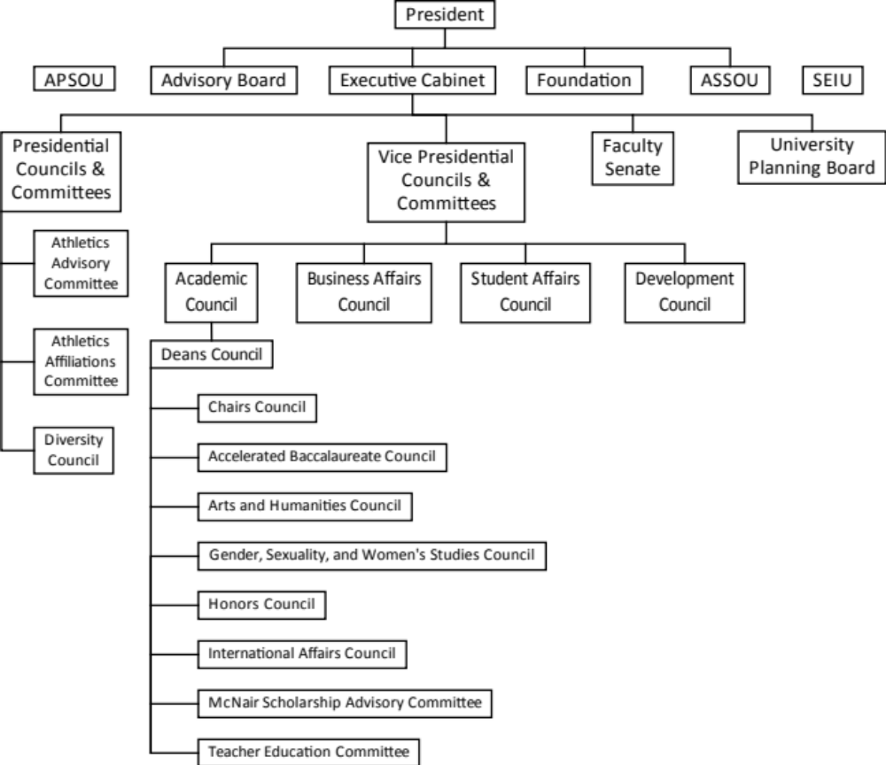
1.610

Select Committees Reporting to the Academic Council
1.611
- Deans Council

- Charge

- The Deans Council is the principal administrative committee for academic affairs. Within its purview, the Council will:
- Review and recommend policies that relate to administrative governance
- Review and recommend tuition and fees budgets
- Review and recommend organizational changes

- Membership

The membership of the Deans Council consists of the Dean and Associate Dean of the College of Arts and Sciences, Dean of Business, Dean of Education, Dean of Hannon Library, Assistant Vice President for Enrollment, Director of Information Technology, Director of Institutional Research and the Faculty Senate Chair. The Provost serves as chair.

- Administrative Contact

The Executive Assistant to the Provost serves as the administrative contact.

- Reporting, Meetings and Workload

The Deans Council makes recommendations to the Provost. The Council meets biweekly. The workload is fairly consistent throughout the year, a bit lighter in the summer.
1.612
- Chairs Council

- Charge

- The Chairs Council assists the Deans and Department Chairs with the optimal functioning and planning of the departments within the College of Arts and Sciences.

- Membership

The membership of the Chairs Council consists of the Dean and Associate Dean of the College of Arts and Sciences, CAS Administrative Staff, CAS Department Chairs, CAS Department Office Coordinators. In addition, some Program Directors and Coordinators are invited to regularly attend. The CAS Dean serves as chair.

- Administrative Contact

The Dean of Arts and Sciences serves as the administrative contact.

- Reporting, Meetings and Workload

The Chairs Council makes recommendations to the Dean of the College of Arts and Sciences. The Council meets twice a month. The workload is fairly consistent throughout the academic year.
1.613
- Accelerated Baccalaureate Council

- Charge

- The Accelerated Baccalaureate Council is the principle administrative committee for Accelerated Baccalaureate Program, which brings increased enrollment of high-quality students to SOU and retain them by offering a 3-year degree.

Specifically, the Council will:
- Review and recommend policies related to eligibility, admissions, and operation of the program.
- Review applications, including determining appropriate reductions for the 3-year degree.
- Oversee advising of Accelerated Baccalaureate students.

- Membership

The membership of the Accelerated Baccalaureate Council consists of the AB Program Director, AB Program Assistant, one representative from each participating major (or department), and one representative from University Studies (or USEM). The AB Program Director serves as chair.

- Administrative Contact

The AB Program Director serves as the administrative contact.

- Reporting, Meetings and Workload

The AB Council makes recommendations to the Program Director. The Council meets once or twice a year, with much of the work being carried out by individuals throughout each term. The workload is heaviest February through October.
1.614
- Arts and Humanities Council

- Charge

- The Arts and Humanities Council supports the role of the arts and humanities in a liberal arts education and the impact of the arts and humanities on public life.

Specifically, the Council will:
- Coordinate efforts to promote the arts and the humanities on campus and in the community.
- Create an identity for the arts and humanities within the College of Arts and Sciences.
- Develop lectures, programs, symposia, etc. that will bring together faculty and students from various disciplines in the arts and humanities and across campus through the annual campus theme.
- Foster understanding of the role of the arts and humanities in the academic community and society at large.

- Membership

The membership of the Arts and Humanities Council consists of:
- One representative from each department/program in the Fine and Performing Arts and Humanities Disciplines: Art and Art History; Performing Arts (Music and Theater Arts); Communication, Language, Literature, and Philosophy; and University Seminar
- One representative from the Computational, Mathematical, and Natural Sciences: Biology; Chemistry, Physics, Materials & Engineering; Computer Science; Environmental Studies; and Mathematics
- One representative from Social Sciences: Criminology & Criminal Justice; Health, Physical Education & Leadership; History & Political Science; Psychology; and Social Sciences, Policy & Culture (Economics, Sociology, Anthropology, Geography, International Studies, Native American Studies, Gender, Sexuality & Women’s Studies)
- One representative from the School of Business
- One representative from the School of Education
- One community member
Members are appointed to three-year renewable terms.

- Administrative Contact

The Provost serves as the administrative contact.

- Reporting, Meetings and Workload

The Arts and Humanities Council makes recommendations to the Provost. The Council meets once or twice each term. The workload is consistent throughout the academic year.
1.615
- Gender, Sexuality, and Women’s Studies Council

- Charge

- The Gender, Sexuality, and Women’s Studies Council is the principle administrative committee for Gender, Sexuality, and Women’s Studies Program.

Specifically, the Council will:
- Make recommendations regarding policies and functions of the program.
- Approve appropriate GSWS courses.
- Act as a liaison with departments on campus to coordinate and develop course offerings.

- Membership

The membership of the Gender, Sexuality, and Women’s Studies Council consists of the faculty members who teach at least one course in the program and/or participate in the program’s administrative business within a two-year period. Two students serve on the Council; preference is given to GSWS minors. Staff and community members may apply to serve. One of the members is appointed to serve as chair (one-year appointment, renewable for up to three years). The GSWS Director serves ex officio.

- Administrative Contact

The GSWS Program Director serves as the administrative contact.

- Reporting, Meetings and Workload

The GSWS Council makes recommendations to the Program Director. The Council meets once or twice a term. The workload is fairly consistent throughout the academic year with a slight rise in the spring.
1.616
- Honors Council

- Charge

- The Honors Council is the principle administrative committee for Honors Program.

Specifically, the Council will:
- Make recommendations regarding policies and functions of the program.
- Approve appropriate honors courses.
- Act as a liaison with departments on campus to coordinate and develop course offerings.

- Membership

The membership of the Honors Council consists of the Honors Program Director, Program Assistant, and representatives from academic departments in each College and School, and the Honors Club President. Ex Officio members include Director of Housing and Registrar. The Honors Program Director serves as chair.

- Administrative Contact

The Honors Program Director serves as the administrative contact.

- Reporting, Meetings and Workload

The Honors Council makes recommendations to the Program Director. The Council meets quarterly. The workload is fairly consistent throughout the academic year. The Honors Council has two subcommittees that meet as needed during the academic year, one to address curricular issues and another focusing on student activities. Members also serving on a subcommittee will be more involved than those only serving on the Council.
1.617
- International Affairs Council

- Charge

- The International Affairs Council is also the principle administrative committee for International Programs.

Specifically, the Council will:
- Advise the University President, the Provost, and the Faculty Senate on matters related to SOU’s international engagement, including strategic planning, alignment, and policy concerning internationally focused academic and experiential programs for students, faculty and staff.
- Make recommendations to the International Programs Director regarding policies and function of the Intensive English Program.
- Make recommendations to the International Programs Director regarding policies and functions related to recruiting international students and providing opportunities for SOU students to study abroad.
- Act as a liaison with departments on campus to advocate for the globalization of the curriculum and to coordinate study abroad opportunities for SOU students.

- Membership

The membership of the International Studies Council consists of six faculty members. Student Senate may appoint one student member. The chair is elected from the membership. The International Programs Director, a representative from Student Affairs, and a representative from Enrollment Services serve ex officio.

- Administrative Contact

The International Program Director serves as the administrative contact.

- Reporting, Meetings and Workload

The International Affairs Council makes recommendations to the Program Director. The Council meets at least once per term. The workload is fairly consistent throughout the academic year.
1.618
- McNair Advisory Council

- Charge

- The McNair Advisory Council is the principle administrative committee for McNair Program.

Specifically, the Council will:
- Make recommendations regarding policies and functions of the program.
- Interviews and selects eligible McNair Scholars.

- Membership

The membership of the McNair Advisory Council consists of six faculty members and one undergraduate student from the target population. Ex Officio members include Director of Housing and Registrar. The Honors Program Director serves as chair.

- Administrative Contact

The McNair Program Director serves as the administrative contact.

- Reporting, Meetings and Workload

The McNair Advisory Council makes recommendations to the Program Director. The Council meets as a whole annually (in September) and in groups of three to four during two selection rounds, one in the spring and one in the fall. The workload is concentrated around the three events mentioned above.
1.619
- Teacher Education Advisory Council

- Charge

- The Teacher Education Advisory Council advises on matters related to the teacher education program.

Specifically, the Council will:
- Periodically review teacher education policies.
- Reviews all proposed changes in policy.

- Membership

The membership of the Teacher Education Advisory Council consists of one representative from each department involved in teacher education. The Student Senate may appoint up to two members. Ex Officio members include Dean of the School of Education and Chair of the Education Department. The Dean of the School of Education serves as chair.

- Administrative Contact

The Dean of the School of Education serves as the administrative contact.

- Reporting, Meetings and Workload

The Teacher Education Advisory Council makes recommendations to the Dean of the School of Education. The Council meets at least once per term. The workload is consistent throughout the academic year.

End of Section 1

