Faculty Senate Minutes
November 17, 2014
SU 313 4:00 – 5:30 pm
Video: http://bit.ly/17juEMP

Members present: Brown, Carter, Feist, Hughes, May, Nordquist, Purslow, Richards, Rosenberg, Russell-Miller, Harvey, Shrewsbury, Slattery, Whitman.
Administrators: Saigo, Walsh,
Guests: Mulliken, Uyehara, Stanek, Morris, Nagy-Catz, Garcia-Hanson, Denney, Jablonski, Conner.

4:06 Approval of Minutes for November 3: Postponed, in order to revise record of discussion of language in Sabbatical Leave Application.

4:09 Announcements: Alice di Micele, LBGQT and Environmental Activist to present in Music recital hall at 10:30 AM, Wednesday, 11/19.

Information Items

4:10 Comments from President Saigo
- Tailgating at SOU football games has grown to 350-400 participants – Parents, alumni and friends of SOU.
- These people have good stories to tell about SOU; they help us build pride in our school, and they and the pride they show are good for recruitment.
- SOU offers a high quality education and it is carrying across generations.
- Dr. Saigo has been active in outreach; e.g. today’s schedule included Appearance on JPR, Meeting with Executive Council; Meetings with community members in Medford.
- A major motion is underway in Oregon (as elsewhere) to compress the educational process by allowing capable students to work simultaneously on High School graduation and higher education requirements. SOU must participate in this process by cooperating with local high schools and community colleges, but we must also be the leaders in ensuring that quality is not compromised in the process of compression. A leading model has come out of McCallum, Texas, and it is being studied by a variety of institutions in our region, especially Klamath Community College under the leadership of Dr. Roberto Gutierrez. We must take into consideration the maturity and social development of our children; this is a matter of concern.
- Had an inspiring meeting with the 30-plus OHSU Nursing students on our campus.
4:15 Comments from Provost Walsh
- Provost council meeting 11-6-14; many things in progress, few ready to report.
- HECC role remains a subject of discussion
- Craig Morris represents SOU on the funding model technical work group which is preparing a funding model to replace the “RAM” enrollment model now in place with a new model that is intended to reward academic institutions based on measures of academic quality; they expect to finish their work in December.
- Craig Morris clarified that the new metrics to replace RAM model for funding will be based on outcomes, especially graduations, weighted for at-risk populations of students: low income, minorities, first-generation, Pell-grant eligible and others. No agreement so far on how to measure or monitor academic quality in the new model so as to avoid incentivizing graduation at cost to quality of education.
- “Texas model” pK– 20 educational models are under discussion – greater coordination of the educational system at all levels; implications for quality control in courses offered off-campus for University credit. (See Dr. Saigo’s comments.)
- Superintendents of local school districts and local Community Colleges (especially Dr. Gutierrez) have been active in promoting the “wraparound models” for compressing the pK-20 educational experience in Southern Oregon (there are several examples of other systems doing this nationally); SOU has been involved in the Southern Oregon Success Collaborative, the Pirates to Raiders Program, and Advanced Southern Credit which are in alignment with the spirit of these initiatives, but, like other 4-year institutions, we have come late to these discussions.
- Secretary’s note: Senate Bill 222, passed during the 2013 Legislative Session, provides the legal incentive for these actions. – John Richards

4:29 ASSOU Report – Torii Uyehara
- 35 SOU students attended the Oregon Students of Color conference in Eugene
  - Good community builder
  - Good conversations around social justice and related topics
  - OSA Board members met and committed to another year’s membership in National OSA; will continue participation in national OSA initiatives, especially with regard to Pell grants
- 11-19-2014 HECC “Textbook Affordability” forum to be held from 1:30 until 3:00 in SU 319
- Some 75 students will be participating in an affordability campaign in Salem in late February; the purpose is to raise the priority the legislature places on Higher Education. Professors are requested to consider making allowances for student absences during the week of the rally, and to consider giving extra credit for participation in the rally.

4:35 Update on Houses and partial assessment of House-USEM-Honors general education programs – Lee Ayers and Kristin Nagy-Catz
- A teaching academy was held for House Faculty.
- Two new Houses, Mind & Body, and Skeptic, in their inaugural year
- No proposals for new Houses this year.
- Statistical review of retention; see slides in Appendix I for details:
  - University Studies retention rate to second year: 71%
  - Students remaining in their original House program: 41%
  - Students initially enrolling in Houses and re-enrolling fall 2014: 71%
  - Return rate for regular USEM students: 74%
  - Retention Rate for Honors students: 93%
- GPA essentially equal within statistical uncertainty for Houses and USEM, about 2/3 grade-point higher for Honors
- USEM sections have accommodated most of the students who were for one reason or another unable to continue with their Houses
- Scheduling conflicts appear to be the main reason students drop out of houses
4:43 Questions:
- (Slattery) What is subsidy to Honors?
  - (Ayers)Nearly 100%
- (Connor) What about the costs of the different programs?
  - (Ayers) We’re watching them closely, but it is still too early to assess cost effectiveness. Houses are loaded differently from USEM. Loaded for advising to relieve burden on faculty in majors.Don’t have enough data yet to assess cost effectiveness.
- (Feist) It seems Karen Stone had detailed cost per student data last spring; has that been lost?
  - (Ayers) Recruitment is about $800.00 per student, so we consider retention a win.
- (Purslow) Thanks for the data and for answering so many questions. Have we a cost per student comparison for the three models?
  - (Ayers) Chris Stanek and others have made this level of transparency possible and that is the key right now.
  - (Purslow) I would like to see the cost per student in the house model compared to the cost per student in the USEM model because there is the differential in faculty loading; and what about the 41% continuation for House students in their second year?
  - (Ayers) most of that is a scheduling issue, and most of those students did return to SOU; they will need to take many extra courses.
  - (Purslow) Did we resolve the issue of “gold sheets”? (details on “Gold Sheets” requirements for House transfers

- (Russell-Miller (Video at 42:39) You mentioned that advising is built into faculty load for University studies, but we recently have been inundated by being assigned freshman advises and we are responsible for lifting their advising holds. I thought those were a function of House and USEM faculty. Has something been changed? Is more freshman advising being moved into Departments now? What does that do in terms of loading?
- (Ayers) It seems there are many people in the background who are not all on the same page. If you are getting push-back, we need to talk about that and talk with the directors (about changing advising loads?). There has been an effort to get more students to declare majors earlier. The idea is not to lose students because they don’t get advising and don’t register before the next term. If there is overlap in advising we need to fix it.
- (Whitman) A lot of students seem to be confused about who their advisor is. Program advisors are not listed for students. There also seem to be some very complex majors with too few professors to teach all their options; the majors need to review and simplify their course options.
- (Ayers) Kristen (Nagy-Catz)(tape at 46:44) is ready to present on Assessment in University Studies
- (Nagy-Catz)Hand-out with data. FUSE = “Final University Seminar Essay” Used to assess achievement relative to senior writing rubric (Based on AAC&U writing rubric for strands A&B) as snapshot of student achievement at end of first year USEM, House, and Honors. (The data presented offer a first opportunity to compare student achievement on Strands A&B in the three University Studies programs: USEM, Houses, and Honors) see (add URL HERE)
Analysis based on random sample of two students from each USEM section, and universe of House and Honors students. (Purslow) Are these samples representative and comparable? (Jim Hatton) On representative: 102 of 555 USEM students in sample (almost 1/5) with a large “n”; full universe for House and Honors; I spoke with Rene Ordoñez, and we can do chi square tests on these samples to look for significant differences across categories.)
- (Harvey) It would be interesting to see how GPAs align with scores on FUSE.
5:00 (57:00 on Video) Update on new sabbatical forms from Faculty Personnel Committee – Dennis Jablonski
Faculty Personnel Committee met with members of the Sabbatical leave application task force
- Three areas of concern:
  - Does the form place boundaries on faculty expertise on determining the benefit of their projects
    - Senate may need to clarify the language in the by-laws to clarify how sabbatical projects should be of benefit to the individual and the University; the senate may want to modify that language
  - Is the scoring guide appropriate and how will it be used?
    - Committee believes categories of benefits addressed in the form are appropriate but
    - Scoring descriptors need further descriptors based on feedback from this year
    - Scoring guide to be used as exploratory, not consequential tool; faculty members will not be denied sabbaticals on the basis of their score; we want to see how the form works.
  - What are the requirements for post-sabbatical reporting?
    - Post-sabbatical report remains appropriate
    - Director and Provost are supposed to respond to the faculty member in writing with regard to the report, and response should be more than perfunctory (Acknowledging faculty accomplishments would be in order.)
- Question (Feist) What next? Should we expect to hear some feedback from you about the evaluation process in the Winter term? (Jablonsky) Probably it will have to wait until spring because that is when those evaluations will go forward. (Walsh) What would you want to see? (Feist) Something like, “Yes, this is the form we want to go forward with next year.” (Walsh) That isn’t a Senate decision, but, yes, we would share that information with you. (Jablonsky) We are willing to work with the form for a year, and then see how to revise it. (Walsh) Many good things have come from this discussion; there seem to be a lot of things we can fix to align expectations and by-laws

5:08 (1:03:40 on video) Carpenter II Grant Recommendations – Anne Connor
- Received 22 applications with requests for just over $15,000 but had only $8,300 to disburse, so had to prioritize
- Ranked applications and recommend awarding 16 grants
- Maximum grant was $750

5:10 (1:05 on video) Assessment Committee Goals & Activities for 2014-15 – Jim Hatton
- The purpose of assessment is to determine whether students are learning what we expect of them
- Assessment is a process of continuous cycles of documented measurement, analysis and adjustment
- This is our third year of assessment review; Information is stored in TracDat®
- Assessment of student learning outcomes takes place in larger context of institutional planning and budgeting
- Important component of enhancing institutional quality and accreditation
- Disappointing data generation from last year.
- This year’s goal includes gathering and analyzing data, and talking about program adjustments; one process will be a FUSE-style report on senior writing performance; portfolio reviews; quantitative literacy; citizenship; do service classes meet needs and goals?
No questions

5:17 (1:12:51 on video) Growing enrollment through athletics – Matt Sayre, Lisa Garcia-Hanson, Mark Denney
- Response to request from President Saigo to increase enrollments via athletics
- (Sayre) capacity largely limited, but we have looked for alternatives and enrolled 18 new students
- The investment is not so much for athletics as for the institution as a whole
- Our athletic program is the lowest-funded in the state from the general fund; playoff travel puts us over budget.
- (Denney) Athletics is one of several paths we are looking at for enrollment growth:
- Because the bulk of our costs are fixed, when enrollment is shrinking, reduction of costs generally do not keep pace with reduction in revenues; by contrast, when a program is growing, increased costs do not generally keep paced with increased revenues (until you run into capacity constraints)
- Generally, athletes, relative to the student body as a whole produce higher marginal revenue-to-marginal cost ratios and have higher retention and graduation rates, more out-of-state residents
- In considering expansion, we need to consider the costs and benefits of adding specific programs
- All additions will have costs , but should we add to rosters or add sports?
- The costs of adding the new sports we are considering will generally be ½ to 1/3 of the revenues those programs will generate.
- Housing has been helping to support student athletes because the general fund has been unable to do so.
- This or any other program that increases enrollment will provide greater revenues than costs.
- (Garcia-Hanson; 1:23 on video) How can this be a good option for increasing enrollment? Anything we undertake needs to have a positive ROI (Return on Investment)
- Student retention (this year) SOU 73.8%; student athletes 89.2%
- 6-year graduation rates: SOU – 39.7; Student athletes – 60.4%
- Full time SOU: 85%; Student athletes 99%
- Ethnic diversity: 75% of SOU African-American students are athletes
- (Sayre) Most comparator schools are growing; we have capacity only in track-and-field at present
- We will need to recruit students who are being recruited by other schools: participation and majors are key attractions
- Criteria: Title 9; we should add women’s wrestling if we want to add men’s soccer; NAIA programs and Local competition; extant facilities; costs per student athlete; season
- “Club sports” – no head coach, no scholarships La Cross. Bicycling is an exception to these club sports restrictions.
- (Denney) need significant ROI; we are looking at a variety of programs and requesting feedback
- (Purslow) What does it take to get going (Sayre) generally a one-year lead time for the programs we are consideration.
- 1,000 Women seniors between anchorage and San Diego looking for a place to wrestle.
- (Waters) Rugby we already have a coach and a team. – (Sayre) Not an NAIA emerging sport
- (Slattery) Have you considered a student enrollment multiplier for student enrollees?
- (Denney) We have decided to be conservative and not use that. (Saigo) you are right – at Southeastern Louisiana University they lost 1-2 additional students for every team player who left.
- (Nordquist) Does the range of 70-50% of new revenues exceeding cost reflect just the costs to the athletics department, or total costs of educating the students?
- (Denney) Just the athletics department. Those students would tend to filter out across the board. If we got an additional 100 students, there might be an additional section here or there, but we would have to be lucky enough to have sustained growth to require additional permanent faculty hires.
(Purslow) Timeline? – Sayre – 30 male soccer players and 20 women wrestlers by fall, 2014; 20
(Slattery) Recruitment multiplier? (denney) Not factored in, to be conservative.
(Nordquist) My concern is we might be pouring additional students into our workloads. Is there any way to check? (Slattery) We already have an issue of overloads across campus; need some way to forecast where extra demand will fall.

Discussion Items

5:42 (1:37:43 on video) Update bylaws for emeritus status for professional rank faculty

Action Items
- Moved (Purslow and seconded (carter) to waive 2-week rule)
- Moved (Richards) and seconded (Rosenberg) To add language to the By-laws to accommodate emeritus status for professional faculty of all ranks
- Passed unanimously
5:46 Senate seats for Divisions
- PROPOSAL:
3 seats each for each of the new divisions:
- Center for the Arts; Business Communication and the Environment;
- Health Physical Education and Leadership; Humanities and Culture;
- Science Technology Engineering and Mathematics;
- Social Sciences (18 senators);
- One seat each for the Library and Undergraduate Studies (2 senators), and
- four at-large senators.
- Total senate of 24.
- Note: STEM is currently over-represented

Questions: (Purslow) Why only one representative for Undergraduate studies?
(Walsh ) To carry forward past practices.
(Whitman) Maybe it should get more representatives as its tasks increase?
(Ayers) Most additional faculty in Undergraduate are already represented through their home divisions; one representative is probably enough.
(Carter) There are relatively few faculty whose primary responsibilities are in the Division of Undergraduate Studies.

Motion (Feist) To institute this representative structure. Second (Ormes)
Passed – Unanimous vote by quorum of 13 senators.

Meeting Adjourned: 5:55 PM.

APPENDIX I: Houses presentation to senate by Lee Ayers
Overview of House
Lee Ayers,
Division Director,

HSE 101 in Fall 13 (n=87)
 91% returned to SOU in Winter 14
 83% returned & stayed enrolled in their HSE course

Of those original 87 students
 90% stayed enrolled at SOU in Spring 14
 67% of them stayed enrolled in a HSE course (n=61)

Of the original 87 students:
 71% came back to SOU and enrolled in Fall 14
 41% enrolled in a HSE 201 course

USem 101 in Fall 13 (n=555)

 94% returned to SOU in Winter 14.

Of those original 555 students

 91% stayed enrolled at SOU in Spring 14

Of those original 555 students

 74% came back to SOU and enrolled in Fall 14.

Honors 101 in Fall 13 (n=28)

 100% returned to SOU in Winter 14.

Of those original 28 students

 100% stayed enrolled at SOU in Spring 14

Of those original 28 students
 93% came back to SOU and enrolled in Fall 14

House USem Honors

Fall 13 Enrollment* 87 students 555 students 28 students

Retained at SOU Winter 14

Retained in House Winter 14

Retained at SOU
Spring 14

Retained in House Spring 14

Retained at SOU
Fall 14

Retained in House
Fall 14
91% 94% 100%

83%

90% 91% 100%

67%

71% 74% 93%

41%

*Populations vary greatly thus significance of results may come into question.
Longitudinal comparisons and/or larger n values
needed before conclusions can be drawn.

Fall 2013
 House: 93% C- or higher
 USem: 91% C- or higher
 Honors: 100% C- or higher
Winter 2014
 House: 89% C- or higher
 USem: 94% C- or higher
 Honors: 100% C- or higher
Spring 2014
 House: 97% C- or higher
 USem: 96% C- or higher C-
 Honors: 100% C- or higher

*Percentages based upon:
grades included in attempted hours &GPA calculations

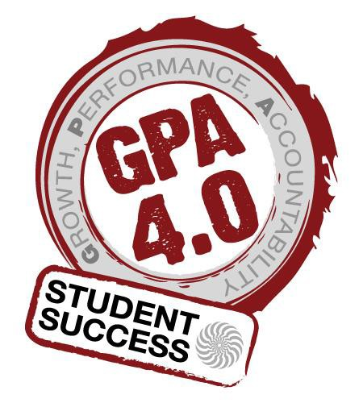
Fall 13
 House =2.93
 USem= 2.91
 Honors = 3.71
Winter 14
 House = 2.87
 USem = 2.97
 Honors = 3.69
Spring 14
 House =2.90
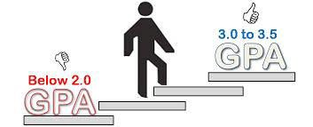
 USem = 3.08
 Honors = 3.65

Fall to Fall 2013-2014

 SOU 72.5%

 Essentially the same as USem 555

 87 vs 555 (*2 more House students retains = to USem)

Worth Noting:

- One Social Justice Student boot camp

- One Green House Student study abroad

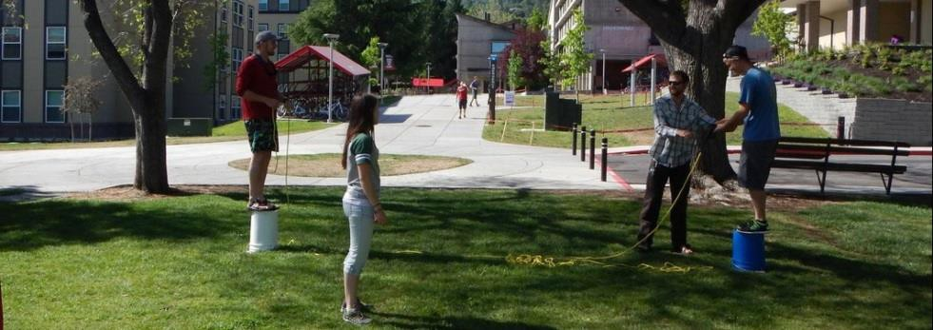
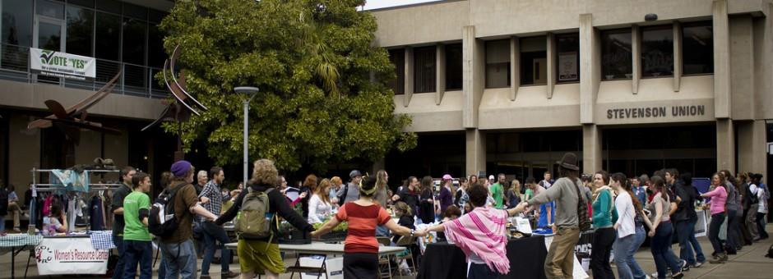
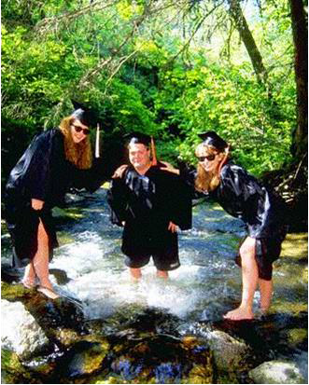
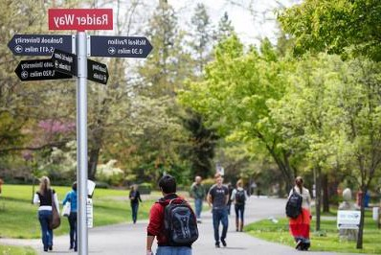

House
- USem
- Honors

