**Assessment Committee Members**

2015-16: Jim Hatton, Kristin Nagy Catz, Craig Stillwell, Lee Ayers, Jamie Vener, Dorothy Ormes, Hart Wilson, Jody Waters, Rene Ordonez, Erin Wilder, John Taylor, Heather Buchanan

**Summary**

The SOU Faculty Senate Assessment Committee devised and tested an oral presentation assessment process. It developed a rubric and a norming process. It took a survey of all programs and then teams attempted to visit thirty presentations both at SOAR and at individual program capstone events.

The teams ended up visiting only eighteen presentations. Given the small sample size, the critical thinking components of the presentations were generally accomplished or exemplary. Language usage and elocution less so. Major issues arose around the difficulties of scheduling team visits and the inappropriateness of the rubric for some types of capstone presentations.

**Recommendations**

***For the Assessment Committee***

Fall 2016

1. Review and improve the rubric with possibly less emphasis on critical thinking or possibly taking a broader view of critical thinking.
2. Devise a smoother way of scheduling team visits.
3. Provide feedback to the programs during the fall assessment workshop.

Winter 2017

1. Conduct a norming session.
2. Find oral capstone presentations for student graduating winter term and test the rubric.

Spring 2017

1. Conduct a campus-wide oral presentation study.

**Background**

### SOU’s Strand A communication goals include effective oral communication as can be seen from this excerpt from the University Studies website.

**Strand A: Communication Goals**

***Communicate effectively using writing, speech, and image****.*

1. **Demonstrate ability to use Standard American English**.  
   *Proficiencies: Students will be able to*  
   1. Use standard conventions of grammar, punctuation, mechanics, and spelling.
   2. Structure sentences in varied and appropriate ways.
   3. Use vocabulary and phrasing appropriate to purpose and audience.
2. **Accurately comprehend written, verbal, visual, and/or symbolic communications.**  
   *Proficiencies: Students will be able to*  
   1. Summarize relevant components and structures in messages.
   2. Interpret communications’ purposes and cultural assumptions.
   3. Identify arguments used to justify a position.
   4. Critique and assess meanings.
3. **Communicate in ways appropriate to purpose and audience.**  
   *Proficiencies: Students will be able to*  
   1. Use effective styles, content, and or images.
   2. Adapt messages to facilitate mutual understandings.
   3. Target varied audiences for specific communication purposes.
   4. Develop claims and supporting information.
4. **Collaborate with others to achieve a common goal.**  
   *Proficiencies: Students will be able to*
   1. Demonstrate accountability to group processes and goals.
   2. Practice norms of effective communication and active listening.
   3. Use a variety of conflict management skills.

The Senior Writing assessment process seems to be working well and the Assessment Committee thought that a similar process could be used to gain a sense of the quality of senior oral presentation skills.

**Process**

During the fall 2015 and winter 2016 the committee revised an oral presentation rubric developed from national standards, an AAC&U rubric and in a faculty workshop in 2011. The rubric can be found at the end of this document. The committee surveyed all departments to determine when, where and if their seniors made oral presentations. It held a norming process lead by Kristin Nagy Catz, Director of Assessment, using videos provided by the Criminal Justice program. The committee divided into six teams and determined that each team should visit five presentations – one USem SOAR presentation to get a sense of what students can do as first year students, one SOAR presentation by a senior (only one since these presentations would probably be more rehearsed) and three senior presentations scheduled as part of a capstone class. The particular presentations were chosen to cover programs in all the different divisions. Teams then visited the presentations and entered their agreed upon results in a Qualtrics survey form.

**Results**

The teams had trouble scheduling and attending student presentations. This was partially because the public SOAR schedule did not contain enough detailed information and partially because conflicts in team members’ schedules together with the times for the student presentations. In the end only eighteen presentations were visited and not always by both members of the team. Visits were made to three biology, three business, three EMDA, one math, three outdoor leadership, one sociology, three USem and one unspecified presentation.

Several of the presentations were more reflective than analytical. This type of speech did not fit into the rubric categories easily. All talks were appropriate and well-adapted for the audience. Time constraints were uniformly met. Fifteen out of eighteen people were suitably attired. Sixteen out of eighteen presentations showed adequate preparation.

The sample was too small to draw any effective conclusions. The following information is provided as a proposed template for future reports only. Note that Usem data has been combined with the senior data and that some categories were not rated by all evaluators.









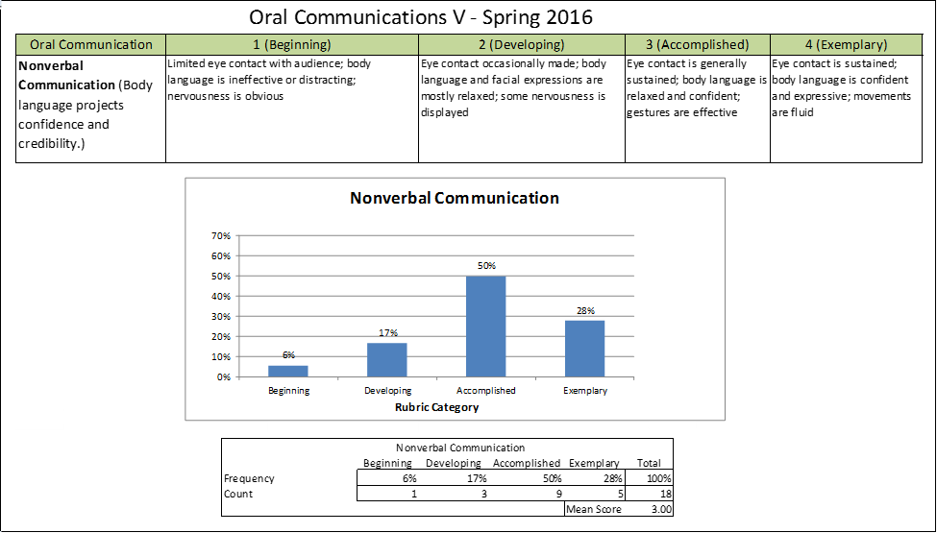





As can be seen, students generally scored in the upper two rubric categories except for elocution and language usage.

This horizontal bar chart offers another way of comparing scores. In the chart below, the more green on a bar, the higher the level of student achievement. The lighter green represents "Accomplished" proficiency. The students that followed-up were good at it.

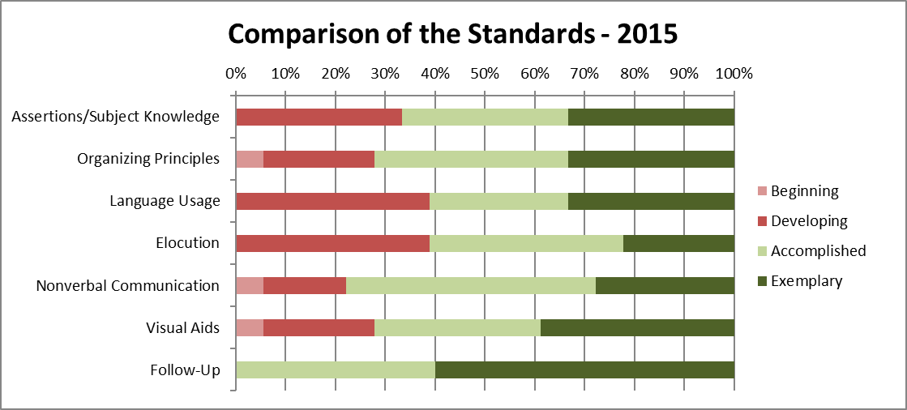

**Quantitative Reasoning Results**

The committee also experimented with oral communication quantitative reasoning (QR) assessments. Nearly sixty percent would or should have used QR.

Those students would did use QR did a good job.

**Interpreting the Results**

Just to be clear, the sample size was too small for any conclusion to be drawn about the quality of SOU senior student presentations.

**Interpreting the Results with a Grain of Salt**

The committee recognizes that there will be systematic flaws in any senior oral presentation study. Here is a list of the committee’s equivocations so far.

1. The exigencies of schedule will necessarily require that not all programs will be visited.
2. The intent of senior presentations appears to vary widely. In particular, many presentations are not of the research/critical genre.
3. SOAR presentations appear more polished.

The recommendations from the beginning are repeated here.

**Recommendations**

***For the Assessment Committee***

Fall 2016

1. Review and improve the rubric with possibly less emphasis on critical thinking or possibly taking a broader view of critical thinking.
2. Devise a smoother way of scheduling team visits.
3. Provide feedback to the programs during the fall assessment workshop.

Winter 2017

1. Conduct a norming session.
2. Find oral capstone presentations for student graduating winter term and test the rubric.

Spring 2017

1. Conduct a campus-wide oral presentation study.

**Improving the Process**

The Committee will have extensive discussions next fall.

**Appendix A**

**Oral Presentation Evaluation Rubric**

