**Assessment Committee Members**

2014-15: Jim Hatton, Kristin Nagy Catz, Craig Stillwell, Lee Ayers, Jamie Vener, Dorothy Ormes, Hart Wilson, Jody Waters, Vicki Suter, Dale Vidmar, Rene Ordonez, Erin Wilder, Peg Sjogren, Tiki Boudreau, John Taylor, Jeff Gayton

2015-16: Jim Hatton, Kristin Nagy Catz, Craig Stillwell, Lee Ayers, Jamie Vener, Dorothy Ormes, Hart Wilson, Jody Waters, Rene Ordonez, Erin Wilder, John Taylor, Heather Buchanan

**Summary**

The SOU Faculty Senate Assessment Committee evaluated 39 senior writing papers randomly selected from 545 submissions gathered from nearly every academic program over the summer of 2015. In addition, the committee evaluated 26 FUSE (Final University Seminar Essay) papers selected from 397 papers. The papers were evaluated using the Senior Writing Evaluation Rubric developed as a result of the 2012-2013 Capstone Assessment Pilot Project. This year the committee also included a pilot evaluation of Quantitative Reasoning(QR).

Papers were reviewed blind, although each paper was identified by major program to enable a representative random sampling. Each paper was identified by student ID number to allow for a deeper analysis of demographic factors, including transfer status. Comparison with the assessment of freshman writing (the Final University Seminar Essay [FUSE]), showed clear improvement from first-year writing to senior writing.

As was the case last year, the evaluation revealed a wide disparity in quality and completeness. There was little change from 2013-2014 to 2014-2015 in average scores though there were more exemplary ratings. General weakness was observed in organization/development, use of evidence, and inferences and conclusion. Over two-thirds of the papers, senior writing and FUSE, used or could have been substantially enhanced by using some quantitative reasoning.

Overall, the Information Literacy (IL)scores of the senior writing sample scores were nearly the same as the scores from last year. Also, the scores of the senior samples were only slightly better than the FUSE scores.  However, the IL senior scores were a little better when the formal research papers were separated from the reflective papers, project documentation, and creative writing samples. That said, the scores indicate there is a lot of room for information Literacy improvement in the senior writing samples.

**Recommendations**

Our recommendations for programs are the same as last year.

***For Programs***

1. Study the results of this report and seek alignment of written proficiency expectations for graduating seniors with the standards articulated in the evaluation rubric.
2. Review how writing skills are developed throughout the program's curriculum.
3. Gain a deeper understanding of student writing proficiency by conducting an internal evaluation of the program's senior writing submissions using the Assessment Committee model. Help and guidance are available from the Assessment Committee on request.
4. Request assistance and guidance from the Assessment Committee; use any and all resources available.
5. Consider using the evaluation rubric in senior writing courses, or other learning tool, as a self-assessment.
6. Directly address the areas of weakness identified by this review:
   1. Work with students to clearly articulate the context and purpose of their papers.
   2. Help students with their tendency to digress.
   3. Focus on critical thinking.
   4. Work more closely with Library faculty to improve scores on information literacy.

***For the University and the Assessment Committee***

1. Repeat the process next year with full participation of all programs, and more precise specifications about the senior writing samples desired, specifying research papers if possible.
2. Continue collecting exemplary papers.
3. Work with the tutoring center to hold a workshop on writing standards using the senior writing rubric.
4. Revise the rubric for clarity and distinction of categories.
5. Include capstone faculty in the spring workshop.
6. Improve the QR rubric and include in the next senior writing assessment iteration.
7. Design and implement professional development initiatives for faculty focused on writing throughout the curriculum.

**Background**

### SOU has had a senior writing requirement since before 1990. The current catalog states:

### Writing and Research Component

Demonstrate writing and research skills within the academic field of study chosen as a major. This upper division requirement is in addition to the University Studies writing requirement. It is met through coursework in the major that is designed to encourage the use of professional literature.

Students who have achieved the writing and research goals will be able to:

1. systematically identify, locate, and select information and professional literature in both print and electronic formats within the knowledge base of the specific discipline;
2. critically evaluate such materials;
3. use the materials in a way that demonstrates understanding and synthesis of the subject matter; and
4. develop cohesive research papers that use data and professional literature as evidence to support an argument or thesis following the style and conventions within the discipline of the major.

For five years prior to 2013-14, SOU administered the Collegiate Learning Assessment (CLA) which compared our students’ writing and critical thinking to those of other schools. While the results were valuable, administering the test and recruiting enough participants was extremely challenging. Because the test was not tied to actual coursework, it was also difficult to gauge the extent to which students took it seriously. As a result, in the spring of 2013, the Assessment Committee proposed and successfully implemented a pilot program to evaluate student writing skills, by examining senior writing samples. This evaluation had the advantage of using embedded artifacts, that is assignments, typically capstone papers, that were intended to be graded and were required for graduation.

**Process**

The Assessment Committee solicited senior writing samples from all programs; specifically, asking for one paper from each of the program's graduating seniors. By the time the sample was taken all programs except Creative Writing, Music and Theater Arts had submitted at least one paper. In total, the Committee received 545 papers, representing over seventy percent of the 762 bachelor's degrees awarded in 2015. Student names were removed from the chosen sample. SOU’s Institutional Research Board approved this process in 2013. An evaluation rubric developed from AAC&U standards was used again with only minor changes. A QR component was developed, modeled on the Carleton College Quantitative Inquiry, Reasoning, and Knowledge (Quirk): Rubric for the Assessment of Quantitative Reasoning in Student Writing.[1] The three hundred and ninety-seven FUSE papers where gathered by the General Studies Office.

While the UAC teams were evaluating writing and critical thinking proficiencies, the Library faculty concentrated on information literacy. Similar to the previous year, eight library faculty members began by assessing three sample papers using a similar norming process used last year and described by Peggy Maki (2010)[2] [1] to establish inter-rater reliability. A total of 67 sample papers were evaluated with each paper being reviewed by three-member teams. The sample papers were a mixture of senior writing samples and first-year FUSE samples.

Sample Size Determination

Using a stratified sampling method as described by Schaeffer et al (1990), Assessment Committee Chair Jim Hatton and committee member Rene Ordonez determined the sample size from each stratum. See Appendix B for the details of the process.

The stratified sampling method was used for the following reasons:

1. It produces a smaller margin of error (*B*) than would be produced by a simple random sampling.
2. It has a lower cost (time) per observation in the survey.
3. It allows for estimating the population means for each stratum, e.g. for estimating averages for each department or program, though for most programs the number of evaluated papers is too small to draw meaningful conclusions.

A total of 34 capstones were selected and randomly chosen from the program strata. The committee determined that a sample size in the thirties was logistically feasible and, in the end, 39 papers were assessed. In order to ensure fair representation of capstones from each program, this sample size was apportioned to each of the strata (programs) proportionate to the total number of submissions contained in each stratum. The sample include selections from the programs that turned in late papers. The paper in a foreign language was evaluated with the assistance of Ann Conners.

Norming and Evaluation of Sample Papers

Prior to evaluating and rating the selected papers, Director of University Assessment Kristin Nagy Catz chose two senior papers and two FUSE papers of varying quality for evaluation by all committee members in order to calibrate the rubric and norm the evaluation process. Once the rubric (see Appendix A) was calibrated and the process normed, six teams (two committee members in each team) evaluated and rated roughly five senior papers and five FUSE papers each. Each evaluation team followed these steps:

1. Each member independently read, evaluated, and rated the papers assigned to the team using the Writing Evaluation Rubric.
2. The team members met, compared, and discussed their ratings on the assigned papers.
3. Where there were differences in their ratings, the members negotiated an agreement on a single rating.
4. Each team entered its ratings for each paper in a Qualtrics survey to facilitate data collection and analysis.

Description of the Sample

The committee classified 37 of the senior writing samples as shown.

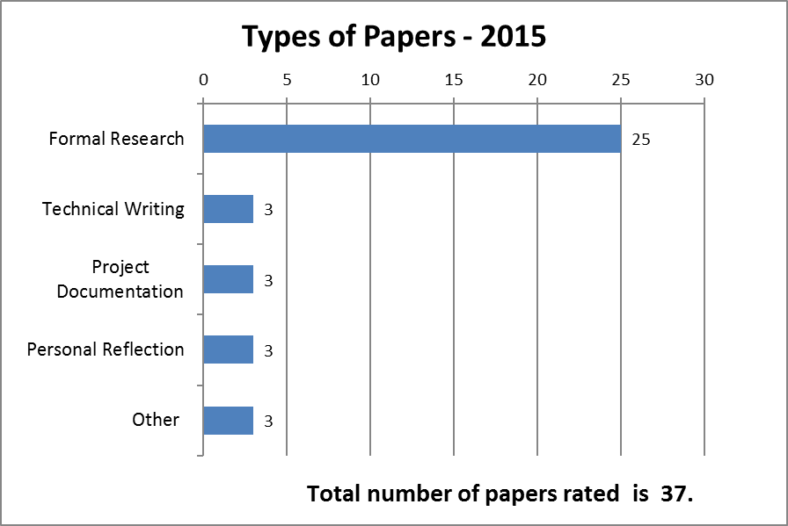

More than half of the papers were 15 pages or less in length as shown. All FUSE papers were around five pages.

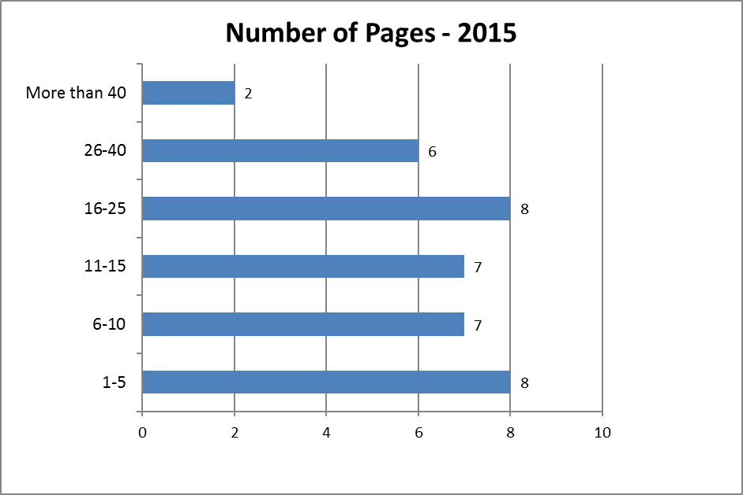

As was the case last year a substantial percentage of all the papers were deemed in need of revision.

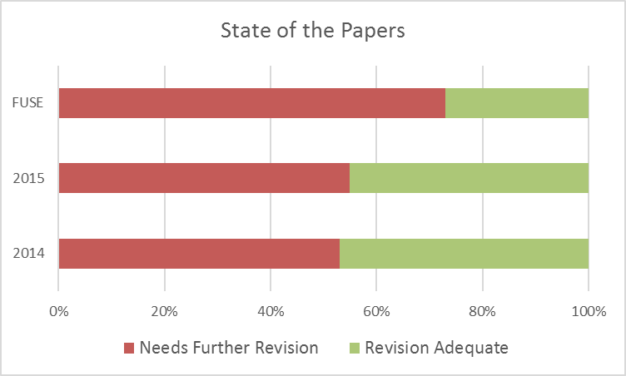

**Results of the Evaluation**

The results are presented as a series of graphs with comments if warranted. While the rubric represents a four-point scale, it's important to keep in mind that a rating of four is considered Exemplary, while a rating of three indicates Accomplished. Also, the kinds of papers submitted varied greatly, resulting in lower scores for some elements that were not required in all papers. Thus, scores between two and three are not necessarily low.

In terms of content development and organization, the scores reflect a large percentage of “developing” writers.



Beginning and developing writers make up thirty-six percent of the papers scored on effectiveness of expression (fluency, word choice, etc.).



Thirty-three percent of the students were less than “Accomplished” in the mechanics of writing.



When evaluated on critical thinking skills, sixty-four percent showed the ability to maintain a central focus.



Sixty percent could provide evidence to support their central theme.



More than half of the students had difficulty drawing valid inferences and/or drawing a clear conclusion. This category had the lowest mean score.



The charts below offer a comparison among the writing and critical thinking standards. Scores for the critical thinking category of drawing inferences seem more widely distributed than other dimensions.



This horizontal bar chart offers another way of comparing scores. In the chart below, the more green on a bar, the higher the level of student achievement. The lighter green represents "Accomplished" proficiency.

This graph shows that a substantial proportion of the seniors are somewhat deficient (at the "Beginning" or "Developing" level) in writing and critical thinking. They are particularly deficient in "Inferences and Conclusions." However, in the first four categories 20% of the papers had exemplary work.

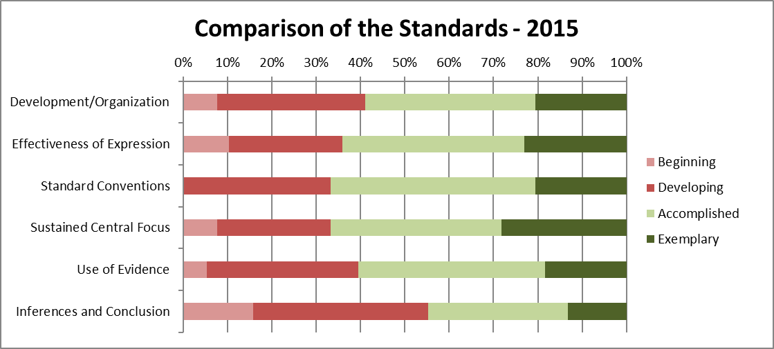

2013-2014 versus 2014-2015

The two charts below show that the overall distributions in categories exhibit little change. Though students from 2015 were somewhat better at using evidence and worse at drawing inferences.

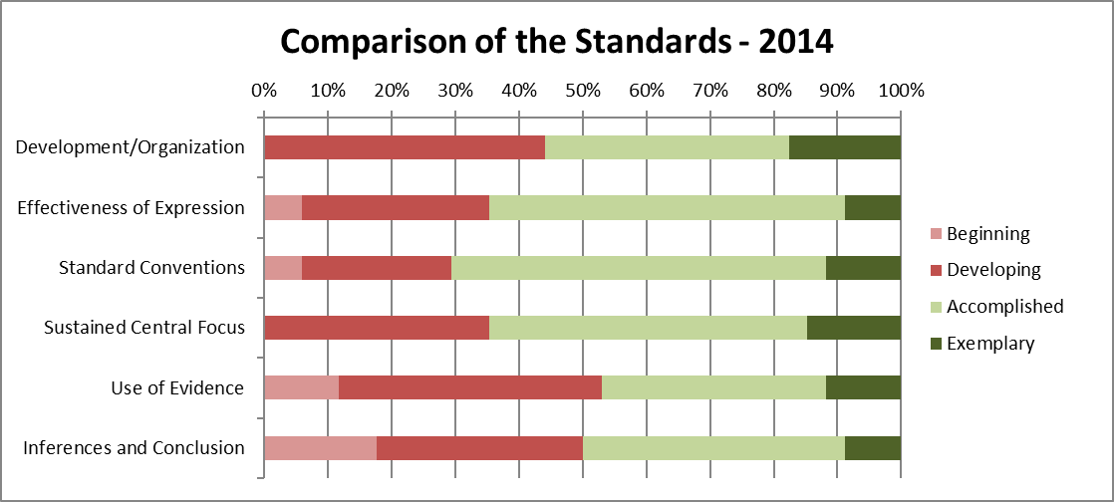



FUSE versus Senior Writing

There is a clear improvement from freshman to senior year.

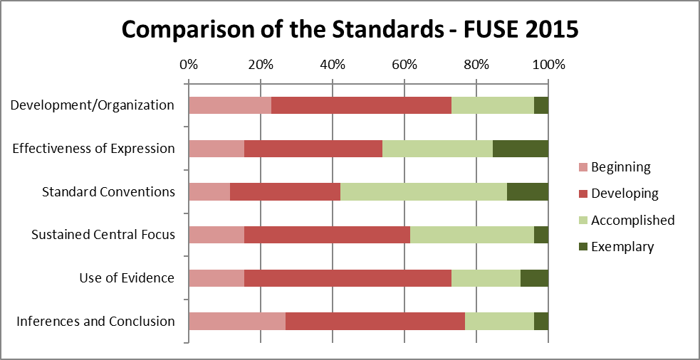

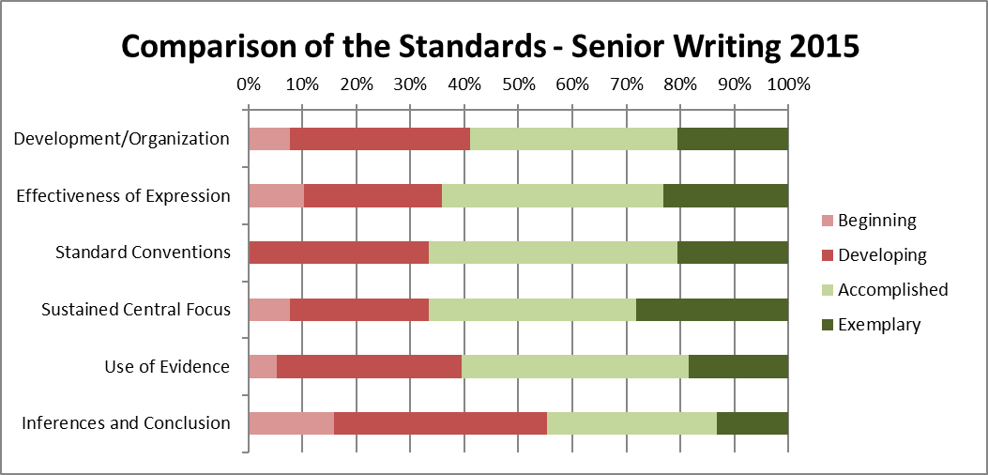

**Information Literacy Results**

These charts represent the results of the assessment conducted by Library faculty.

“Necessity to Cite” has a fairly flat distribution.



Forty percent of the students were inconsistent in their citations.

A majority of the students used timely sources.



Two-thirds of the students used sources relevant to their thesis.



Source quality had a flat distribution.



Forty-six percent of writers integrated an acceptable range of sources.



This graph allows comparison of the Information Literacy standards. The large percentage of students in the beginning and developing categories for range of sources may be the result of the variety of different types of papers submitted to the committee. The writing samples ranged from academic research papers to reflective essays, with many more sources required for the former. Over 30% of student papers in all categories were rated in the beginning or developing range.

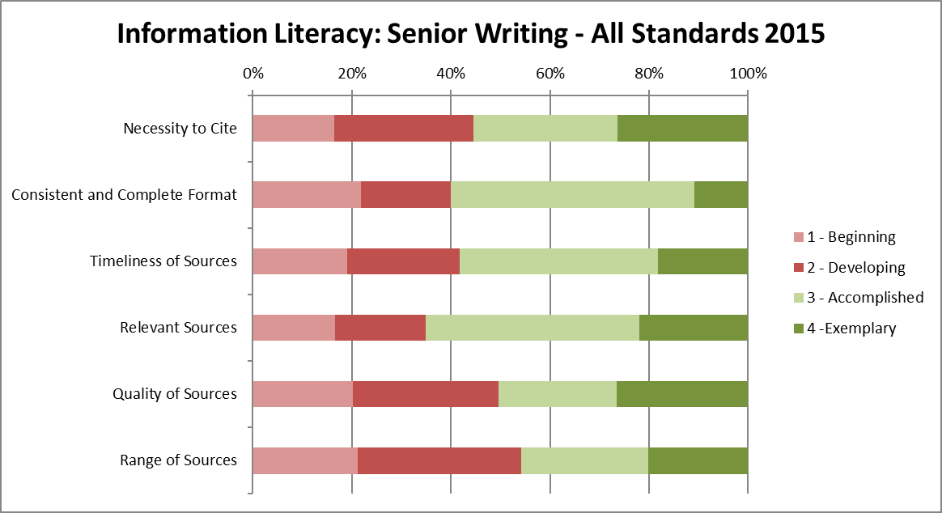

For comparison purposes, the results from 2014 are below. This year’s students are better at formatting citations.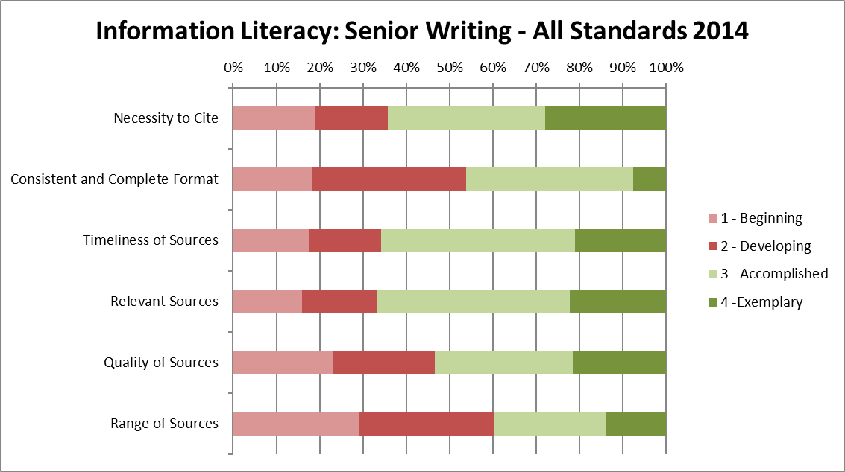

FUSE versus Senior Writing

Seniors show noted improvement.

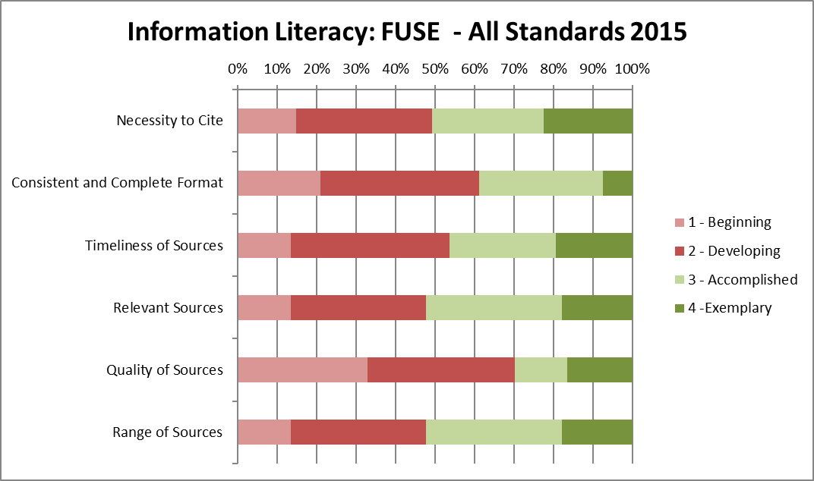

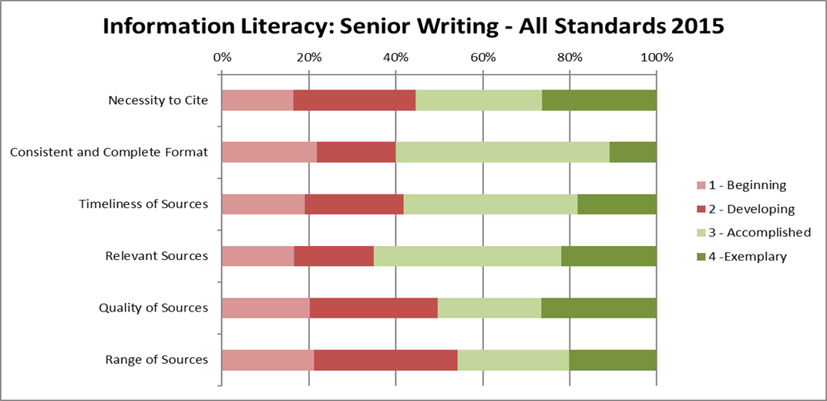

**Quantitative Reasoning Results**

The results from the pilot QR rubric are below. Nearly forty-one percent of senior papers needed to include QR and an additional eighteen percent would have been enhanced by using some form of QR.

Seventy-seven percent of FUSE papers need to have some QR thinking.

As part of their pilot study the Assessment Committee attempted to evaluate the quality of the quantitative reasoning that was present in the papers using a rubric which can be found in an appendix. Some members rated a quality as beginning if it was nonexistent and others only if it existed and was rudimentary. This is the reason why the two graphs below have omitted the beginning category.

Over sixty percent of seniors did not explore the credibility of their sources for numeric data.

A large majority of first year students are weak at using quantitative reasoning.

**Interpreting the Results**

The committee has now evaluated senior writing for two consecutive years. The results were consistent from year to year. Since there were no major changes in the teaching of writing university wide, the consistency of results can be attributed to consistency of measurement. The norming methods and the rubric are working. The information generated by this evaluation can be considered baseline data, the first measurement in a time series of succeeding studies. This baseline suggests that large percentages of SOU senior writers are less than accomplished in several categories. Improving this situation should be a goal of the University.

A comparison of senior writing with FUSE samples reveals a significant rise in proficiency. Yet over thirty percent of seniors were deficient (beginning or developing) in one or more categories. While writing skills are emphasized in University Seminar classes, it is possible that these skills atrophy from first year to senior year due to lack of focus on writing in later terms.

There are many other ways to have organized the results of the study that might have yielded more insight. As questions come up, the data captured through this analysis can easily be reanalyzed. In addition, we now have a repository of1002 papers which can be used to answer other research questions.

**Interpreting the Results with a Grain of Salt**

The committee recognizes that systematic flaws in the Senior Writing study make it hard to come to definitive conclusions. Here is a list of the committee’s equivocations.

1. Small programs are overrepresented in the sample. Since small programs can give their individual majors more attention, this may have resulted in overly high averages in the rubric categories.
2. Not all possible writing samples were submitted. The number of 2014 graduates was 762. The number of submissions was 545. It is possible that the non-submitted samples would have been of lower quality. Without these lower scores, the results in this sample may have been skewed upwards.
3. The degree of polish of the writings can have many causes. The students could have been required by their program to revise and edit their papers multiple times. The program's capstone process could include multiple revisions under the guidance of a faculty member. The students could have had “outside” help, using the writing lab or having access to a good editor. In other words, it is unclear how much the degree of polish is directly due to the individual student’s abilities.
4. The committee explicitly decided not to check for the possibility of plagiarism which might account for some degree of polish. With a repository of 1002 papers, questions of plagiarism could be pursued easily by submitting a random sample to Turnitin.com.
5. The submitted papers may not have been the best senior writing samples available from a given program. Programs may not have obtained and stored electronic copies of their students’ work. This may have resulted in skewing the results downward.
6. Expectations for the senior writing were probably higher than those of the FUSE paper since the writers were graduating seniors.
7. Expectations of the seniors’ professors may not have been consistent with the writing and critical thinking expectations that the rubric presumed.
8. The rubric was generated for use by a committee representing various disciplines and with a specific focus on assessment. While the committee urges the use of a rubric as a tool for evaluating writing, it does not prescribe or mandate the use of this particular rubric.

The recommendations from the beginning are repeated here.

**Recommendations**

Our recommendations for programs are the same as last year.

***For Programs***

1. Study the results of this report and seek alignment of written proficiency expectations for graduating seniors with the standards articulated in the evaluation rubric.
2. Review how writing skills are developed throughout the program's curriculum.
3. Gain a deeper understanding of student writing proficiency by conducting an internal evaluation of the program's senior writing submissions using the Assessment Committee model. Help and guidance are available from the Assessment Committee on request.
4. Request assistance and guidance from the Assessment Committee; use any and all resources available.
5. Consider using the evaluation rubric in senior writing courses, or other learning tool, as a self-assessment.
6. Directly address the areas of weakness identified by this review:
   1. Work with students to clearly articulate the context and purpose of their papers.
   2. Help students with their tendency to digress.
   3. Focus on critical thinking.
   4. Work more closely with Library faculty to improve scores on information literacy.

***For the University and the Assessment Committee***

1. Repeat the process next year with full participation of all programs, and more precise specifications about the senior writing samples desired, specifying research papers if possible.
2. Continue collecting exemplary papers.
3. Work with the tutoring center to hold a workshop on writing standards using the senior writing rubric.
4. Revise the rubric for clarity and distinction of categories.
5. Include capstone faculty in the spring workshop.
6. Improve the QR rubric and include in the next senior writing assessment iteration.
7. Design and implement professional development initiatives for faculty focused on writing throughout the curriculum.

**Improving the Process**

The Assessment Committee will be repeating the Senior Writing Assessment process next year. It will be asking for more promptness in program submissions. It will also be more careful in expressing the specifications for submissions, asking for complete, finished, polished written examples of seniors’ critical thinking. The committee is considering using outside evaluators.

**Appendix A**

**Senior Writing Evaluation Rubric**

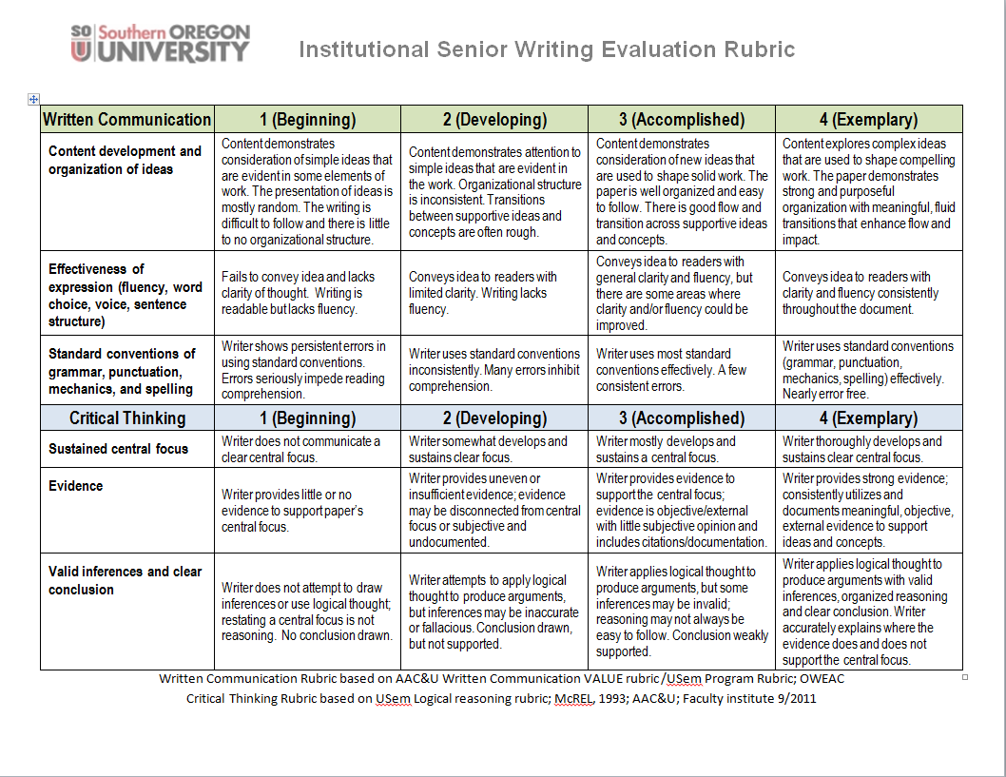

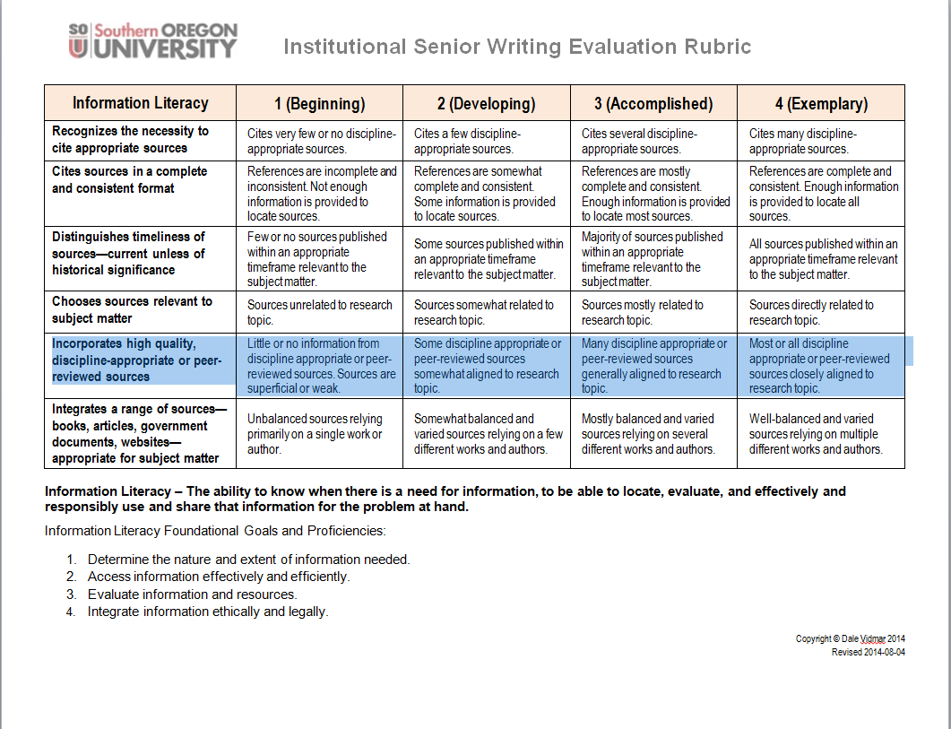

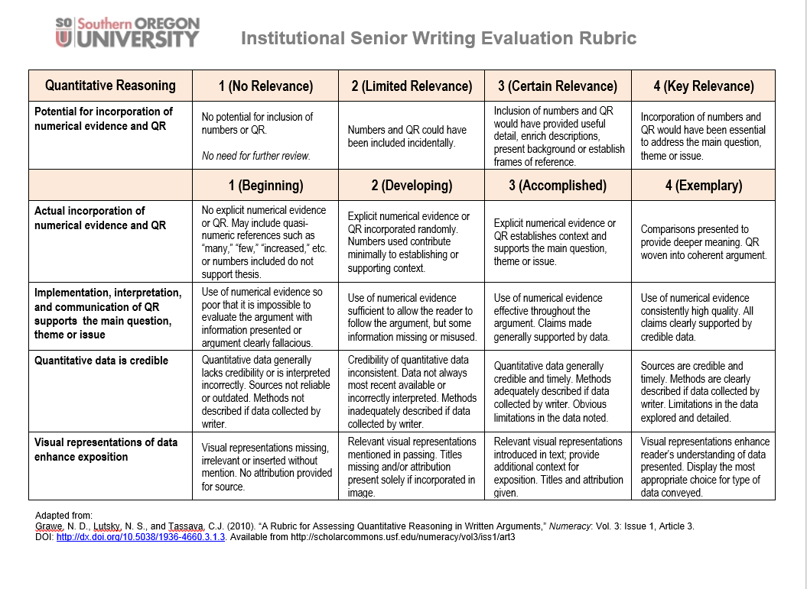

**Appendix B**

**Sample Size Computation**

We used the stratified random sampling in determining the sample size for the study. We defined the strata as the various departments or programs.

The rationale for the stratification of the population was to:

1. Produce a smaller margin of error (*B*) than would be by a simple random sampling,
2. Lower cost (to time) per observation in the survey, and
3. Allow for estimating the population means for each stratum, e.g. for estimating averages for each department or program.

The formula used for computing the sample size for estimating the population mean (µ) is:

$$n=\frac{\sum_{i=1}^{L}{N_{i}^{2}σ_{i}^{2}/w_{i}^{}}}{N_{}^{2}D+\sum_{i=1}^{L}{N_{i}^{}σ_{i}^{2}}}$$

Where:

$w_{i}^{}$ is the fraction of observations allocated to stratum i,

$σ_{i}^{2}$ is the population variance for stratum *i*, Since the actual standard deviation of each stratum, $σ_{i}$ is unknown, it was estimated as: (H-L)/6, or (4-1)/6 = 0.50

*D*, is computed as:

$$D=\frac{B^{2}}{4}$$

*B* is the margin of error for estimating the population mean (µ)

The computation of the samples from each of the strata is detailed in the table below.

Source: Elementary Survey Sampling, 4th Edition, Scheaffer, Mendenhall, Ott (page105)

**Appendix C**

**Sample Distribution**

**Senior Writing**



**FUSE**



1. Grawe, Nathan D.; Lutsky, Neil S.; and Tassava, Christopher J. (2010) "A Rubric for Assessing Quantitative Reasoning in WrittenArguments," *Numeracy*: Vol. 3: Iss. 1, Article 3. DOI: <http://dx.doi.org/10.5038/1936-4660.3.1.3> Available at: <http://scholarcommons.usf.edu/numeracy/vol3/iss1/art3>
2. Maki, Peggy L. *Assessing for learning: Building a sustainable commitment across the institution* (2nd Edition). Sterling, VA, USA: Stylus Publishing, 2010. Retrieved from <http://www.ebrary.com>