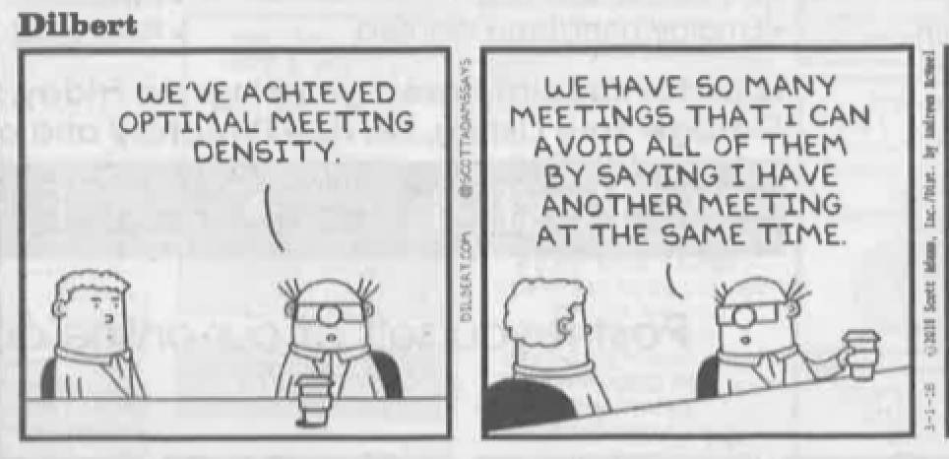

YES, we have. Note the attendance list.

Assessment Committee Meeting – Minutes
March 9, 2018
| 11:00 - 12:30 pm |Library 329
Possible Attendees: Jim Hatton, Kristin Nagy Catz, Craig Stillwell, Lee Ayers, Dorothy Ormes, Hart Wilson, Jody Waters, Dylann Loverro, Christina Richardson, Shanell Sanchez, Erin Wilder, Michael Stanfill, Rene Ordonez.
- Plan oral presentation assessments for winter term.
  - Review sign up sheet. Everyone needs to be signed up for 2 hours.
  - Everybody normed? As far as we know.
  - Changes to rubric made – We review moodle topic = oral presentations. Done.
- Overview of senior writing results. Information literacy assessment update. Items from our discussion
  - Jim was overgeneralizing and ignoring sampling variation. Rene will take a closer look at the data.
  - Jim will send the business results to Rene.
  - Jim will bring a sample of papers that needed more revision to the next meeting, so we can see how they could be improved.
  - Because, for instance, we might have subconsciously rated FUSE papers differently, next year we will have the major blind to the raters.
- Lee included assessment in the maximums document – wow! Any issues? No discussion.
- MSC News – Kristin update on them using one of our student papers. No new info.
- Academic Program Review – Guides and evaluation documents out. What needs to be done? Jim noticed that the report form was missing boxes for TD file names. Kristin has been informed. We will know more after the new themes workshops.
- Spring workshop scheduling? Nothing at this time.
- Anything else? None.

