**Assessment Committee Members**

2016-17: Jim Hatton, Kristin Nagy Catz, Craig Stillwell, Lee Ayers, Jamie Vener(non-member), Dorothy Ormes, Hart Wilson, Jody Waters, Rene Ordonez, Erin Wilder, John Taylor, Heather Buchanan(student)

2017-18: Jim Hatton, Kristin Nagy Catz, Craig Stillwell, Lee Ayers, Dorothy Ormes, Hart Wilson, Jody Waters, Rene Ordonez, Erin Wilder, Shanell Sanchez, Michael Stanfill, Christina Richardson (student), Dylann Loverro (student)

**Summary**

The SOU Faculty Senate Assessment Committee evaluated 56 (60 last year) senior writing papers randomly selected from 625 (up from 601) submissions gathered from nearly every academic program over the summer of 2017. There were 865 graduating seniors in 2017. In addition, the committee evaluated 40 (51 last year) FUSE (Final University Seminar Essay) papers selected from 514 (512 last year) papers. The papers were evaluated using the Senior Writing Evaluation Rubric developed as a result of the 2012-2013 Capstone Assessment Pilot Project. The rubric was revised this year during a committee norming process.

Papers were reviewed blind, although each paper was identified by major program to enable a representative random sampling. Each paper was also identified by student ID number to allow for a deeper analysis of demographic factors. Comparison with the assessment of freshman writing (the Final University Seminar Essay [FUSE]), showed clear improvement from first-year writing to senior writing.

As was the case last year, the evaluation revealed a wide disparity in quality and completeness. There was little change from 2013-2014 to 2014-2015 to 2015-2016 to 2016-2017 in average scores. General weakness was observed in organization/development, use of evidence, and inferences and conclusion. Over two-thirds of the papers, senior writing and FUSE, used or could have been substantially enhanced by using some quantitative reasoning.

Overall, the Information Literacy (IL)scores of the senior writing sample scores were nearly the same as the scores from past years. In addition, the scores of the senior samples were only slightly better than the FUSE scores.  The scores indicate there is a lot of room for information Literacy improvement in the senior writing samples.

**Recommendations**

Many recommendations are nearly the same as last year.

***For Programs***

1. Study the results of this report and seek alignment of written proficiency expectations for graduating seniors with the standards articulated in the evaluation rubric. This year each program will be provided with a summary of the results for all four years for their majors.
2. Review how writing skills are developed throughout the program's curriculum.
3. Gain a deeper understanding of student writing proficiency by conducting an internal evaluation of the program's senior writing submissions using the Assessment Committee model. Help and guidance are available from the Assessment Committee on request.
4. Request assistance and guidance from the Assessment Committee; use any and all resources available.
5. Consider using the evaluation rubric in senior writing courses, or other learning tool, as a self-assessment.
6. Directly address the areas of weakness identified by this review:
   1. Work with students to clearly articulate the context and purpose of their papers.
   2. Help students with their tendency to digress.
   3. Focus on critical thinking.
   4. Work more closely with Library faculty to improve scores on information literacy.

***For the University and the Assessment Committee***

1. Repeat the process next year with full participation of all programs.
2. Help programs define the writing and critical thinking skills needed by their graduating seniors.
3. Help programs identify the written artifact that best expresses their intentions for their majors.
4. Continue to intend to collect exemplary papers. Not very many have been found.
5. Simplify the rubric for use by students and faculty.
6. Begin a conversation on how to improve students’ QR skills.
7. Implement an information literacy workshop for capstone faculty.
8. Design and implement professional development initiatives for faculty focused on writing throughout the curriculum.
9. Recommend purchase of professional quality bibliography software, namely EndNote™.

**Background**

### SOU has had a senior writing requirement since before 1990. The current catalog states:

### Writing and Research Component

Demonstrate writing and research skills within the academic field of study chosen as a major. This upper division requirement is in addition to the University Studies writing requirement. It is met through coursework in the major that is designed to encourage the use of professional literature.

Students who have achieved the writing and research goals will be able to:

1. systematically identify, locate, and select information and professional literature in both print and electronic formats within the knowledge base of the specific discipline;
2. critically evaluate such materials;
3. use the materials in a way that demonstrates understanding and synthesis of the subject matter; and
4. develop cohesive research papers that use data and professional literature as evidence to support an argument or thesis following the style and conventions within the discipline of the major.

For five years prior to 2013-14, SOU administered the Collegiate Learning Assessment (CLA) which compared our students’ writing and critical thinking to those of other schools. While the results were valuable, administering the test and recruiting enough participants was extremely challenging. Because the test was not tied to actual coursework, it was also difficult to gauge the extent to which students took it seriously. As a result, in the spring of 2013, the Assessment Committee proposed and successfully implemented a pilot program to evaluate student writing skills by examining senior writing samples. This evaluation had the advantage of using embedded artifacts, that is assignments, typically capstone papers, that were intended to be graded and were required for graduation.

**Process**

The Assessment Committee solicited senior writing samples from all programs; specifically, asking for one paper from each of the program's graduating seniors. By the time the sample was taken all programs had submitted at least one paper. In total, the Committee received 625 papers, representing seventy-two percent of the 865 bachelor's degrees awarded in 2017. Student names were removed from the chosen sample. SOU’s Institutional Research Board approved this process in 2013. An evaluation rubric developed from AAC&U standards was revised based on the committee’s norming experience this year. Of note is that last year the first rubric category for written communication was divided into two sections: Content and Organization since the committee felt that each was an important aspect of writing in itself. A QR component modeled on the Carleton College Quantitative Inquiry, Reasoning, and Knowledge (Quirk): Rubric for the Assessment of Quantitative Reasoning in Student Writing was permanently added to the assessment last year.[1] The five hundred and fourteen FUSE papers where gathered by the General Studies Office.

While the UAC teams were evaluating writing and critical thinking proficiencies, the library faculty concentrated on information literacy. Similar to the previous year, library faculty members used a norming process used to establish inter-rater reliability. They evaluated the same papers as did the committee.

Sample Size Determination

Using a stratified sampling method as described by Schaeffer et al (1990), committee member Rene Ordonez determined the sample size from each stratum. See Appendix B for the details of the process.

The stratified sampling method was used for the following reasons:

1. It produces a smaller margin of error (*B*) than would be produced by a simple random sampling.
2. It has a lower cost (time) per observation in the survey.
3. It allows for estimating the population means for each stratum, e.g. for estimating averages for each department or program, though for most programs the number of evaluated papers is too small to draw meaningful conclusions.

A total of 58 capstones were selected and randomly chosen from the program strata. The committee determined that a sample size in the thirties was logistically feasible and, in the end, 56 papers were assessed. In order to ensure fair representation of capstones from each program, this sample size was apportioned to each of the strata (programs) proportionate to the total number of submissions contained in each stratum.

Norming and Evaluation of Sample Papers

Prior to evaluating and rating the selected papers, Director of University Assessment Kristin Nagy Catz chose a senior paper for evaluation by all committee members in order to calibrate the rubric and norm the evaluation process. Once the rubric (see Appendix A) was calibrated and the process normed, six teams (two committee members in each team) evaluated and rated roughly five senior papers and five FUSE papers each. Each evaluation team followed these steps:

1. Each member independently read, evaluated, and rated the papers assigned to the team using the Writing Evaluation Rubric.
2. The team members met, compared, and discussed their ratings on the assigned papers.
3. Where there were differences in their ratings, the members negotiated an agreement on a single rating.
4. Each team entered its ratings for each paper in a Qualtrics survey to facilitate data collection and analysis.

Description of the Sample

The committee classified 53 of the senior writing samples as shown.

Sixty-four percent of the papers were 15 pages or less in length as shown. All FUSE papers were around six pages.

As was the case last year a substantial percentage of all the papers were deemed in need of revision.

**Results of the Evaluation**

The results are presented as a series of graphs with comments if warranted. While the rubric represents a four-point scale, it's important to keep in mind that a rating of four is considered Exemplary, while a rating of three indicates Accomplished. Also, the kinds of papers submitted varied greatly, resulting in lower scores for some elements that were not required in all papers. Thus, scores between two and three are not necessarily low. Since the results are substantially the same as the last three years only summary graphs will be included.

This horizontal bar chart offers way of comparing scores. In the chart below, the more green on a bar, the higher the level of student achievement. The lighter green represents "Accomplished" proficiency.

This graph shows that a substantial proportion of the seniors are somewhat deficient (at the "Beginning" or "Developing" level) in writing and critical thinking. They are particularly deficient in "Inferences and Conclusions."

Three Years of Data

This chart compares four years of data from the senior writing samples. The first two categories from the 2016 and 2017 results were averaged for comparison purposes.

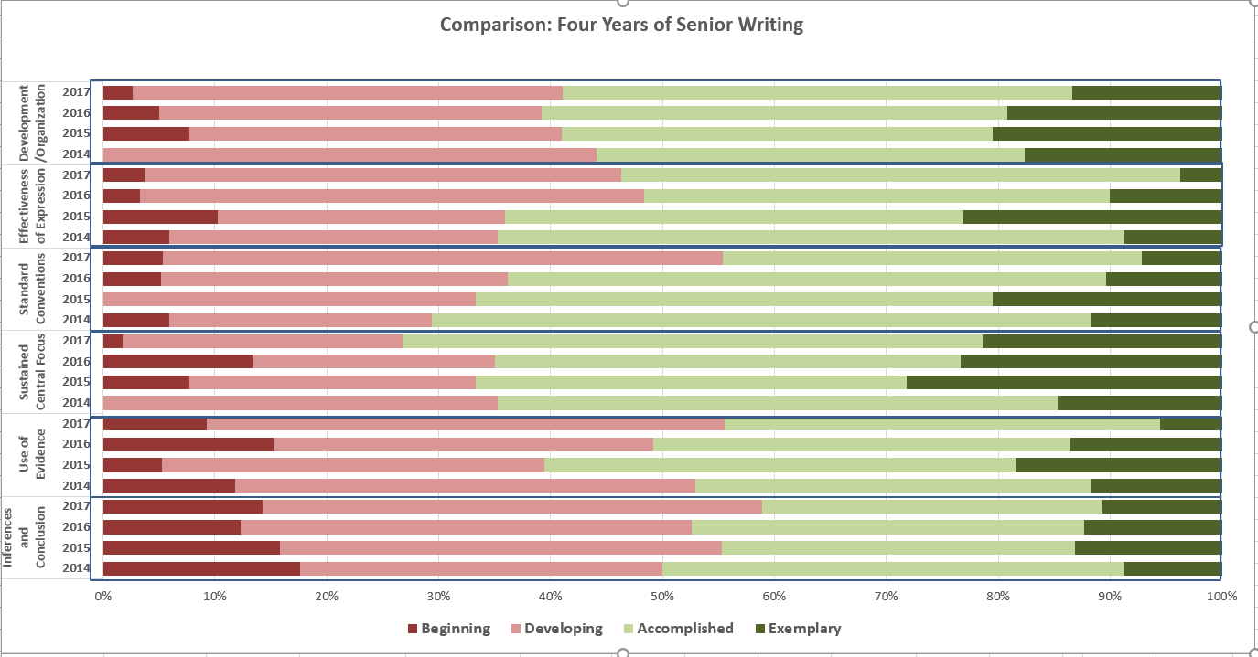

FUSE versus Senior Writing

There is a clear improvement from freshman to senior year.

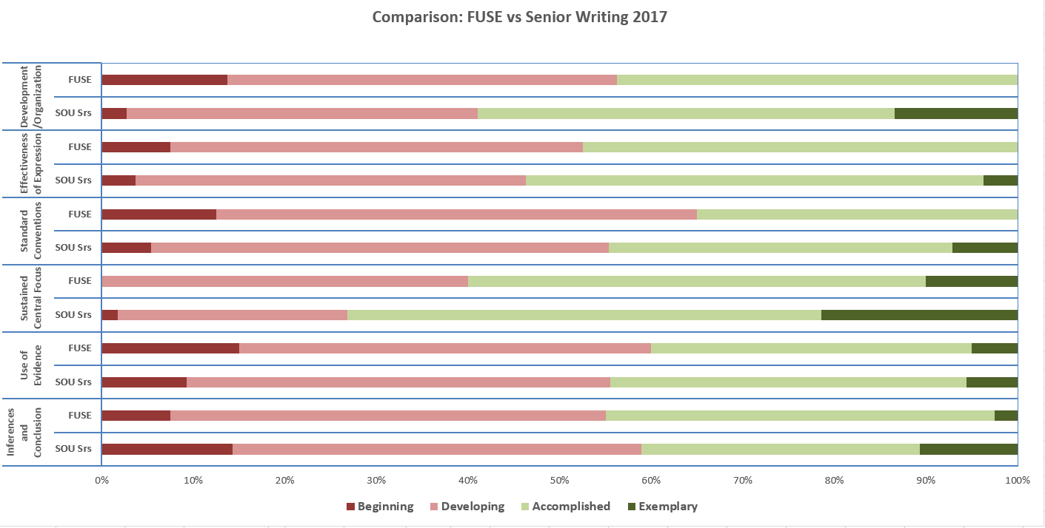

**Information Literacy Results**

This chart represents the results of the assessment conducted by Library faculty. The library staff have noticed little change over the four years.

It is possible that the FUSE are better in some categories by the nature of the assignment.

**Quantitative Reasoning Results**

The results from the QR rubric are below. Nearly forty-one percent of senior papers needed to include QR and an additional eighteen percent would have been enhanced by using some form of QR.

Seventy-seven percent of FUSE papers need to have some QR thinking.

Of the students that used QR in their papers, fifty percent of seniors and seventy percent of freshman were below the accomplished level.

**Interpreting the Results**

The committee has now evaluated senior writing for four consecutive years. The results have been consistent within error bounds from year to year. Since there were no major changes in the teaching of writing university wide, the consistency of results can be attributed to consistency of measurement. The norming methods and the rubric are working. The information generated by this evaluation can be considered baseline data, the first measurement in a time series of succeeding studies. This baseline suggests that large percentages of SOU senior writers are less than accomplished in several categories. Improving this situation should be a goal of the University.

A comparison of senior writing with FUSE samples reveals a significant rise in proficiency. Yet over thirty percent of seniors were deficient (beginning or developing) in one or more categories. While writing skills are emphasized in University Seminar classes, it is possible that these skills atrophy from first year to senior year due to lack of focus on writing in later terms. In addition, many seniors are transfer students and do not come through the USem experience.

There are many other ways to have organized the results of the study that might have yielded more insight. As questions come up, the data captured through this analysis can easily be reanalyzed. In addition, we now have a repository of 2228 papers that can be used to answer other research questions.

**Interpreting the Results with a Grain of Salt**

The committee recognizes that systematic flaws in the Senior Writing study make it hard to come to definitive conclusions. Here is a list of the committee’s equivocations.

1. Small programs are overrepresented in the sample. Since small programs can give their individual majors more attention, this may have resulted in overly high averages in the rubric categories.
2. Not all possible writing samples were submitted. The number of 2017 graduates was 865. The number of submissions was 625. It is possible that the non-submitted samples would have been of lower quality. Without these lower scores, the results in this sample may have been skewed upwards.
3. The degree of polish of the writings can have many causes. The students could have been required by their program to revise and edit their papers multiple times. The program's capstone process could include multiple revisions under the guidance of a faculty member. The students could have had “outside” help, using the writing lab or having access to a good editor. In other words, it is unclear how much the degree of polish is directly due to the individual student’s abilities.
4. The committee explicitly decided not to check for the possibility of plagiarism which might account for some degree of polish. With a repository of 2228 papers, questions of plagiarism could be pursued easily by submitting a random sample to a plagiarism checker.
5. The submitted papers may not have been the best senior writing samples available from a given program. Programs may not have obtained and stored electronic copies of their students’ work. This may have resulted in skewing the results downward.
6. Expectations for the senior writing were probably higher than those of the FUSE paper since the writers were graduating seniors.
7. Expectations of the seniors’ professors may not have been consistent with the writing and critical thinking expectations that the rubric presumed.
8. The rubric was generated for use by a committee representing various disciplines and with a specific focus on assessment. While the committee urges the use of a rubric as a tool for evaluating writing, it does not prescribe or mandate the use of this particular rubric.

The recommendations from the beginning are repeated here.

**Recommendations**

Many recommendations are nearly the same as last year.

***For Programs***

1. Study the results of this report and seek alignment of written proficiency expectations for graduating seniors with the standards articulated in the evaluation rubric. This year each program will be provided with a summary of the results for all four years for their majors.
2. Review how writing skills are developed throughout the program's curriculum.
3. Gain a deeper understanding of student writing proficiency by conducting an internal evaluation of the program's senior writing submissions using the Assessment Committee model. Help and guidance are available from the Assessment Committee on request.
4. Request assistance and guidance from the Assessment Committee; use any and all resources available.
5. Consider using the evaluation rubric in senior writing courses, or other learning tool, as a self-assessment.
6. Directly address the areas of weakness identified by this review:
   1. Work with students to clearly articulate the context and purpose of their papers.
   2. Help students with their tendency to digress.
   3. Focus on critical thinking.
   4. Work more closely with Library faculty to improve scores on information literacy.

***For the University and the Assessment Committee***

1. Repeat the process next year with full participation of all programs.
2. Help programs define the writing and critical thinking skills needed by their graduating seniors.
3. Help programs identify the written artifact that best expresses their intentions for their majors.
4. Continue to intend to collect exemplary papers. Not very many have been found.
5. Simplify the rubric for use by students and faculty.
6. Begin a conversation on how to improve students’ QR skills.
7. Implement an information literacy workshop for capstone faculty.
8. Design and implement professional development initiatives for faculty focused on writing throughout the curriculum.
9. Recommend purchase of professional quality bibliography software, namely EndNote™.

**Improving the Process**

The Assessment Committee will be repeating the Senior Writing Assessment process next year. It will be asking for more promptness in program submissions. It will also be more careful in expressing the specifications for submissions, asking for complete, finished, polished written examples of seniors’ critical thinking. The committee is considering using outside evaluators.

**Appendix A**

**Senior Writing Evaluation Rubric**

|  |  |  |  |  |
| --- | --- | --- | --- | --- |
| **Written Communication** | **1 (Beginning)** | **2 (Developing)** | **3 (Accomplished)** | **4 (Exemplary)** |
| **Content development** | Presents simple ideas but does not develop them. | Presents and develops simple ideas. | Presents complex ideas but may not fully develop them. | Explores complex ideas and develops them fully. |
| **Organization of ideas** | Organizational structure is random. The writing is difficult to follow and transitions are abrupt or nonexistent. | Organizational structure is inconsistent. Transitions between supportive ideas and concepts are awkward or choppy. | Is organized. There is good flow and transition across supportive ideas and concepts. | Demonstrates strong and purposeful organization with meaningful, fluid transitions that enhance flow and impact. |
| **Effectiveness of expression (fluency, word choice, voice, sentence structure)** | Expression is ineffective. Communicates without fluency. Voice is inconsistent or inappropriate for audience or purpose. | Expression is somewhat effective. Communicates with limited fluency. Voice is consistent but is not completely appropriate for audience or purpose. | Expression is effective. Communicates with fluency. Voice is consistent and generally appropriate for audience and purpose. | Expression is very effective. Communicates with fluency. Voice is consistent and appropriate as well as persuasive or compelling. |
| **Standard conventions of grammar, punctuation, mechanics, and spelling** | Contains multiple errors in standard conventions. Errors impede reading comprehension. | Uses standard conventions inconsistently. Errors distract from comprehension. | Uses most standard conventions effectively. Minor errors do not limit comprehension. | Uses standard conventions effectively. Nearly error free. |
| **Critical Thinking** | **1 (Beginning)** | **2 (Developing)** | **3 (Accomplished)** | **4 (Exemplary)** |
| **Sustained central focus** | Does not communicate a clear central focus. | Attempts to establish a central focus, but does not sustain it. | Develops and sustains a central focus. | Reflects strong sense of purpose in establishing and sustaining a central focus.. |
| **Evidence**  **(supports claim effectively)** | Provides little or no evidence to support paper’s central focus. Evidence disconnected from central focus or subjective and undocumented. | Provides uneven or insufficient evidence. Some evidence disconnected from central focus or subjective and undocumented. | Provides sufficient evidence to support the central focus. Evidence is objective and includes citations. | Provides strong evidence. Cites meaningful, objective evidence to support ideas and concepts. |
| **Valid inferences and clear conclusion** | Does not draw inferences or make claims. No conclusion drawn. | Makes claims. Inferences may be inaccurate or fallacious. Conclusion drawn, but not supported. | Produces logical arguments. Most inferences are valid. Conclusion partially supported. | Produces logical arguments with valid inferences and organized reasoning. Conclusion fully supported. |

Written Communication Rubric based on AAC&U Written Communication VALUE rubric /USem Program Rubric; OWEAC

Critical Thinking Rubric based on USem Logical Reasoning Rubric; McREL, 1993; AAC&U; Faculty Institute 9/2011

**Updated by SOU University Assessment Committee October 2016**

|  |  |  |  |  |
| --- | --- | --- | --- | --- |
| **Information Literacy** | **1 (Beginning)** | **2 (Developing)** | **3 (Accomplished)** | **4 (Exemplary)** |
| **Recognizes the necessity to cite appropriate sources** | Cites very few or no discipline-appropriate sources. | Cites a few discipline-appropriate sources. | Cites several discipline-appropriate sources. | Cites many discipline-appropriate sources. |
| **Cites sources in a complete and consistent format** | References are incomplete and inconsistent. Not enough information is provided to locate sources. | References are somewhat complete and consistent. Some information is provided to locate sources. | References are mostly complete and consistent. Enough information is provided to locate most sources. | References are complete and consistent. Enough information is provided to locate all sources. |
| **Distinguishes timeliness of sources—current unless of historical significance** | Few or no sources published within an appropriate timeframe relevant to the subject matter. | Some sources published within an appropriate timeframe relevant to the subject matter. | Majority of sources published within an appropriate timeframe relevant to the subject matter. | All sources published within an appropriate timeframe relevant to the subject matter. |
| **Chooses sources relevant to subject matter** | Sources unrelated to research topic. | Sources somewhat related to research topic. | Sources mostly related to research topic. | Sources directly related to research topic. |
| **Incorporates high quality, discipline-appropriate or peer-reviewed sources** | Little or no information from discipline appropriate or peer-reviewed sources. Sources are superficial or weak. | Some discipline appropriate or peer-reviewed sources somewhat aligned to research topic. | Many discipline appropriate or peer-reviewed sources generally aligned to research topic. | Most or all discipline appropriate or peer-reviewed sources closely aligned to research topic. |
| **Integrates a range of sources—books, articles, government documents, websites—appropriate for subject matter** | Unbalanced sources relying primarily on a single work or author. | Somewhat balanced and varied sources relying on a few different works and authors. | Mostly balanced and varied sources relying on several different works and authors. | Well-balanced and varied sources relying on multiple different works and authors. |

Copyright © Dale Vidmar 2014   
Revised 2014-08-04

**Information Literacy – The ability to know when there is a need for information, to be able to locate, evaluate, and effectively and responsibly use and share that information for the problem at hand.**

Information Literacy Foundational Goals and Proficiencies:

1. Determine the nature and extent of information needed.
2. Access information effectively and efficiently.
3. Evaluate information and resources.
4. Integrate information ethically and legally.

|  |  |  |  |  |
| --- | --- | --- | --- | --- |
| **Quantitative Reasoning** | **1 (No Relevance)** | **2 (Limited Relevance)** | **3 (Certain Relevance)** | **4 (Key Relevance)** |
| **Potential for incorporation of numerical evidence and QR** | No potential for inclusion of numbers or QR.  *No need for further review.* | Numbers and QR could have been/was included incidentally. | Inclusion of numbers and QR could have provided/did provide useful detail, enrich descriptions, present background or establish frames of reference. | Incorporation of numbers and QR would have been/was essential to address the main question, theme or issue. |
|  | **1 (Beginning)** | **2 (Developing)** | **3 (Accomplished)** | **4 (Exemplary)** |
| **Actual incorporation of numerical evidence and QR** | No explicit numerical evidence or QR. May include quasi-numeric references such as “many,” “few,” “increased,” etc. Numbers included do not support thesis. | Explicit numerical evidence or QR incorporated randomly. Numbers used contribute minimally to establishing or supporting context. | Explicit numerical evidence or QR establishes context and supports the main question, theme or issue. | Comparisons presented to provide deeper meaning. QR woven into coherent argument. |
| **Implementation, interpretation, and communication of QR supports the main question, theme or issue** | Use of numerical evidence does not support or is inappropriately applied to argument. | Use of numerical evidence supports the argument, but some information missing or misused. | Use of numerical evidence effective throughout the argument. Claims made generally supported by data. | Use of numerical evidence consistently high quality. All claims clearly supported by data. |
| **Quantitative data is credible** | Quantitative data generally lacks credibility or is interpreted incorrectly. Sources not reliable or outdated. Methods not described if data collected by writer. | Data not always most recent available or incorrectly interpreted. Methods inadequately described if data collected by writer. | Quantitative data generally credible and timely. Methods adequately described if data collected by writer. | Sources are credible and timely. Methods are clearly described if data collected by writer. Limitations in the data are noted. |
| **Visual representations of data enhance exposition** | Visual representations missing, irrelevant or inserted without mention. No attribution provided for sources. | Relevant visual representations mentioned in passing. Titles missing and/or attribution present solely if incorporated in image. | Relevant visual representations introduced in text. Images provide additional context for exposition. Titles and attribution given. | Visual representations enhance reader’s understanding of data presented. Display the most appropriate choice for type of data conveyed. |

Adapted from:

Grawe, N. D., Lutsky, N. S., and Tassava, C.J. (2010). “A Rubric for Assessing Quantitative Reasoning in Written Arguments,” *Numeracy*: Vol. 3: Issue 1, Article 3.

DOI: <http://dx.doi.org/10.5038/1936-4660.3.1.3>. Available from http://scholarcommons.usf.edu/numeracy/vol3/iss1/art3

**Appendix B**

**Sample Size Computation**

We used the stratified random sampling in determining the sample size for the study. We defined the strata as the various departments or programs.

The rationale for the stratification of the population was to:

1. Produce a smaller margin of error (*B*) than would be by a simple random sampling,
2. Lower cost (to time) per observation in the survey, and
3. Allow for estimating the population means for each stratum, e.g. for estimating averages for each department or program.

The formula used for computing the sample size for estimating the population mean (µ) is:

$$n=\frac{\sum_{i=1}^{L}{N_{i}^{2}σ_{i}^{2}/w_{i}^{}}}{N_{}^{2}D+\sum_{i=1}^{L}{N_{i}^{}σ_{i}^{2}}}$$

Where:

$w_{i}^{}$ is the fraction of observations allocated to stratum i,

$σ_{i}^{2}$ is the population variance for stratum *i*, Since the actual standard deviation of each stratum, $σ_{i}$ is unknown, it was estimated as: (H-L)/6, or (4-1)/6 = 0.50

*D*, is computed as:

$$D=\frac{B^{2}}{4}$$

*B* is the margin of error for estimating the population mean (µ)

The computation of the samples from each of the strata is detailed in the table below.

Source: Elementary Survey Sampling, 4th Edition, Scheaffer, Mendenhall, Ott (page105)

**Appendix C**

**Sample Distribution**

**Senior Writing**



**FUSE**



1. Grawe, Nathan D.; Lutsky, Neil S.; and Tassava, Christopher J. (2010) "A Rubric for Assessing Quantitative Reasoning in WrittenArguments," *Numeracy*: Vol. 3: Iss. 1, Article 3. DOI: <http://dx.doi.org/10.5038/1936-4660.3.1.3> Available at: <http://scholarcommons.usf.edu/numeracy/vol3/iss1/art3>