University Studies Committee
Academic Year
2017-2018

Senate Committee:

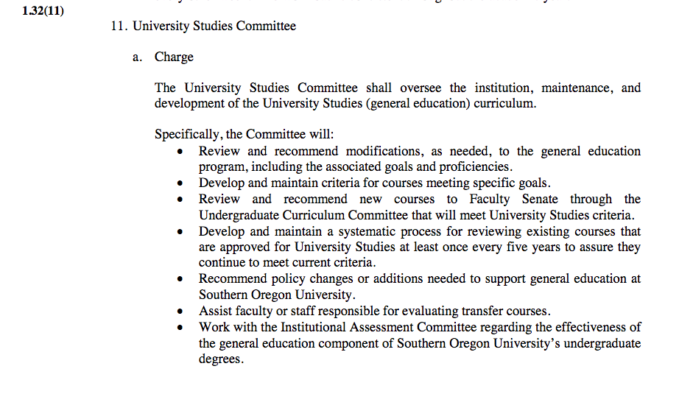
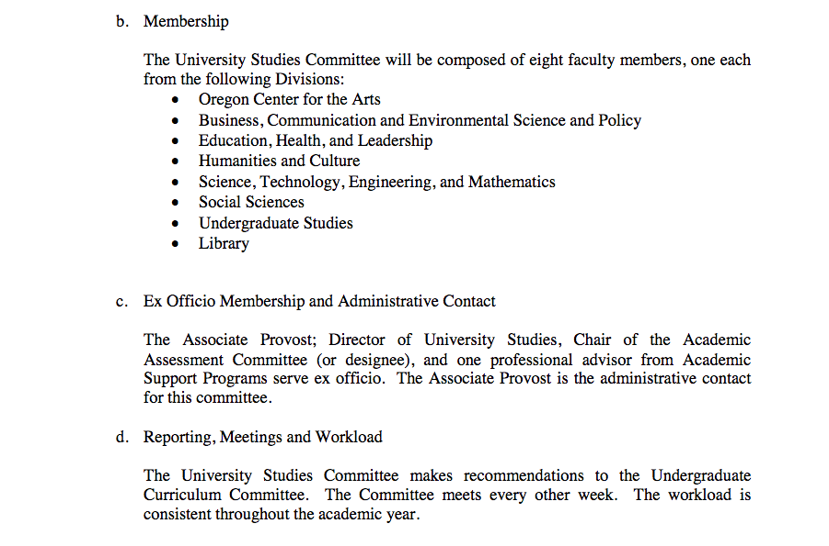

What is the primary duty of this committee? (see: https://inside.sou.edu/senate/committees/universitystudies.html)

Suggest revision to the verbiage above.

Ex Officio Membership and Administrative Contact
The Associate Provost, Division Director of Undergraduate Studies, one professional advisor from Academic Support Programs, and representative of the Registrar’s office. The Associate Provost is the administrative contact for this committee.

Reporting, Meetings and Workload

The University Studies Committee makes recommendations to the Faculty Senate for Exploration and Integration courses. The Committee meets every other week. The workload is consistent throughout the academic year.

What did you accomplish this year?

This year the UStudies Committee set the following goals:
- A five-year review of all Explorations and Integration courses was conducted
- Reviewed Exploration courses for possible alignment with Interstate Passport Model through HECC grant
- Approve submitted courses in a timely manner or offer suggestions for resubmission
- Promoted Awareness of University Studies through ROAR, Preview Day, and Advising Sessions
- Held Faculty Working Sessions to assist with completion of the five-year review strand templates
- Provided decisions on University Studies Petition
- Provost’s Office detailed catalog alignment for approved courses (Website, catalog, and DegreeWorks)
- Worked on Accreditation report and TracDat (*update in summer 2017)

Senate Committee Annual Report
What is the duty of this committee?

1.32(11)

- What did the committee accomplish during this academic year? UStudies reviewed 21 new course applications during AY 2017-2018. Of those reviewed, the following were approved by UStudies & Faculty Senate:

Explorations:  Strand E Arts & Humanities | Explorations:  Strand F  Social Science | Explorations:  Strand G  Science
GL 103  MUS 208  PHL 211 | MUS 208 | ES 103  ES 215
Integrations:  Strand H  Science, Technology & Society | Integrations:  Strand I  Citizenship & Social Responsibility | Integrations:  Strand J  Diversity & Global Awareness
COMM 460E  ENG 497  ENG 480  GSWS 313  OAL/PE 470  SOAN 350 | ENG 447  ENG 315  NAS 368 | COMM 364  EC 389  UGS 325
Courses Reviewed and Pending Revisions:
MUS 195 & MUS 197
E-Strand Humanities submission for 1 credit repeatable course. Does not fit the current model. UStudies Committee suggests additional guidance and direction from the Faculty Senate.

SOAN 339 (J) Pending return of faculty sabbatical. New course proposal required to Curriculum Committee and additional information needed for final approval.

There were 12 University Studies meetings during AY 2017-2018. Of the 12 meetings, two were workshops structured around reworking Integration templates for faculty submission of strand H, I and J courses.

TASK: Revisit Faculty Templates for Integration Courses (*based on the number of courses not approved or sent back for revisions) the committee revisited the faculty templates. This task will continue into academic year 2018-2019. The H-strand template is posted in the Google shared drive for Faculty Senate review, and was also presented at the final meeting June 4th, 2018 meeting. Strands I & J still are still under consideration and the work will continue in AY 2018-2019.

TASK: Created a pathway for Integration intensive writing course to submit student samples for Institutional assessment review. A pathway for Writing Intensive Courses (WIC) in Integration was created through the course maximum work completed across campus. The goal is to work with faculty who have identified their Integration course as WIC. Through a transparent assignment design, the student writing sample will be collected for Institutional Assessment. As WIC for Integration move forward, samples will be collected and scored. Starting fall, 2018, the faculty will receive a reminder from the Division of Undergraduate Studies noting the process for collection (insert link in Moodle student to self -submit or??…work in progress). With the assistance of the Center for Instructional Support, transparent assignment assistance will be offered to support faculty working through this process.

TASK: Promoted Awareness of University Studies through Raider Registration, Preview Day, & Advising
Through the Office of Undergraduate Studies, presentations for parents, prospective students, families and the community continue to occur across campus and beyond. Raider Reg. opportunities allow for parents to become acquainted with the liberal arts education and our SOU University Studies model. The shift from a high school to college, how to be successful in college, and understanding the difference in workload.

3. Given what you have learned this year, what goals do you recommend this senate committee
focus upon in the upcoming year?
- Revisit University Studies Curriculum under new strategic plan and work with Provost’s Office for a discussion around general education curriculum.
- Collect Institutional Assessment student work samples from Integration Courses approved for (WIC) and use this sample for paired matches to FUSE.
- Complete Foundations Strand Review and Alignment for strands A, B, and C.
- Continue Campus conversation concerning University Studies as a program.
4. Who currently serves on this committee? AY 2017-2018 membership?
One Year Term | Two Year Terms |  | Three Year Terms: 1 positions
Charles Welden, STEM  Brian Stonelake, STEM | Brook Colley, HC Kylan deVries, SS  Prakash, Chenjeri HC |  | Dale Vidmar, LIB* Chair  BCE? OCA? DHEL?
Ex Officio members include: SSC: Donny Nickelson, Division Director UGS: Lee Ayers, Associate Provost: Jody Waters

*Both Charles Welden, STEM and Brian Stonelake, STEM have requested to stay on the Committee and continue with the work for UStudies. No new membership needed at this time.

Respectfully Submitted, University Studies Committee AY 2017-2018

