Year
2016-2017
University Studies Committee

Senate Committee:
Senate Committee Annual Report
- What is the primary duty of this committee? (see: https://inside.sou.edu/senate/committees/universitystudies.html)
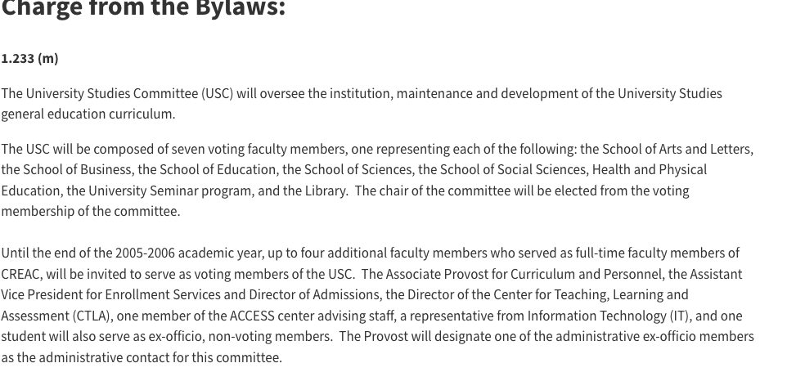
Suggest revision to the verbiage above.

Ex Officio Membership and Administrative Contact
The Associate Provost, Division Director of Undergraduate Studies, one professional advisor from Academic Support Programs, and representative of the Registrar’s office. The Associate Provost is the administrative contact for this committee.

Reporting, Meetings and Workload

The University Studies Committee makes recommendations to the Faculty Senate for Exploration and Integration courses. The Committee meets every other week. The workload is consistent throughout the academic year.

What did you accomplish this year?

This year the UStudies Committee set the following goals:
- A five-year review of all Explorations and Integration courses was conducted
- Reviewed Exploration courses for possible alignment with Interstate Passport Model through HECC grant
- Approve submitted courses in a timely manner or offer suggestions for resubmission
- Promoted Awareness of University Studies through ROAR, Preview Day, and Advising Sessions
- Held Faculty Working Sessions to assist with completion of the five-year review strand templates
- Provided decisions on University Studies Petition
- Provost’s Office detailed catalog alignment for approved courses (Website, catalog, and DegreeWorks)
- Worked on Accreditation report and TracDat (*update in summer 2017)

- What did the committee accomplish during this academic year? UStudies reviewed 19 new course applications during AY 2016-2017. Of those reviewed, the following 17 classes were approved:

Explorations:  Strand E Arts & Humanities | Explorations:  Strand F  Social Science | Explorations:  Strand G  Science
FR 103, 201  JPN 103, 201  SPAN 103, 201 |  | PH 203
Integrations:  Strand H  Science, Technology & Society | Integrations:  Strand I  Citizenship & Social Responsibility | Integrations:  Strand J  Diversity & Global Awareness
PS/HST 393  SOAN 355 | COMM 363  ENG 472  NAS 301  PHL 353  SOAN 372 | ENG 448  CCJ 460  PHL 373
Courses Reviewed and Pending Revisions:
COMM 364, J Strand
BA 496 – H Strand

TASK: A five-year review of all Explorations and Integration Courses
In accordance with the University Studies Committee Faculty Senate charge, the following represents the course count for the 5-year review process conducted AY 2016- 2017.

Exploration Strands | Received  Current | Pending | Total Possible
E Strand | 38 | 20 | 58
F Strand | 26 | 10 | 36
G Strand | 14 | 10 | 24
Integration  Strands | Received  Current | Pending | Total Possible | Honors  College
H Strand | 14 | 22 | 37 | 1
I Strand | 30 | 22 | 55 | 3
J Strand | 35 | 28 | 65 | 2
After updates and eliminations (courses not longer offered), there are 275 University Studies Exploration and Integration courses offered. Of the 275 courses, 118 are Exploration offered as E, F, or G strand designations. During the review, 78 Explorations courses were submitted for review or held a current status, 40 are still pending action (outdated or no paperwork on file).

There are 157 Integrations courses possible for H, I, or J strands. Of those, 79 were submitted for review or are current, 72 still need to be resubmitted (or have no paperwork is on file), and six courses are template level classes taught only in Honors College. Honors College submits templates for every new course taught in each of the designated Integration Strand areas.

TASK: Reviewed Exploration courses for possible alignment with Interstate Passport Model
As the USC review process was completed, suggestions were made as to how and where current US courses might possibly fit into Interstate Passport (IP). Programs received outcome sheets and were asked to be part of the conversation. “Knowledge of Concepts” fits well into the Exploration strands; however, “Crosscutting Skills” are not tracked separately. Through self-evaluation of the courses current in University Studies Exploration strands, once the program review is complete, University Studies will review and make a final recommendation to the Faculty Senate on the “fit” of IP to be met within the current University Studies structure.

TASK: Promoted Awareness of University Studies through ROAR, Preview Day, & Advising Sessions
Through the Office of Undergraduate Studies, presentations for parents, prospective students, families and the community continue to occur across campus. ROAR opportunities allow for parents to become acquainted with the liberal arts education and our SOU model. The shift from a high school to college, how to be successful in college.

3. Given what you have learned this year, what goals do you recommend this senate committee
focus upon in the upcoming year?
- Create time for discussion with faculty who submit courses not approved in University Studies
- Close the loop for 5-Year Review
- 5-Year Review of Foundations Strands 2017-2018
- IP final report to Senate fall 2017
- Realign TracDat University Studies and new accreditation cycle
- Possible Institutional Rubric and common assignment for assessment of writing in Integration Courses. Work with Center for Instructional Support for process and opportunities. As assessments for the Integration courses are developed, using Integration to FUSE assessment as a method of growth might offer a stronger option. The FUSE – to- Senior Writing paired assessment does not always offer Foundations measurements.
- Complete the 5-year review of Integration courses and alignment for possible Institution Assessment.
4. Who currently serves on this committee? University Studies (7—one from each School and Univ Seminar) (2016-2017)
One Year Term | Two Year Terms |  | Three Year Terms
Brian Fedorek, SS | Charles Welden, STEM  Brian Stonelake, STEM |  | Prakash Chenjeri, HC  Brook Colley, HC  Kylan deVries, SS
*AY (2017-2018) Membership  One Year Term |  | Two Year Terms | Three Year Terms: 1 positions
Charles Welden, STEM  Brian Stonelake, STEM |  | Brook Colley, HC Kylan deVries, SS  Prakash, Chenjeri HC | Dale Vidmar, LIB* Chair  BCE? OCA? DHEL?
Respectfully Submitted, University Studies Committee AY 2016-2017

