2019 Middle School State of Jefferson Scavenger Hunt Questions
DEDICATEE
1. When the dedicatee made a record setting drive from Bend to Medford, how many times did he stop to fill the radiator?
(3pts)
2. On his drive from Bend to Medford most, if not all, the route outside of towns was not paved. In 1917 the Oregon legislature designated what highway number for the road the dedicatee followed coming out of Bend to the south?
(3pts)

3. The dedicatee was one of the first in an air transport company founded in 1926. The company flew routes long before GPS and even the interstate system. What did the company convince an oil company to do to help ensure successful flights?
(4pts: 1pt bold, 3pts answer)

4. When the dedicatee first was engaged in the airmail business there was only one airport in Oregon. What hypermarket superstore now sits near the site?
(4pts: 1pt bold, 3pts answer)

5. The air transport company the dedicatee helped start eventually became what today is a major airline. What was the dedicatee’s position in the company at the time of his retirement?
(4pts: 1pt bold, 3pts answer)

6. The dedicatee and a partner purchased a Jenny for business. The story has it that they named it after a dialogue questioning its reliability. What did they name their business acquisition?
(4pts: 1pt bold, 3pts answer)

7. The dedicatee’s father was a sportsman. He managed a Medford team. When he went around the community to promote support to continue a local league that was on the verge of folding, the fans in Ashland got cold feet. When the team he managed team did play a match game against Jacksonville. What was the final score?
(4pts: 1pt bold, 3pts answer)

8. The dedicatee’s father lost half of a binary part of the nervous system in a hunting accident. Later he almost lost his life. He was saved by a girl visiting from out of state. Who drove the girl to the site of the rescue? (F&L)
(4pts: 1pt bold, 3pts answer)

9. Who is the dedicatee? (F,M,&L)
(3pts)

GENERAL KNOWLEDGE
1. On what date was the first person recognized as a slave in a court of law in what is now the United States? (D,M,&Y)
(3pts)

2. The Quaker’s hat was last cleaned in 2017. The hat was not topped until 1986. What is the street address of where it was topped? (Number, Street, City, State,& Zip)
(6pts: 1pt bold, 5pt answer)

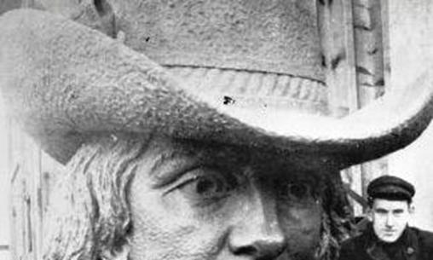

3. “Necessary measures” needed to be taken to right a severe wrong. Nose was bent out of shape when forced to roam out of town. He metamorphosed from a writer of poems of the heart to a writer of poems of disheartenment. We would say today he drifted into a sea of black. How long after he was forced out was he allowed to return?
(5pts: 3pts bold, 2pts answer)

4. In the early 1950s the girl in the photo below was admitted to St. Agnes Hospital. She was diagnosed with acute lymphocytic leukemia. Her successful recovery led to a unique recognition to the canon. What was the relic given the girl that was used as part of proof for the unique recognition?
(5pts: 2pts bold, 3pts answer)
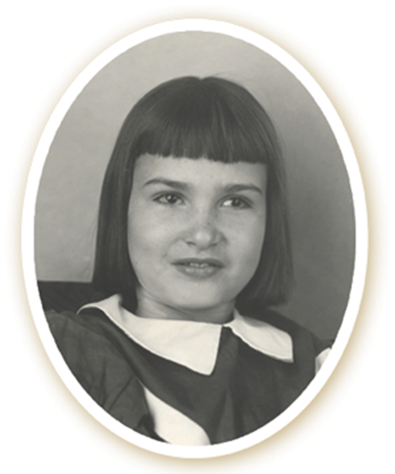
5. During excavation a mysterious skeleton was found at a depth of about 20 feet. Scientists were able to do an analysis to tell where and when death occurred. When did death occur, and where did death occur? (Year, C&S) (HINT: For when the death occurred a time frame of ten years can be given, as in between ___ and ___. –Jim)
(5pts: 2pts bold, 3pts answer)
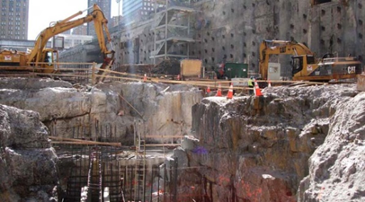

6. The lyrics may give directions to a restroom (on the starboard side), oddly clearwater was never an issue. The writer sometimes included the misheard lyrics in revival performances. He also wrote a piece about being down at an intersection. In the song, how much money does he suggest one should show up at the intersection with?
(4pts: 1pt bold, 3pts answer)

7. Sixty plus years ago almost 100 people arrived for a putative BBQ and to visit their “made” ill friend Barbara. Due to much outside and uninvited interest, they had to leave very quickly. According to the current owner, about how often do people now come by to visit?
(4pts: 1pt bold, 3pts answer)
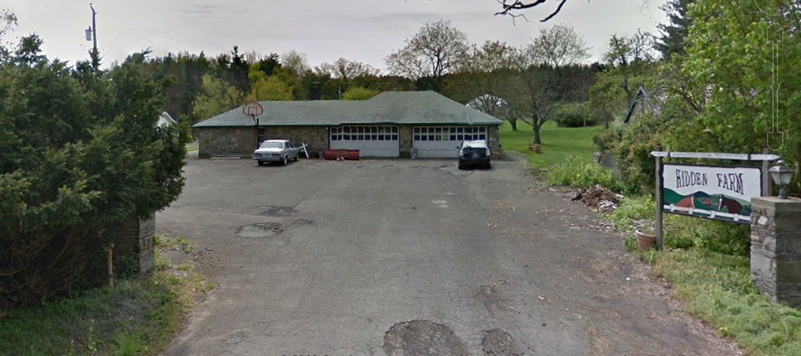

8. Bees love it. Scots love it. Cattle won’t eat it. It resists removal efforts with a coat of painful glove penetrating spikes. How is the plant in the picture below rated by the state of Oregon?
(4pts: 2pts bold, 2pts answer)
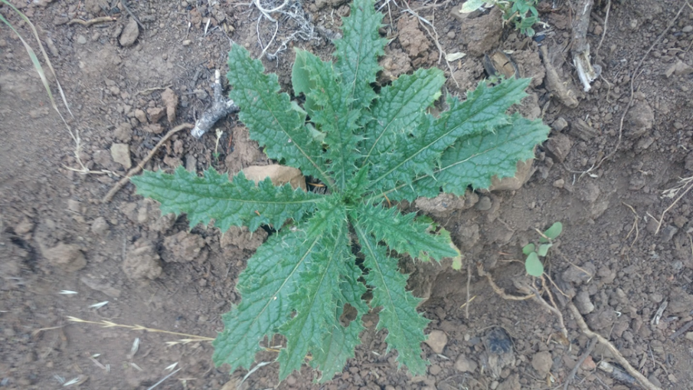

9. At the end of his enshrinement speech, he received a four minute and four second standing ovation. Probably longer than any his record making first-cousin-once-removed ever received. When his cousin was asked to cite a greatest influence, his cousin answered, “Well, me, of course.” But, when our orator was asked for his own greatest influences, he listed: Monte Coleman, Ken Coffey, and fellow classmate, Darrell Green. Who was the speechmaker? (F&L)
(4pts: 2pts bold, 2pts answer)

10. What is the complete street address of the manufacturer of the instruments featured on this video? https://www.youtube.com/watch?v=MFm2C-ve7qw
(4pts)

11. For most it is absolutely necessary that one start with a “strong” variety of the base; make sure that proof is apparent. Autolysis is sometimes used, though the eukaryote involved will die during the application of heat from an energy source. An aerobically produced greenhouse gas will be released. Protein bonding is water induced, and Maillard reactions are generated by the heat source. Diacetyl is produced first, followed by lactones and esters. Furan and maltol are created. What is the end result of the chemical process described?
(5pts: 3pts bold, 2pts answer)

12. A proprietor wrote at length about heavy baggage of humiliation and resentment. An entrepreneur said that there can be a lot of negativity from freely speaking. Both were courting with the hope of netting millions and their billions. What was the statement that started the whole affair?
(4pts: 2pts bold, 2pts answer)

13. He had 14 and had soloed with the Chicago Symphony. She won four in one night, it was her golden hour. In the summer of her golden hour quartet they both participated in events in the same state. If they went out for the official state drink, what would they order?
(6pts: 2pts bold, 4pts answer)

14. To start it all off they had to make sure to dot their i and cross their t’s. Under a tight schedule, producers had to band together : Superman slipping into a phone booth, and then righting a falling building; Harry Potter on a broom playing Quidditch between goals; and T-rex eating an opposing lion and spitting out the remains. At the end, the ship of what institution was sunk? (You must cite at least one YouTube source)

(5pts: 2pts bold, 3pts answer)

15. A composer who grew up in Sherwood, OR claimed to have written the recorded song found at https://www.loc.gov/item/ihas.200197143/. Most musicologists discount his claim. The origin of the song seems to be from among a group that spoke Creole with English elements. Scholarship based on wax rolls at the Library of Congress indicates the recording was made between what dates, and in what year? (D,M,&Y)
(6pts: 2pts bold, 2pts year, 2pts. dates)

16. In the fall of 2018, which city was ranked 11th on the list of American cities with the most challenging autumnal allergy problems? (C&S)
(2pts)

17. Watch the video: https://www.youtube.com/watch?v=Rkp8YSuePPM&list=RDRkp8YSuePPM&index=1 . With whose violin does the soloist finish the piece? (F&L)
(4pts)

18. Washington didn’t sleep there, but as the years went by and people confused father and son it became a place Washington slept, and therefore worth preserving. Fortunately, the old building was made of stone. The confusion extended to L’Enfant during land negotiations for his ambitious layout. What is the current street address for the aged masonry building? (street number and street)
(4pts: 1pt bold, 3pts answer)

19. Percy Mayfield wrote it and Ray Charles performed it. In the song, the girl runs off with a man with medicine and money. What surgery did the eponymous doctor perform on the performer?
(3pts: 1pt bold, 2pts answer)

20. Who led the first group of firefighters onto the roof section during this fire? (Title, F&L)
(3pts)
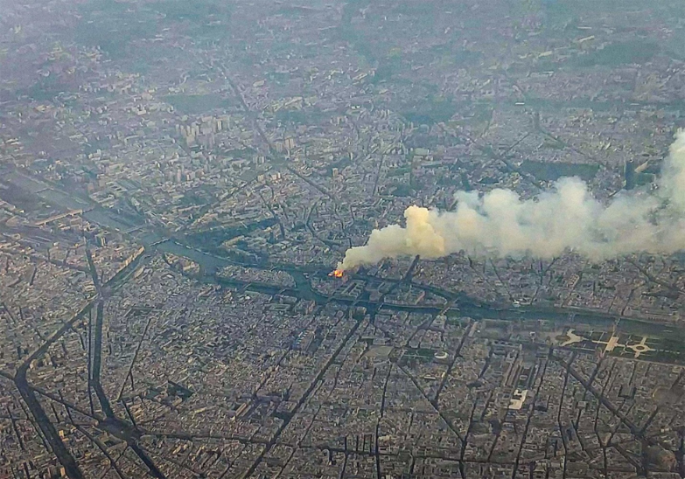

21. He was the mayor’s chief of staff and then chief operating officer of a foundation chartered by a junior and senior in 1913. What was the name of the place where was his father born?
(4pts: 1pts bold, 3pts answer)

22. China, in violation of the Montreal Protocol, released more than 11,000 metric tons per year of CFC-11 (an ozone destroying chlorofluorocarbon) into the atmosphere. It is estimated that this will set back ozone layer recovery by at least how long?
(4pts: 1pt bold, 3pts answer)

23. Located in a town that once vied to be a capital, how many generations within the same family have been owners of the business in this picture?
(5pts: 2pt bold, 3pts answer)
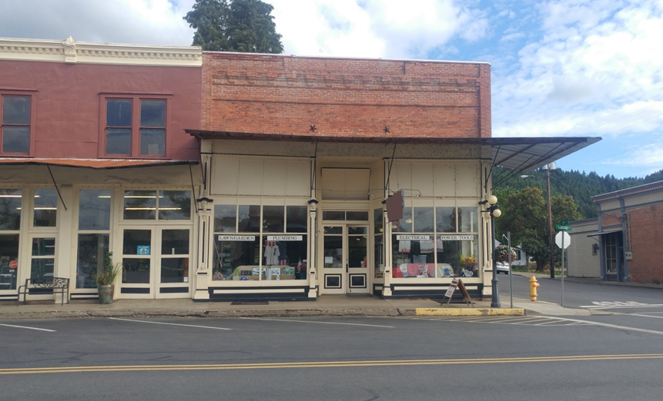

24. It is suggested that the name for the type of connector in the photograph first appeared in 1592. What is the hook part (not the cotter pin or bolt) called?
(3pts: 1pt bold, 2pts answer)
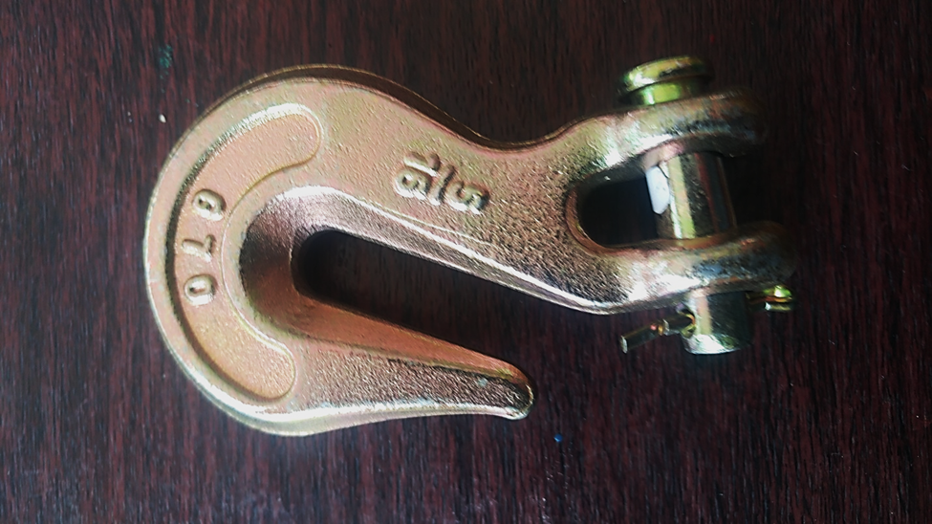

25. Who was the first customer in the first department store in the United States owned by the oldest incorporated commercial enterprise in North America as of August 18, 2019?(Title, F&L)
(4pts: 1pt bold, 3pts answer)

26. Watch this video: https://www.youtube.com/watch?v=Lj-epjtyZ_Y. One of the players who scored a touchdown has an aunt and uncle in the entertainment business. When his aunt and uncle first met, why was she turned down?
(5pts: 1pt bold, 4pts answer)

27. Watch this video: https://www.youtube.com/watch?v=BaevBH5Fl6k. Who is the conductor of the sequence shot in the recording studio? (F&L)
(3pts)

28. The break in bulk town, now part of a capital, was isolated from the main capital area until a 1915 bridge was completed. In what year was a paved road completed from the old break in bulk town to the “Nation’s Summer Capital”?
(5pts: 2pts bold, 3 pts answer)

29. Below is a photo of the line to the start of the run. Sadly, there is no lift to the top, so an intrepid skier must haul skis and gear to the starting spot. To reach BC from the top of the run takes about five hours. The first to complete the run from the top of the line made a real-time online video of his descent. Viewers were encouraged by what organization to watch the event live to view a live realization of their award?
(4pts: 1pt bold, 3pts answer)
